3A Flows in Networks
Capacitated directed network:

Source and sink:

1. The diagram shows a capacitated directed network.
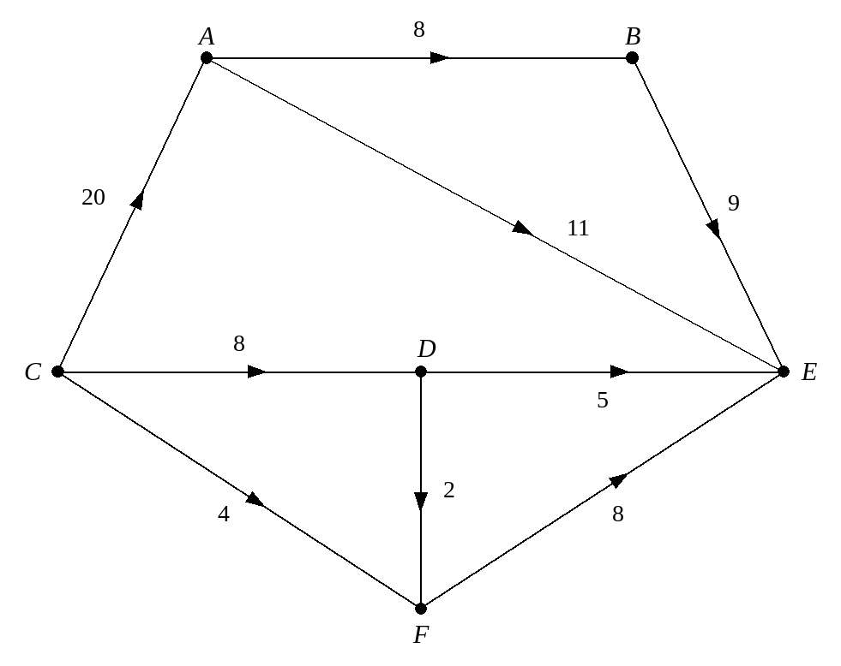
a) Write down the capacity of arcs DF and BE.

b) State the source vertex.

c) State the sink vertex.

A flow (the feasibility condition and the conservation condition):

Saturated arc:

Value of a flow:

2. The diagram below shows a possible flow through the capacitated directed network from question 1.
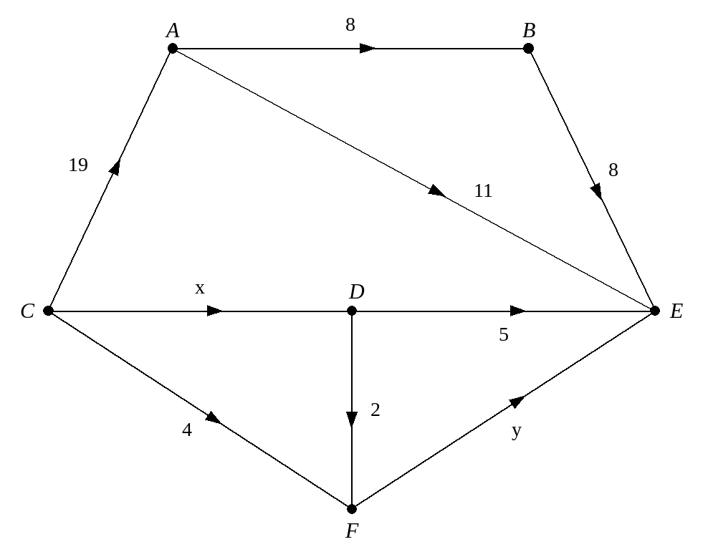
a) Find the values of x and y, explaining your reasoning.

b) List the five saturated arcs.

c) Write down the value of the flow.

d) What is the current flow along route CAE?

Showing capacities and a flow on one diagram:

3. The diagram shows a capacitated directed network. The number on each arc represents the capacity of that arc. The numbers in circles represent an initial flow pattern.
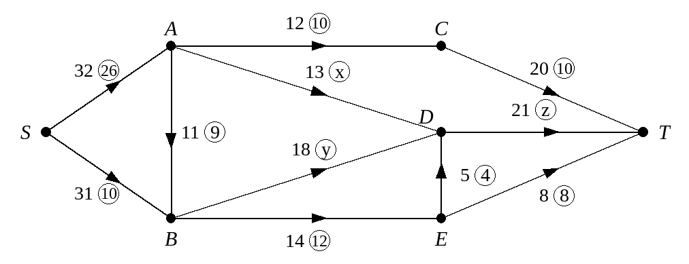
a) State a saturated arc.

b) Find the values of x, y and z, explaining your reasoning.

c) State the value of the initial flow.

d) Write down: i the capacity of arc BE ii the current flow along arc BE.

e) Find the current flow along SABET.

3B Cuts and Their Capacities
Maximal flow:

Cut:

Capacity (value) of a cut:

This network shows three different cuts, C₁, C₂ and C₃. Find the capacity of each cut.
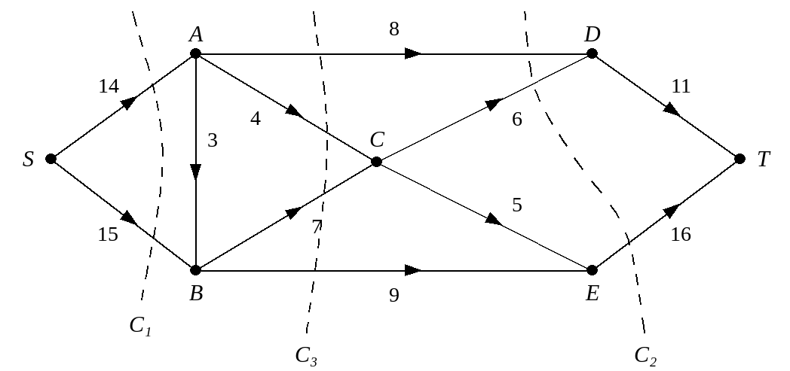

Arcs flowing into and out of a cut:

1. The diagram shows the capacitated directed network from above. The number on each arc represents the capacity of that arc. Determine the values of cuts C₄ and C₅.
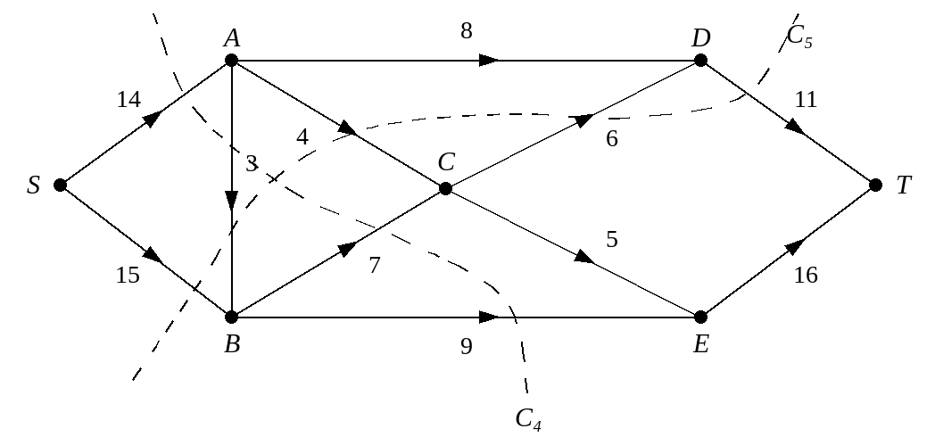

2. The diagram shows a capacitated directed network. The number on each arc represents the capacity of that arc. The numbers in circles represent an initial flow pattern. Find the values of cuts C₁ and C₂.
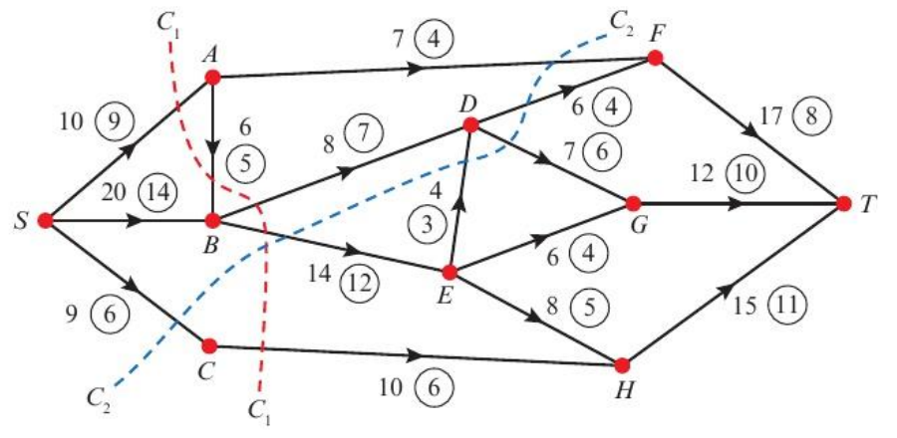

3C Finding an Initial Flow
Initial flow:

1. The diagram shows a capacitated directed network. The number on each arc represents the capacity of that arc.
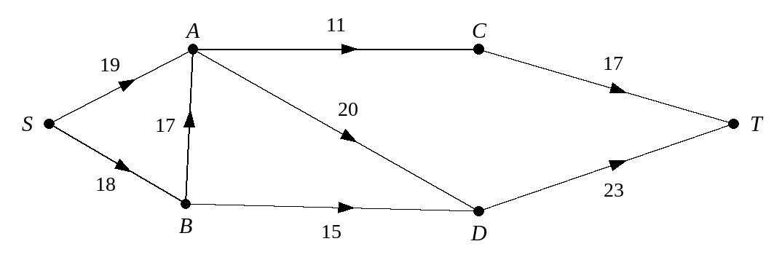
a) State the maximum flows along SACT and SBADT.

b) Show these on a diagram.
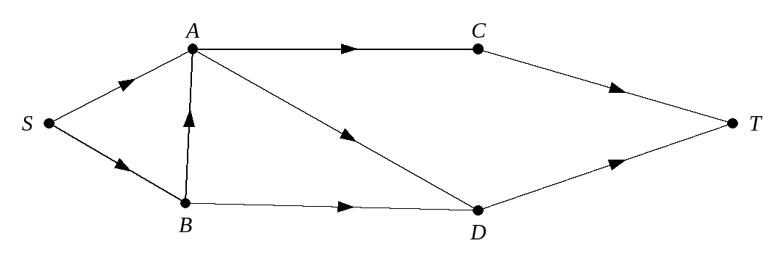
Using this as your initial flow pattern,
c) calculate the value of the initial flow.

2. The diagram shows a capacitated directed network. The number on each arc represents the capacity of that arc.
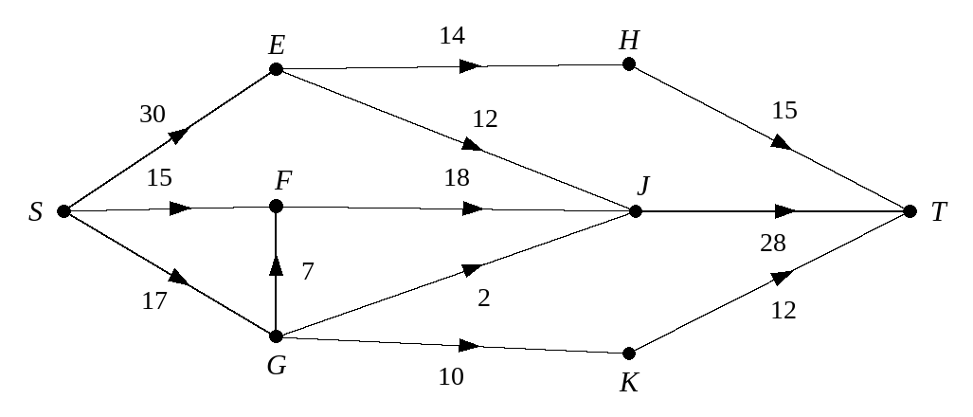
Given that arcs SG, EH, EJ, GJ, GK and JT are saturated, draw an initial flow through the network.
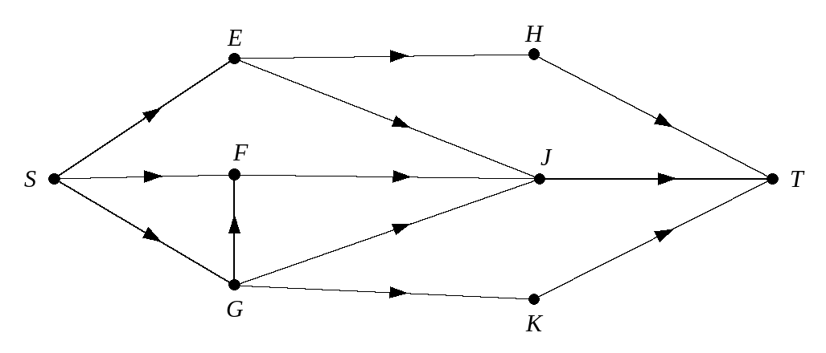

3D Flow-Augmenting Routes
The labelling procedure (forward and backward arrows):

Flow-augmenting route:

1. The diagram shows a capacitated directed network. The number on each arc represents the capacity of that arc. The numbers in circles represent an initial flow pattern.
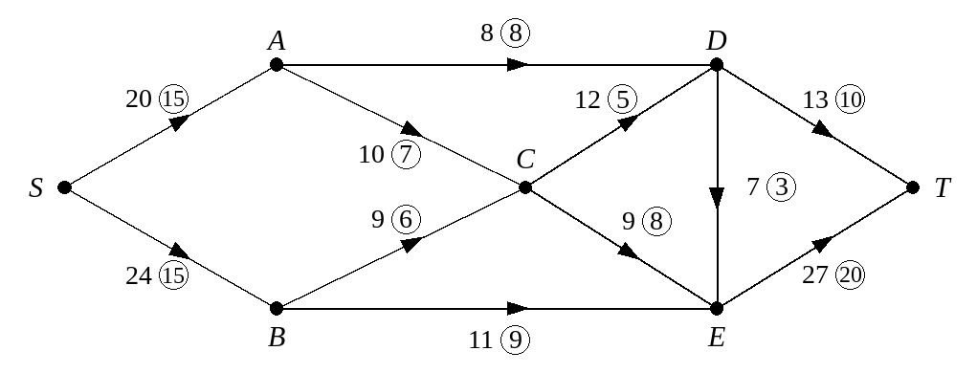
Starting from this initial flow pattern,
a) use the labelling procedure to obtain a maximum flow pattern through the network from S to T, and explain why your flow is maximal. You should list each flow-augmenting route you use together with its flow.
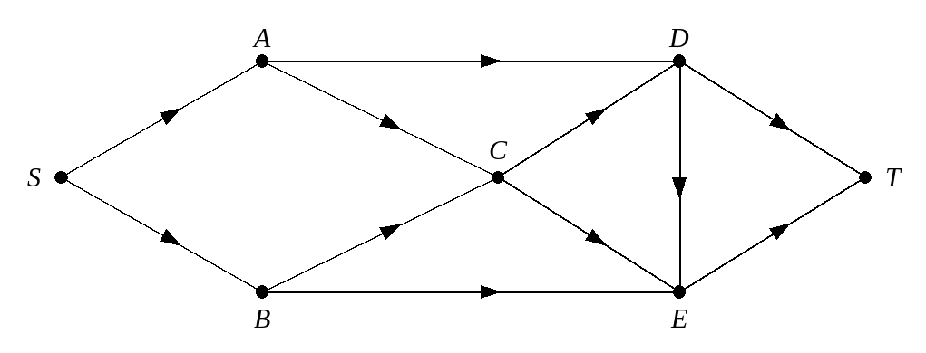

b) Draw your final flow pattern.
When sending an extra flow f along a flow-augmenting route:

2. The diagram shows a capacitated directed network. The number on each arc represents the capacity of that arc. The numbers in circles represent an initial flow pattern.
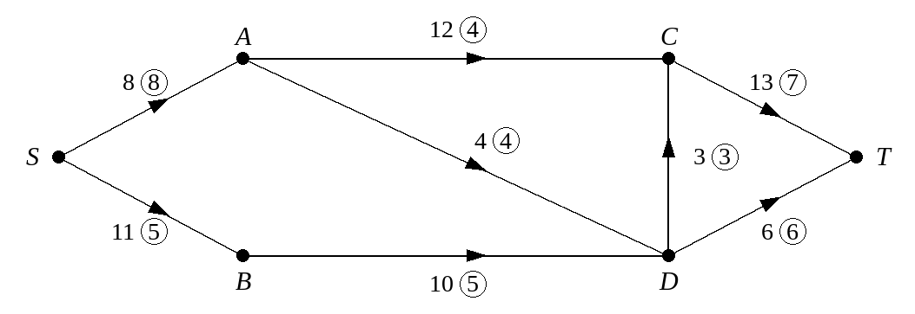
a) Write down the value of the initial flow.

Starting from this initial flow pattern,
b) use the labelling procedure to obtain a maximum flow pattern through the network from S to T, listing each flow-augmenting route you use together with its flow.
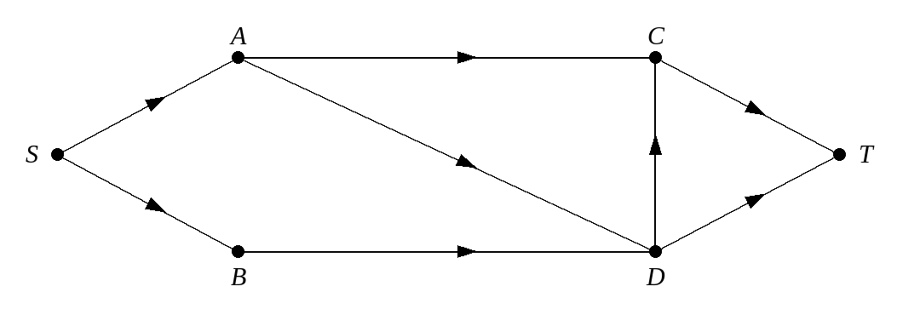

c) Draw your final flow pattern.
d) State the value of the maximum flow through this network.

3. The diagram shows a network of corridors represented by arcs. The corridors are those that will be used in evacuating a large cinema in the event of a fire. The capacity of each corridor is shown on each arc. The numbers in circles represent a possible flow of 41 people per second, from S to T. In order for the building to achieve a safety certificate it is necessary to show that it is possible for at least 70 people per second to pass from S to T.
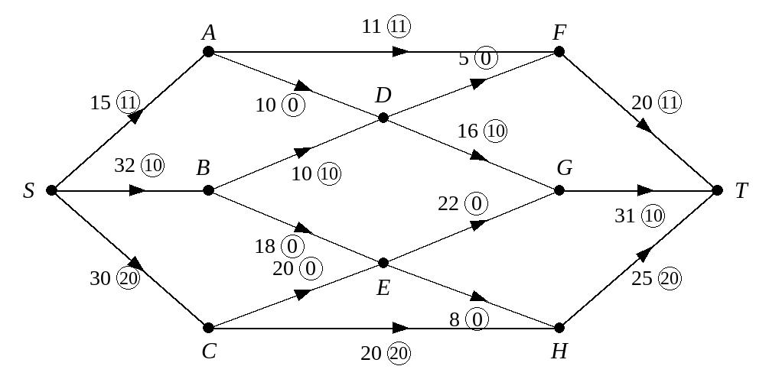
a) Use the initial flow and the labelling procedure to find a maximum flow through the network. You must list each flow-augmenting route you use, together with its flow.
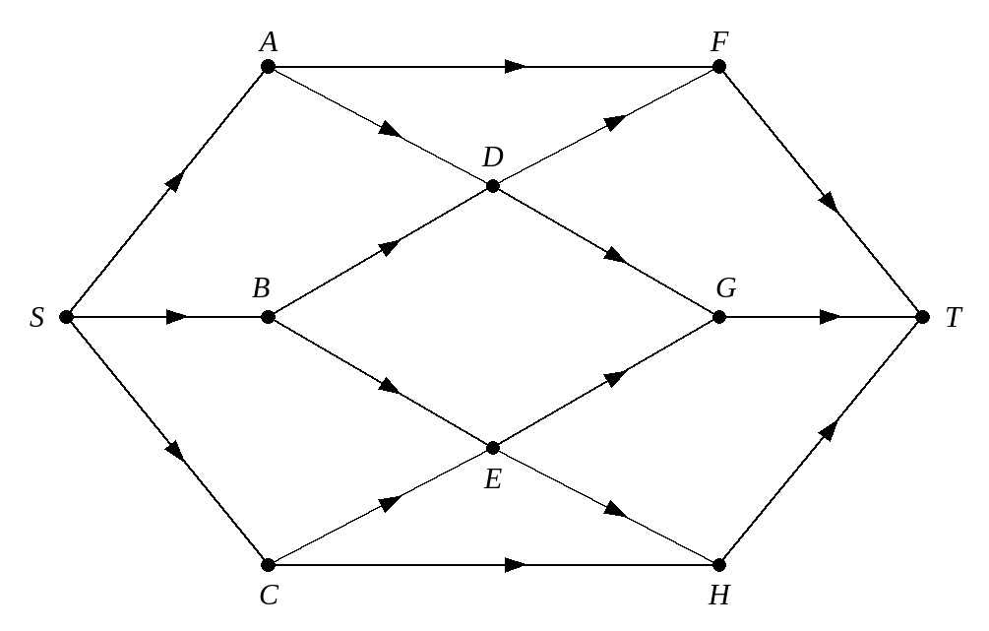

b) Draw your maximal flow pattern.
c) Will the cinema achieve its safety certificate?

3E Maximum Flow–Minimum Cut Theorem
The maximum flow–minimum cut theorem:

Proving a flow is maximal:

The minimum cut passes through:

1. The diagram shows a capacitated directed network and a flow of 38 passing through the same network. (This is the network used in Example 8.) Use the maximum flow–minimum cut theorem to prove that the flow is maximal.
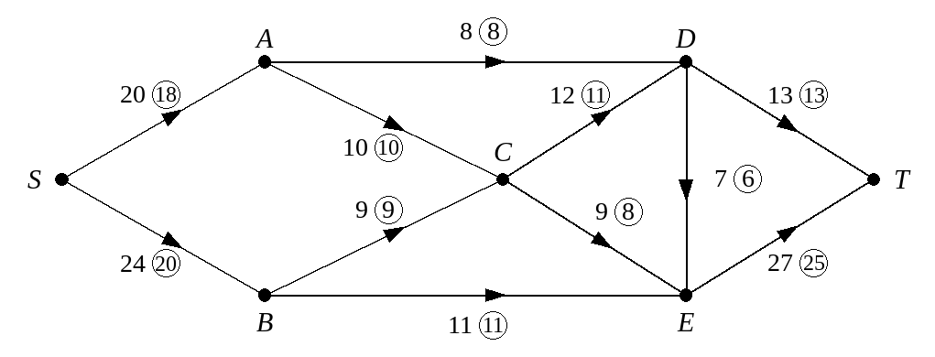

2. Figure 1 shows a capacitated directed network. Figure 2 shows a flow of 17 passing through the same network. Use the maximum flow–minimum cut theorem to prove that the flow is maximal.
Figure 1
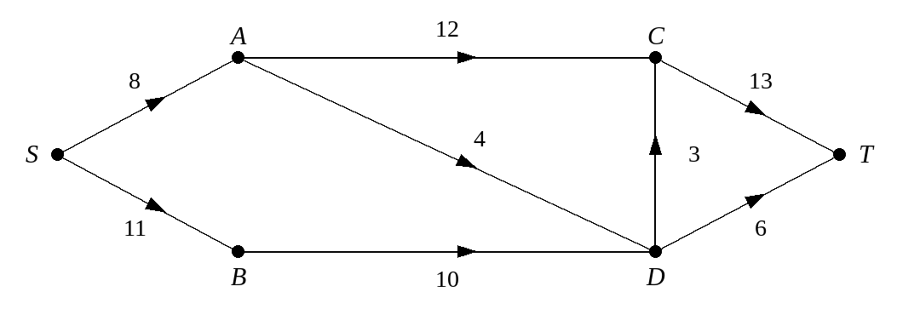
Figure 2
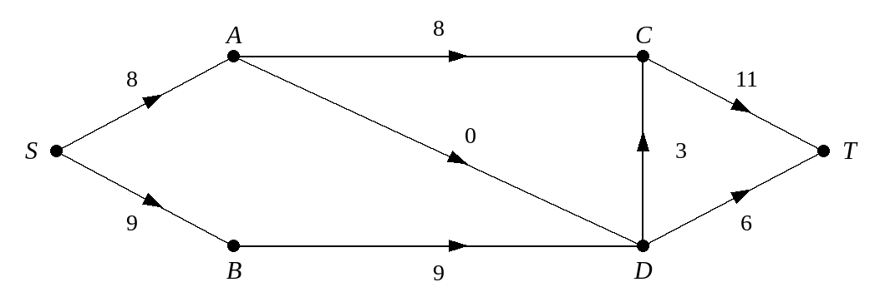

3. The diagram shows a capacitated directed network and a flow through the same network. Use the maximum flow–minimum cut theorem to prove that the flow is maximal.
