8B Utility
A school fete runs a dice game in which six dice are thrown. The charge is £1 for each attempt and the prize is £2000 for obtaining six sixes in a single throw. There are expected to be 400 attempts during the day, and at most one prize is awarded.

P(Win) on each throw =

P(Someone wins) =

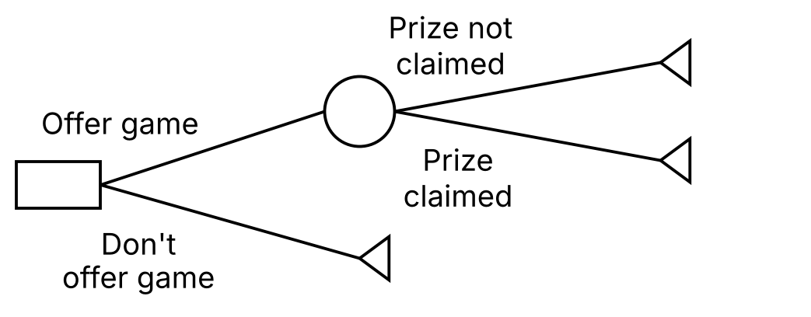

Why the EMV may not be the best criterion here:

Utility function:

Expected utility, E(U), and utils:

The utility function u(x) = 1 − e^{−x/R}, and the effect of R:

1. A school has to decide whether to offer the dice game described above. For a pay-off of £x, the school determines that its utility function is 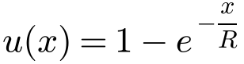.
Calculate the school’s expected utility, given that:
a) R = 400

b) R = 200

In each case, interpret the results.

2. A company can choose one of three business options A, B or C. The profits in pounds associated with each outcome are shown on the decision tree below.
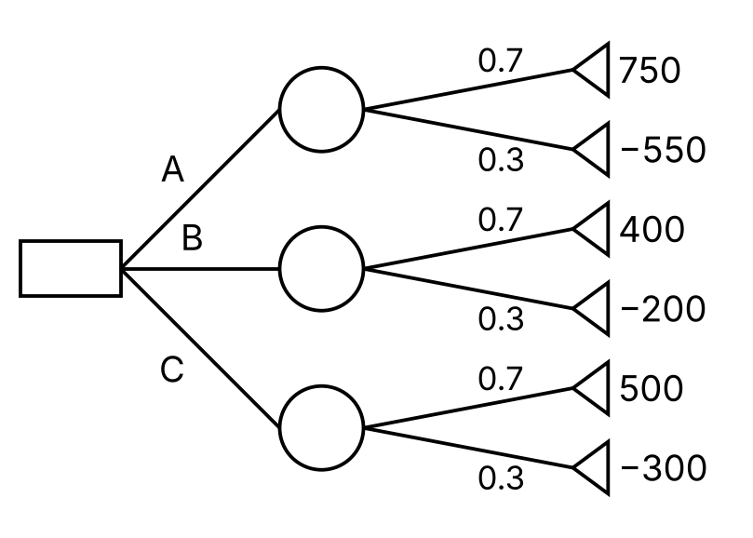
a) Using the decision tree, calculate the optimal EMV to determine the best choice.

For a profit of £x, the company’s utility is given by 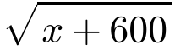.
b) Using expected utility as the criterion, determine the optimal choice.

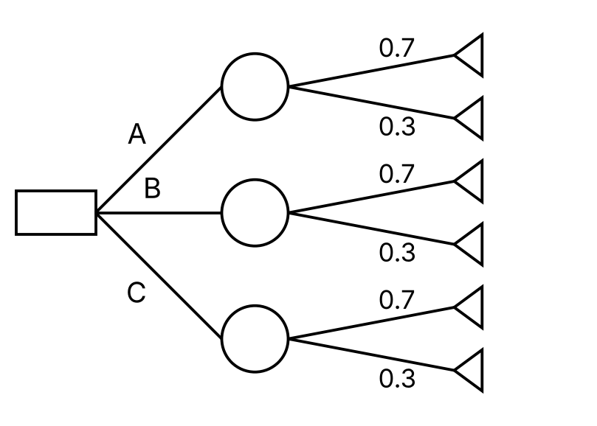

3. Tim is considering whether to play a card game. If he picks a Jack, Queen or King, at random from a standard pack of playing cards, then he wins a prize. If he picks any other card, then he loses £5.
a) Draw a decision tree and state Tim’s best course of action using the EMV criterion, given that the prize on offer is £12.
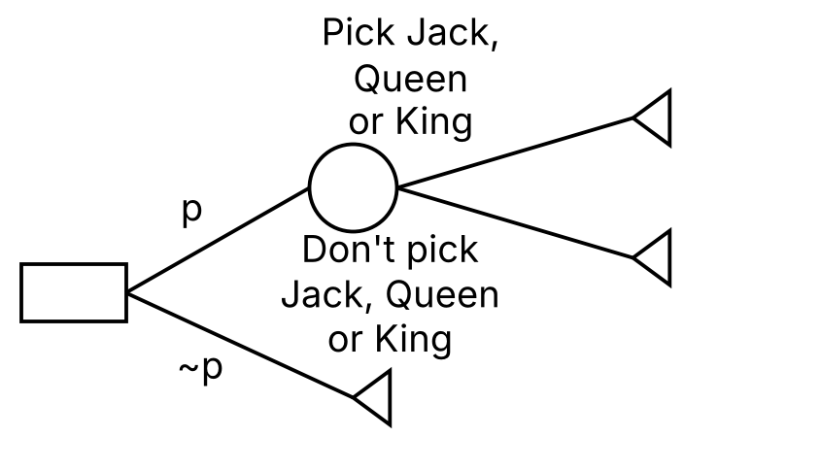

Tim only has £5. He uses utility = 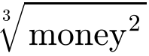 to reflect his risk aversion.
b) Calculate the minimum prize amount that would make it worthwhile for Tim to play the game.

