5A Shortest and Longest Path Problems
Dynamic programming:

Bellman's principle of optimality:

If the shortest/longest path from S to T is SABCT, then the shortest/longest path from S to C is

and the shortest/longest path from A to C is

Stage:

State:

Action:

Destination:

Value:

Which way do you work through the network in dynamic programming?

1. a Use dynamic programming to find the minimum cost route from S to T in the network below.
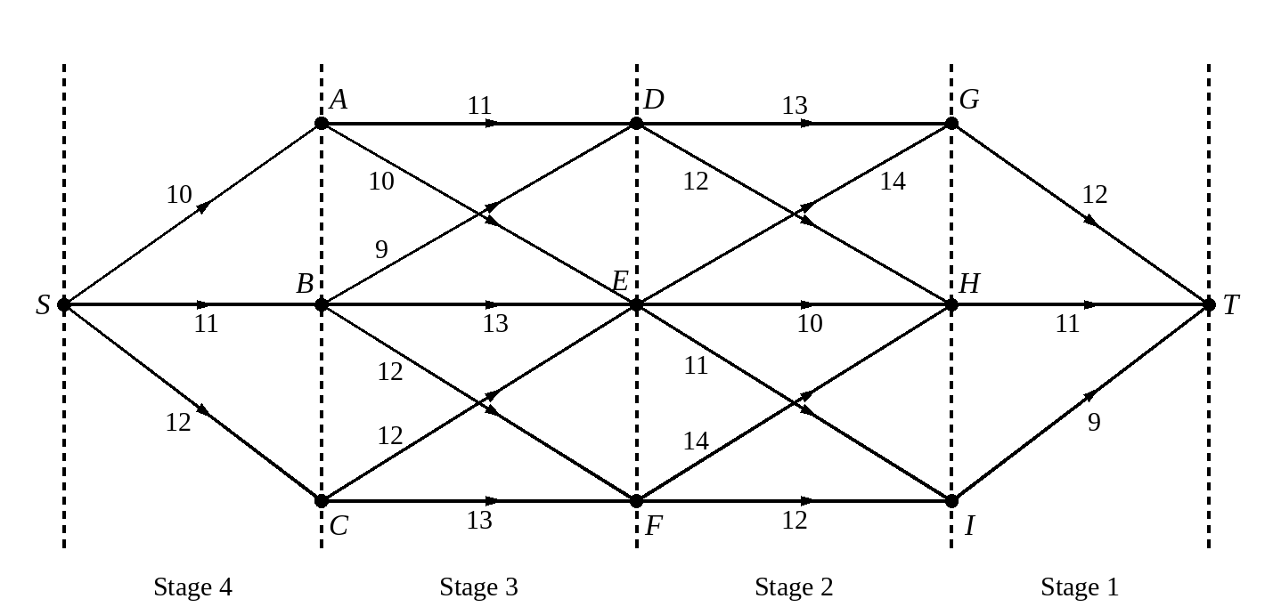
b Hence write down the minimum cost route from S to I.

Stage | State | Action | Destination | Value
1 | G | GT | T | 12*
 | H | HT | T | 11*
 | I | IT | T | 9*
2 | D | DG | G
 |  | DH | H
 | E | EG | G
 |  | EH | H
 |  | EI | I
 | F | FH | H
 |  | FI | I
3 | A | AD | D
 |  | AE | E
 | B | BD | D
 |  | BE | E
 |  | BF | F
 | C | CE | E
 |  | CF | F
4 | S | SA | A
 |  | SB | B
 |  | SC | C

2. Use dynamic programming to find the maximum cost route from S to T in the network below.
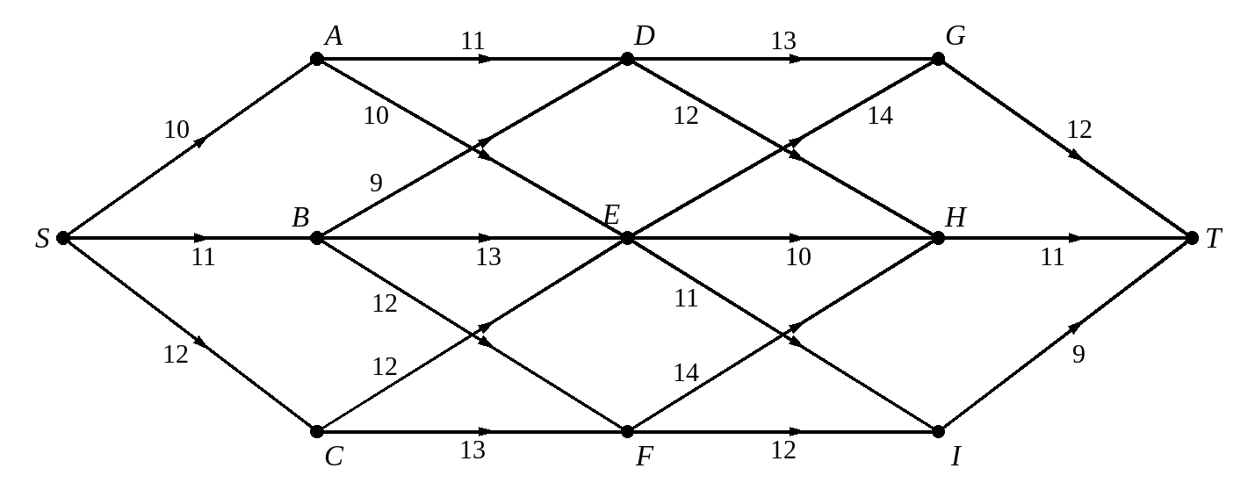
Stage | State | Action | Destination | Value
1 | G | GT | T
 | H | HT | T
 | I | IT | T
2 | D | DG | G
 |  | DH | H
 | E | EG | G
 |  | EH | H
 |  | EI | I
 | F | FH | H
 |  | FI | I
3 | A | AD | D
 |  | AE | E
 | B | BD | D
 |  | BE | E
 |  | BF | F
 | C | CE | E
 |  | CF | F
4 | S | SA | A
 |  | SB | B
 |  | SC | C

What do you do when two actions from the same state give the same optimal value?

3. Use dynamic programming to find: a the shortest b the longest route between S and T. State the route and its length in each case.
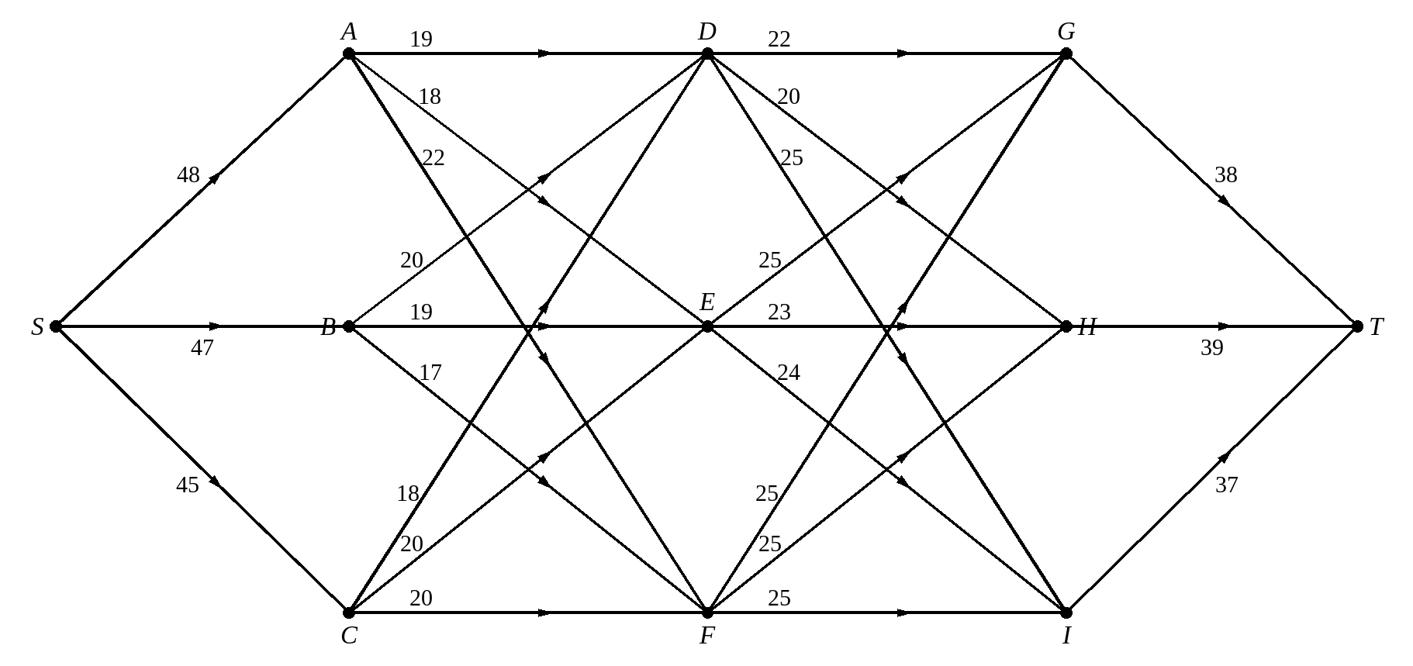
a The shortest route
Stage | State | Action | Destination | Value
1 | G | GT | T
 | H | HT | T
 | I | IT | T
2 | D | DG | G
 |  | DH | H
 |  | DI | I
 | E | EG | G
 |  | EH | H
 |  | EI | I
 | F | FG | G
 |  | FH | H
 |  | FI | I
3 | A | AD | D
 |  | AE | E
 |  | AF | F
 | B | BD | D
 |  | BE | E
 |  | BF | F
 | C | CD | D
 |  | CE | E
 |  | CF | F
4 | S | SA | A
 |  | SB | B
 |  | SC | C

b The longest route
Stage | State | Action | Destination | Value
1 | G | GT | T
 | H | HT | T
 | I | IT | T
2 | D | DG | G
 |  | DH | H
 |  | DI | I
 | E | EG | G
 |  | EH | H
 |  | EI | I
 | F | FG | G
 |  | FH | H
 |  | FI | I
3 | A | AD | D
 |  | AE | E
 |  | AF | F
 | B | BD | D
 |  | BE | E
 |  | BF | F
 | C | CD | D
 |  | CE | E
 |  | CF | F
4 | S | SA | A
 |  | SB | B
 |  | SC | C

4. A firm is creating a three-year plan, and considering a possible expansion. If the firm expands there will be costs, due to purchasing new premises and equipment, but also increased revenue. To establish the effect of the decisions, the firm will then calculate the effect on selling all of its assets at the end of the three-year period. The firm can only expand a maximum of two times due to plant restrictions. The results of the decisions are shown in the network below, with negative numbers indicating costs and positive numbers indicating revenues, in £100 000s.
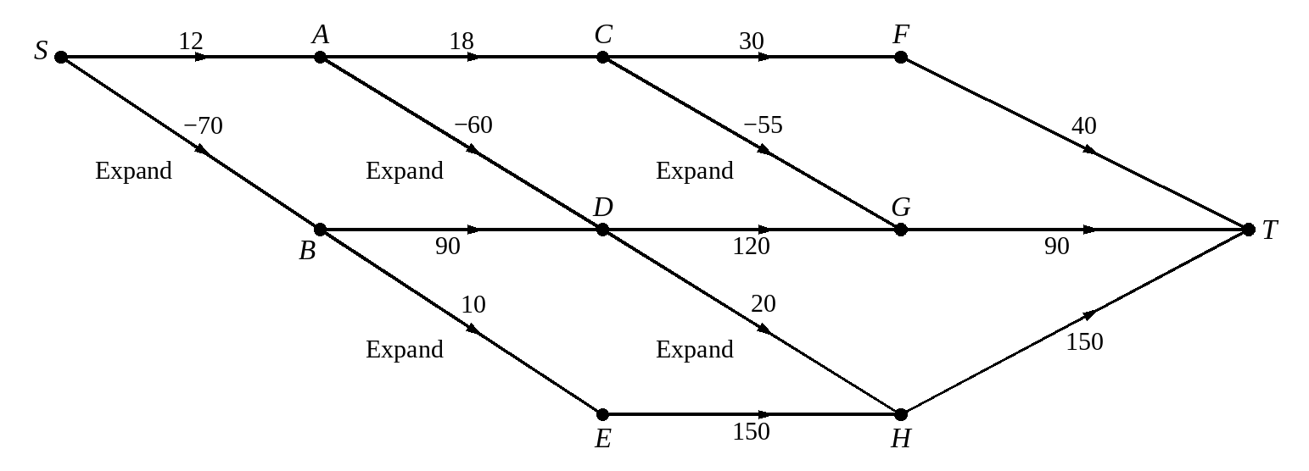
Determine the strategy that maximises the profit over the three-year period.
Stage | State | Action | Destination | Value
1 | F | FT | T
 | G | GT | T
 | H | HT | T
2 | C | CF | F
 |  | CG | G
 | D | DG | G
 |  | DH | H
 | E | EH | H
3 | A | AC | C
 |  | AD | D
 | B | BD | D
 |  | BE | E
4 | S | SA | A
 |  | SB | B

