4C Restricted Capacity Nodes
Restricted capacity node:

1. The diagram shows part of a capacitated directed network. The node, C, has a restricted capacity of 41. Show this information on the diagram.
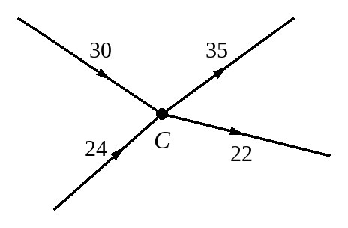

2. The diagram shows part of a capacitated directed network. The node, C, has a restricted capacity of 15. Show this information on the diagram.
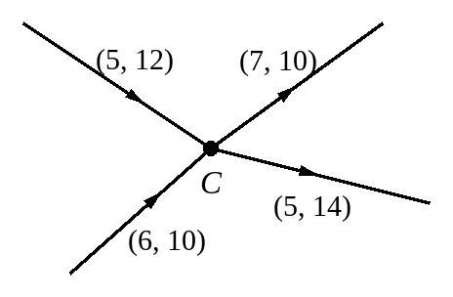

3. Here is the diagram used in 4B question 3.
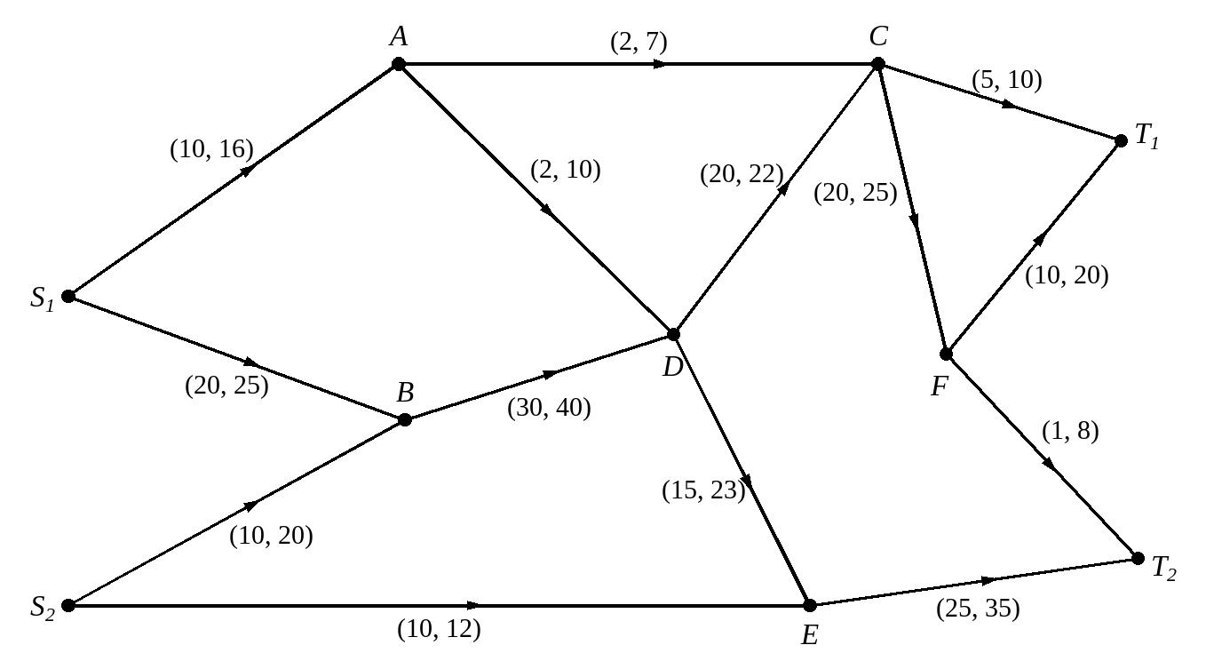
The maximum flow through the network is 64, as shown in this diagram.
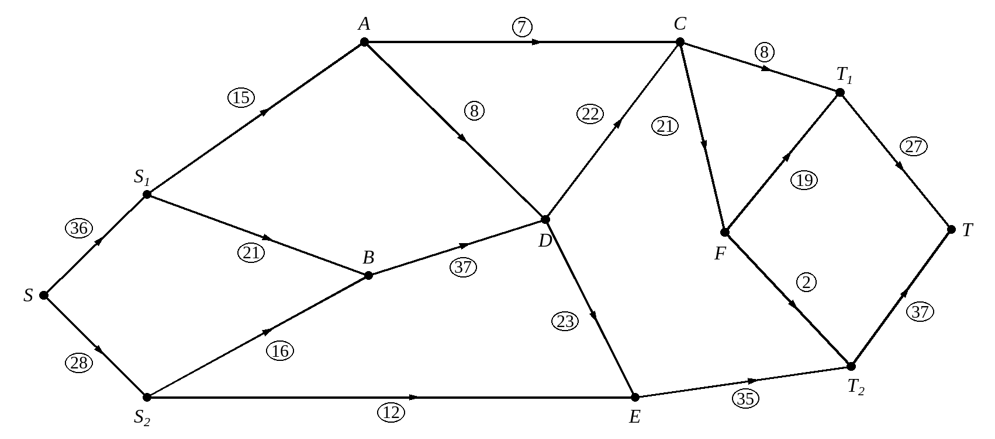
The node at B now has a restricted capacity of 30.
a) Explain why the maximum flow in the network cannot now exceed 58.

b) Show a feasible flow of 58 for the new network.
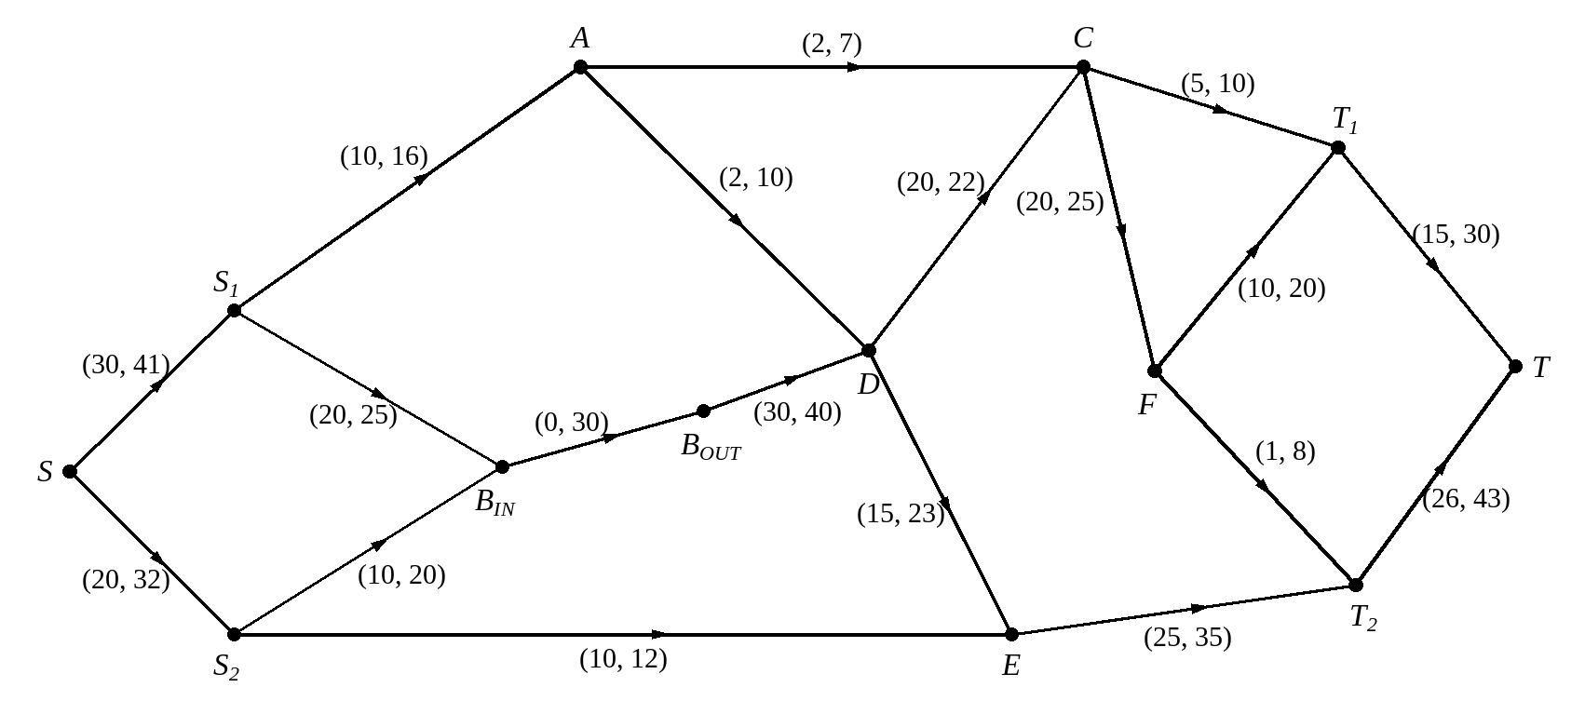

A node that is completely blocked:

