4B Sources and Sinks
Supersource:

Supersink:

Capacity and flow of the arcs from the supersource and to the supersink:

How do you recognise a source or a sink?

1. The diagram shows a capacitated directed network. The capacity of each arc is shown on each arc. The numbers in circles represent an initial flow.
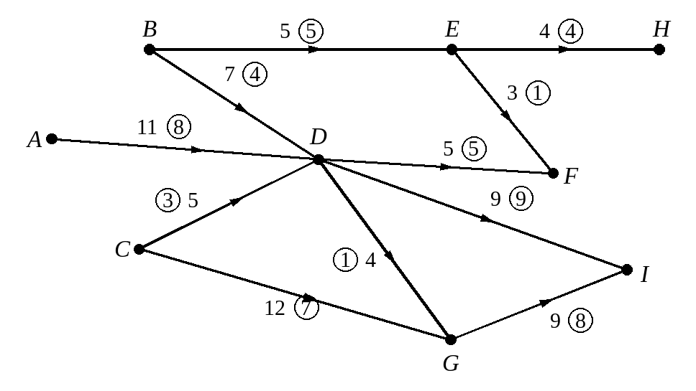
a) List the source vertices.

b) List the sink vertices.

c) Add a supersource, S, a supersink, T, and appropriate arcs and flows to the diagram.
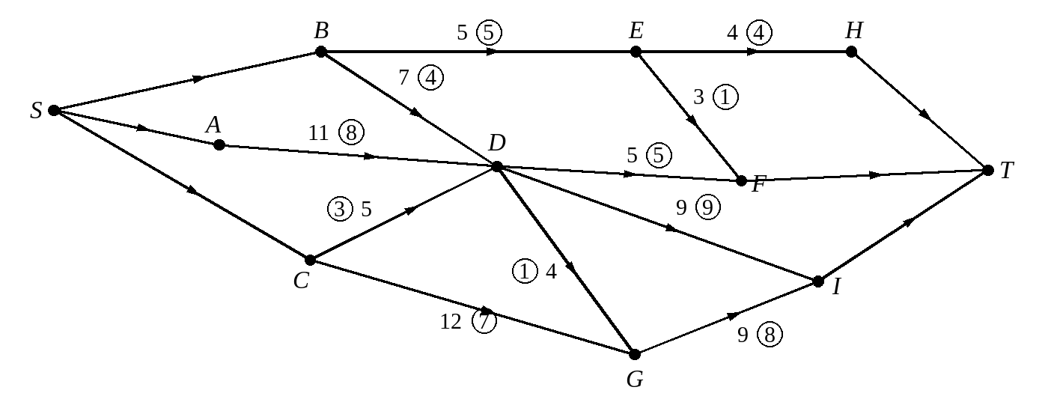

2. Water from three reservoirs, S₁, S₂ and S₃, is used to supply two towns T₁ and T₂, using a network of pipes. The capacity of each pipe is given by the number on each arc. The numbers in circles represent an initial flow.
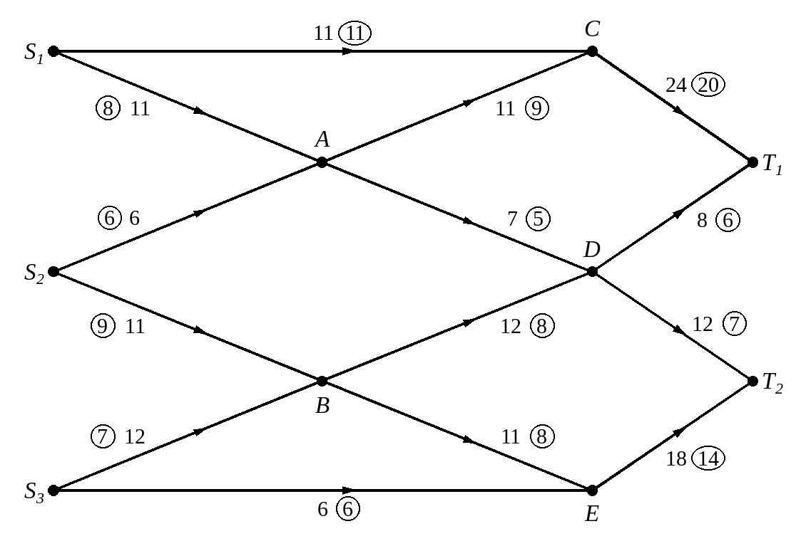
a) Add a supersource, supersink and appropriate arcs to the diagram.
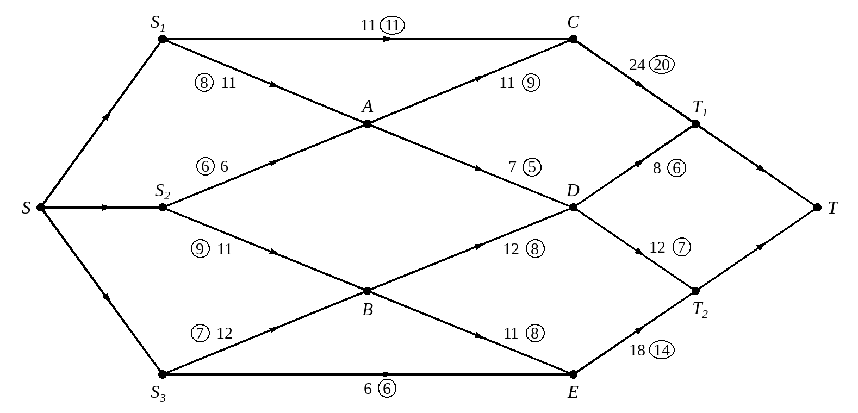
b) Use the initial flow and the labelling procedure to find the maximum flow through the network. List each flow-augmenting route you use, together with its flow.

c) Draw your maximal flow pattern.
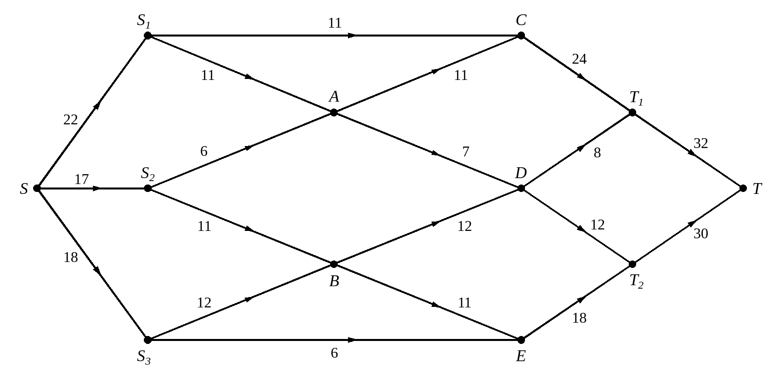
d) State the value of your flow.

e) Show that there are two minimum cuts.
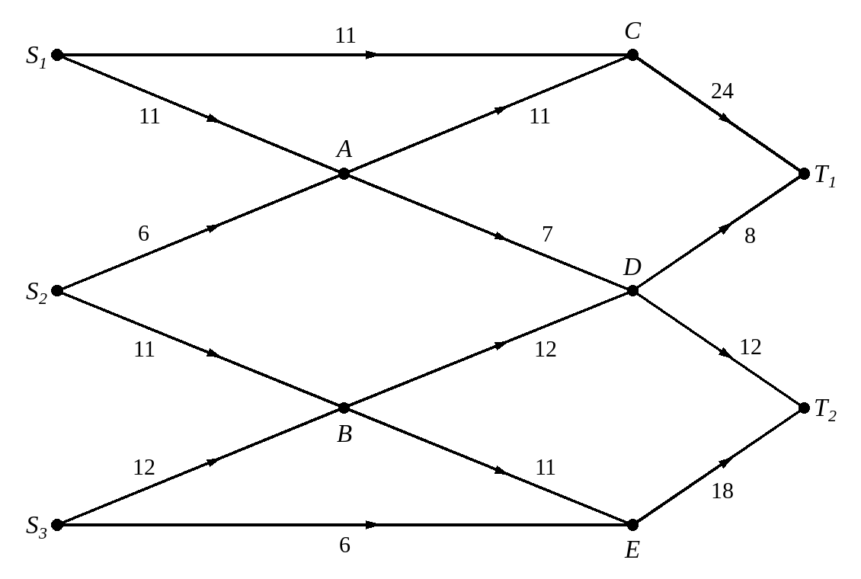

Supersource and supersink arcs when there are lower capacities:

3. The diagram shows a network of oil pipes with separate sources S₁ and S₂, and separate sinks T₁ and T₂. The numbers on the arcs represent the lower and upper capacities through the pipes.
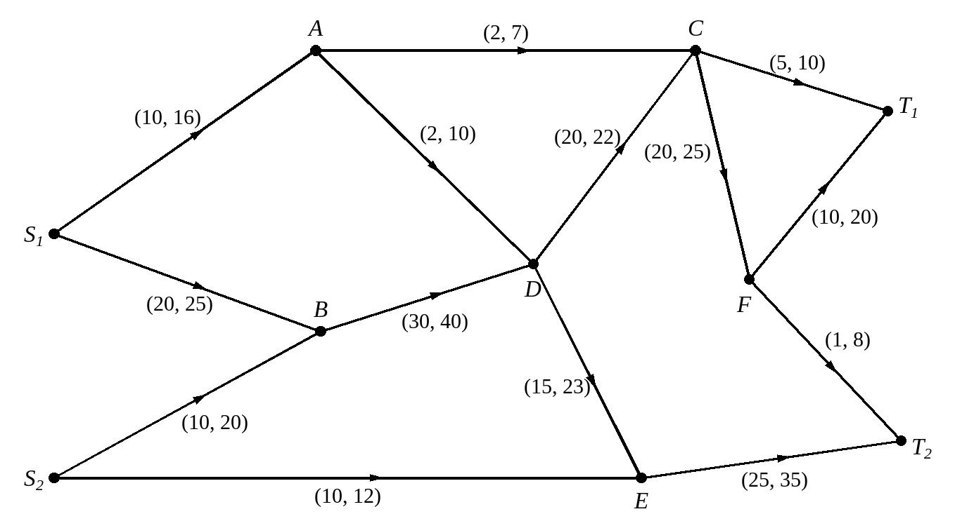
a) Add a supersource and supersink to the network with appropriate arcs. Label the new arcs with their lower and upper capacities.
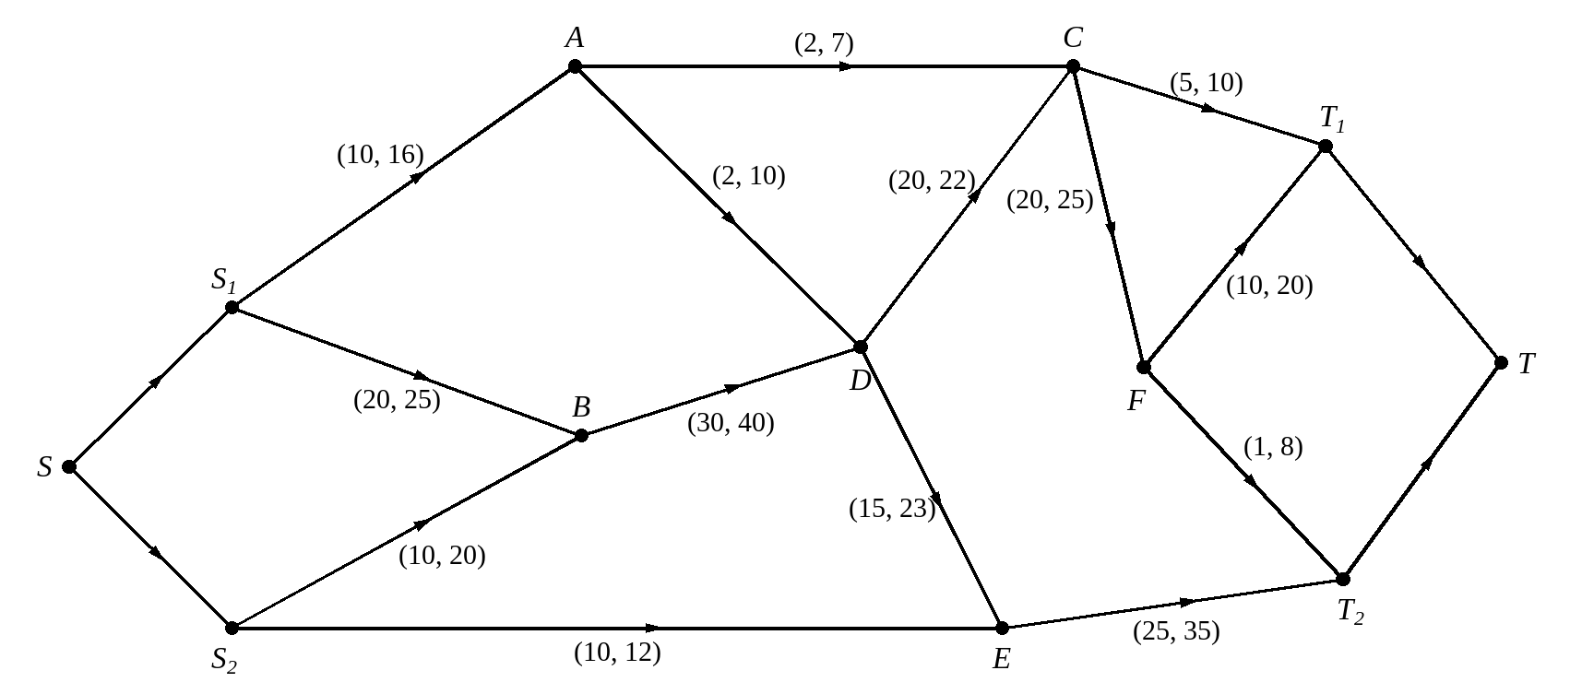

The diagram shows a partly completed feasible flow for the network.
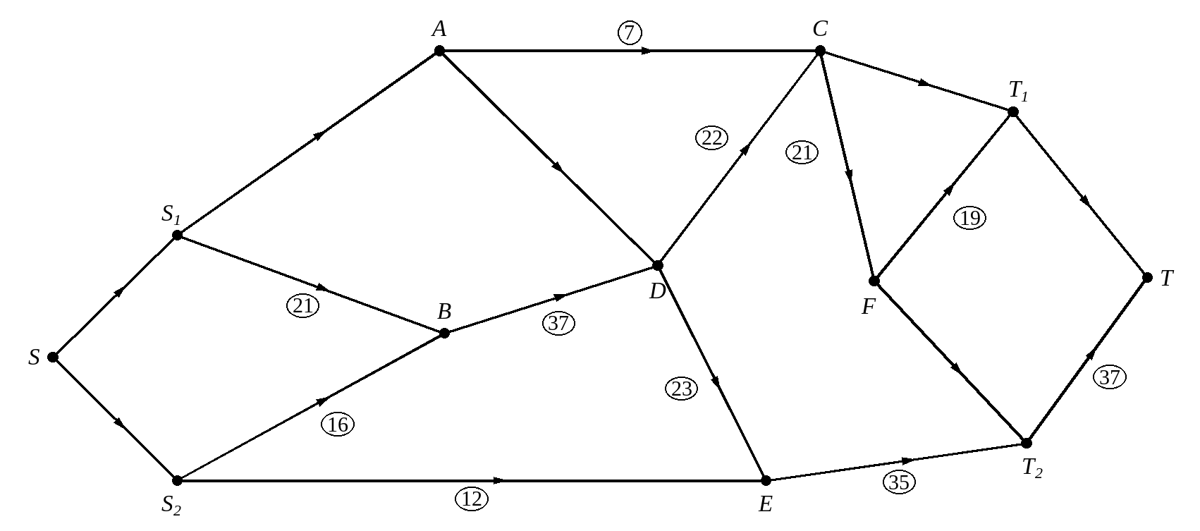
b) Complete the diagram to show a feasible flow of 64.

c) Prove that 64 is the maximum flow for the network.
