4A Lower Capacities
Lower capacity and upper capacity:

An arc labelled (3, 7) means

The conservation condition:

1. In the diagram, arcs AB, BC and BD represent part of a directed capacitated network. Deduce the value of the flow in each arc.
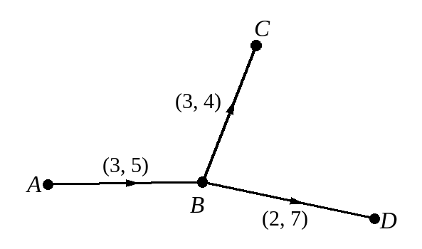

If the maximum total flow into a vertex is equal to the minimum total flow out of that vertex, then:

If the minimum total flow into a vertex is equal to the maximum total flow out of that vertex, then:

2. The diagram shows a directed capacitated network. The numbers on each arc represent the lower and upper capacities of that arc.
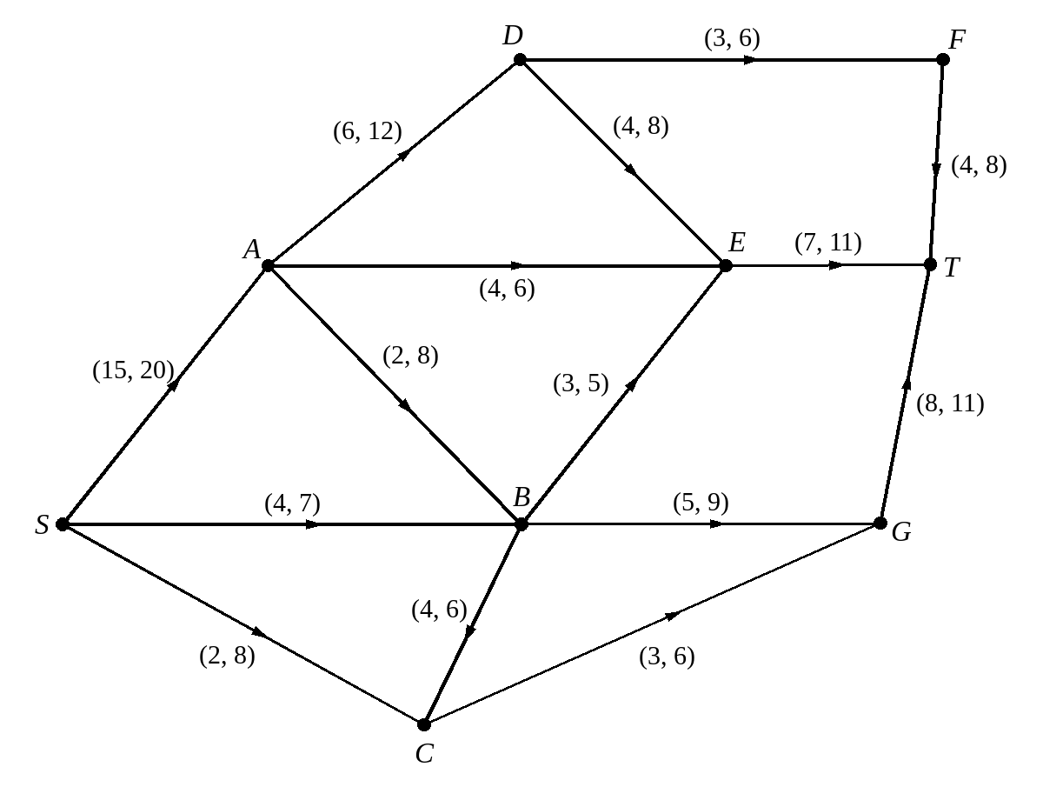
a) By considering vertex C, calculate the flow in: i SC ii BC iii CG

b) Explain why arcs DE, AE and BE must all be at their lower capacities.

c) Calculate the flow in GT.

Flow augmentation with lower capacities (excess capacity and potential backflow):

3. The diagram shows a feasible flow for the network given in question 2.
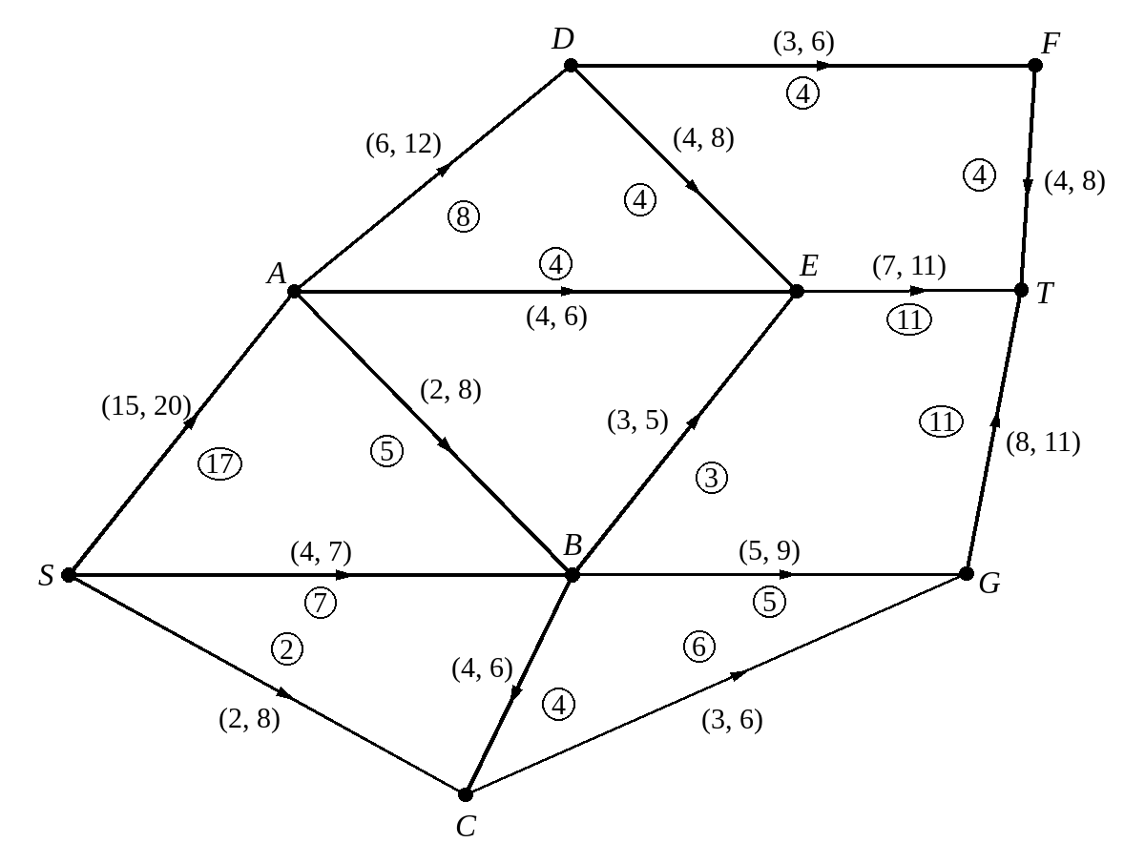
a) Use flow augmentation to find the maximum flow through the network.

b) Show the maximum flow on a diagram.

The capacity (value) of a cut in a network with lower capacities:

4. Here is the network used in questions 2 and 3.
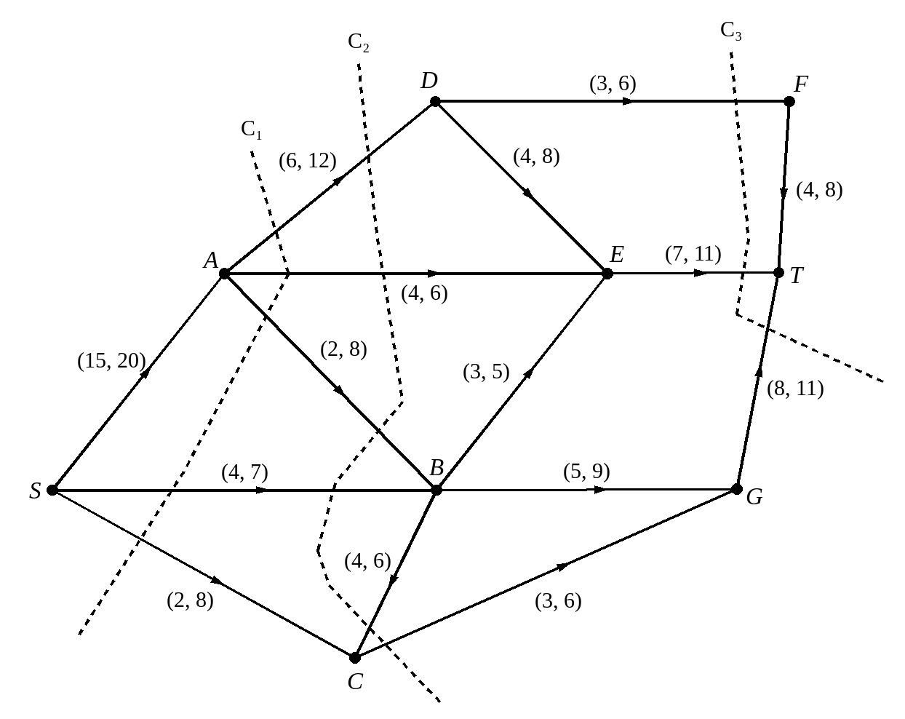
a) Find the capacity of the cuts C₁, C₂ and C₃.

b) Explain what this shows about the maximal flow.

