3E Maximum Flow–Minimum Cut Theorem
The maximum flow–minimum cut theorem:

Proving a flow is maximal:

The minimum cut passes through:

1. The diagram shows a capacitated directed network and a flow of 38 passing through the same network. (This is the network used in Example 8.) Use the maximum flow–minimum cut theorem to prove that the flow is maximal.
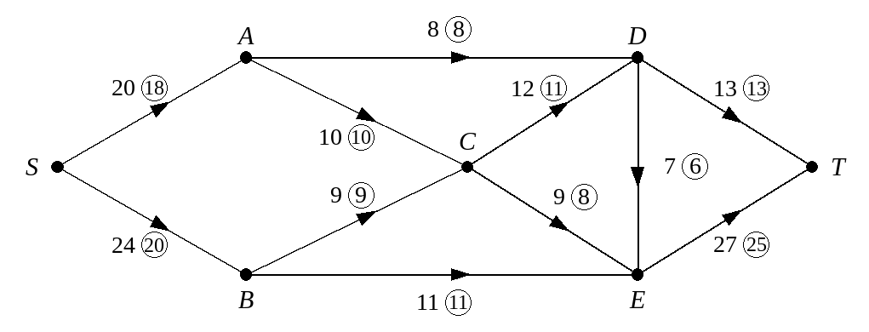

2. Figure 1 shows a capacitated directed network. Figure 2 shows a flow of 17 passing through the same network. Use the maximum flow–minimum cut theorem to prove that the flow is maximal.
Figure 1
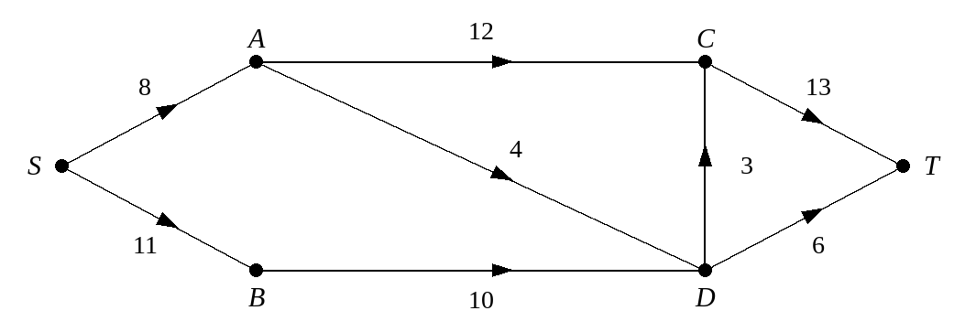
Figure 2
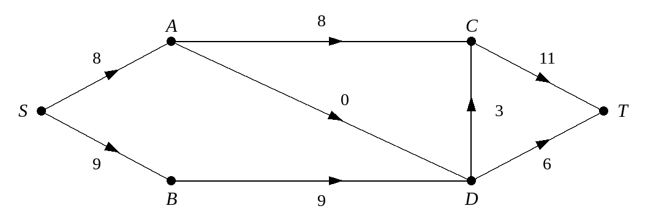

3. The diagram shows a capacitated directed network and a flow through the same network. Use the maximum flow–minimum cut theorem to prove that the flow is maximal.
