3D Flow-Augmenting Routes
The labelling procedure (forward and backward arrows):

Flow-augmenting route:

1. The diagram shows a capacitated directed network. The number on each arc represents the capacity of that arc. The numbers in circles represent an initial flow pattern.
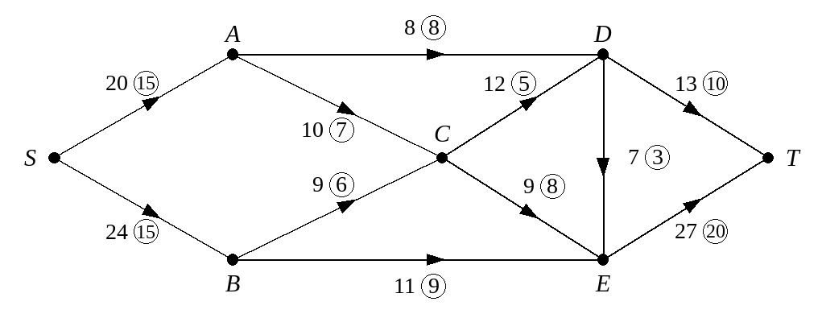
Starting from this initial flow pattern,
a) use the labelling procedure to obtain a maximum flow pattern through the network from S to T, and explain why your flow is maximal. You should list each flow-augmenting route you use together with its flow.
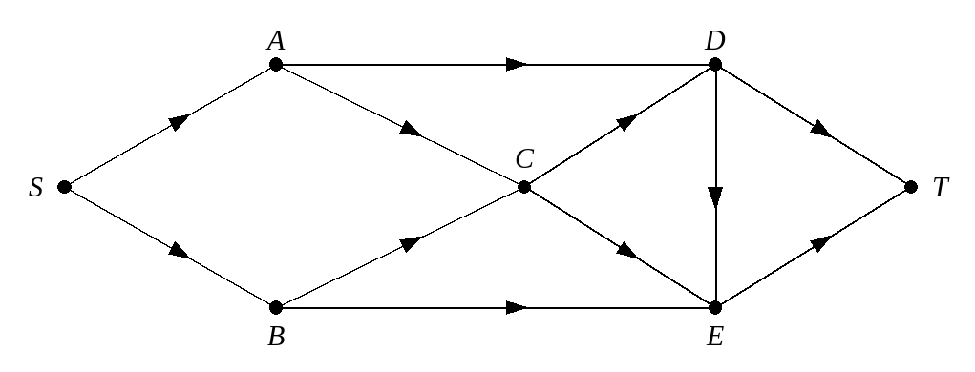

b) Draw your final flow pattern.
When sending an extra flow f along a flow-augmenting route:

2. The diagram shows a capacitated directed network. The number on each arc represents the capacity of that arc. The numbers in circles represent an initial flow pattern.
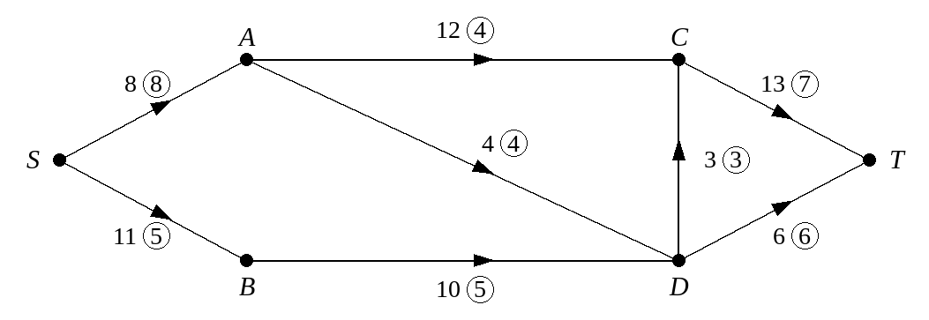
a) Write down the value of the initial flow.

Starting from this initial flow pattern,
b) use the labelling procedure to obtain a maximum flow pattern through the network from S to T, listing each flow-augmenting route you use together with its flow.
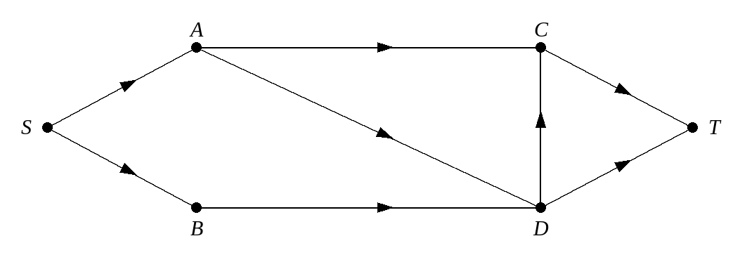

c) Draw your final flow pattern.
d) State the value of the maximum flow through this network.

3. The diagram shows a network of corridors represented by arcs. The corridors are those that will be used in evacuating a large cinema in the event of a fire. The capacity of each corridor is shown on each arc. The numbers in circles represent a possible flow of 41 people per second, from S to T. In order for the building to achieve a safety certificate it is necessary to show that it is possible for at least 70 people per second to pass from S to T.
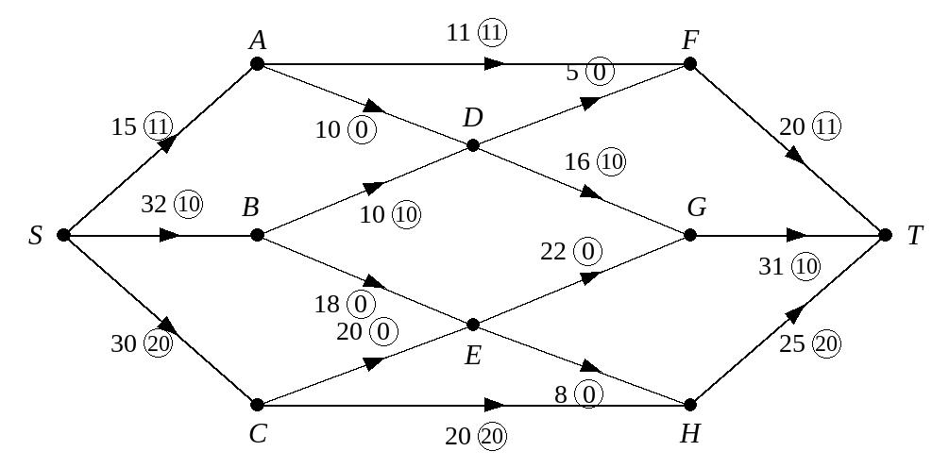
a) Use the initial flow and the labelling procedure to find a maximum flow through the network. You must list each flow-augmenting route you use, together with its flow.
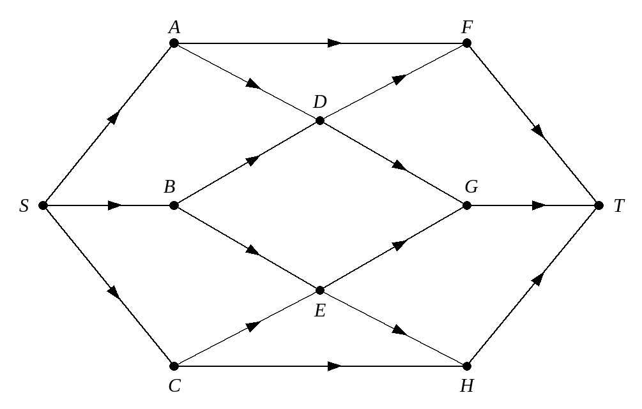

b) Draw your maximal flow pattern.
c) Will the cinema achieve its safety certificate?

