3B Cuts and Their Capacities
Maximal flow:

Cut:

Capacity (value) of a cut:

This network shows three different cuts, C₁, C₂ and C₃. Find the capacity of each cut.
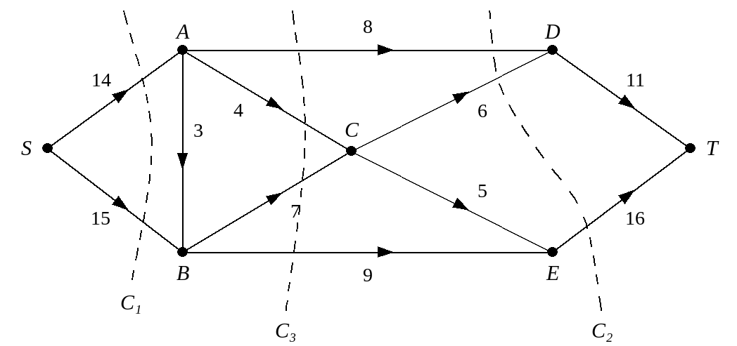

Arcs flowing into and out of a cut:

1. The diagram shows the capacitated directed network from above. The number on each arc represents the capacity of that arc. Determine the values of cuts C₄ and C₅.
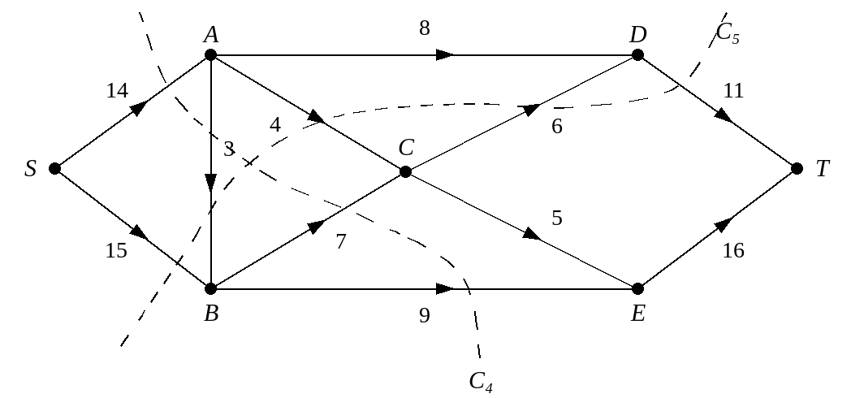

2. The diagram shows a capacitated directed network. The number on each arc represents the capacity of that arc. The numbers in circles represent an initial flow pattern. Find the values of cuts C₁ and C₂.
