8A Modelling a Project
Dependency:

Precedence (dependence) table:

1. The manufacture of a sofa involves the construction of a wooden frame which is then fitted with springs. The frame is then covered with padding and fabric. Cushions are cut out of the same fabric which must then be stitched and filled. The assembly of the sofa is completed by attaching the cushions. It is then inspected before being wrapped in a protective covering ready for shipping.
Represent the information above in a systematic way that makes any dependencies clear.

Activity | Depends on
A
B
C
D
E
F
G
H

2. The production of a new textbook may be broken down into activities A to G. Activities A and B do not depend on any other activities. Both activities C and D can only be started once A has been completed. Activity E cannot be started until activity B has been completed and activity F cannot be started until activities C and E have been completed. Activity G can only begin once all other activities have been completed.
Draw a precedence table to represent this information.

Activity | Depends on
A
B
C
D
E
F
G

Activity on arc network:

Events (nodes):

Source node and sink node:

3. Draw an activity network for the precedence table given in question 2.

8B Dummy Activities
1. Draw an activity network for this precedence table.
Activity | Depends on
A | –
B | –
C | A, B
D | A

Dummy activity:

Uniqueness: every activity must be uniquely represented in terms of its events, so

2. This diagram shows part of an activity network. Event S depends on activities P, Q and R. Activities P and Q both start at event 6. Explain why P cannot also be drawn from event 6 to event 8, and show how a dummy can be used instead.
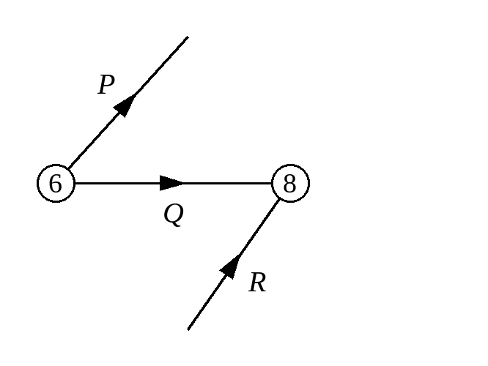

3. Draw an activity network for this precedence table. Use exactly two dummies.
Activity | Immediately preceding activities
A | –
B | A
C | A
D | A
E | B
F | B, C
G | D, F
H | D
I | G, H

8C Early and Late Event Times
Duration:

Early event time:

Late event time:

Forward pass (forward scan):

Backward pass (backward scan):

1. The activity network below shows the duration of each activity in hours. Work out the early and late event time at each event, writing the early time in the top box and the late time in the bottom box.
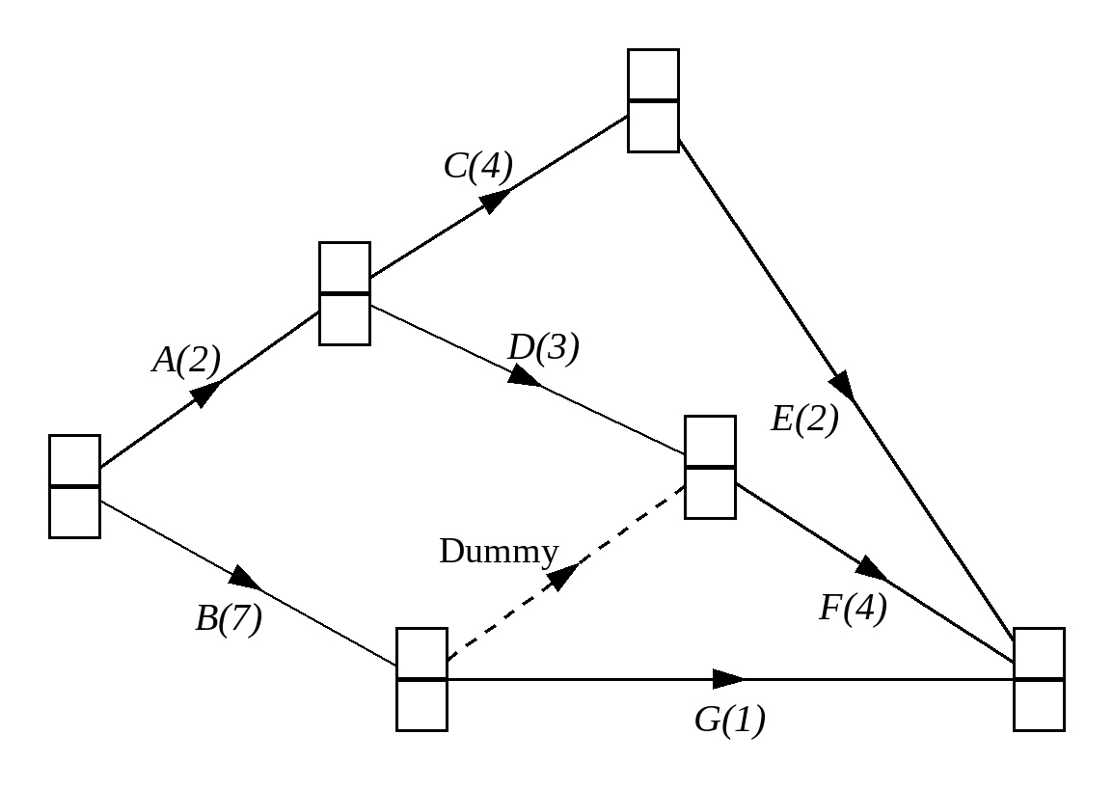

2. The diagram shows part of an activity network. Calculate the value of x.
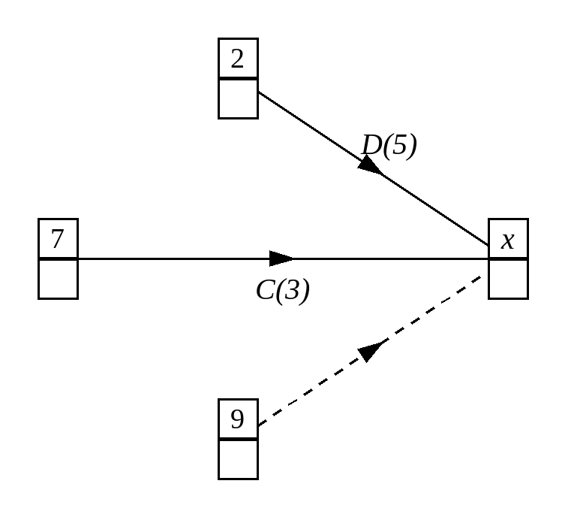

3. The diagram shows part of an activity network. Calculate the value of y.
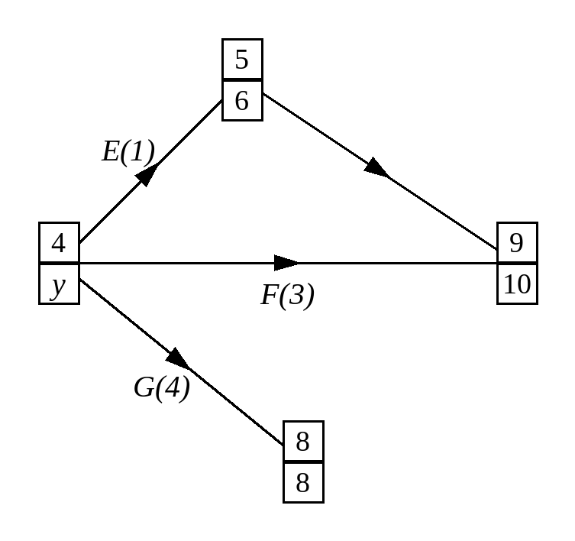

8D Critical Activities
Critical activity:

Critical path:

At each event on a critical path:

1. The diagram shows an activity network with early and late event times shown at the nodes. Identify the critical activities.
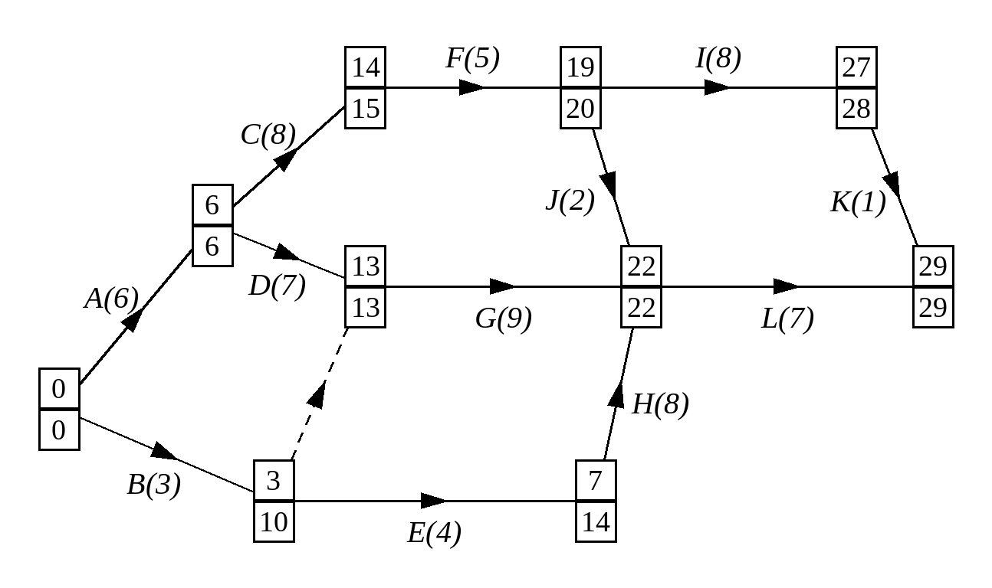

An activity connecting two critical events:

2. Part of an activity network is shown below including the early and late event times given in hours. Which are the critical activities?
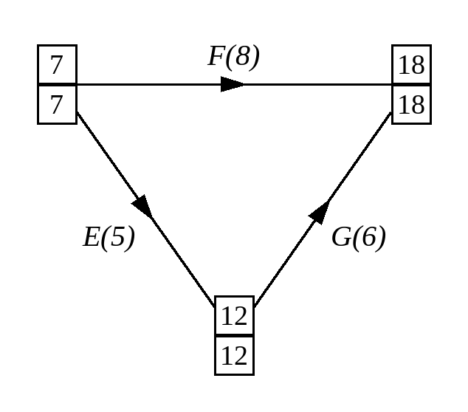

3. Find the critical paths in this activity network and identify the critical activities.
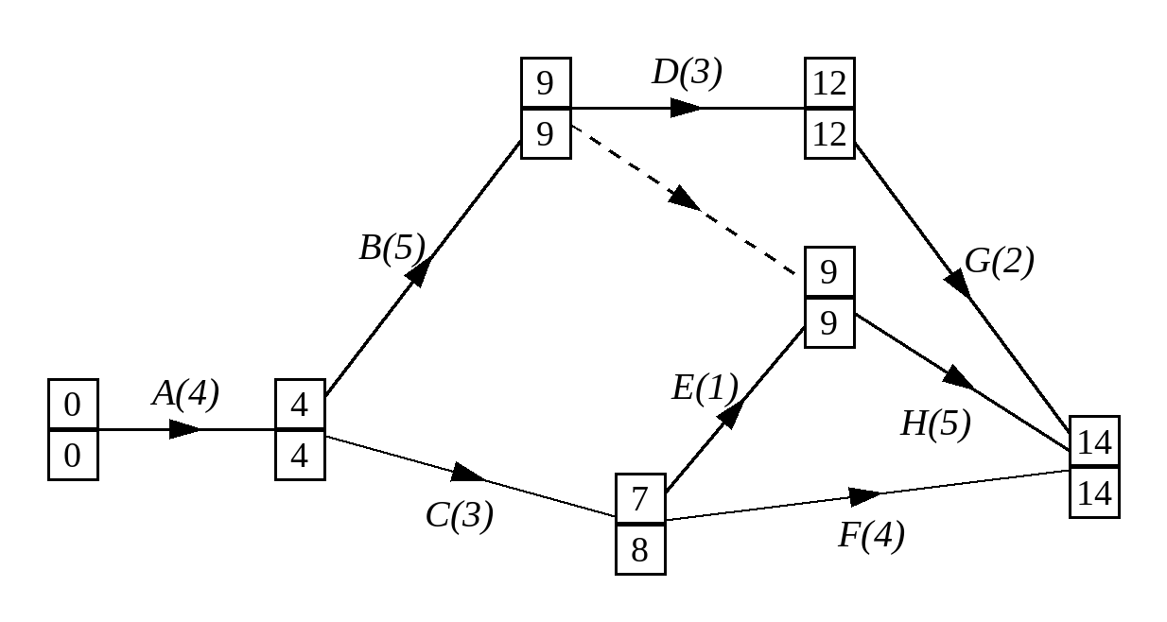

8E The Float of an Activity
Total float:

Formula: total float =

The total float of a critical activity is

1. Determine the total float of each activity in this activity network.
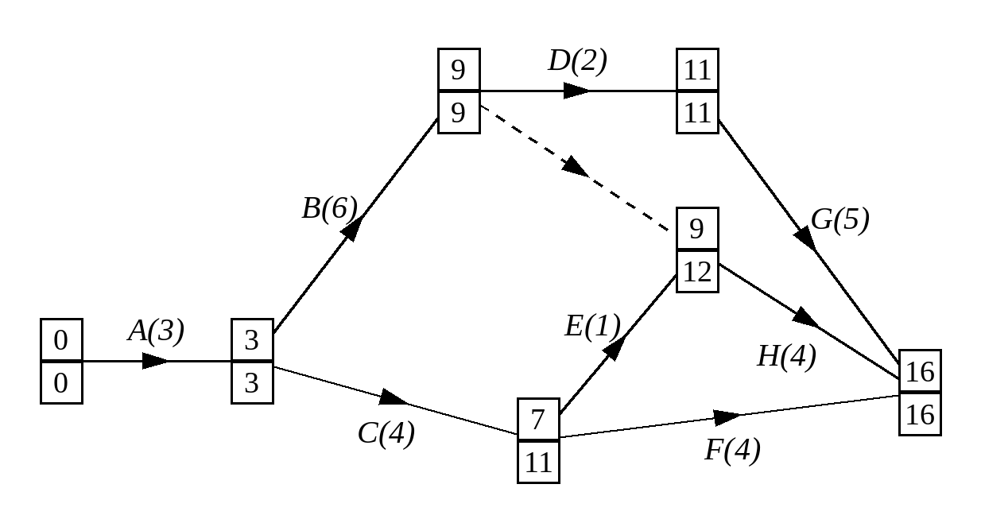

Activity | Latest finish − duration − earliest start | Total float
A
B
C
D
E
F
G
H

8F Gantt Charts
Gantt (cascade) chart:

The scale shows elapsed time, so the first hour is shown between

How critical activities and total float are shown:

1. Here is an activity network for a project. Early and late event times are shown in hours at the nodes. Draw a Gantt chart to represent the project.
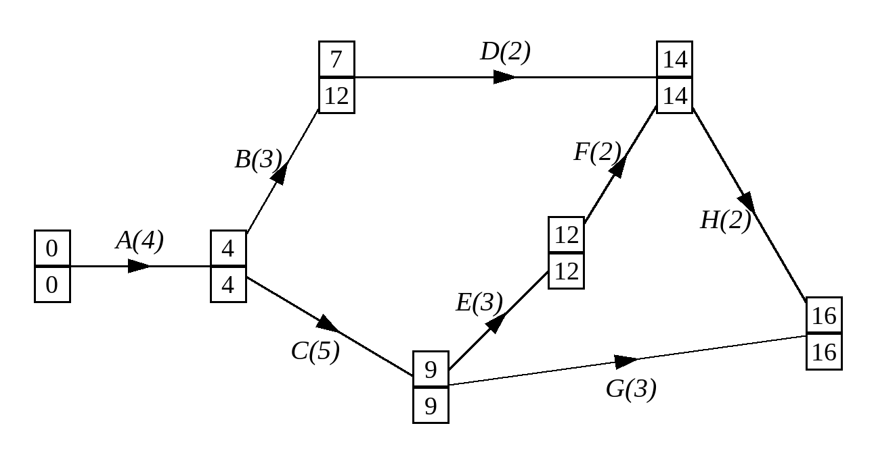
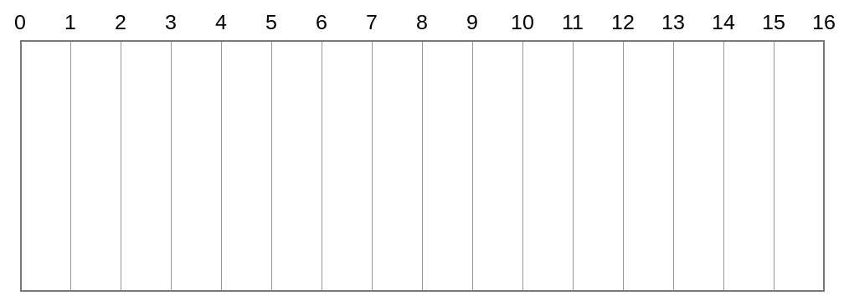

“Must be happening” and “may be happening”:

2. The Gantt chart below represents a project that must be completed within 25 days. Given that the project is on time,
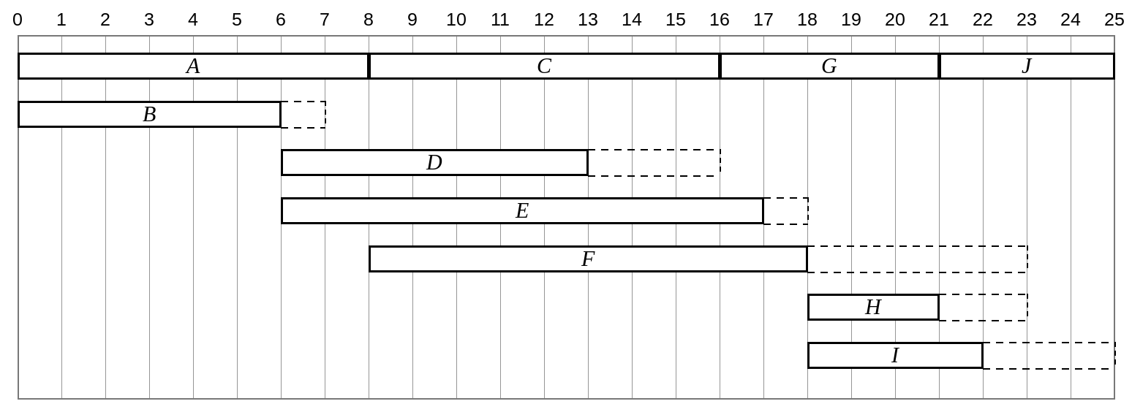
a) determine 3 activities that must be happening at midday on day 10.

b) determine 1 additional activity that may be happening at midday on day 10.

8H Resource Histograms
A level only

Rules for workers:

Resource histogram:

Resource levelling:

1. Here is the Gantt chart from question 2 of Exercise 8G.
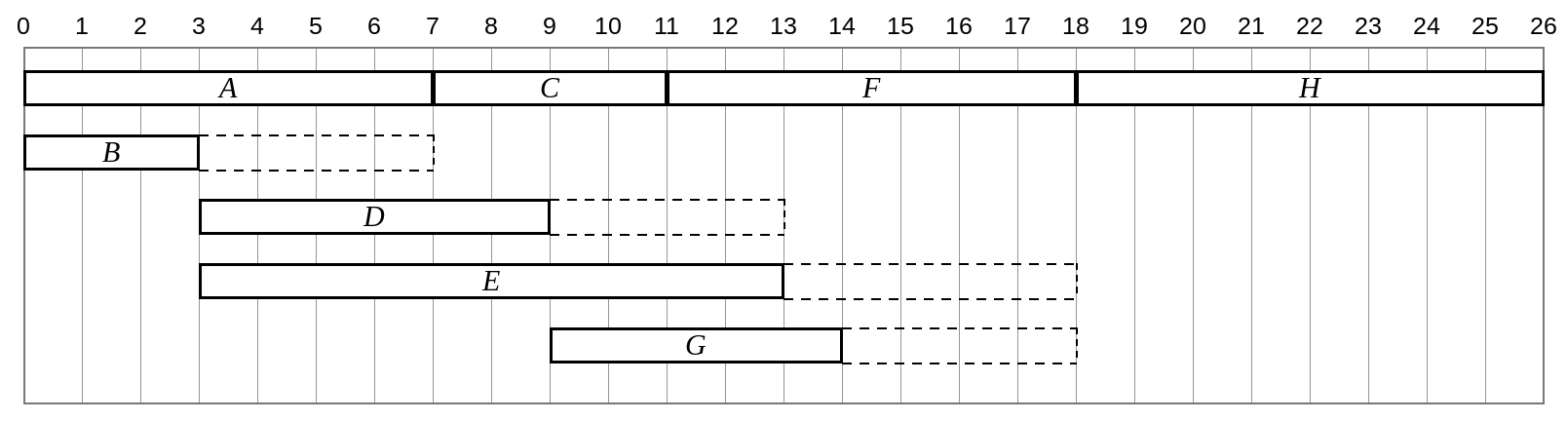
The number of workers required for each activity is shown in this table.
Activity | A | B | C | D | E | F | G | H
Workers | 2 | 1 | 1 | 2 | 1 | 1 | 2 | 1

Draw a resource histogram to show the number of workers required each day when each activity begins at its earliest time.

From end of day | To end of day | Activities | Number of workers

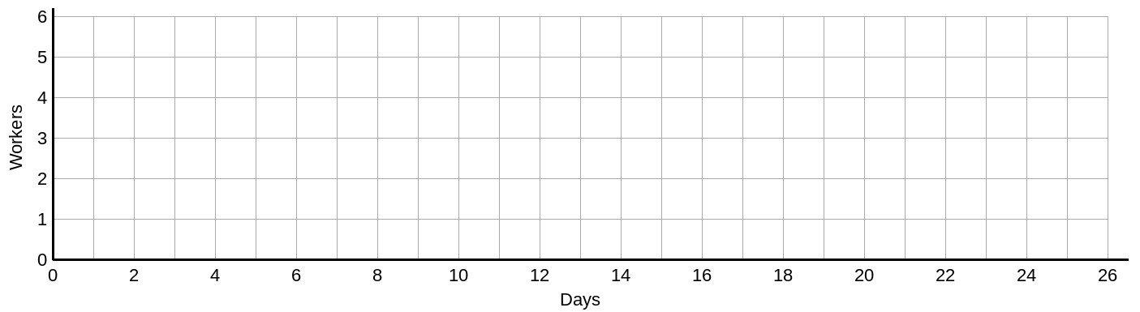

2. The diagram shows a project modelled by an activity network. The number on each arc gives the time, in days, required to complete each activity, and the number of workers needed for each activity is shown in the table.
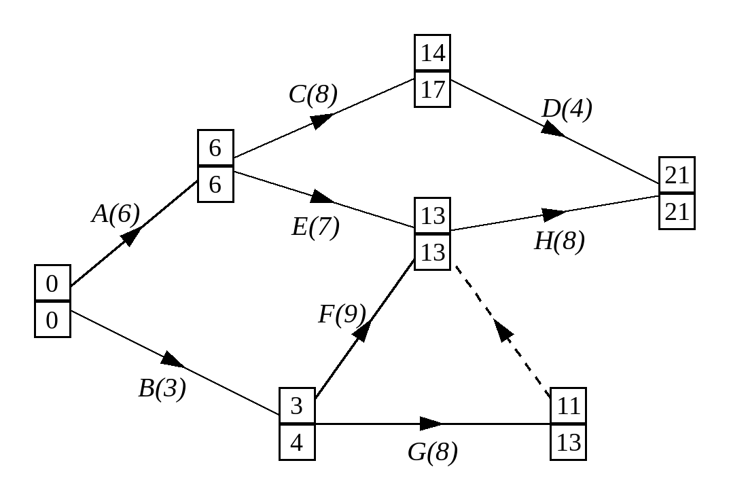
Activity | A | B | C | D | E | F | G | H
Workers | 1 | 2 | 2 | 1 | 1 | 1 | 2 | 1

A project manager determines that each activity should start at the earliest possible time.
a) Draw a resource histogram to show the number of workers required on each day, and state the total number of workers needed in this situation.
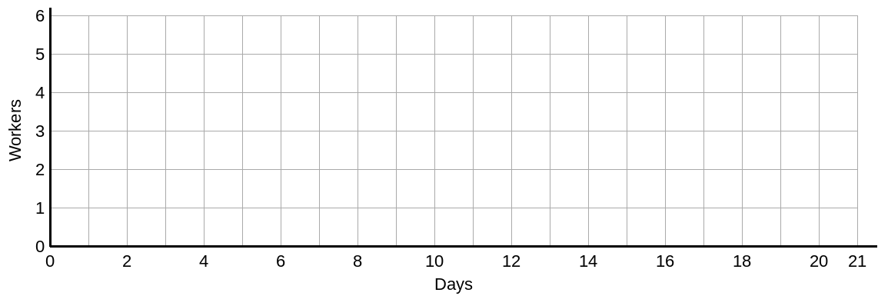

Due to budget cuts, only four workers are available for the project.
b) Use resource levelling to show how the project can be completed with just 4 workers, and state the time required to complete the project in this case.

Activity | Total float

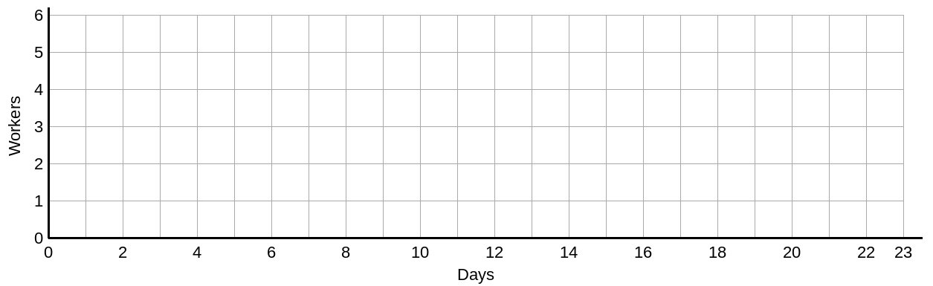

8I Scheduling Diagrams
A level only

Scheduling:

When you are scheduling a project:

1. The diagram shows a Gantt chart for a project.
a) Schedule the activities to be completed in the critical time by the minimum number of workers.
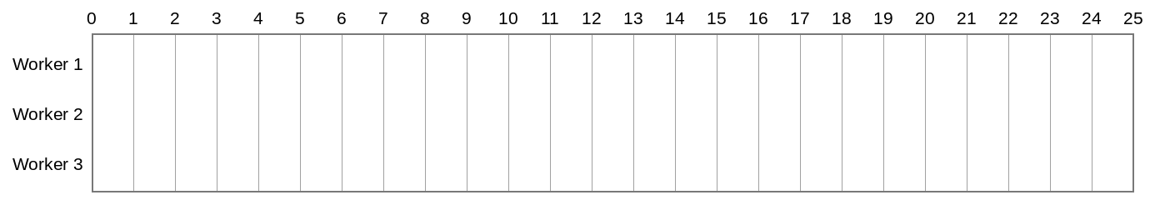

Lower bound for the number of workers:

b) Use the durations of the activities in the Gantt chart to calculate a lower bound for the number of workers needed to complete the project in its critical time.

2. The diagram shows an activity network representing a project with a minimum time of 31 days. Use a scheduling diagram to find the new completion time for the project given that only two workers are available.
