7A And You Thought Chapter 6 Was Complicated…

- A grower specialising in cut flowers is considering cultivating four varieties of new ‘Sunlip’ flowers A, B, C and D in one of his fields. He estimates the time, in hours per hectare, taken for each of four stages – sowing, thinning, picking and packing for each variety.
For variety A sowing, thinning, picking and packing will take 3, 18, 20 and 24 hours per hectare respectively.
For variety B sowing, thinning, picking and packing will take 4, 17, 25 and 27 hours per hectare respectively.
For variety C sowing, thinning, picking and packing will take 3, 19, 26 and 28 hours per hectare respectively.
For variety D sowing, thinning, picking and packing will take 5, 16, 22 and 23 hours per hectare respectively.
For this crop he can devote up to 70 hours to sowing, 360 to thinning, 500 to picking and 550 to packing.
He estimates the total profit, in pounds per hectare, as 67, 63, 71 and 75 for varieties A, B, C and D respectively.
He has up to 20 hectares to use for this crop and wishes to maximise his profit.
Formulate this as a linear programming problem. Define your variables, state your objective and write your constraints as inequalities.

- In order to supplement his diet Andy wishes to take some Vitatab, Weldo, Xtramin and Yestivit tablets. Amongst other ingredients, the contents of vitamins A, B, C and iron, in milligrams per tablet, are shown in the table.
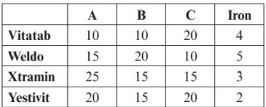
Andy wishes to take tablets to provide him with at least 80, 30, 60 and 14 milligrams of vitamins A, B, C and iron per day.
Because of other factors Andy wants at least 25% of the tablets he takes to be Vitatab and wants to take at least twice as many Weldo as Yestivit.
The costs of the tablets are 4, 6, 12 and 7 pence per tablet. Andy wishes to minimise the cost.
Formulate this as a linear programming problem, defining your variables, stating your objective and writing your constraints as inequalities.

Slack variables:

- Rewrite the inequality
$$x₁ + 3x_{2}+5x_{3}≤23$$

As an equation, using the slack variable, $r$.

- Rewrite the constraints for Example 1 as equations using slack variables $r, s, t$and$u.$
$$3x_{A}+4x_{B}+3x_{C}+5x_{D}≤70$$
$$18x_{A}+17x_{B}+19x_{C}+16x_{D}≤360$$
$$20x_{A}+25x_{B}+26x_{C}+22x_{D}≤500$$
$$24x_{A}+27x_{B}+28x_{C}+23x_{D}≤550$$
$$x_{A}, x_{B}, x_{C},x_{D}≥0$$

7B The Simplex Method

In chapter 6 we used graphs to help visualise where each vertex would be with two variables. This is much harder with three variables and dang near impossible with four or more. The simplex method:
- Starts at one vertex
- Moves between vertices in sequence, increasing the objective function and one variable at a time, until it is optimal
- Slack variables are key

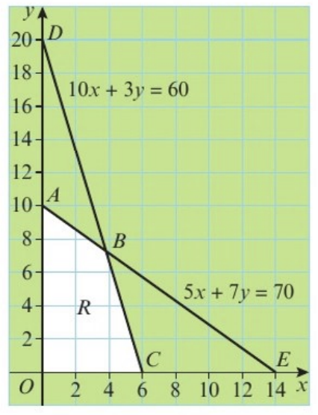
- Explain the significance of the slack variables in the graphical representation of the linear programming problem below.
Maximise $P = 3x + 2y$
Subject to:
$$5x + 7y + r = 70$$
$$10x + 3y +s = 60$$
$x,y,r,s≥0$
The feasible region, R, is shown.

At each vertex, two of the four vertices are zero.
- Explain, in detail, how the algebraic simplex algorithm is used to solve the above problem, relating each stage to the given graph.

- Show, in detail, the application of the algebraic simplex algorithm to the linear programming problem below.
Maximise $P=10x+12y+8z$
Subject to :
$$2x+2y≤5$$
$$5x+3y+4z≤15$$
$$x,y,z≥0$$

- Solve the linear programming problem in Example 1 using simplex tableaux (plural of tableau).
Maximise $P=3x+2y$
Subject to:
$$5x+7y+r=70$$
$$10x+3y+s=60$$
$$x,y,r,s≥0$$

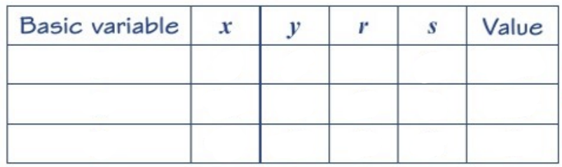

$$θ calculations$$

Always start at x=0, y=0 and follow the steps:
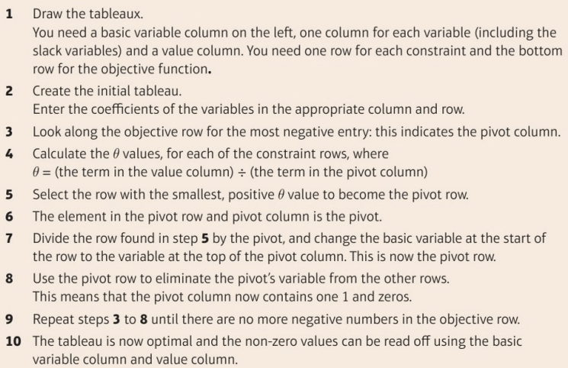
- Minimise $P=3x-y$
Subject to:
$$2x+y≤12$$
$$x+4y≤8$$
$$x≥0, y≥0$$

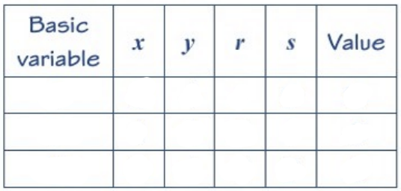

- Use simplex tableaux to solve the linear programming problem below (from Example 2).
Maximise $P=10x+12y+8y$
Subject to:
$$2x+2y≤5$$
$$5x+3y+4z≤15$$
$$x,y,z≥0$$

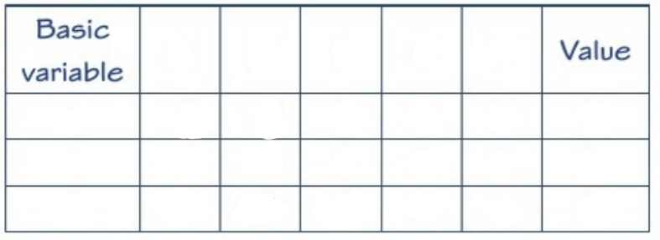

- Verify your solution using the original problem.

- Use the simplex tableau method to solve the following linear programming problem.
Maximise $P=3x+4y-5z$
Subject to:
$$2x-3y+2z+r=4$$
$$x+2y+4z+s=8$$
$$y-z+t=6$$
$$x,y,z,r,s,t≥0$$

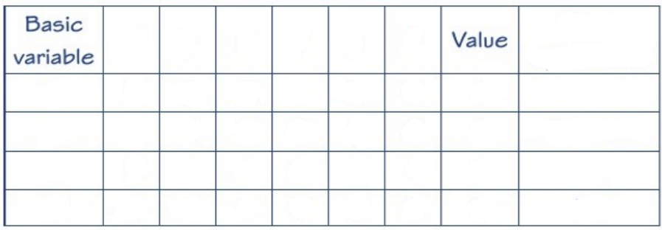

- State the values of the objective function and every variable at the optimal point.

- Write down the equations given by your optimal tableau.

- Use the profit equation you wrote down in part c to explain why your final tableau is optimal.

7C Integer Solutions
Consider integer solutions near the optimal solution

- Recall (1/3) from 7B solutions:
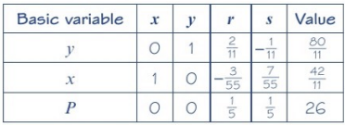
$$P=26, x=\frac{42}{11} or 3\frac{9}{11}, y=\frac{80}{11} or 7\frac{3}{11}$$

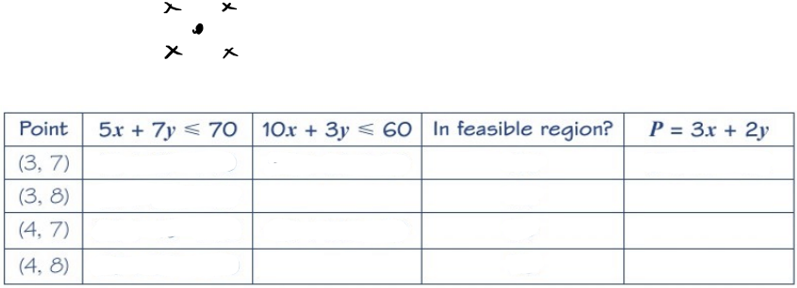

- Solve the linear programming model from example 2 in 7B
Maximise $P=10x+12y+8z$
Subject to :
$$2x+2y≤5$$
$$5x+3y+4z≤15$$
$$x,y,z≥0$$
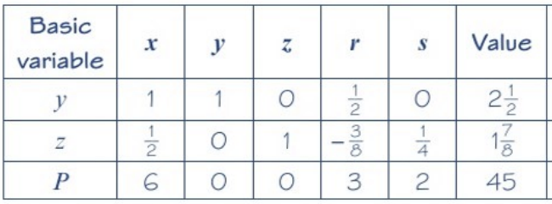

$$P=45, x=0 , y=\frac{5}{2} or 2\frac{1}{2}, z=\frac{15}{8} or 1\frac{7}{8}$$

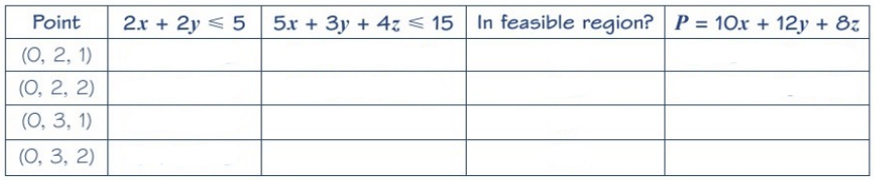

7D Two-Stage Simplex Method
What if we have $≥$ constraints?
- (0,0) is no linger in the feasible region

Slack variables can’t “just” be taken away instead. Eg.
$$x+3y≥10$$

Would become
$$x+3y-s=10, s≥0$$
(s is now called a surplus value)
But this means when $x,y=0$
$$s=-10$$
Which contradicts $s≥0$

We therefore introduce ANOTHER “artificial” variable such as $a$
$$x+3y-s+a=10, s,a≥0$$
Which can now be written in a simplex tableau

- Use surplus and artificial variables to write the following inequalities as equations.
$$3x-2y≥7$$
$$4x+5y-3z≥9$$

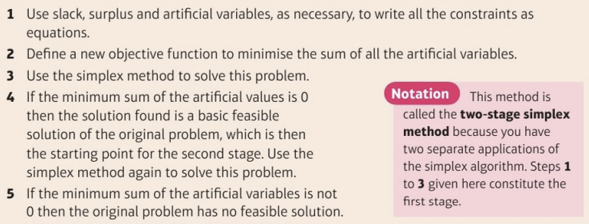
Step 2 is the really new bit! MINIMISE sum of artificial variables so
$$I=-(a_{1}+a_{2}+a_{3}+…a_{n})$$
If this is zero, then a solution exists (so simplex to this row in tableau)
- Minimise $P=3x-2y+z$
Subject to $x+y+2z≤10$
2$x-3y+z≥5$
$x+y≥8$
$x,y,z≥0$

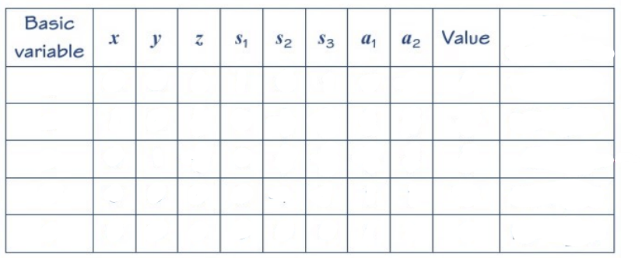

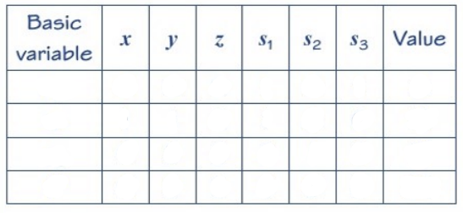
- Verify that the following linear programming problem has no feasible solution.
Maximise $P=3x-2y+z$
Subject to $x+y+2z≤8$
2$x-3y+z≥5$
$x+y≥10$
$x,y,z≥0$

7E The Big-M Method
$M$ is an arbitrarily large number so things like:
$M-100$ is positive
$75-0.5M$ is negative

- Solve the following linear programming problem using the Big-M method.
Maximise $P=x-y+z$
Subject to:
2$x+y+z≤20$
$x-2y-z≤7$
$x≥4$
$x,y,z≥0$

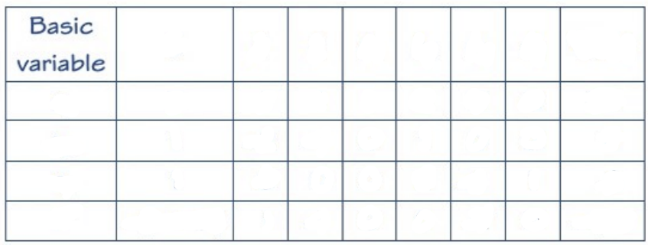

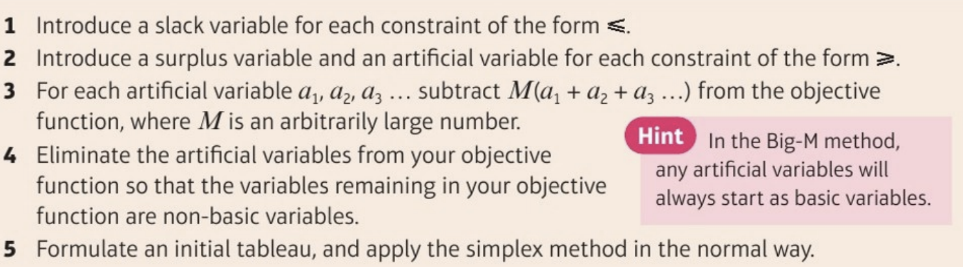
Step 3 is the new bit here.
- Use the Big-M method to solve this linear programming problem.
Minimise $P=x-y+z$
Subject to:
2$x+y+z≤20$
$x-2y-z≤7$
$x≥4$
$x,y,z≥0$

- Set up the initial tableau for solving the following linear programming problem using the Big-M method:
Maximise $P=3x-2y+z$
Subject to $x+y+2z≤10$
2$x-3y+z≥5$
$x+y≥8$

$$x,y,z≥0$$

(Draw your own tables!)

