6A Linear Programming intro

- “decision variables” x, y z etc are the letters that make up the “objective function”
- Objective is to maximise or minimise the cost
- Constraints give rise to inequalities
- Satisfying each constraint gives values of a feasible solution
- All feasible solutions make up a feasible region (graphical inequality)
- The optimal solution is the feasible solution that meets the objective (there can be more than one)

To formulae a problem:
- Define decision variables
- State objective
- Write constraints as inequalities

- Mrs Cook is making cakes to sell for charity. She makes two types of cake, fruit and chocolate. Amongst other ingredients, each fruit cake requires 1 egg, 250g of flour and 200g of sugar. Each chocolate cake requires 2 eggs, 250 g of flour and 300 g of sugar. Mrs Cook has 36 eggs, 7kg of flour and 6kg of sugar. She will sell the fruit cakes for £3.50 and the chocolate cakes for £5. She wishes to maximise the money she makes from these sales. You may assume she sells all the cakes that she makes. Formulate this as a linear programming problem.

- A company buys two types of diary to send to its customers, a desk top diary and a pocket diary. They will need to place a minimum order of 200 desk top and 80 pocket diaries. They will need at least twice as many pocket diaries as desk top diaries. They will need a total of at least 400 diaries. Each desk top diary costs £6 and each pocket diary costs £3. The company wishes to minimise the cost of buying the diaries. Formulate this as a linear programming problem.

- A company produces two types of syrup, A and B. The syrups are a blend of sugar, fruit and juice.
Syrup A contains 30% sugar, 50% fruit and 20% juice.
Syrup B contains 20% sugar, 35% fruit and 45% juice.
Each litre of syrup A costs 50p and each litre of syrup B costs 40p.
There is a maximum daily production of 40 000 litres of syrup A and 45000 litres of syrup B. A confectionery manufacturer places an order for 60 000 litres of syrup but requires:
- Below 25% sugar
- At least 40% fruit
- No more than 35% juice
The company will blend syrups A and B to meet the confectionery manufacturer's requirements.
The company wishes to minimise its costs.
Letting x be the number of litres of syrup A used, and y be the number of litres of syrup B used, formulate this as a linear programming problem.

6B Graphical Methods and Feasible Regions

- A linear programming problem is given as:
minimise $C = 0.5x + 0.4y$
subject to
$x<y$
$$2x≥y$$
$$3x≥y$$
$$x+y≥60000$$
$$x,y≥0$$
On a graph, represent the feasible region for this problem, and label it R.



6C Optimal Points
To solve a linear programming problem, you need to find the point in the feasible region that maximises or minimises the objective function.
- This can be done by the objective line method or ruler method. We can finaly use a set square!

- Nigel is making ice cream for sale at a charity fair. He makes two flavours of ice cream: vanilla and chocolate. Let the number of litres of vanilla ice cream made be x and the number of litres of chocolate ice cream made be y. Nigel decides to use linear programming to determine the number of litres of each type of ice cream he should make. The constraints and the feasible region $R$ are illustrated in the diagram below.
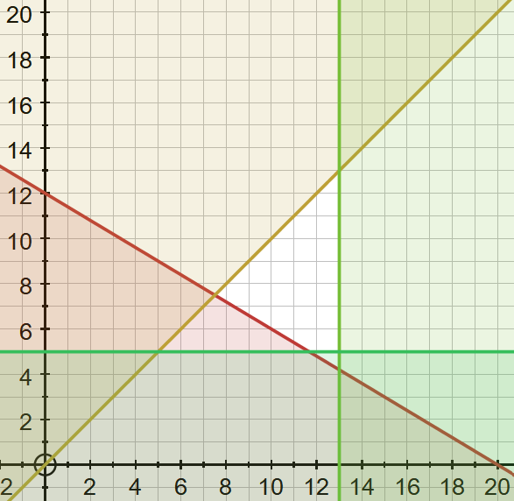
Determine the optimal solution for this problem, given the objective is to
- Maximise the profit on sales, $P=2x+y$

- Minimise the production costs, $C=5x+2y$

- Using the feasible region determined by the inequalities
$$x≥2, 4x+3y≤12, 2y≤x, x,y≥0$$
find the optimal point and the optimal value when the objective is to:
- Maximise $P=2x+y$

- Minimise $P=x+2y$

- In a linear programming problem the constraints are given by:
$$3x+y≥90$$
$$2x+7y≥140$$
$$x+y≥50$$
$$x, y≥0$$
- Minimise $C=3x+2y$

- Minimise $C=3x+7y$

- Find an optimal solution given that the objective function is to minimise $C=x+y$

Vertex Method:
- First find the coordinates of each vertex of the feasible region.
- Evaluate the objective function at each of these points.
- Select the vertex that gives the optimal value of the objective function.

- Use the vertex testing method to solve the following linear programming problem:
Minimise: $x+3y$
Subject to $y≤x$
$3x+5y≥60$
$y≥5$
$x≤13$
$x, y≥0$

- A feasible region is defined by the following constraints:
$$9x+11y≤99$$
$$4x+y≤28$$
$$5x+3y≥30$$
$$x+2y≥8$$
$$y≤x$$
Find the optimal point and optimal value given that the objective is:
- Maximise $x+y$

- Minimise $3x+4y$

6D Integer Value Solutions
Consider integer vales near a vertex

- Given that x and y must be integers, solve the following linear programming problem.
Maximise $P=x+2y$
Subject to $3x+4y≤36$
$13x+9y≤117$
$5y-4x≤10$
$6x+5y≥30$
$y≥2$

- Minimise $x+y$
Subject to $3x+5y≥1500$
$5x+2y≥1000$
$x,y≥0$
given that x and y must be integers.

