5A The Classical and Practical Travelling Salesman Problems
Walk:

Tour:

The travelling salesman problem:

Heuristic algorithm:

Upper and lower bounds (‘trapping’ the optimal solution):

The classical problem:

The practical problem:

Triangle inequality:

Table of least distances:

1. Create a table of least distances for the network below.
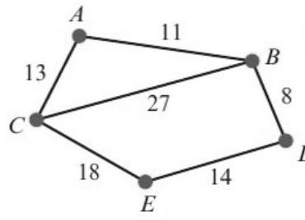
 | A | B | C | D | E
A | –
B |  | –
C |  |  | –
D |  |  |  | –
E |  |  |  |  | –

2. The network below shows the distances, in km, between the central sorting office at S and six post offices A, B, C, D, E and F. The table shows a partially completed table of least distances.
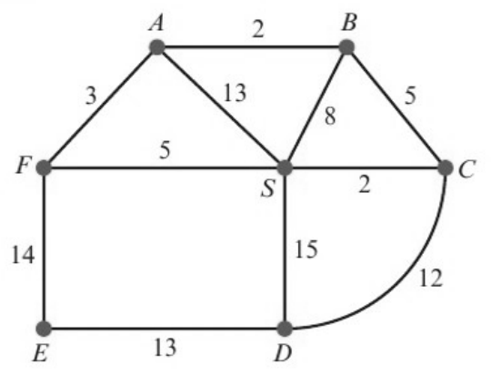
 | S | A | B | C | D | E | F
S | – |  |  | 2 |  |  | 5
A |  | – | 2 |  | 19 | 17 | 3
B |  | 2 | – | 5 | 17
C | 2 |  | 5 | – | 12 | 21 | 7
D |  | 19 | 17 | 12 | – | 13
E |  | 17 |  | 21 | 13 | – | 14
F | 5 | 3 |  | 7 |  | 14 | –

Complete the table of least distances for the network, stating your shortest route for each of the entries.

5B Using a Minimum Spanning Tree Method to Find an Upper Bound
Using a minimum spanning tree method to find an upper bound for the practical problem:
1

2

3

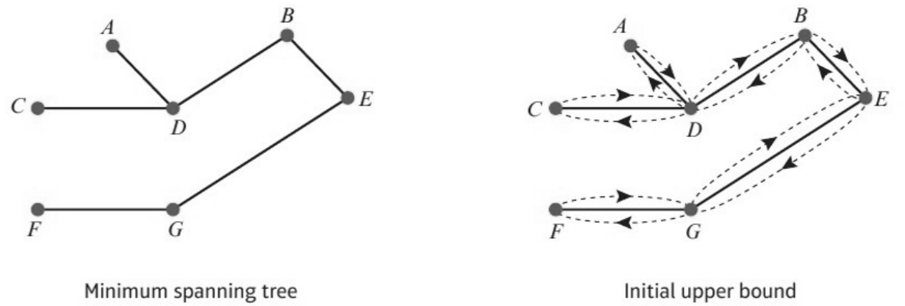
Initial upper bound:

1. For the network below:
a) Use Kruskal’s algorithm to find a minimum spanning tree for the network below.
b) Hence find an initial upper bound for the travelling salesman problem.
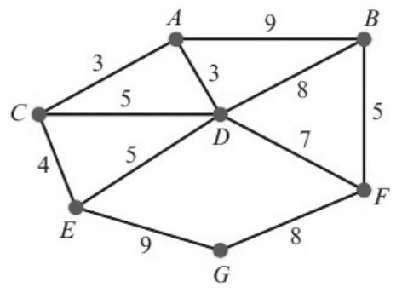

2. The table of least distances for a network is given below. Find an initial upper bound for the travelling salesman problem for this network.
 | A | B | C | D | E
A | – | 11 | 13 | 19 | 31
B | 11 | – | 24 | 8 | 22
C | 13 | 24 | – | 32 | 18
D | 19 | 8 | 32 | – | 14
E | 31 | 22 | 18 | 14 | –

Improving the upper bound (shortcuts):

3. Starting from the initial upper bound found in question 2, use a shortcut to reduce the upper bound to below 70.

4. The table shows the distances, in miles, between eight cities. A politician has to visit each city, starting and finishing at A. She wishes to minimise the total distance travelled.
 | A | B | C | D | E | F | G | H
A | – | 47 | 84 | 382 | 120 | 172 | 299 | 144
B | 47 | – | 121 | 402 | 155 | 193 | 319 | 165
C | 84 | 121 | – | 456 | 200 | 246 | 373 | 218
D | 382 | 402 | 456 | – | 413 | 220 | 155 | 289
E | 120 | 155 | 200 | 413 | – | 204 | 286 | 131
F | 172 | 193 | 246 | 220 | 204 | – | 144 | 70
G | 299 | 319 | 373 | 155 | 286 | 144 | – | 160
H | 144 | 165 | 218 | 289 | 131 | 70 | 160 | –

a) Find a minimum spanning tree for this network.

b) Hence find an upper bound for this problem.

c) Use shortcuts to reduce this upper bound to a value below 1300 miles.

Selecting shortcuts: try the shortcuts BD, CB + AF + FD and CD for question 4. Which gives the best upper bound? (Aim to make the upper bound as ... as possible.)

5C Using a Minimum Spanning Tree Method to Find a Lower Bound
Using a minimum spanning tree method to find a lower bound for the classical problem:
1

2

3

4

5

6

Residual minimum spanning tree (RMST):

Lower bound for the practical problem:

1. The table of least distances for a network is shown.
 | A | B | C | D | E
A | – | 11 | 13 | 19 | 31
B | 11 | – | 24 | 8 | 22
C | 13 | 24 | – | 32 | 18
D | 19 | 8 | 32 | – | 14
E | 31 | 22 | 18 | 14 | –

a) By deleting vertex A, find a lower bound to the travelling salesman problem for this network.
 | B | C | D | E
B | – | 24 | 8 | 22
C | 24 | – | 32 | 18
D | 8 | 32 | – | 14
E | 22 | 18 | 14 | –

b) State whether this lower bound represents an optimal solution. Give a reason for your answer.

2. The table below is the table of distances from question 4 in 5B.
 | A | B | C | D | E | F | G | H
A | – | 47 | 84 | 382 | 120 | 172 | 299 | 144
B | 47 | – | 121 | 402 | 155 | 193 | 319 | 165
C | 84 | 121 | – | 456 | 200 | 246 | 373 | 218
D | 382 | 402 | 456 | – | 413 | 220 | 155 | 289
E | 120 | 155 | 200 | 413 | – | 204 | 286 | 131
F | 172 | 193 | 246 | 220 | 204 | – | 144 | 70
G | 299 | 319 | 373 | 155 | 286 | 144 | – | 160
H | 144 | 165 | 218 | 289 | 131 | 70 | 160 | –

a) By deleting vertices A then G, find two lower bounds to the travelling salesman problem for the network above.
Deleting A:
 | B | C | D | E | F | G | H
B | – | 121 | 402 | 155 | 193 | 319 | 165
C | 121 | – | 456 | 200 | 246 | 373 | 218
D | 402 | 456 | – | 413 | 220 | 155 | 289
E | 155 | 200 | 413 | – | 204 | 286 | 131
F | 193 | 246 | 220 | 204 | – | 144 | 70
G | 319 | 373 | 155 | 286 | 144 | – | 160
H | 165 | 218 | 289 | 131 | 70 | 160 | –

Deleting G:
 | A | B | C | D | E | F | H
A | – | 47 | 84 | 382 | 120 | 172 | 144
B | 47 | – | 121 | 402 | 155 | 193 | 165
C | 84 | 121 | – | 456 | 200 | 246 | 218
D | 382 | 402 | 456 | – | 413 | 220 | 289
E | 120 | 155 | 200 | 413 | – | 204 | 131
F | 172 | 193 | 246 | 220 | 204 | – | 70
H | 144 | 165 | 218 | 289 | 131 | 70 | –

b) Select the better lower bound of the two found in part a, giving a reason for your answer.

c) Taking your answer to b and using the better upper bound, 1237 miles, found in 5B, write down the smallest interval that must contain the length of the optimal route.

Choosing inequalities (< or ≤):

5D Using the Nearest Neighbour Algorithm to Find an Upper Bound
The nearest neighbour algorithm:
1

2

3

4

Difference between the nearest neighbour algorithm and Prim’s algorithm:

1. Apply the nearest neighbour algorithm, using A then B then C as starting vertices, to find an upper bound to the travelling salesman problem.
 | A | B | C | D | E
A | – | 8 | 7 | 29 | 13
B | 8 | – | 9 | 24 | 14
C | 7 | 9 | – | 23 | 6
D | 29 | 24 | 23 | – | 21
E | 13 | 14 | 6 | 21 | –

2. This is the table of distances from question 2 in 5C. We found that the optimal solution lay in the interval 971 miles < optimal solution ≤ 1237 miles.
 | A | B | C | D | E | F | G | H
A | – | 47 | 84 | 382 | 120 | 172 | 299 | 144
B | 47 | – | 121 | 402 | 155 | 193 | 319 | 165
C | 84 | 121 | – | 456 | 200 | 246 | 373 | 218
D | 382 | 402 | 456 | – | 413 | 220 | 155 | 289
E | 120 | 155 | 200 | 413 | – | 204 | 286 | 131
F | 172 | 193 | 246 | 220 | 204 | – | 144 | 70
G | 299 | 319 | 373 | 155 | 286 | 144 | – | 160
H | 144 | 165 | 218 | 289 | 131 | 70 | 160 | –

a) Use the nearest neighbour algorithm, using A then B as starting vertices, to find upper bounds for the travelling salesman problem.

b) Review the interval containing the optimal solution and amend it if necessary, giving a reason for your answer.

