Crossing Bridges
Try to find a route to cross every bridge once.
Plot twist: the bridges are old and fragile – you have to run to cross them and they collapse immediately afterwards
Bonus points for managing to start and end at the same place!
Does it matter where you start? Can you complete the network from every possible starting point?
What would the mathematical graph look like? (use the space next to each one)

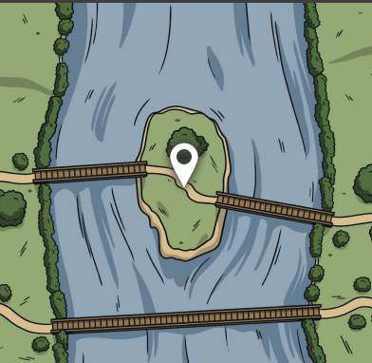

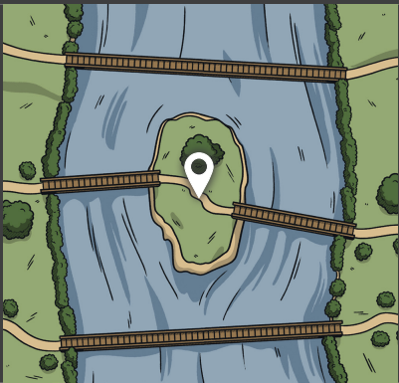
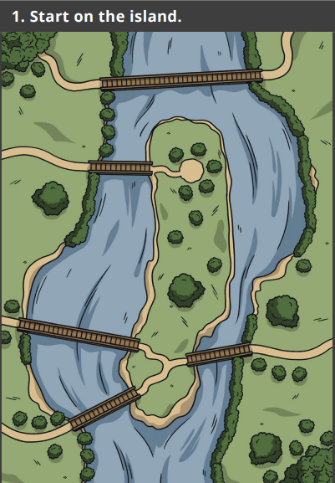

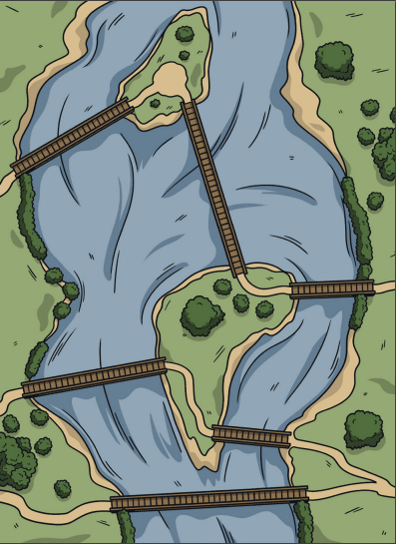
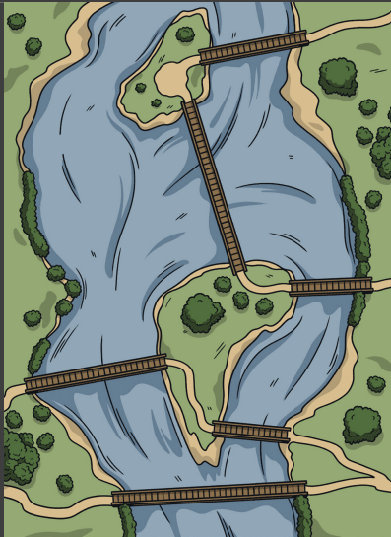

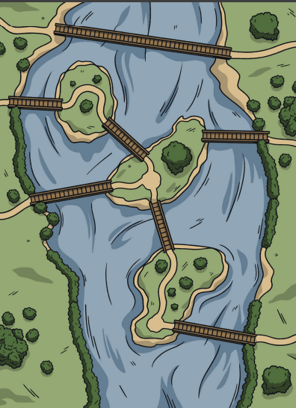
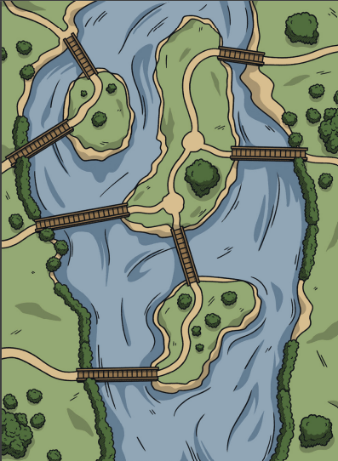

Euler and Königsberg
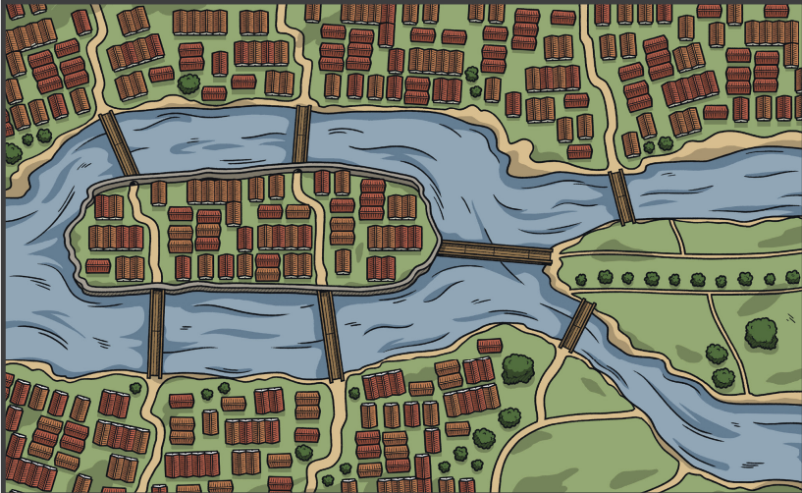

Historical Setting and Problem
- The City: Königsberg in Prussia (now Kaliningrad, Russia) was built around the Pregel River.
- The Geography: The river split the city into two mainland areas and two large islands (Kneiphof and Lomse) connected by seven distinct bridges. [1]
- The Puzzle: Local residents enjoyed a Sunday tradition of trying to walk through the city in a route that crossed every single bridge exactly once, without doubling back.
- The Frustration: Despite trying for years, no one could find a successful route, but no one could prove whether it was truly impossible.

Leonhard Euler’s Solution
In 1735, the Swiss mathematician Leonhard Euler solved the puzzle and presented a rigorous proof that the walk was impossible:
- Abstraction: Euler realized that the exact sizes, distances, and shapes of the landmasses and bridges did not matter.
- The First Graph: He stripped away the physical map, representing the four land areas as points (called vertices or nodes) and the seven bridges as lines (called edges).
- Odd and Even Degrees: Euler observed that every time you enter a landmass by a bridge, you must leave it by a different bridge. This means every intermediate landmass must touch an even number of bridges.
- The Verdict: In Königsberg’s layout, all four landmasses were connected to an odd number of bridges (three landmasses had 3 bridges, and one had 5). Because a valid path can only have zero or two odd-degree vertices, Euler proved mathematically that the walk could not exist.

4A Eulerian Graphs

Make this shape without taking your pencil off the paper or going over any lines more than once

- We call any graph in which we can do this “Semi-Eulerian”
- A Graph where we can begin and end at the same vertex is an “Eulerian Graph”

In General, for any connected network:
- Eulerian Graphs exist when each vertex is even
- Semi-Eulerian Graphs exist when exactly two vertices are odd

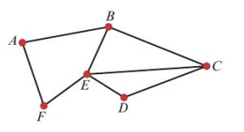

- State whether the graph above is Eulerian, semi-Eulerian or neither.

- If possible, find a trail that traverses each edge of this graph exactly once

- A connected graph has 5 nodes. The order of the nodes are 4, 6, 3, p and 2.
- Explain why the graph cannot be Eulerian

- Explain why the graph must be semi-Eulerian

- Give the number of edges contained within the network in terms of p.

- Draw a graph with two nodes that is neither Eulerian or semi-Eulerian

4B Route Inspection (Chinese Postman Algorithm)
The shortest route to complete a network such that every connection is traversed at least once AND returns to its starting point.

- If the network is Eulerian (every node has even degree), then the shortest route will be the sum of the lengths of all connections (as we can hit exactly every route once and end where we started).

- If the network is semi-Eulerian (exactly two nodes of odd degree), then the shortest route will be the sum of the network, plus the shortest route between the odd nodes (as we have to get back to a starting point).

- If the network has more than two odd nodes:
  - Route inspection algorithm:
    - Identify the odd vertices
    - Consider all pairings of these vertices
    - Select the pairings with the smallest sum
    - Add a repeat of the arcs indicated by this pairing to the network

- The diagram show a network of trails on a BMX course. The number on each edge is the length, in metres, of the trail. Hannah wants to start at A, traverse every trail on the network, then return to A. Find the length of the shortest path she could take.

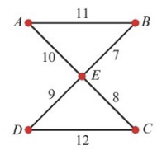

- The diagram shows a network of undersea cables. The number on each arc is the length, in kilometres, of that cable. A diver needs to inspect the cables and needs to find a route of minimum length that traverses every cable and starts and finished at S.
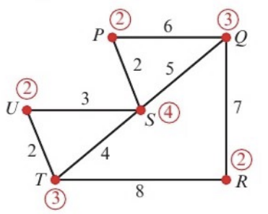
Note: the numbers in circles indicate the degree of each vertex
(you can label your graphs like this in your exam)

- State the cables that will be traversed twice.

- State the minimum length of the diver’s route.

- A route is needed that starts at A, traverses every arc in this network, and returns to A. Find a possible route and state its length.
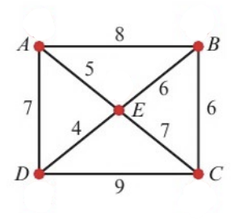

- The diagram represents a network of roads. The numbers on the arcs represent the lengths of each road in miles. The roads need to be resurfaced. The council wants to find the shortest possible route which traverses every road and starts and ends at A.
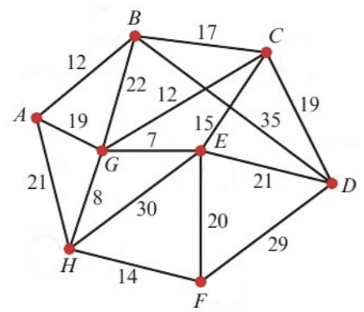
- Determine the length of this route. You must show your method and working, and state clearly which roads must be traversed twice.

The council decides that, in order to save money, the route can start and end at different vertices.
- State which two vertices should be chosen to minimise the length of the new route. Give a reason for your answer, and state the length of the new route.

4C Lots of Odd Nodes
As you can imagine, when there are a lot of odd nodes, the possible combinations for pairs will grow quickly (${{}_{}^{n}C}_{2}$)
2 odd nodes will have ${{}_{}^{2}C}_{2}=1$ possible pairing
4 odd nodes will have ${{}_{}^{4}C}_{2}=6$ possible pairings
6 odd nodes will have ${{}_{}^{6}C}_{2}=15$ possible pairings
8 odd nodes will have ${{}_{}^{8}C}_{2}=28$ possible pairings
10 odd nodes will have ${{}_{}^{10}C}_{2}=45$ possible pairings
And so on
When a network has more than 4 odd nodes, additional information will be provided to reduce the number of combinations.
- A night watchman has to patrol a network of paths as shown in the diagram. The number shown on each arc represents the time taken, in minutes, to walk between the labelled points.
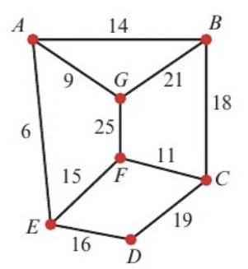
- Use the route inspection, starting at A and finishing at C, to find the minimum time taken to traverse each arc at least once.

- State a possible route

An extra path is added joining B and F directly. After the addition of this path, the minimum time needed to traverse all paths, starting at A and finishing at C, is reduced by twice the length of time needed to traverse this path.
- Calculate the time needed to traverse the new path BF.

- The network represents the roads that must be travelled by a police patrol car. The length of each road in kilometres is shown on each arc.
The patrol starts at A and can finish at either of the two police stations at G or D.
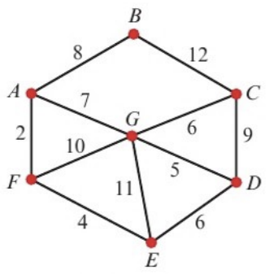
- Find the length of the shortest route, such that every road is traversed at least once.

- State which police station the patrol car finishes at, and which roads must be traversed twice.

