2A Modelling with Graphs
Graph:

Vertex (node):

Edge (arc):

Weighted graph (network):

1. This graph shows the routes flown by an airline.
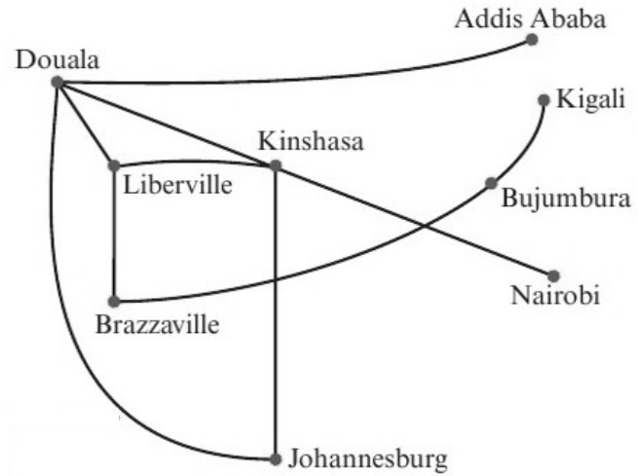
a) Explain why this is a graph.

b) Describe what is represented by i the vertices ii the edges.

c) Describe two possible flight routes from Johannesburg to Liberville.

2. This network shows the lengths of pipes running between water standpipes on a camp site. The lengths on the edges are given in metres.
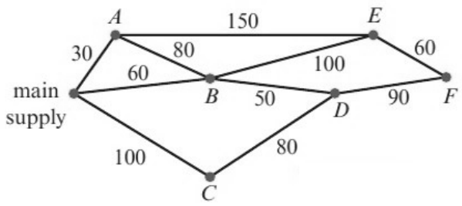
a) Write down the length of the pipe connecting standpipe B to standpipe D.

b) Write a list of the standpipes that are directly connected to standpipe E.

3. The network shows the times taken, in minutes, by a car to travel along some sections of road.
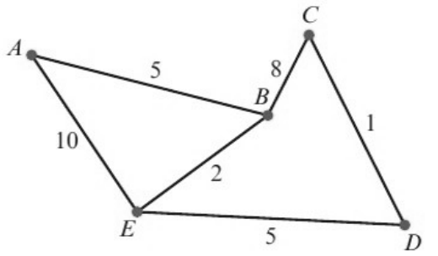
Calculate the minimum time needed to travel from A to D and give the route taken.

Route | Time needed (mins)

2B Graph Theory
Vertex set and edge set:

Subgraph:

Degree (valency / order) of a vertex:

Even degree / odd degree:

Walk:

Path:

Trail:

Cycle:

Hamiltonian cycle:

1. For the graph below, give an example of:
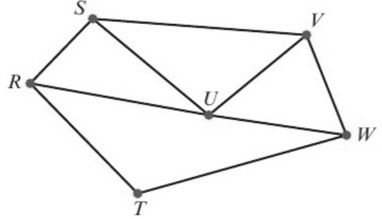
a) a walk

b) a path

c) a trail

d) a cycle

e) a Hamiltonian cycle.

Connected vertices / connected graph:

Loop:

Simple graph:

Directed graph (digraph):

Euler’s handshaking lemma:

2. For the graph below:
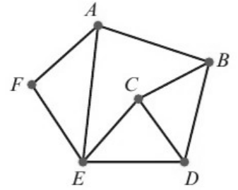
a) Find the sum of the valencies of the vertices in this graph.
Vertex | Valency
A
B
C
D
E
F
Total

b) Verify that your answer to part a is twice the number of edges in the graph.

3. A graph has 5 nodes and 8 edges. The valencies of the nodes are x, x − 1, x + 1, 2x − 1 and x − 1. Find the value of x.

2C Special Types of Graph
Tree:

1. Explain why the first graph is a tree but the second graph is not.
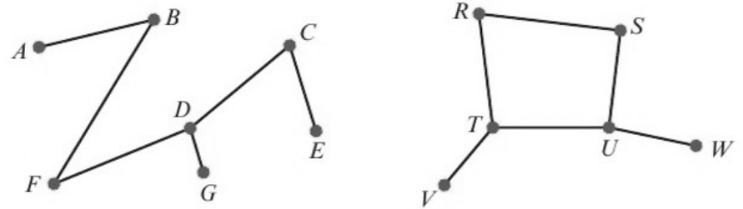

Spanning tree:

2. Draw two possible spanning trees for this graph.
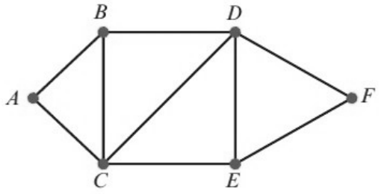

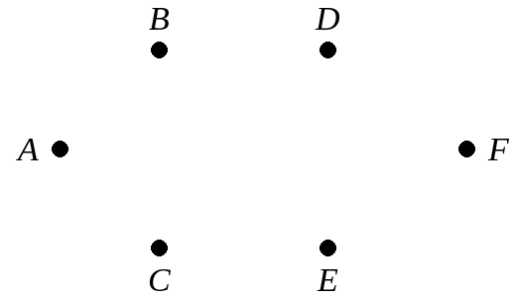

Complete graph:

Notation Kₙ:

3. Draw the complete graphs K₃, K₄ and K₆.

Isomorphic graphs:

4. Show that this graph
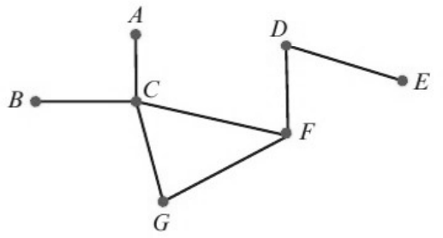
is isomorphic to each of these graphs by pairing equivalent vertices.
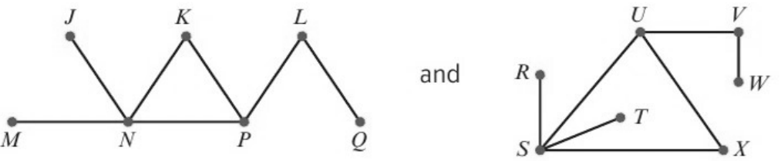

First graph | A | B | C | D | E | F | G
Second graph
Third graph

2D Representing Graphs and Networks Using Matrices
Adjacency matrix:

1. Use an adjacency matrix to represent this graph.
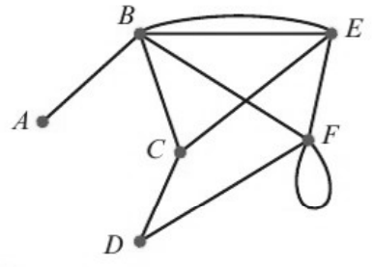
 | A | B | C | D | E | F
A
B
C
D
E
F

What does the 2 in row B, column E mean? What about the 2 in row F, column F?

Distance matrix:

2. Use a distance matrix to represent this network.
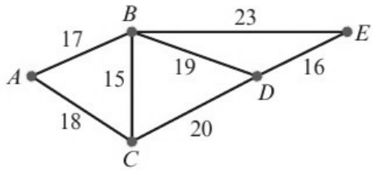
 | A | B | C | D | E
A
B
C
D
E

What do you notice about the matrix?

3. Use a distance matrix to represent this directed network.
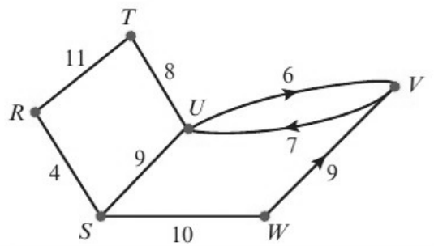
 | R | S | T | U | V | W
R
S
T
U
V
W

What do you notice about the matrix this time?

2E The Planarity Algorithm
(A level only)
Planar graph:

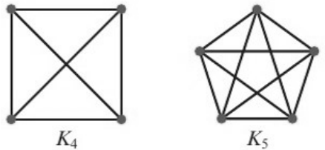
Which of K₄ and K₅ is planar? Redraw it with no edges crossing.

The planarity algorithm (steps):
1 Identify a Hamiltonian cycle.

2 Draw a polygon ...

3 Draw edges inside the polygon ...

4 Make a list ...

5 Choose any unlabelled edge ...

6 Look at any unlabelled edges that cross the edge(s) just labelled:

1. Use the planarity algorithm to determine whether this graph is planar.
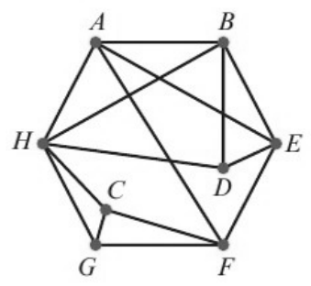
Step 1:

Steps 2, 3:
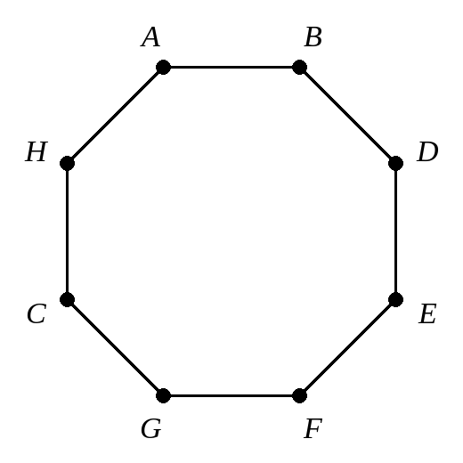
Step 4:

Steps 5 and 6:

Draw the graph with no edges crossing:
2. An electronics company attaches components A, B, C, D, E and F to a circuit board. These components are to be connected by wires that are not allowed to cross. The table gives information about the connections.
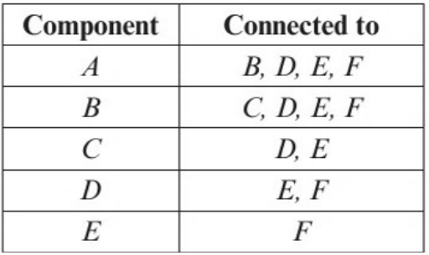
Using the Hamiltonian cycle ABCDEFA, apply the planarity algorithm to determine whether the connections can be made without any wires crossing.
