8I Scheduling Diagrams
A level only

Scheduling:

When you are scheduling a project:

1. The diagram shows a Gantt chart for a project.
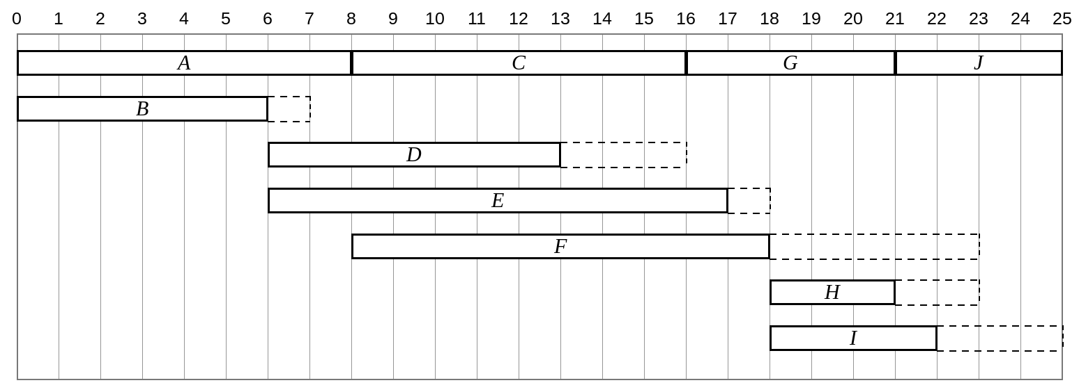
a) Schedule the activities to be completed in the critical time by the minimum number of workers.
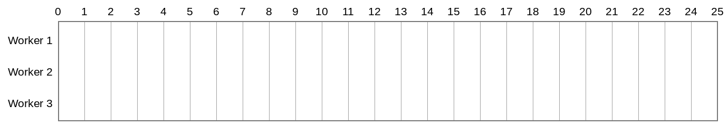

Lower bound for the number of workers:

b) Use the durations of the activities in the Gantt chart to calculate a lower bound for the number of workers needed to complete the project in its critical time.

2. The diagram shows an activity network representing a project with a minimum time of 31 days. Use a scheduling diagram to find the new completion time for the project given that only two workers are available.
