8H Resource Histograms
A level only

Rules for workers:

Resource histogram:

Resource levelling:

1. Here is the Gantt chart from question 2 of Exercise 8G.
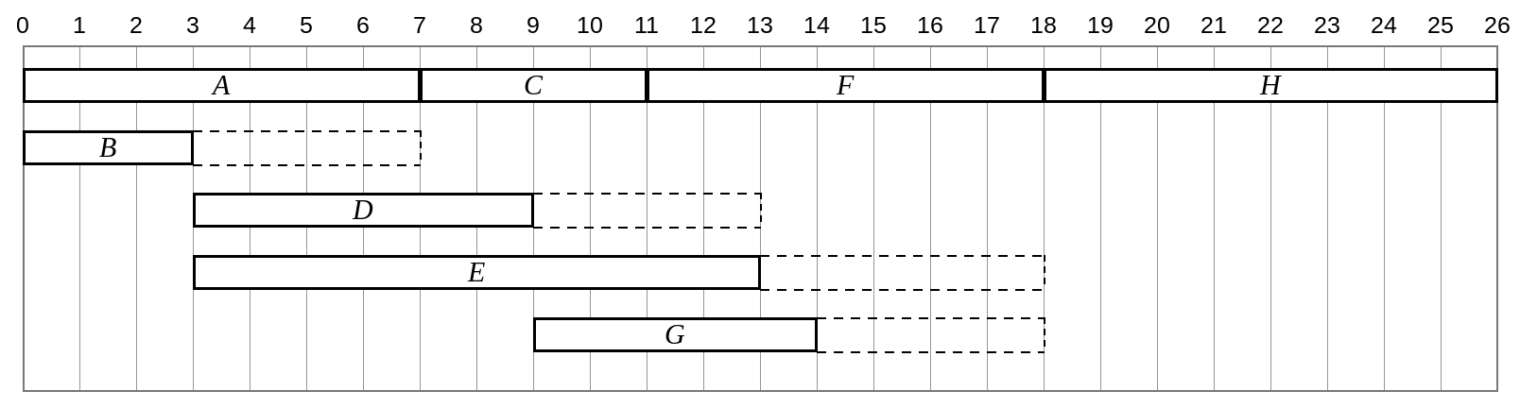
The number of workers required for each activity is shown in this table.
Activity | A | B | C | D | E | F | G | H
Workers | 2 | 1 | 1 | 2 | 1 | 1 | 2 | 1

Draw a resource histogram to show the number of workers required each day when each activity begins at its earliest time.

From end of day | To end of day | Activities | Number of workers

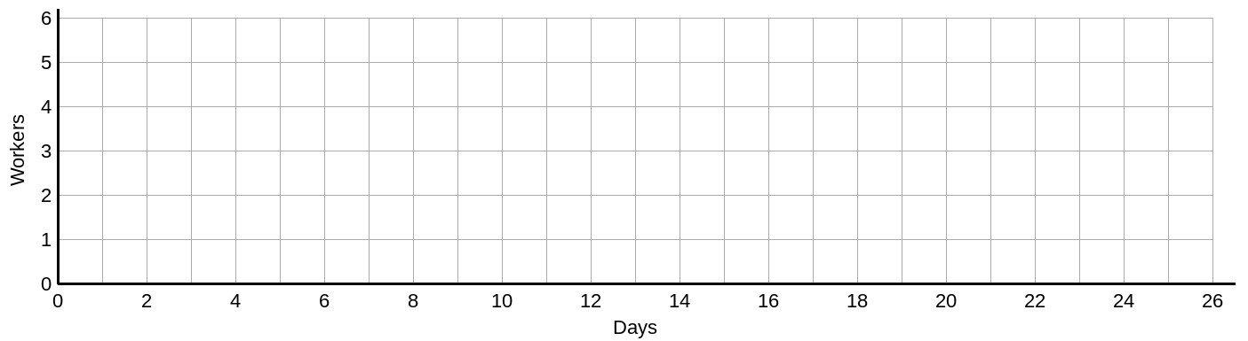

2. The diagram shows a project modelled by an activity network. The number on each arc gives the time, in days, required to complete each activity, and the number of workers needed for each activity is shown in the table.
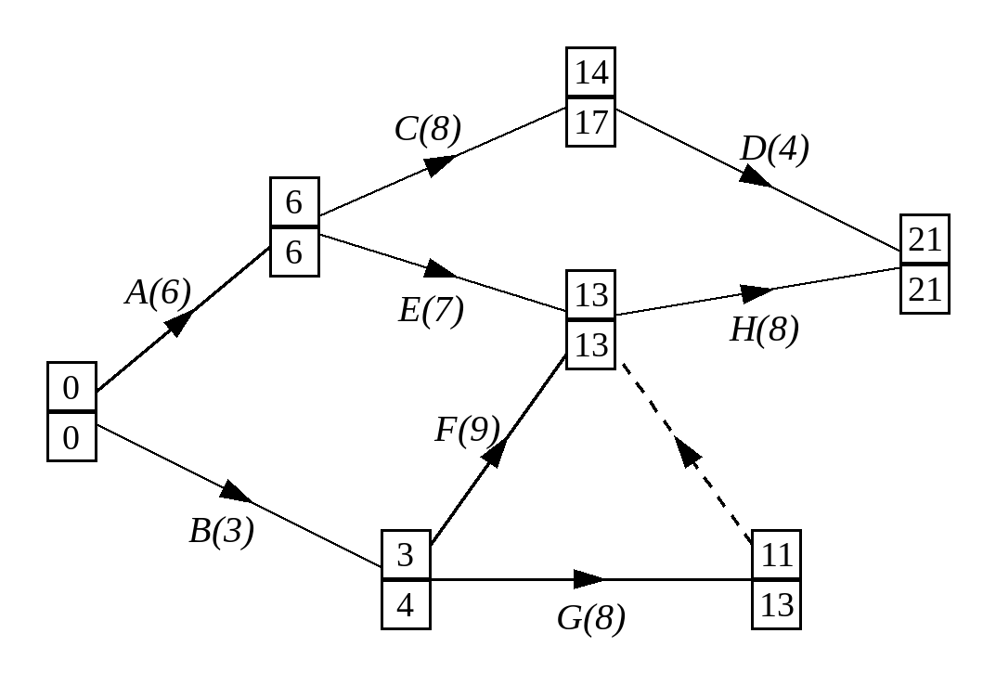
Activity | A | B | C | D | E | F | G | H
Workers | 1 | 2 | 2 | 1 | 1 | 1 | 2 | 1

A project manager determines that each activity should start at the earliest possible time.
a) Draw a resource histogram to show the number of workers required on each day, and state the total number of workers needed in this situation.
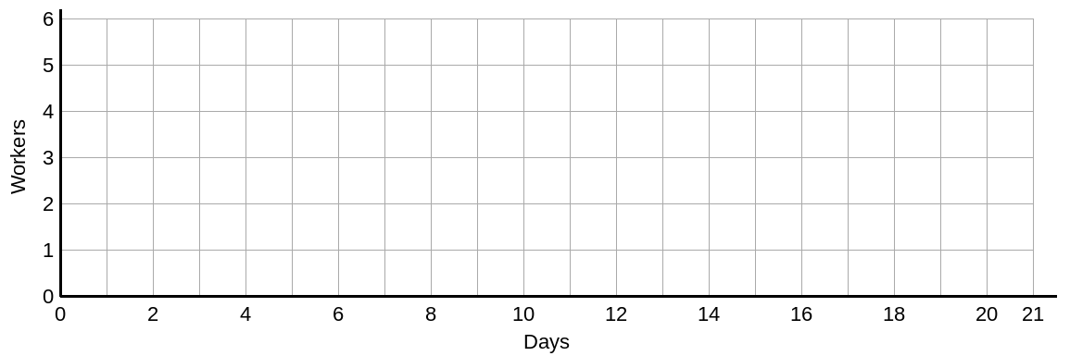

Due to budget cuts, only four workers are available for the project.
b) Use resource levelling to show how the project can be completed with just 4 workers, and state the time required to complete the project in this case.

Activity | Total float

