8D Critical Activities
Critical activity:

Critical path:

At each event on a critical path:

1. The diagram shows an activity network with early and late event times shown at the nodes. Identify the critical activities.
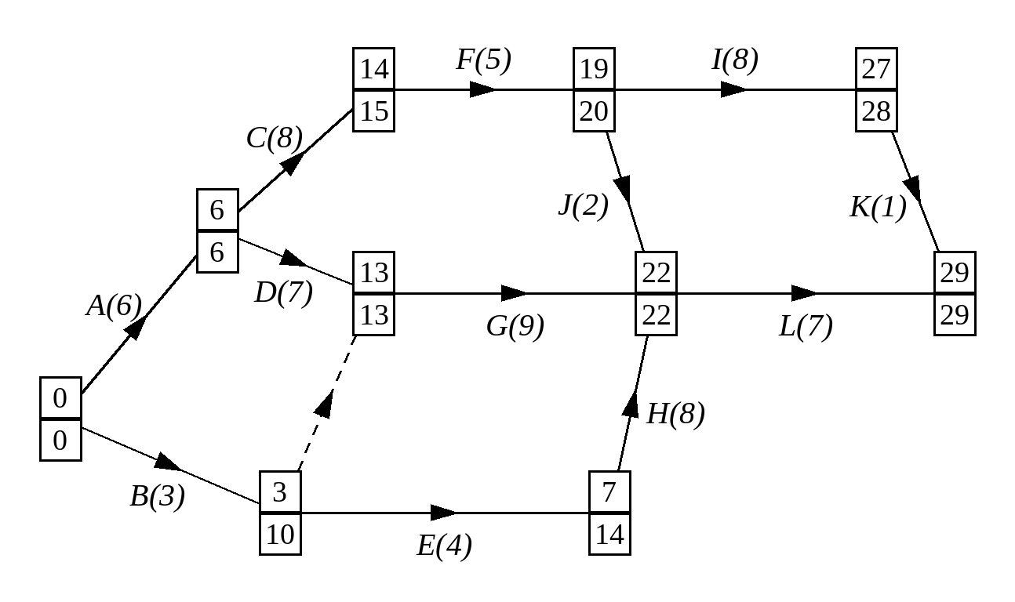

An activity connecting two critical events:

2. Part of an activity network is shown below including the early and late event times given in hours. Which are the critical activities?
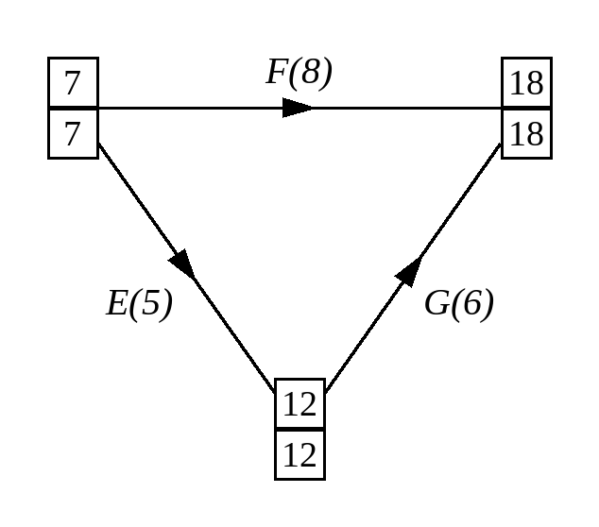

3. Find the critical paths in this activity network and identify the critical activities.
