7E The Big-M Method
$M$ is an arbitrarily large number so things like:
$M-100$ is positive
$75-0.5M$ is negative

- Solve the following linear programming problem using the Big-M method.
Maximise $P=x-y+z$
Subject to:
2$x+y+z≤20$
$x-2y-z≤7$
$x≥4$
$x,y,z≥0$

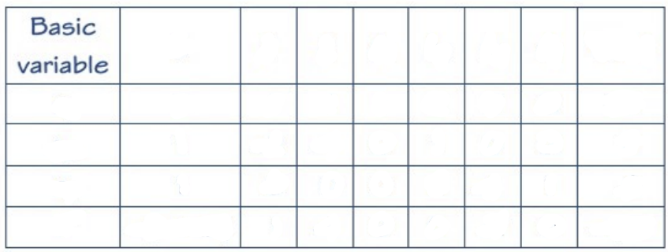

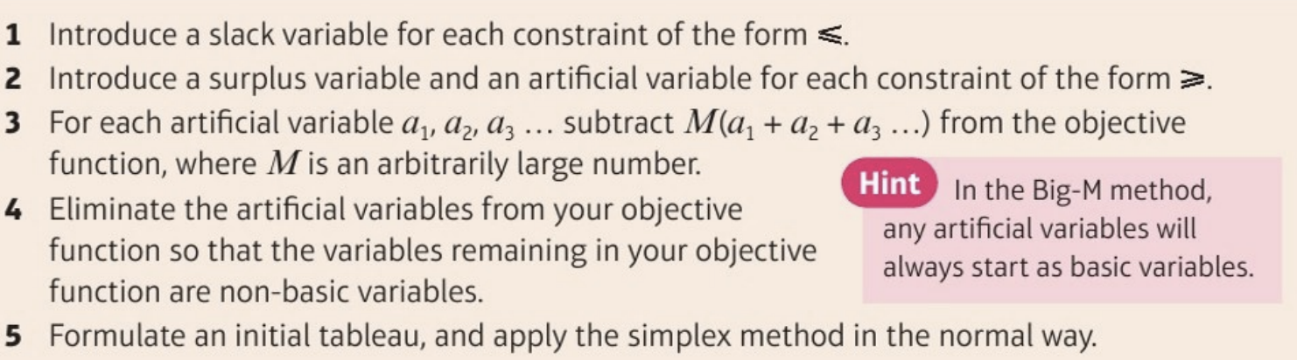
Step 3 is the new bit here.
- Use the Big-M method to solve this linear programming problem.
Minimise $P=x-y+z$
Subject to:
2$x+y+z≤20$
$x-2y-z≤7$
$x≥4$
$x,y,z≥0$

- Set up the initial tableau for solving the following linear programming problem using the Big-M method:
Maximise $P=3x-2y+z$
Subject to $x+y+2z≤10$
2$x-3y+z≥5$
$x+y≥8$

$$x,y,z≥0$$

(Draw your own tables!)

