7D Two-Stage Simplex Method
What if we have $≥$ constraints?
- (0,0) is no linger in the feasible region

Slack variables can’t “just” be taken away instead. Eg.
$$x+3y≥10$$

Would become
$$x+3y-s=10, s≥0$$
(s is now called a surplus value)
But this means when $x,y=0$
$$s=-10$$
Which contradicts $s≥0$

We therefore introduce ANOTHER “artificial” variable such as $a$
$$x+3y-s+a=10, s,a≥0$$
Which can now be written in a simplex tableau

- Use surplus and artificial variables to write the following inequalities as equations.
$$3x-2y≥7$$
$$4x+5y-3z≥9$$

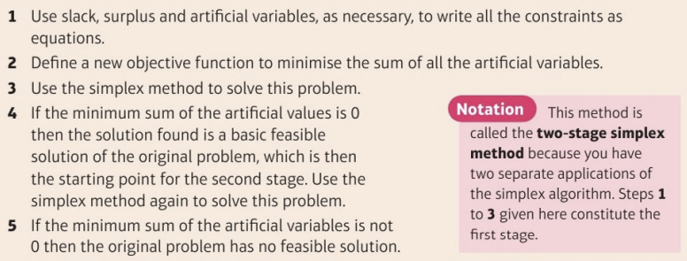
Step 2 is the really new bit! MINIMISE sum of artificial variables so
$$I=-(a_{1}+a_{2}+a_{3}+…a_{n})$$
If this is zero, then a solution exists (so simplex to this row in tableau)
- Minimise $P=3x-2y+z$
Subject to $x+y+2z≤10$
2$x-3y+z≥5$
$x+y≥8$
$x,y,z≥0$

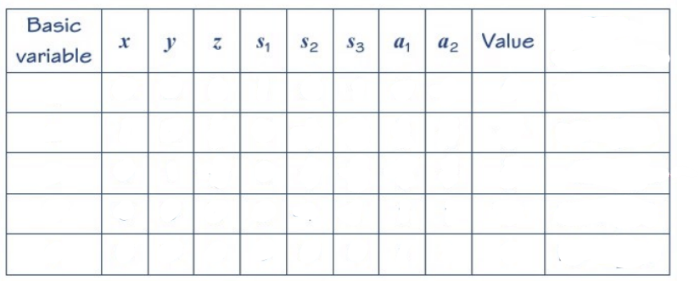

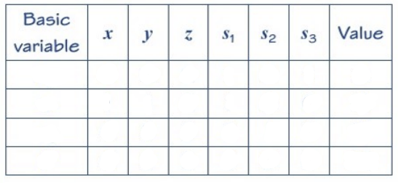
- Verify that the following linear programming problem has no feasible solution.
Maximise $P=3x-2y+z$
Subject to $x+y+2z≤8$
2$x-3y+z≥5$
$x+y≥10$
$x,y,z≥0$

