7C Integer Solutions
Consider integer solutions near the optimal solution

- Recall (1/3) from 7B solutions:
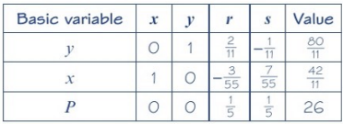
$$P=26, x=\frac{42}{11} or 3\frac{9}{11}, y=\frac{80}{11} or 7\frac{3}{11}$$

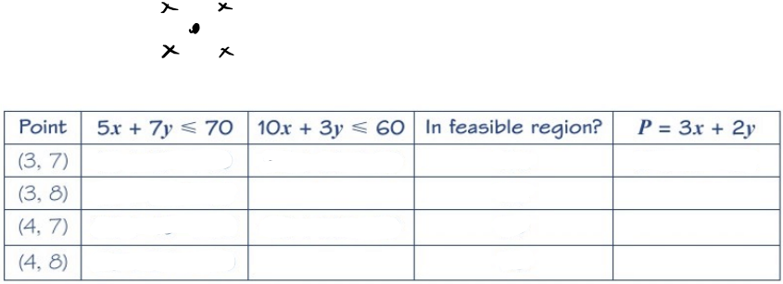

- Solve the linear programming model from example 2 in 7B
Maximise $P=10x+12y+8z$
Subject to :
$$2x+2y≤5$$
$$5x+3y+4z≤15$$
$$x,y,z≥0$$
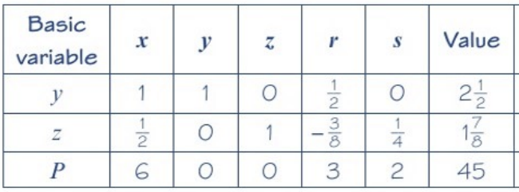

$$P=45, x=0 , y=\frac{5}{2} or 2\frac{1}{2}, z=\frac{15}{8} or 1\frac{7}{8}$$

