7B The Simplex Method

In chapter 6 we used graphs to help visualise where each vertex would be with two variables. This is much harder with three variables and dang near impossible with four or more. The simplex method:
- Starts at one vertex
- Moves between vertices in sequence, increasing the objective function and one variable at a time, until it is optimal
- Slack variables are key

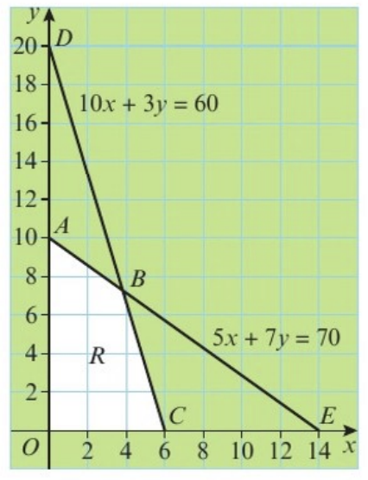
- Explain the significance of the slack variables in the graphical representation of the linear programming problem below.
Maximise $P = 3x + 2y$
Subject to:
$$5x + 7y + r = 70$$
$$10x + 3y +s = 60$$
$x,y,r,s≥0$
The feasible region, R, is shown.

At each vertex, two of the four vertices are zero.
- Explain, in detail, how the algebraic simplex algorithm is used to solve the above problem, relating each stage to the given graph.

- Show, in detail, the application of the algebraic simplex algorithm to the linear programming problem below.
Maximise $P=10x+12y+8z$
Subject to :
$$2x+2y≤5$$
$$5x+3y+4z≤15$$
$$x,y,z≥0$$

- Solve the linear programming problem in Example 1 using simplex tableaux (plural of tableau).
Maximise $P=3x+2y$
Subject to:
$$5x+7y+r=70$$
$$10x+3y+s=60$$
$$x,y,r,s≥0$$

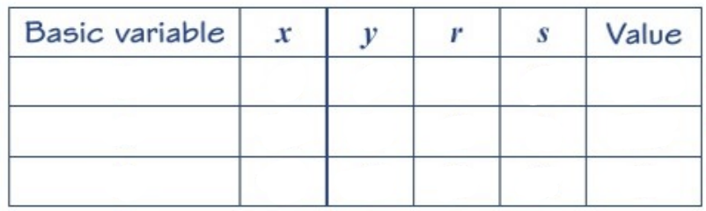

$$θ calculations$$

Always start at x=0, y=0 and follow the steps:
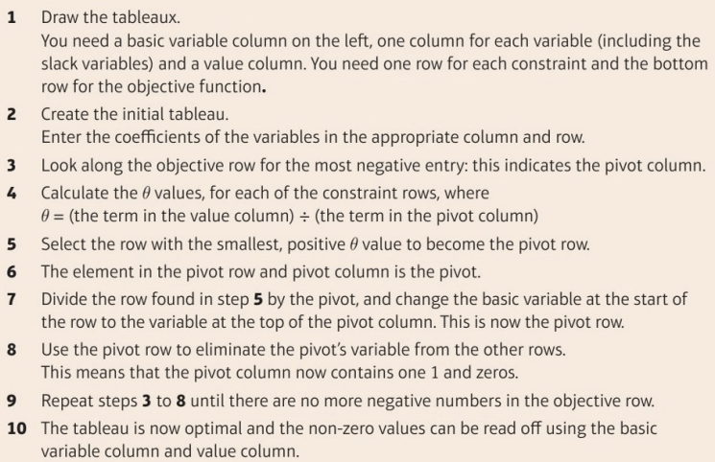
- Minimise $P=3x-y$
Subject to:
$$2x+y≤12$$
$$x+4y≤8$$
$$x≥0, y≥0$$

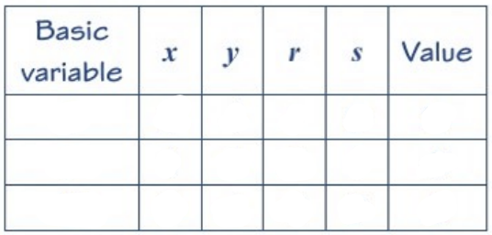

- Use simplex tableaux to solve the linear programming problem below (from Example 2).
Maximise $P=10x+12y+8y$
Subject to:
$$2x+2y≤5$$
$$5x+3y+4z≤15$$
$$x,y,z≥0$$

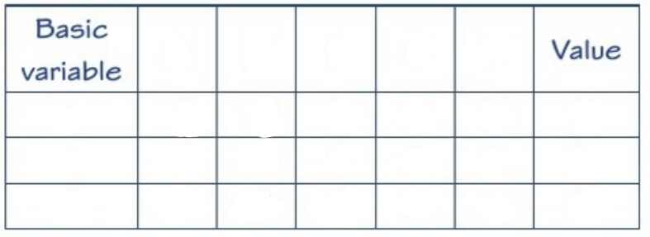

- Verify your solution using the original problem.

- Use the simplex tableau method to solve the following linear programming problem.
Maximise $P=3x+4y-5z$
Subject to:
$$2x-3y+2z+r=4$$
$$x+2y+4z+s=8$$
$$y-z+t=6$$
$$x,y,z,r,s,t≥0$$

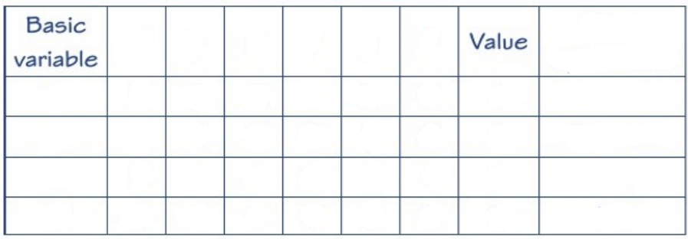

- State the values of the objective function and every variable at the optimal point.

- Write down the equations given by your optimal tableau.

- Use the profit equation you wrote down in part c to explain why your final tableau is optimal.

