5B Using a Minimum Spanning Tree Method to Find an Upper Bound
Using a minimum spanning tree method to find an upper bound for the practical problem:
1

2

3

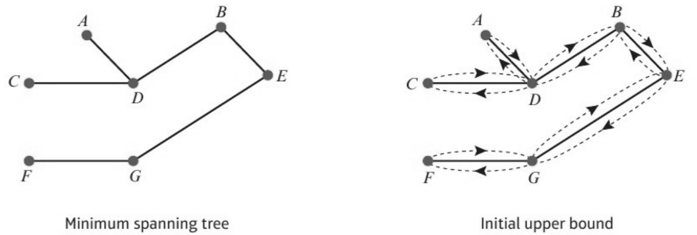
Initial upper bound:

1. For the network below:
a) Use Kruskal’s algorithm to find a minimum spanning tree for the network below.
b) Hence find an initial upper bound for the travelling salesman problem.
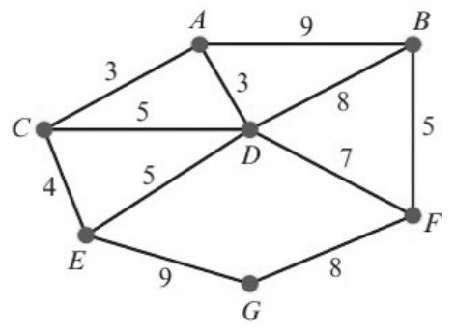

2. The table of least distances for a network is given below. Find an initial upper bound for the travelling salesman problem for this network.
 | A | B | C | D | E
A | – | 11 | 13 | 19 | 31
B | 11 | – | 24 | 8 | 22
C | 13 | 24 | – | 32 | 18
D | 19 | 8 | 32 | – | 14
E | 31 | 22 | 18 | 14 | –

Improving the upper bound (shortcuts):

3. Starting from the initial upper bound found in question 2, use a shortcut to reduce the upper bound to below 70.

4. The table shows the distances, in miles, between eight cities. A politician has to visit each city, starting and finishing at A. She wishes to minimise the total distance travelled.
 | A | B | C | D | E | F | G | H
A | – | 47 | 84 | 382 | 120 | 172 | 299 | 144
B | 47 | – | 121 | 402 | 155 | 193 | 319 | 165
C | 84 | 121 | – | 456 | 200 | 246 | 373 | 218
D | 382 | 402 | 456 | – | 413 | 220 | 155 | 289
E | 120 | 155 | 200 | 413 | – | 204 | 286 | 131
F | 172 | 193 | 246 | 220 | 204 | – | 144 | 70
G | 299 | 319 | 373 | 155 | 286 | 144 | – | 160
H | 144 | 165 | 218 | 289 | 131 | 70 | 160 | –

a) Find a minimum spanning tree for this network.

b) Hence find an upper bound for this problem.

c) Use shortcuts to reduce this upper bound to a value below 1300 miles.

Selecting shortcuts: try the shortcuts BD, CB + AF + FD and CD for question 4. Which gives the best upper bound? (Aim to make the upper bound as ... as possible.)

