5A The Classical and Practical Travelling Salesman Problems
Walk:

Tour:

The travelling salesman problem:

Heuristic algorithm:

Upper and lower bounds (‘trapping’ the optimal solution):

The classical problem:

The practical problem:

Triangle inequality:

Table of least distances:

1. Create a table of least distances for the network below.
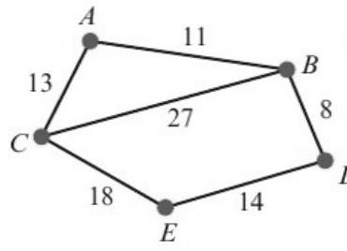
 | A | B | C | D | E
A | –
B |  | –
C |  |  | –
D |  |  |  | –
E |  |  |  |  | –

2. The network below shows the distances, in km, between the central sorting office at S and six post offices A, B, C, D, E and F. The table shows a partially completed table of least distances.
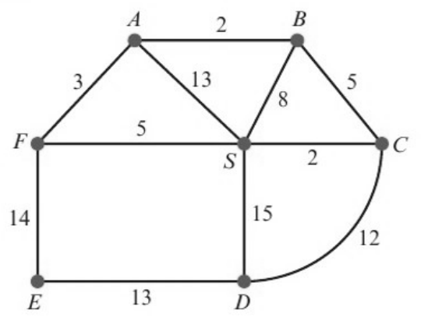
 | S | A | B | C | D | E | F
S | – |  |  | 2 |  |  | 5
A |  | – | 2 |  | 19 | 17 | 3
B |  | 2 | – | 5 | 17
C | 2 |  | 5 | – | 12 | 21 | 7
D |  | 19 | 17 | 12 | – | 13
E |  | 17 |  | 21 | 13 | – | 14
F | 5 | 3 |  | 7 |  | 14 | –

Complete the table of least distances for the network, stating your shortest route for each of the entries.

