4C Lots of Odd Nodes
As you can imagine, when there are a lot of odd nodes, the possible combinations for pairs will grow quickly (${{}_{}^{n}C}_{2}$)
2 odd nodes will have ${{}_{}^{2}C}_{2}=1$ possible pairing
4 odd nodes will have ${{}_{}^{4}C}_{2}=6$ possible pairings
6 odd nodes will have ${{}_{}^{6}C}_{2}=15$ possible pairings
8 odd nodes will have ${{}_{}^{8}C}_{2}=28$ possible pairings
10 odd nodes will have ${{}_{}^{10}C}_{2}=45$ possible pairings
And so on
When a network has more than 4 odd nodes, additional information will be provided to reduce the number of combinations.
- A night watchman has to patrol a network of paths as shown in the diagram. The number shown on each arc represents the time taken, in minutes, to walk between the labelled points.
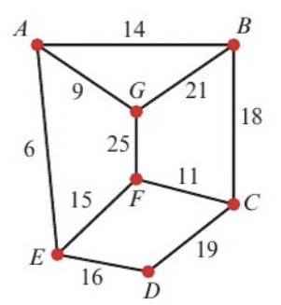
- Use the route inspection, starting at A and finishing at C, to find the minimum time taken to traverse each arc at least once.

- State a possible route

An extra path is added joining B and F directly. After the addition of this path, the minimum time needed to traverse all paths, starting at A and finishing at C, is reduced by twice the length of time needed to traverse this path.
- Calculate the time needed to traverse the new path BF.

- The network represents the roads that must be travelled by a police patrol car. The length of each road in kilometres is shown on each arc.
The patrol starts at A and can finish at either of the two police stations at G or D.
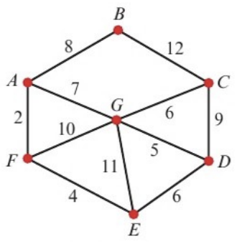
- Find the length of the shortest route, such that every road is traversed at least once.

- State which police station the patrol car finishes at, and which roads must be traversed twice.

