4B Route Inspection (Chinese Postman Algorithm)
The shortest route to complete a network such that every connection is traversed at least once AND returns to its starting point.

- If the network is Eulerian (every node has even degree), then the shortest route will be the sum of the lengths of all connections (as we can hit exactly every route once and end where we started).

- If the network is semi-Eulerian (exactly two nodes of odd degree), then the shortest route will be the sum of the network, plus the shortest route between the odd nodes (as we have to get back to a starting point).

- If the network has more than two odd nodes:
  - Route inspection algorithm:
    - Identify the odd vertices
    - Consider all pairings of these vertices
    - Select the pairings with the smallest sum
    - Add a repeat of the arcs indicated by this pairing to the network

- The diagram show a network of trails on a BMX course. The number on each edge is the length, in metres, of the trail. Hannah wants to start at A, traverse every trail on the network, then return to A. Find the length of the shortest path she could take.

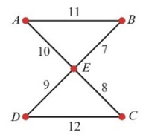

- The diagram shows a network of undersea cables. The number on each arc is the length, in kilometres, of that cable. A diver needs to inspect the cables and needs to find a route of minimum length that traverses every cable and starts and finished at S.
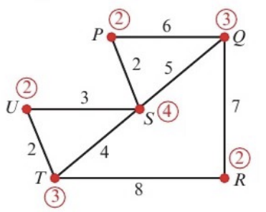
Note: the numbers in circles indicate the degree of each vertex
(you can label your graphs like this in your exam)

- State the cables that will be traversed twice.

- State the minimum length of the diver’s route.

- A route is needed that starts at A, traverses every arc in this network, and returns to A. Find a possible route and state its length.
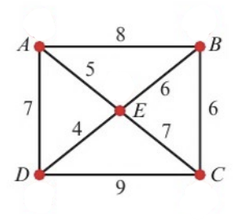

- The diagram represents a network of roads. The numbers on the arcs represent the lengths of each road in miles. The roads need to be resurfaced. The council wants to find the shortest possible route which traverses every road and starts and ends at A.
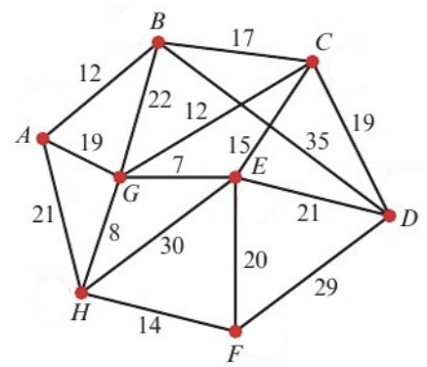
- Determine the length of this route. You must show your method and working, and state clearly which roads must be traversed twice.

The council decides that, in order to save money, the route can start and end at different vertices.
- State which two vertices should be chosen to minimise the length of the new route. Give a reason for your answer, and state the length of the new route.

