Crossing Bridges
Try to find a route to cross every bridge once.
Plot twist: the bridges are old and fragile – you have to run to cross them and they collapse immediately afterwards
Bonus points for managing to start and end at the same place!
Does it matter where you start? Can you complete the network from every possible starting point?
What would the mathematical graph look like? (use the space next to each one)

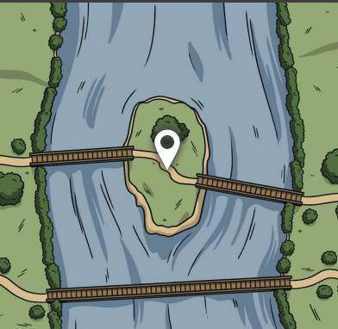

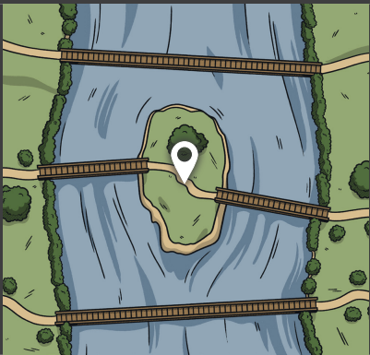
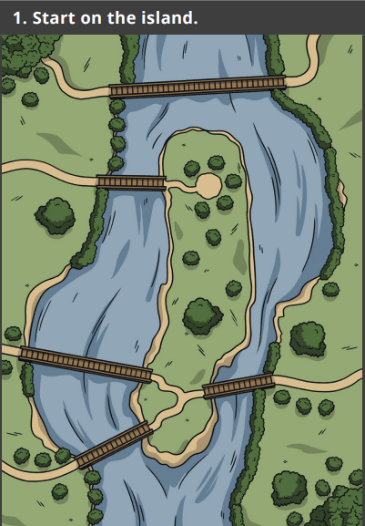

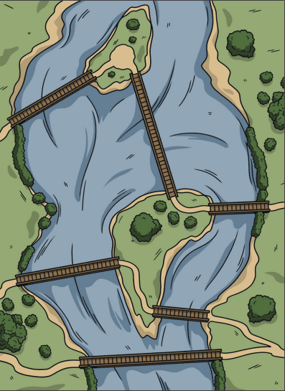
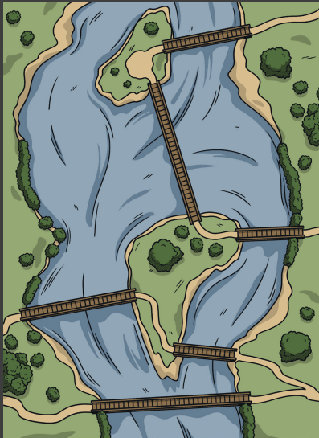

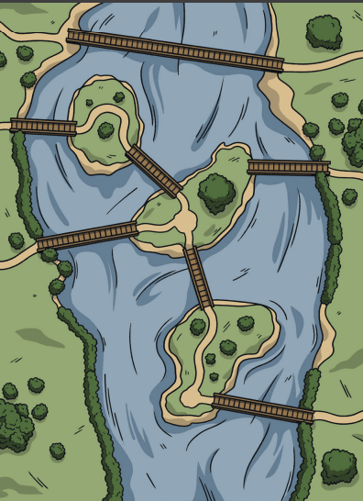
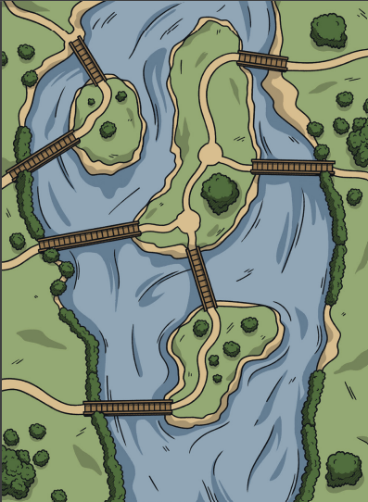

Euler and Königsberg
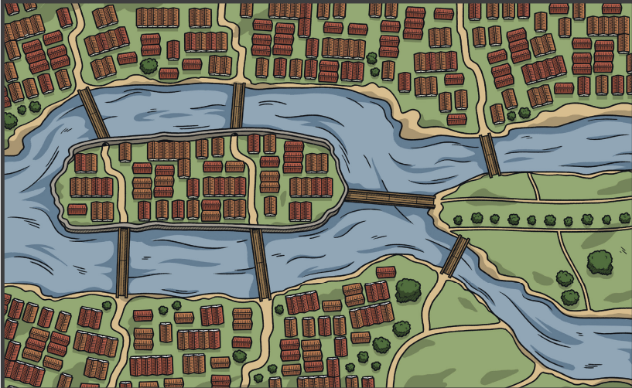

Historical Setting and Problem
- The City: Königsberg in Prussia (now Kaliningrad, Russia) was built around the Pregel River.
- The Geography: The river split the city into two mainland areas and two large islands (Kneiphof and Lomse) connected by seven distinct bridges. [1]
- The Puzzle: Local residents enjoyed a Sunday tradition of trying to walk through the city in a route that crossed every single bridge exactly once, without doubling back.
- The Frustration: Despite trying for years, no one could find a successful route, but no one could prove whether it was truly impossible.

Leonhard Euler’s Solution
In 1735, the Swiss mathematician Leonhard Euler solved the puzzle and presented a rigorous proof that the walk was impossible:
- Abstraction: Euler realized that the exact sizes, distances, and shapes of the landmasses and bridges did not matter.
- The First Graph: He stripped away the physical map, representing the four land areas as points (called vertices or nodes) and the seven bridges as lines (called edges).
- Odd and Even Degrees: Euler observed that every time you enter a landmass by a bridge, you must leave it by a different bridge. This means every intermediate landmass must touch an even number of bridges.
- The Verdict: In Königsberg’s layout, all four landmasses were connected to an odd number of bridges (three landmasses had 3 bridges, and one had 5). Because a valid path can only have zero or two odd-degree vertices, Euler proved mathematically that the walk could not exist.

4A Eulerian Graphs

Make this shape without taking your pencil off the paper or going over any lines more than once

- We call any graph in which we can do this “Semi-Eulerian”
- A Graph where we can begin and end at the same vertex is an “Eulerian Graph”

In General, for any connected network:
- Eulerian Graphs exist when each vertex is even
- Semi-Eulerian Graphs exist when exactly two vertices are odd

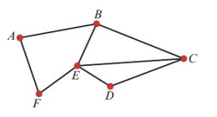

- State whether the graph above is Eulerian, semi-Eulerian or neither.

- If possible, find a trail that traverses each edge of this graph exactly once

- A connected graph has 5 nodes. The order of the nodes are 4, 6, 3, p and 2.
- Explain why the graph cannot be Eulerian

- Explain why the graph must be semi-Eulerian

- Give the number of edges contained within the network in terms of p.

- Draw a graph with two nodes that is neither Eulerian or semi-Eulerian

