3E Floyd’s Algorithm
A level only.

What does Floyd’s algorithm find? (compare with Dijkstra’s algorithm)

Floyd’s algorithm:

1. This distance graph shows the direct distances, by road, between four towns A, B, C and D, in miles. The road from D to A is a one-way road as shown by the arrow.
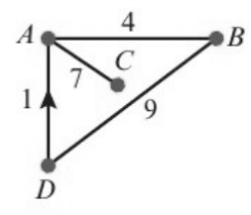
a) Use Floyd’s algorithm to produce a table of shortest distances. You should give the distance table and route table for each iteration.
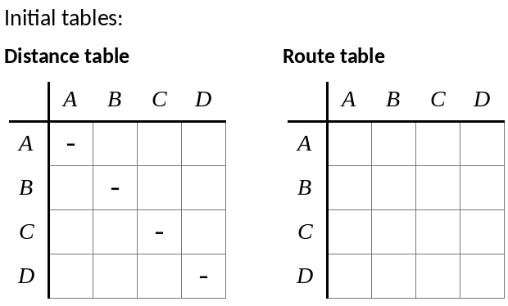
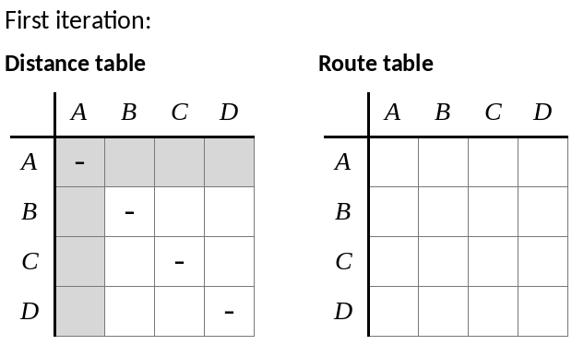
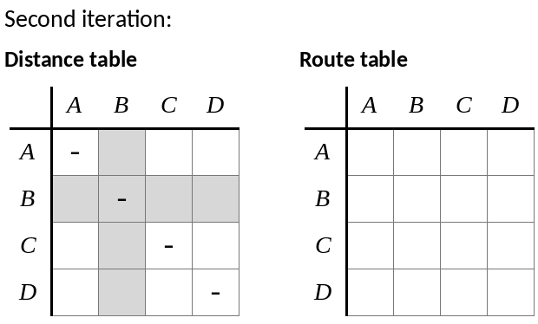
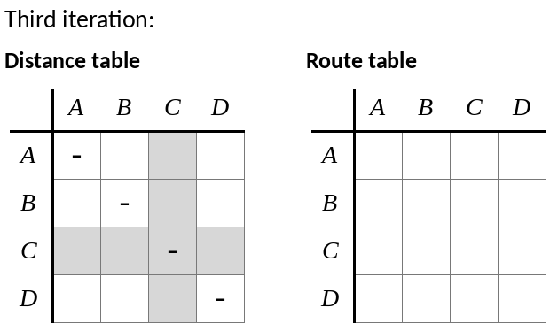
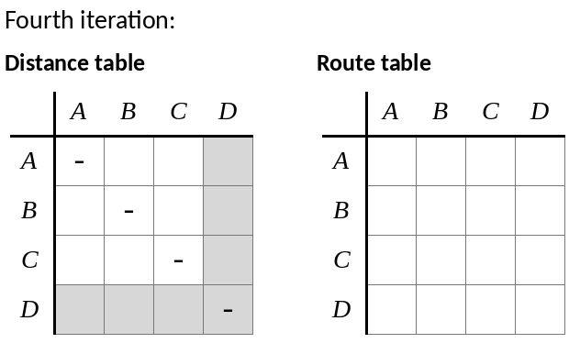
b) Find the route of minimum length from C to D.

2. 8 departure gates in an airport, which are linked by a system of travellators and escalators, are modelled using the directed network shown. The weight of each edge represents the travel time, in minutes, from one gate to another.
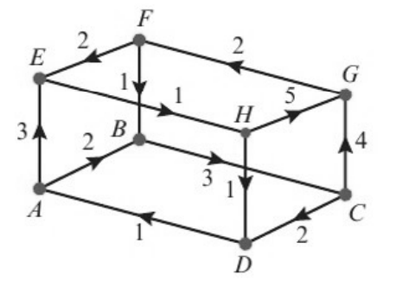
7 iterations of Floyd’s algorithm are applied to the network, resulting in the following distance and route tables.
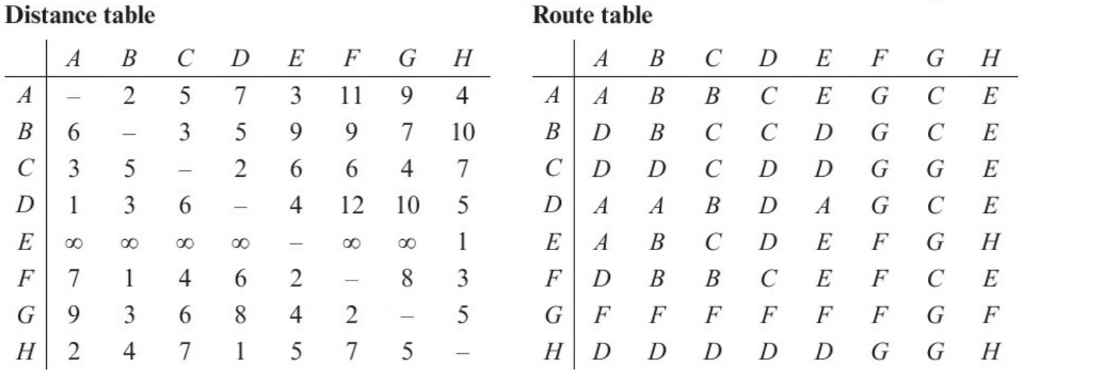

a) Apply the final iteration of Floyd’s algorithm to give the final distance and route tables for the network.
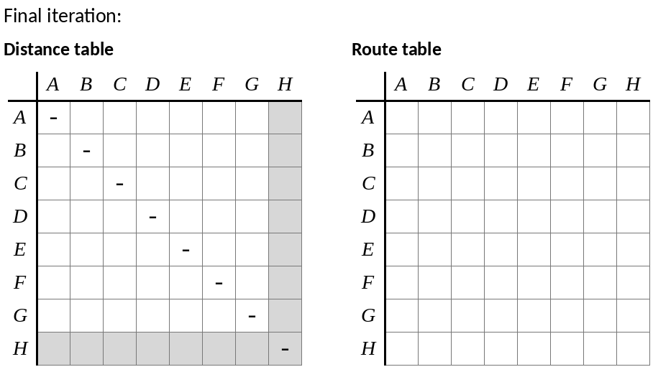

b) Sarah needs to get from gate D to gate F. State the minimum time needed to make this journey, and determine the route she should take.

