3D Using Dijkstra’s Algorithm to Find the Shortest Path
Dijkstra’s algorithm:

Final (permanent) label and working values (temporary labels):

To make the working clear, replace each vertex with a box like this:
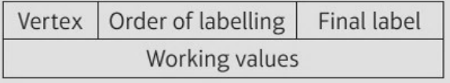
Finding the shortest route (tracing back from T to S):

1. Use Dijkstra’s algorithm to find the shortest route from S to T in the network below.
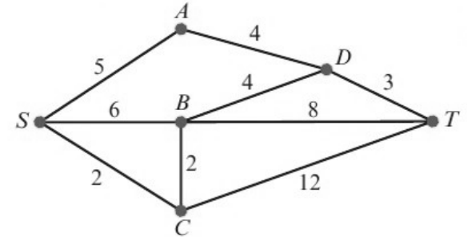
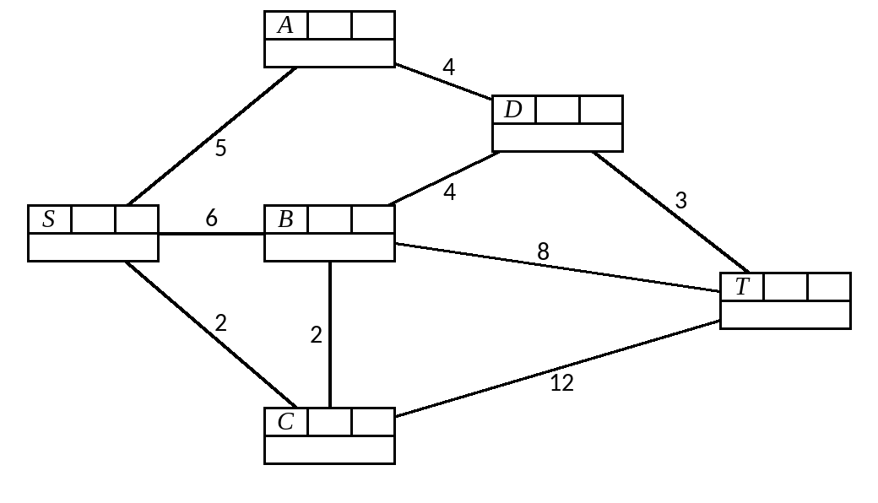

2. Use Dijkstra’s algorithm in this network to find the length of the shortest route:
a) from A to H
b) from A to G.
List the routes you use.
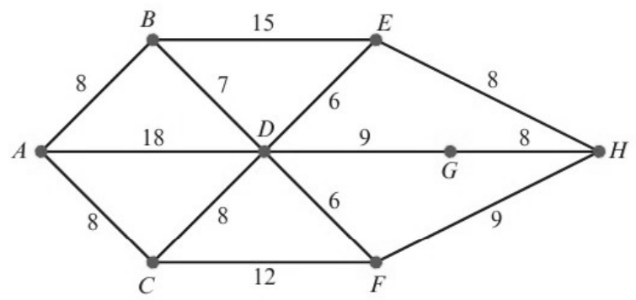
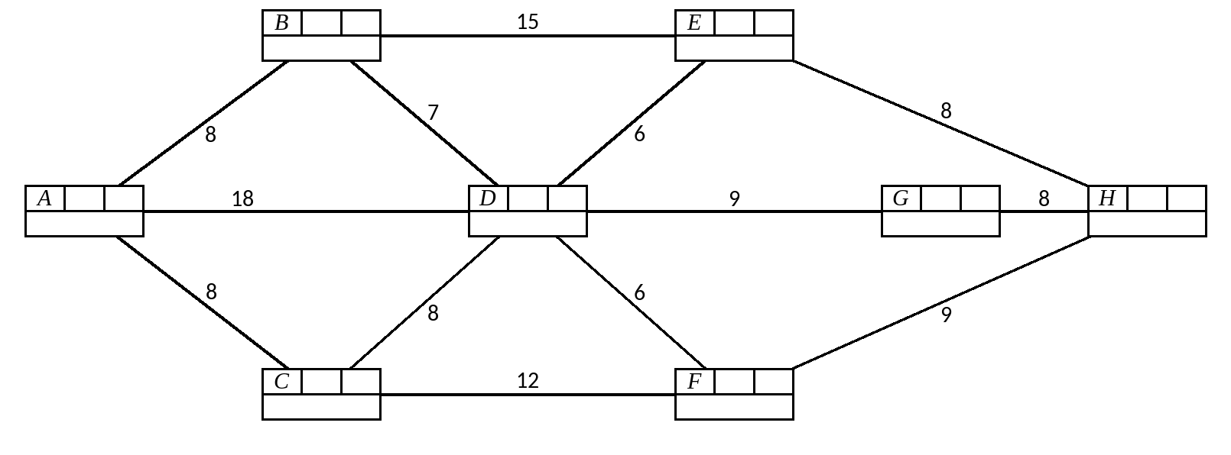

Directed networks:

3. The network below represents part of a road system in a city. Some roads are one-way and these are indicated by directed arcs. The number on each arc represents the time, in minutes, to travel along that arc.
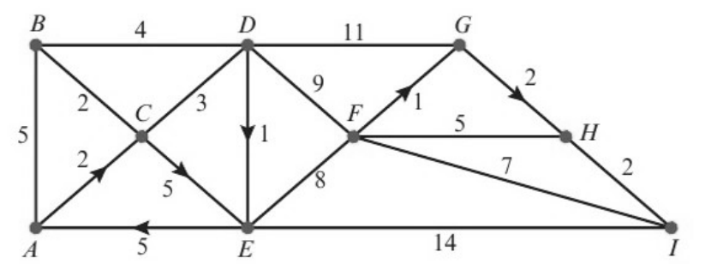
a) Show that there are two quickest routes from A to I. Explain how you found your routes from your labelled diagram.
Road HI is closed due to roadworks.
b) Find the quickest route from A to I, avoiding HI.
