3A Kruskal’s Algorithm
Minimum spanning tree (MST) / minimum connector:

Kruskal’s algorithm:

Number of arcs in a spanning tree of a network with n vertices:

1. Use Kruskal’s algorithm to find a minimum spanning tree for this network. List the arcs in the order that you consider them. State the weight of your tree.
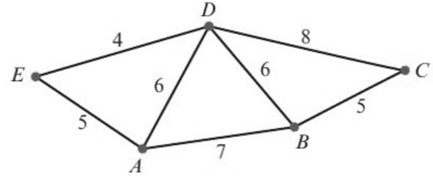

2. Use Kruskal’s algorithm and show that there are four minimum spanning trees for this network. State their weight.
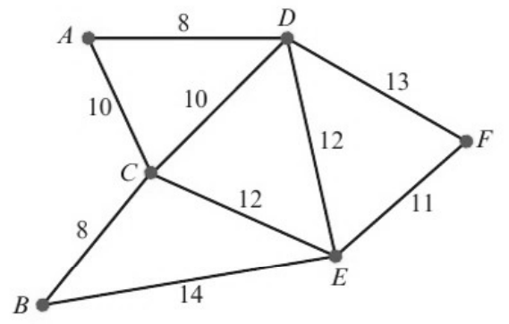

Draw the four minimum spanning trees:
