2E The Planarity Algorithm
(A level only)
Planar graph:

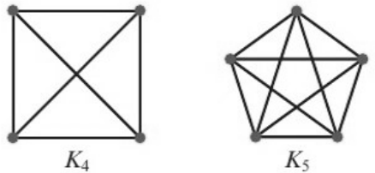
Which of K₄ and K₅ is planar? Redraw it with no edges crossing.

The planarity algorithm (steps):
1 Identify a Hamiltonian cycle.

2 Draw a polygon ...

3 Draw edges inside the polygon ...

4 Make a list ...

5 Choose any unlabelled edge ...

6 Look at any unlabelled edges that cross the edge(s) just labelled:

1. Use the planarity algorithm to determine whether this graph is planar.
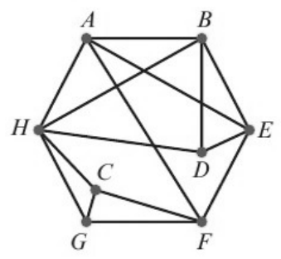
Step 1:

Steps 2, 3:
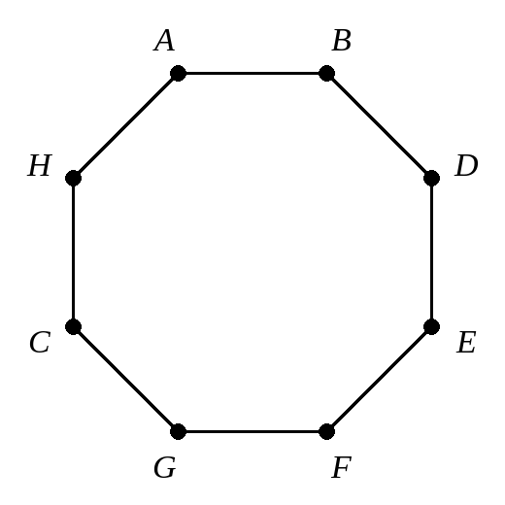
Step 4:

Steps 5 and 6:

Draw the graph with no edges crossing:
2. An electronics company attaches components A, B, C, D, E and F to a circuit board. These components are to be connected by wires that are not allowed to cross. The table gives information about the connections.
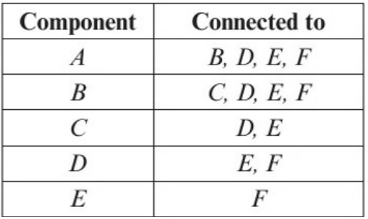
Using the Hamiltonian cycle ABCDEFA, apply the planarity algorithm to determine whether the connections can be made without any wires crossing.
