2D Representing Graphs and Networks Using Matrices
Adjacency matrix:

1. Use an adjacency matrix to represent this graph.
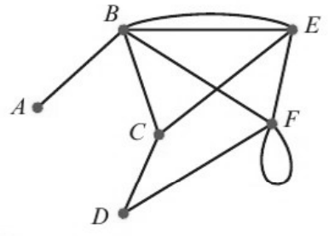
 | A | B | C | D | E | F
A
B
C
D
E
F

What does the 2 in row B, column E mean? What about the 2 in row F, column F?

Distance matrix:

2. Use a distance matrix to represent this network.
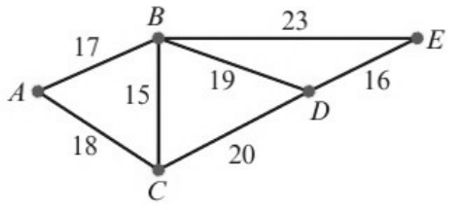
 | A | B | C | D | E
A
B
C
D
E

What do you notice about the matrix?

3. Use a distance matrix to represent this directed network.
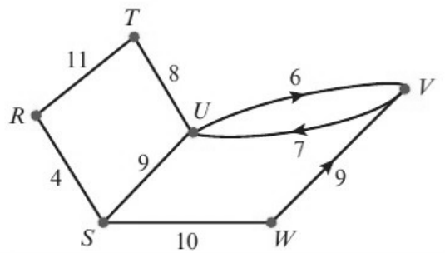
 | R | S | T | U | V | W
R
S
T
U
V
W

What do you notice about the matrix this time?

