2C Special Types of Graph
Tree:

1. Explain why the first graph is a tree but the second graph is not.
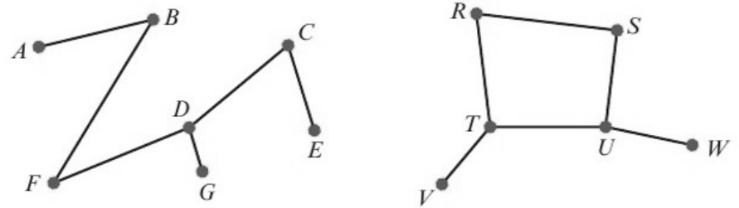

Spanning tree:

2. Draw two possible spanning trees for this graph.
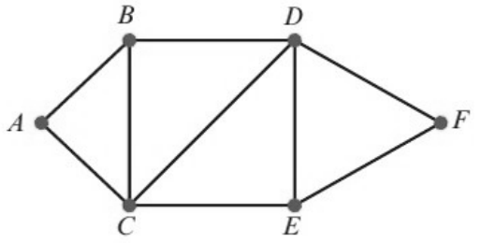

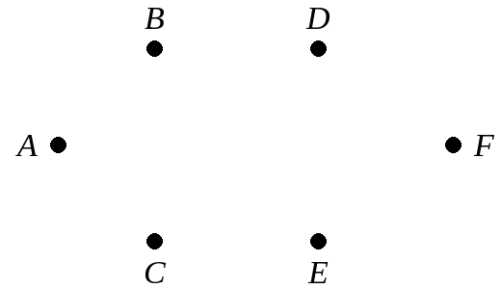

Complete graph:

Notation Kₙ:

3. Draw the complete graphs K₃, K₄ and K₆.

Isomorphic graphs:

4. Show that this graph
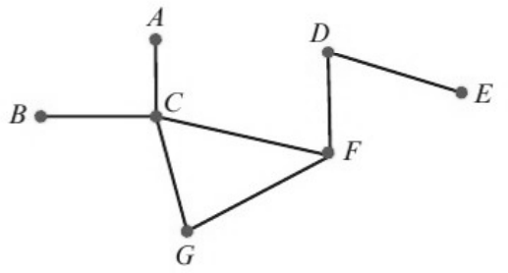
is isomorphic to each of these graphs by pairing equivalent vertices.
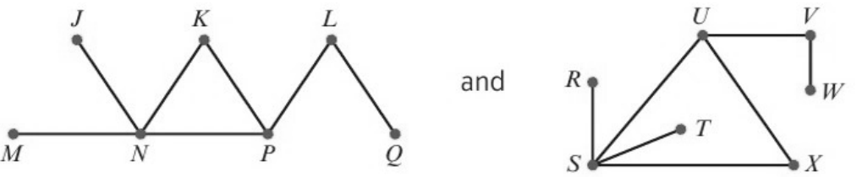

First graph | A | B | C | D | E | F | G
Second graph
Third graph

