2B Graph Theory
Vertex set and edge set:

Subgraph:

Degree (valency / order) of a vertex:

Even degree / odd degree:

Walk:

Path:

Trail:

Cycle:

Hamiltonian cycle:

1. For the graph below, give an example of:
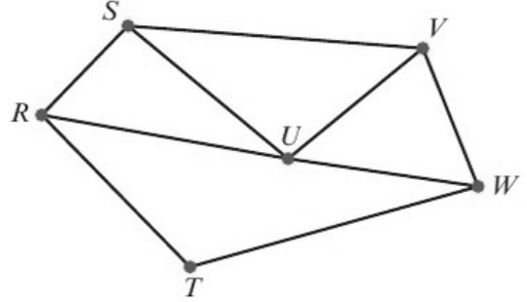
a) a walk

b) a path

c) a trail

d) a cycle

e) a Hamiltonian cycle.

Connected vertices / connected graph:

Loop:

Simple graph:

Directed graph (digraph):

Euler’s handshaking lemma:

2. For the graph below:
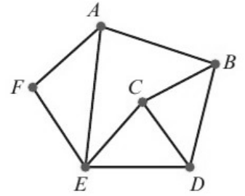
a) Find the sum of the valencies of the vertices in this graph.
Vertex | Valency
A
B
C
D
E
F
Total

b) Verify that your answer to part a is twice the number of edges in the graph.

3. A graph has 5 nodes and 8 edges. The valencies of the nodes are x, x − 1, x + 1, 2x − 1 and x − 1. Find the value of x.

