2A Modelling with Graphs
Graph:

Vertex (node):

Edge (arc):

Weighted graph (network):

1. This graph shows the routes flown by an airline.
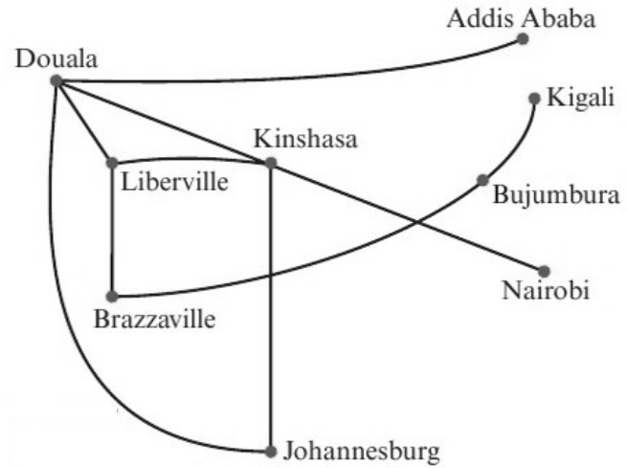
a) Explain why this is a graph.

b) Describe what is represented by i the vertices ii the edges.

c) Describe two possible flight routes from Johannesburg to Liberville.

2. This network shows the lengths of pipes running between water standpipes on a camp site. The lengths on the edges are given in metres.
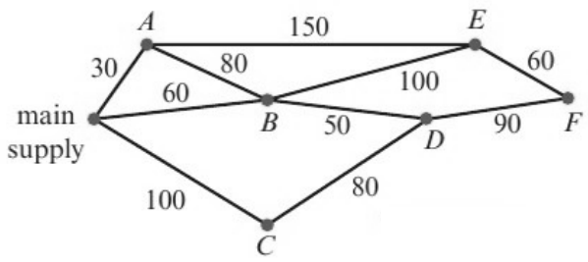
a) Write down the length of the pipe connecting standpipe B to standpipe D.

b) Write a list of the standpipes that are directly connected to standpipe E.

3. The network shows the times taken, in minutes, by a car to travel along some sections of road.
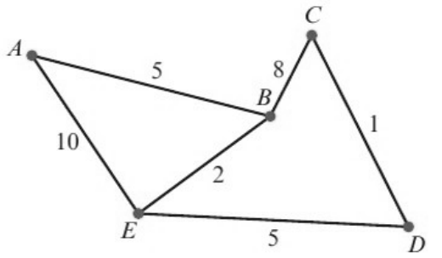
Calculate the minimum time needed to travel from A to D and give the route taken.

Route | Time needed (mins)

