1B Flow Charts
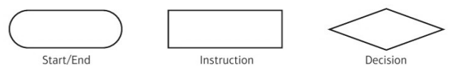
1.
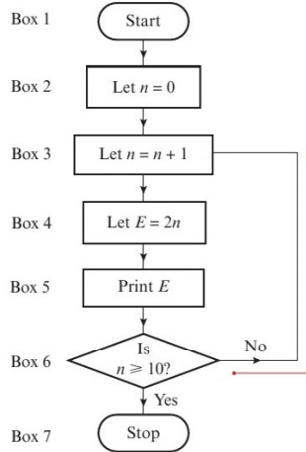
- Implement this algorithm using a trace table

- Alter box 4 to read “let E=3n” and implement the algorithm again.
What do you notice?

2.
This flow chart can be used to find the roots of an equation of the form $ax^{2}+bx+c=0$

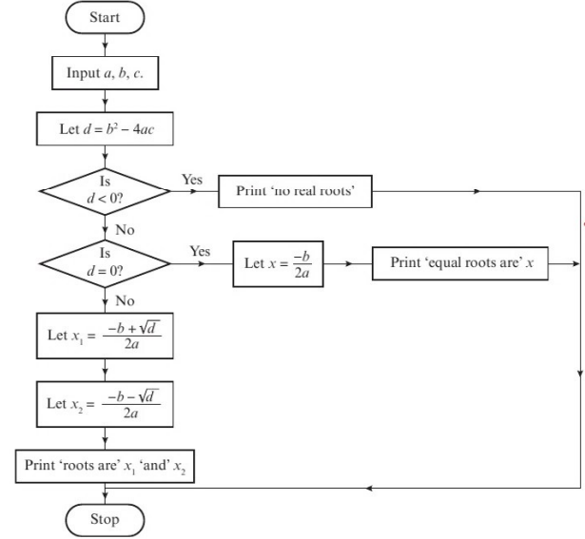

Demonstrate this algorithm for these equations:
- $6x^{2}-5x-11=0$

- $x^{2}-6x+9=0$

- $4x^{2}+3x+8=0$

3. Apply the algorithm shown by the flow chart to the data
$$u_{1}=10, u_{2}=15, u_{3}=9, u_{4}=7,u_{5}=11,$$

