1A Understanding Algorithms

Magic Trick
- Pick any number.
- Double it.
- Add 10 to the total.
- Divide the result by 2.
- Subtract the original number.
5?

- Happy numbers:
- Write down any integer
- Square its digits and find the sum of the squares
- Repeat this process with the new number until you get 1 (happy) or identify a cycle (unhappy)
- Show that 70 is happy

- Show that 4 is unhappy

  - Implement this algorithm using a trace table
- Let n=1, A=1, B=1
- Print A and B
- Let C=A+B
- Print C
- Let n=n+1, A=B, B=C
- If n<5, go to 3.
- If n=5, stop.

Instruction Step | n | A | B | C | Print

  - Describe the numbers generated by the algorithm

- The algorithm multiplies the two numbers A and B
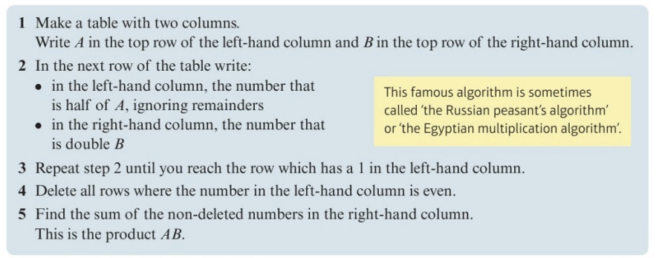
Implement this algorithm for:
- A=29 and B=34

- A=66 and B=56

