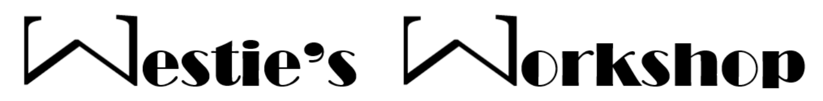

IGCSE Hit List

- Topics in this resource have been organised based on probability of come up. This should be taken with the pinch of salt all probability-based predictions come with.
- I have tried to pick questions types from each topic that I feel are likely to come up, but the style in which they will be asked is not certain. It could be similar to previous years or posed in a completely new way.
- To get more practice on topics, please use the links sent out on teams.

Certain to very likely: 100-80% topics
Differentiation (100%)
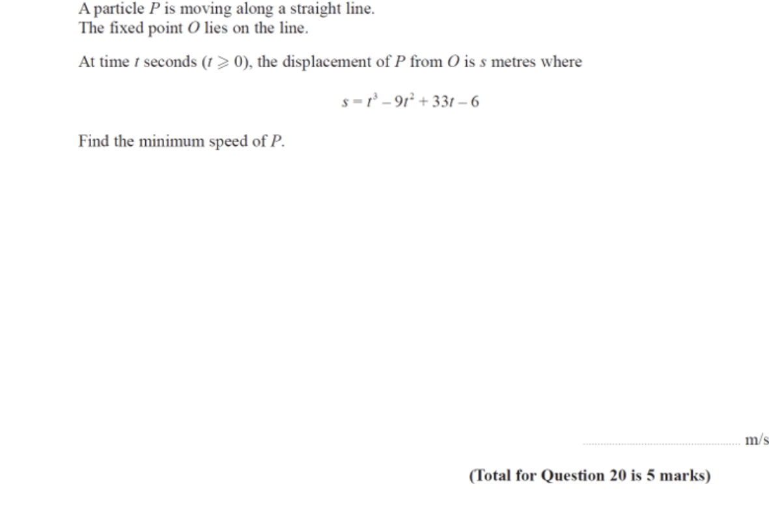

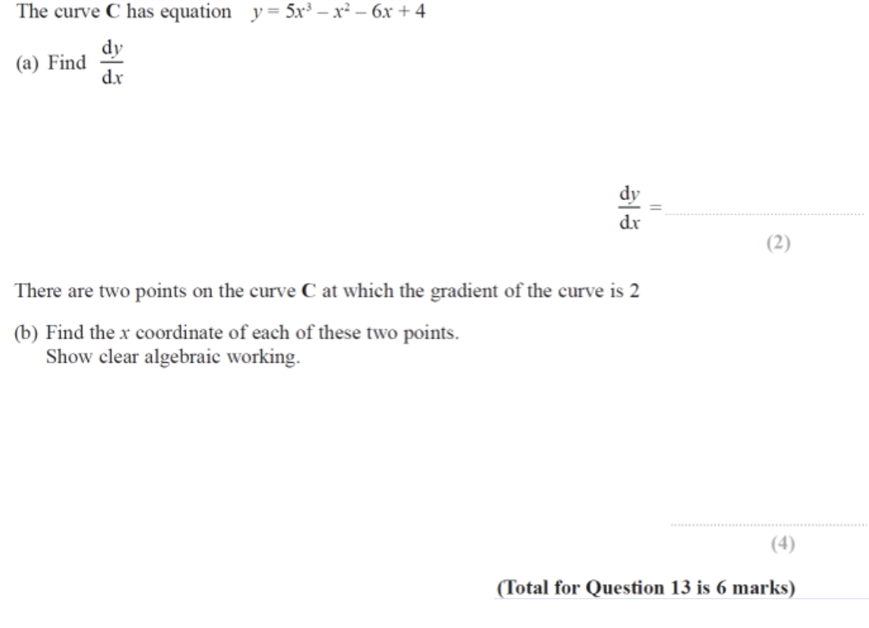

Pythagoras (100%)
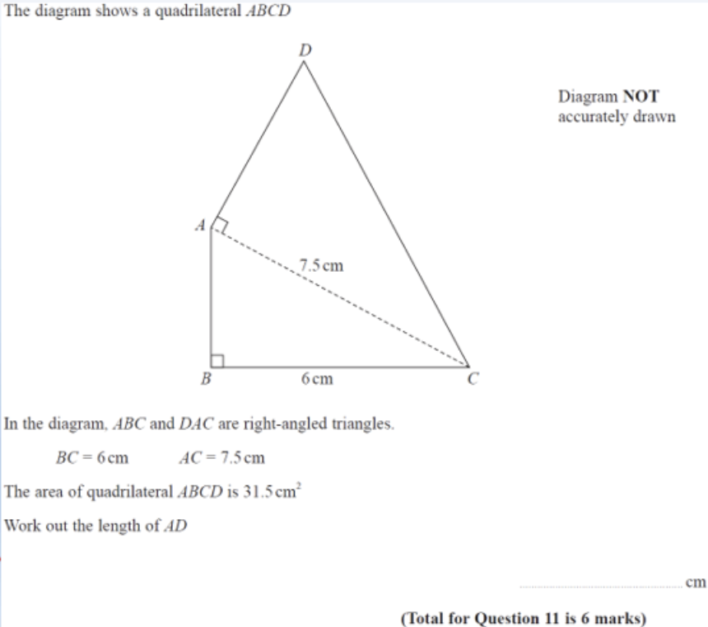

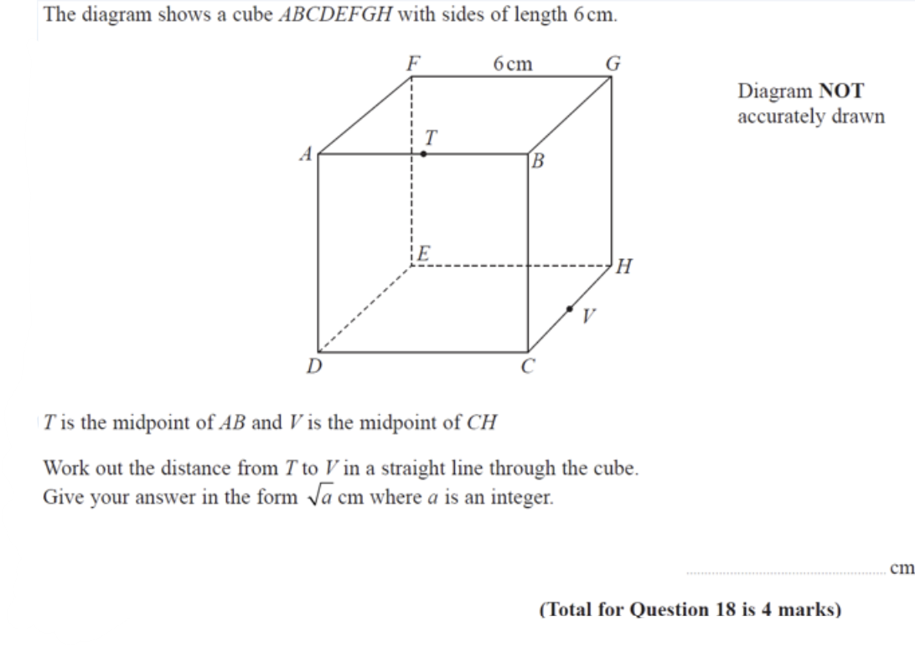

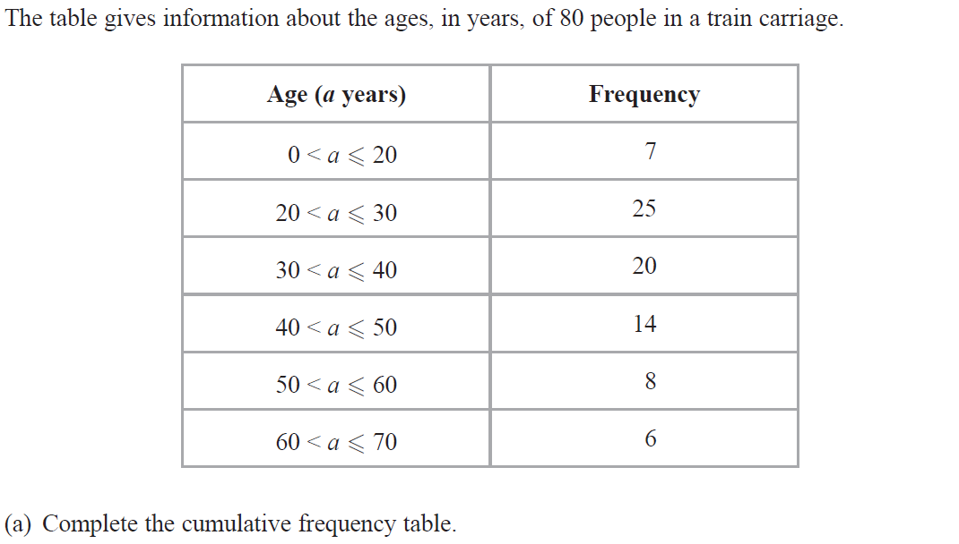
Cumulative Frequency (100%)

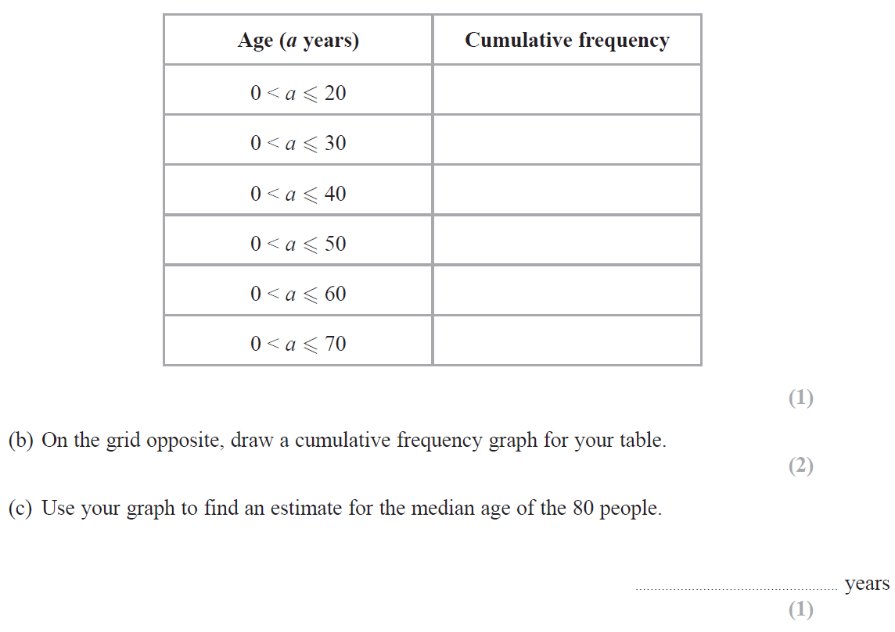

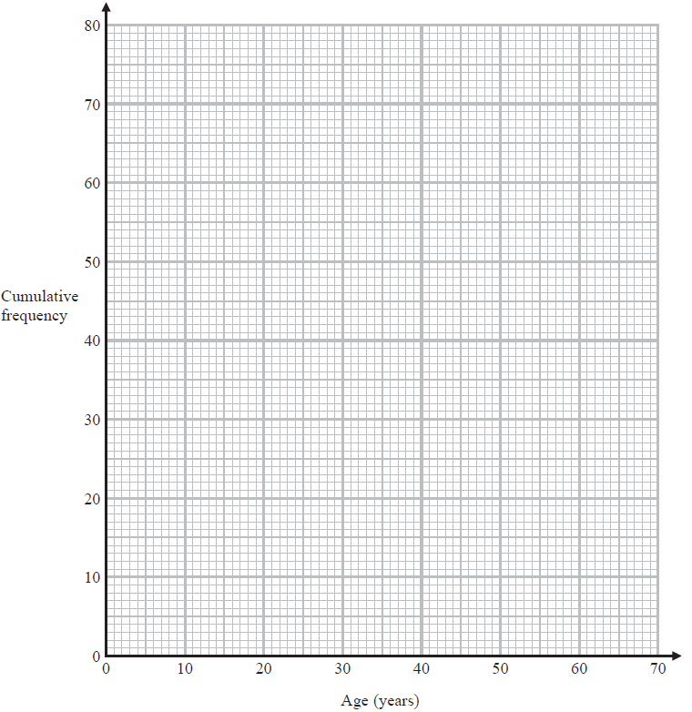
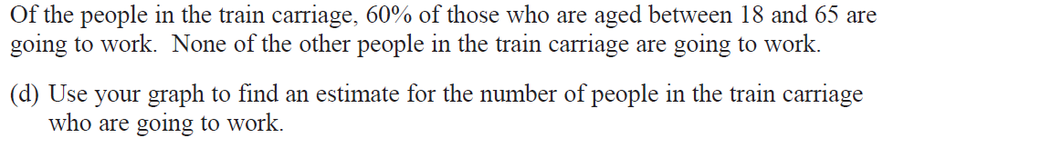

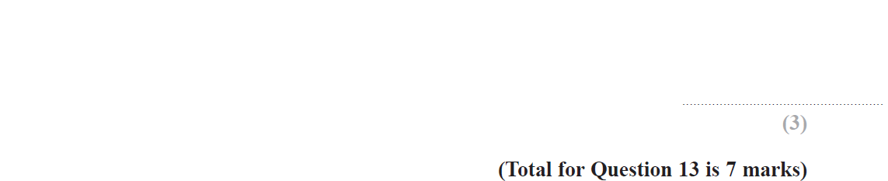
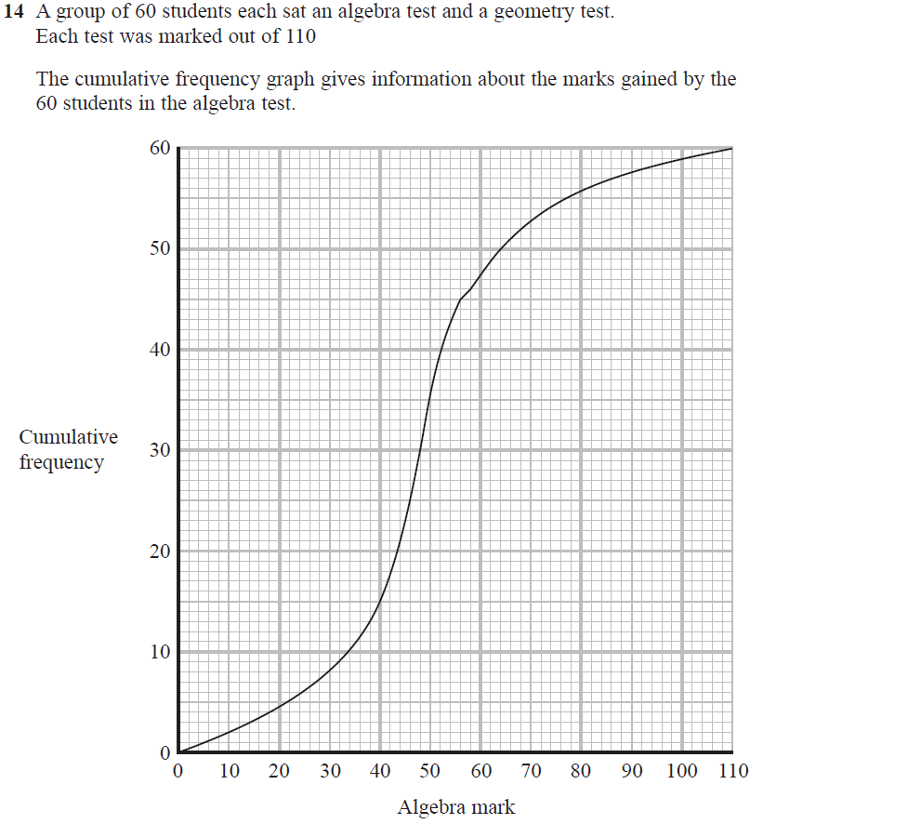
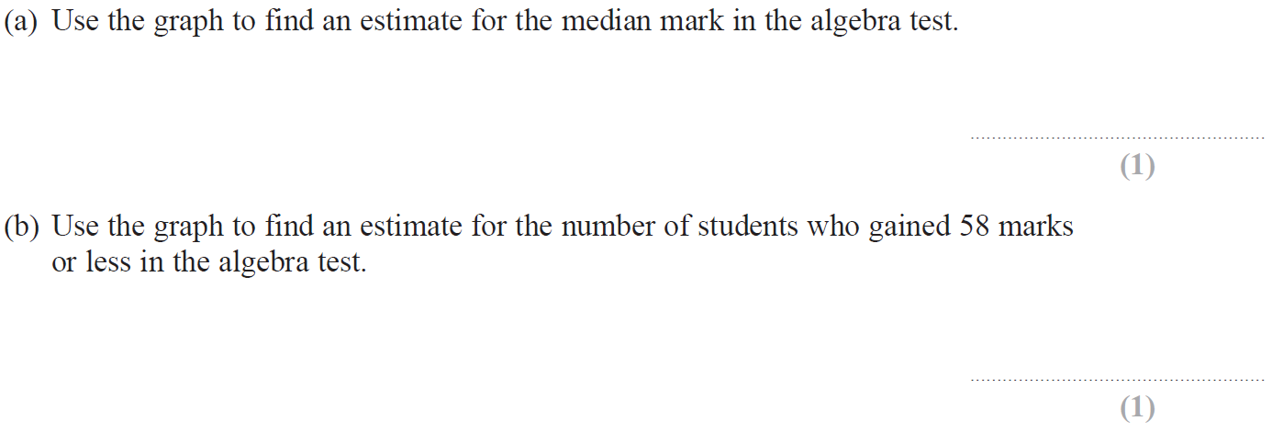

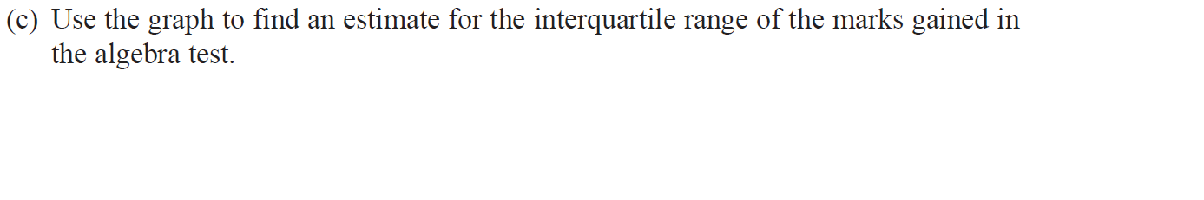

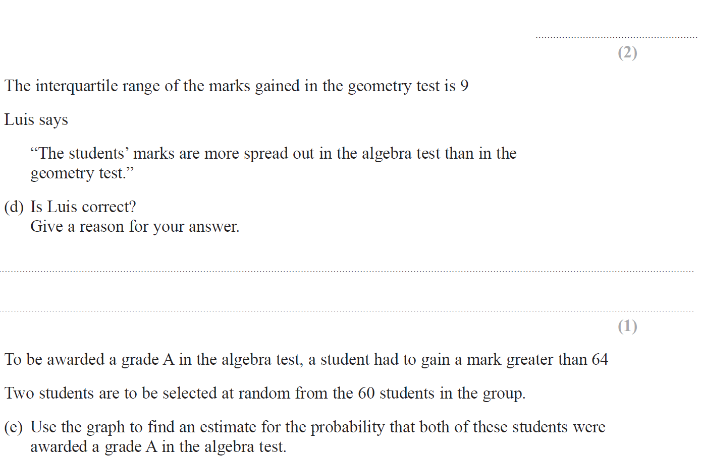

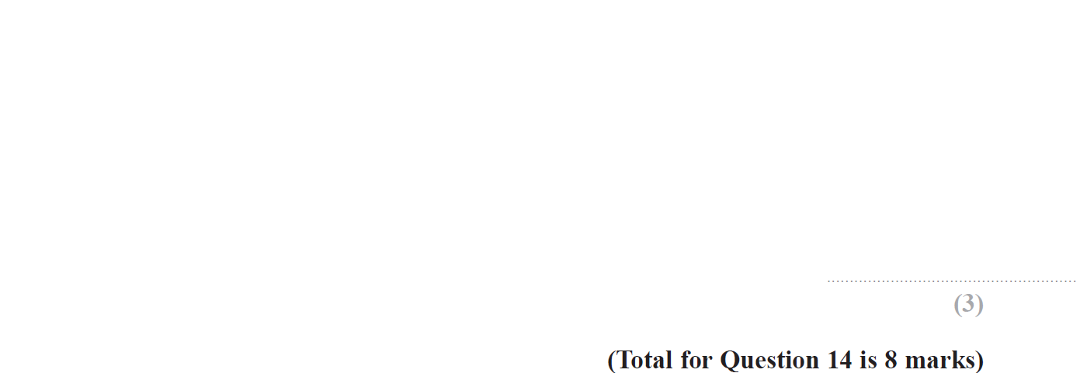
Changing the Subject (92.3%)
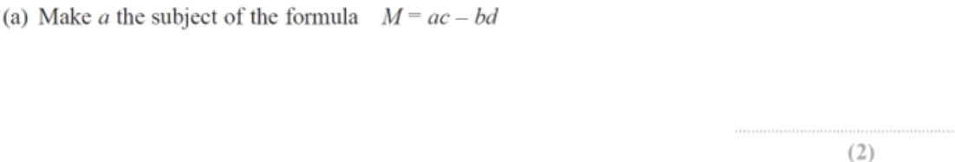

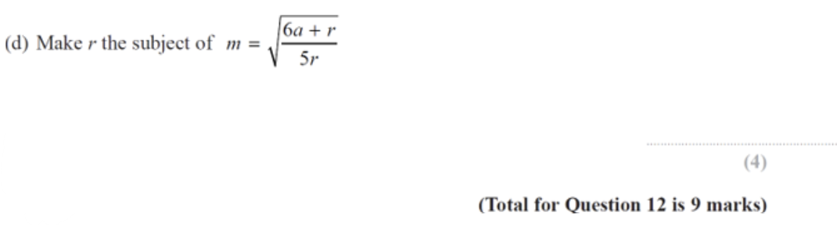

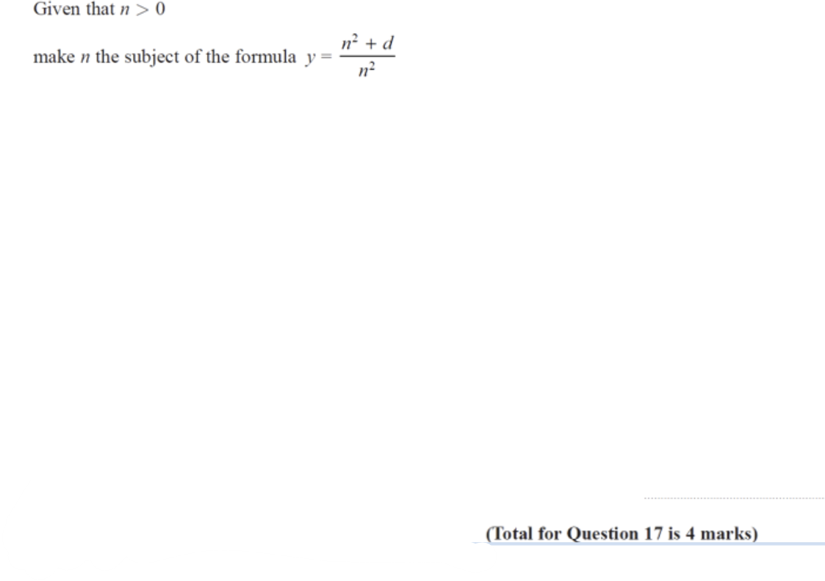
Properties of Numbers (92.3%)
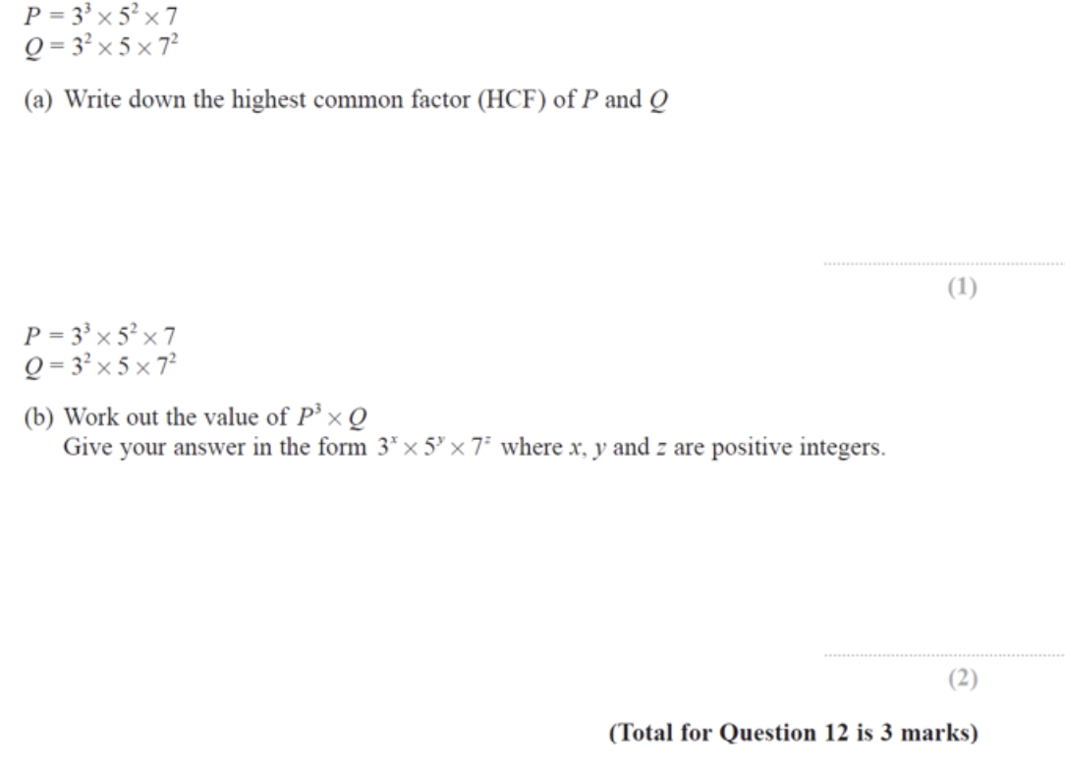
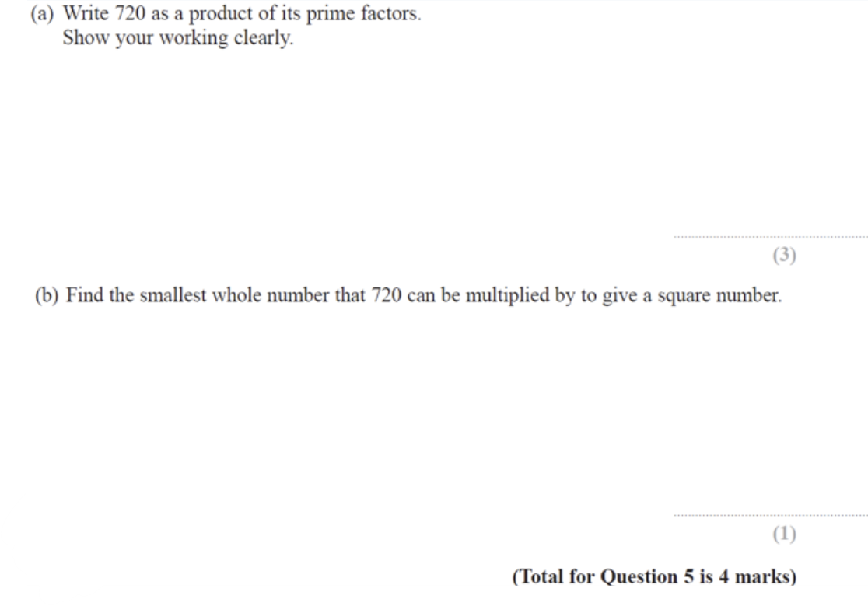

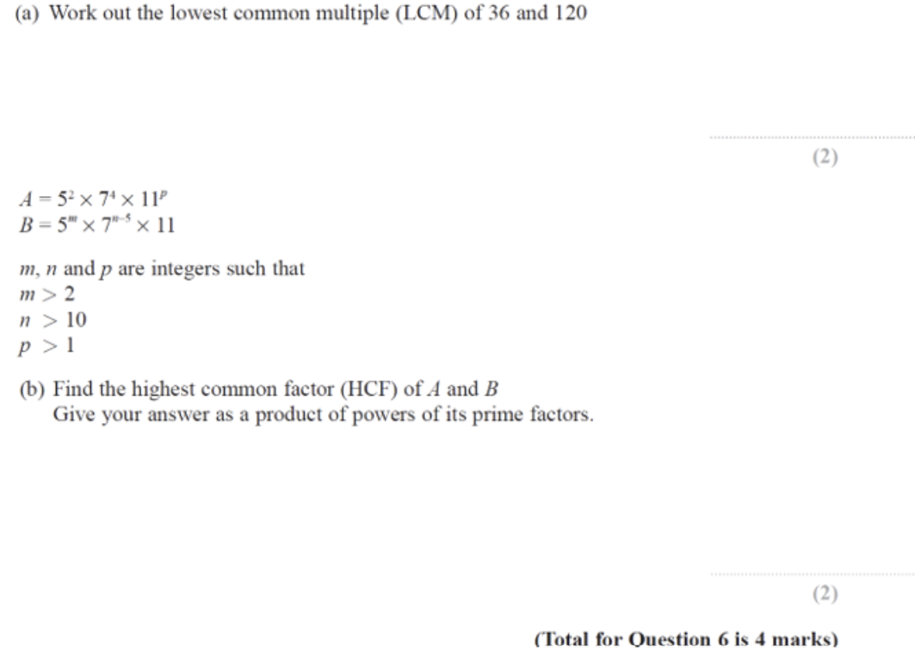

Circle Theorems – Angles (92.3%)
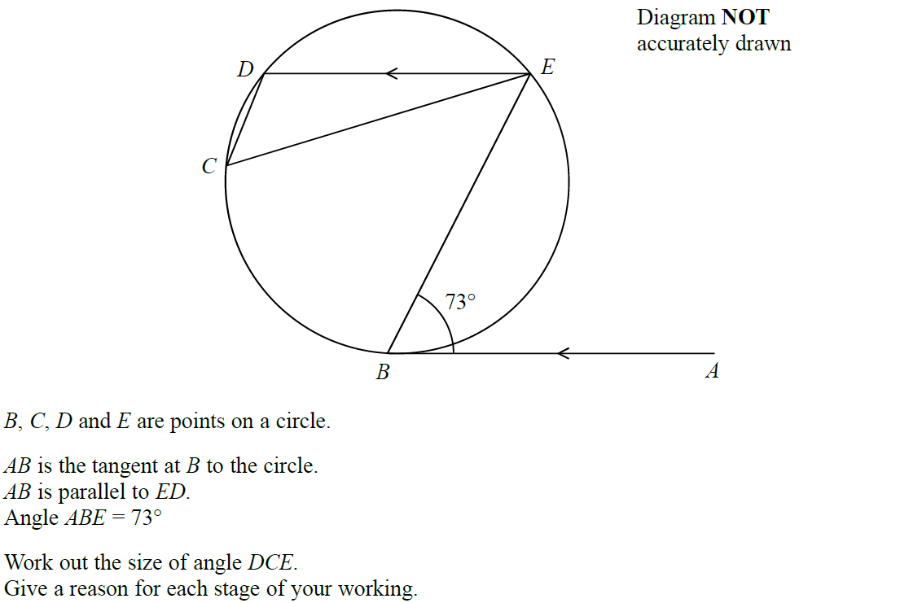

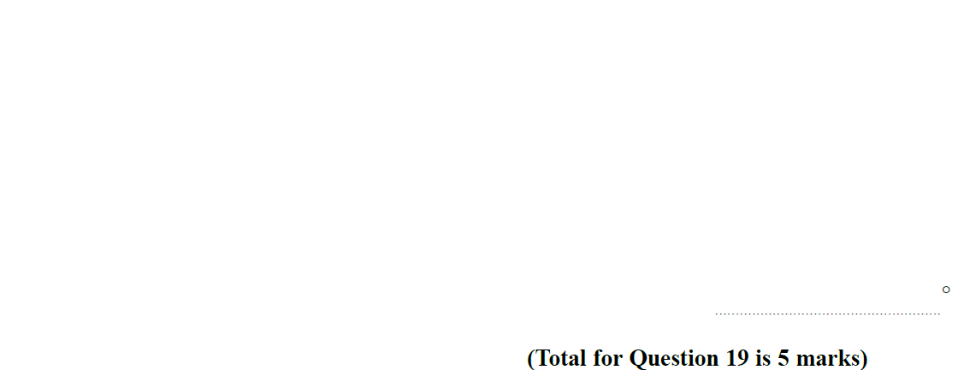
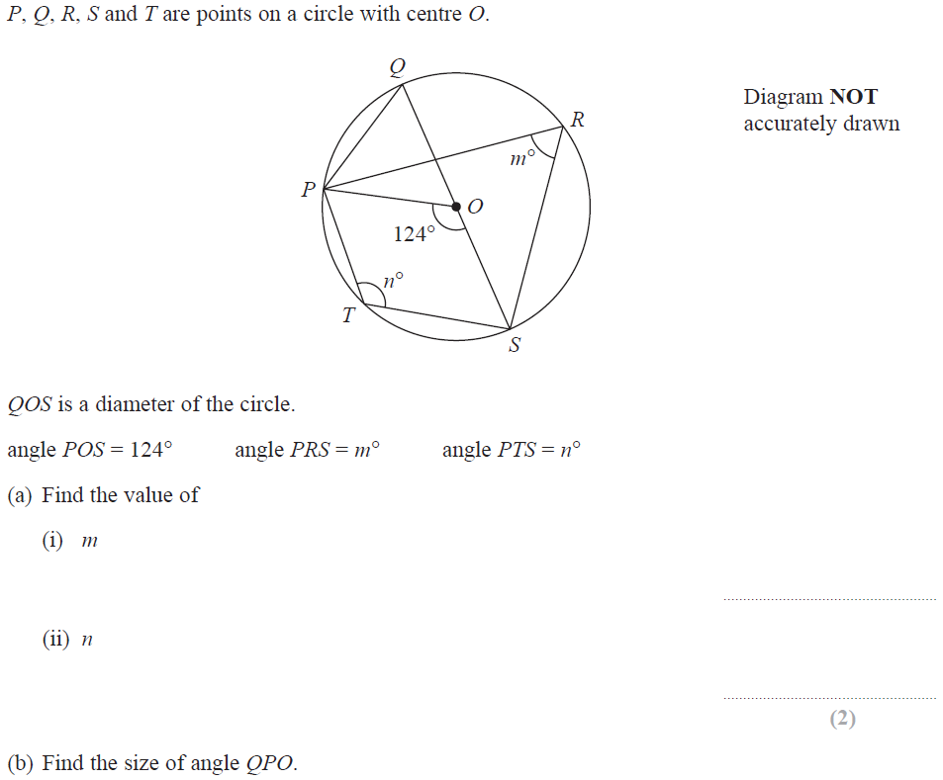

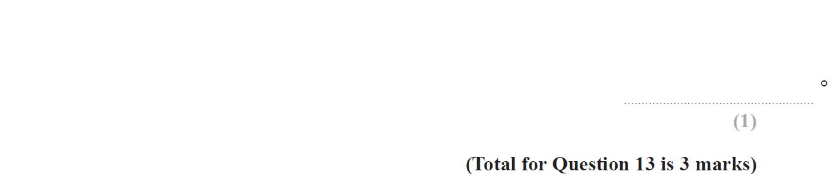
Linear Simultaneous Equations (88.5%)
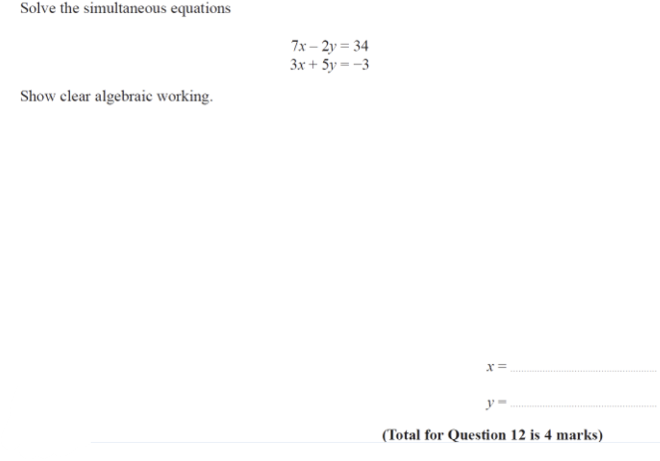
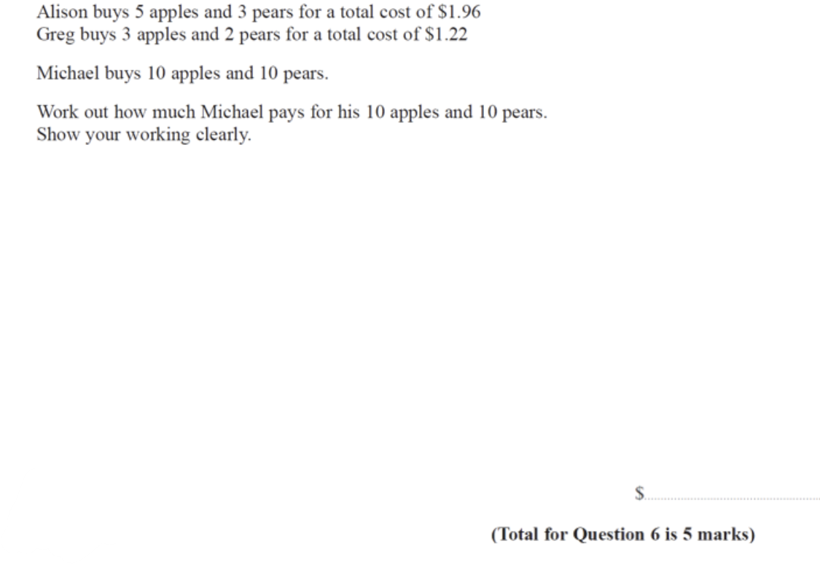

Compound Measures (88.5%)
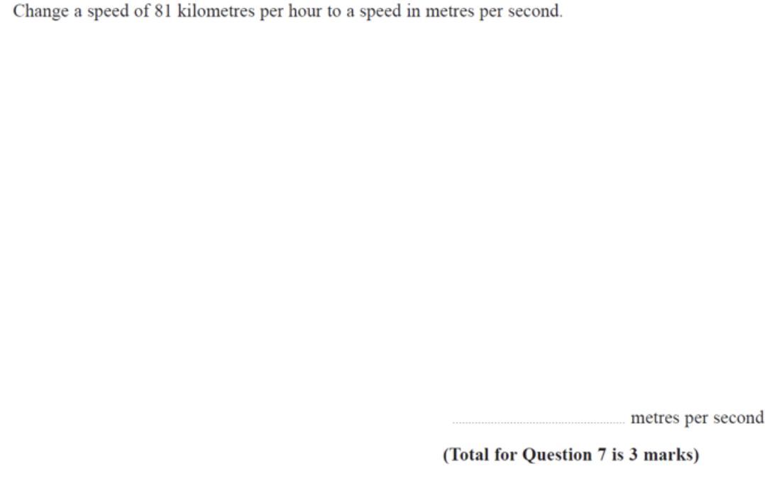
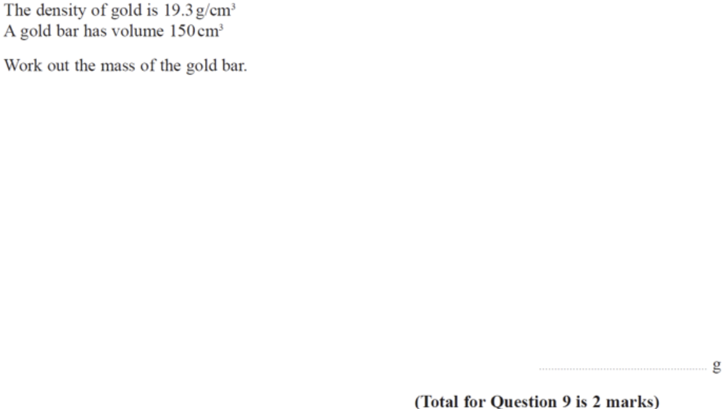

Sets – Venn (88.5%)
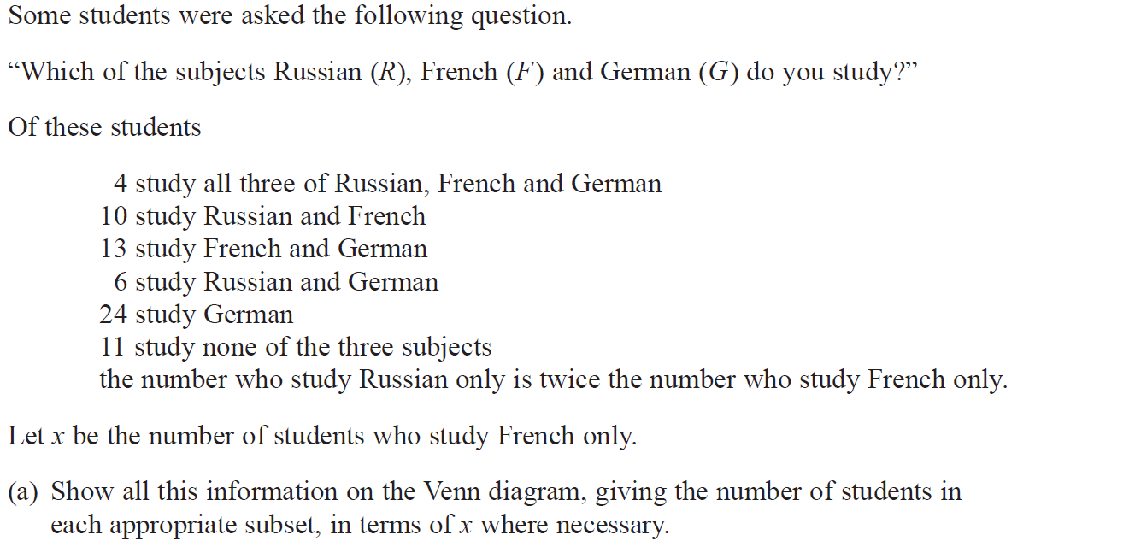
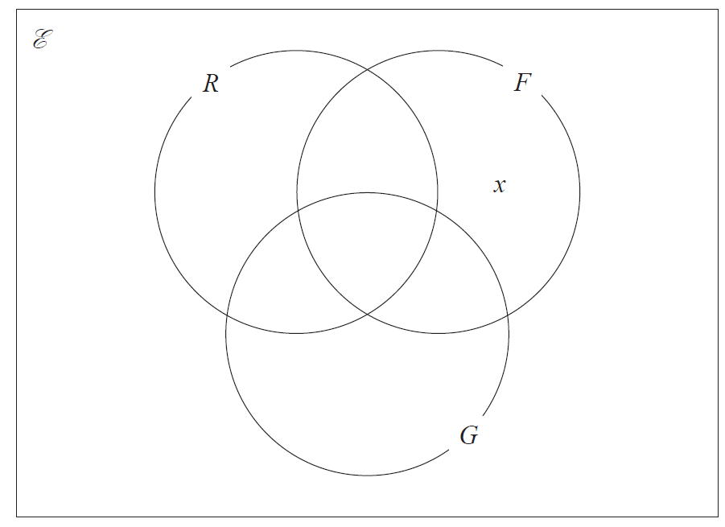
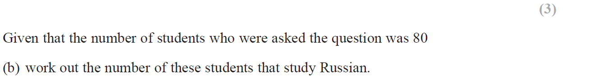

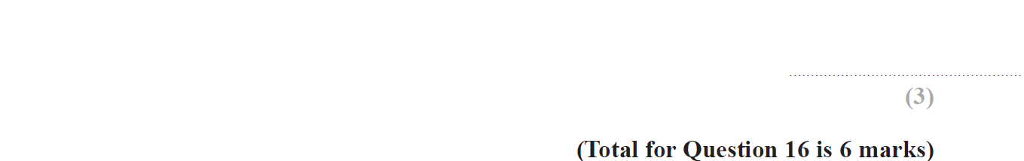
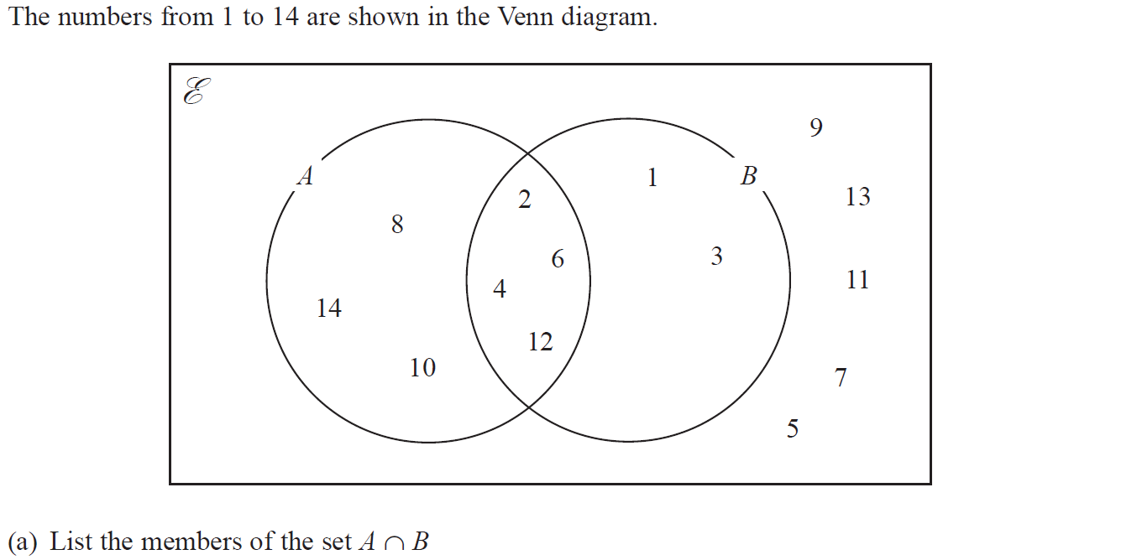
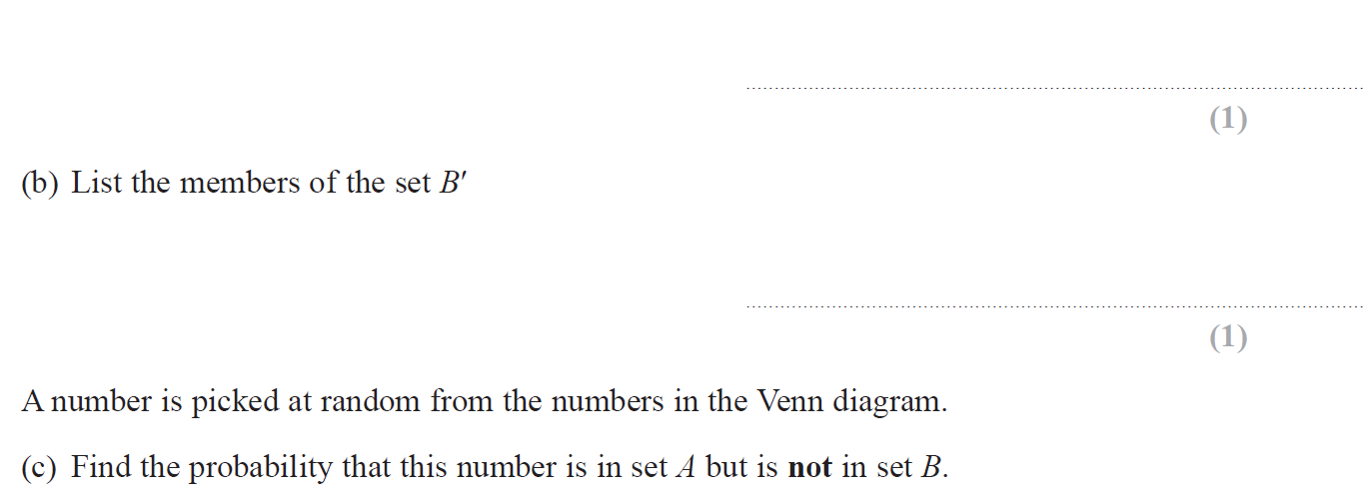
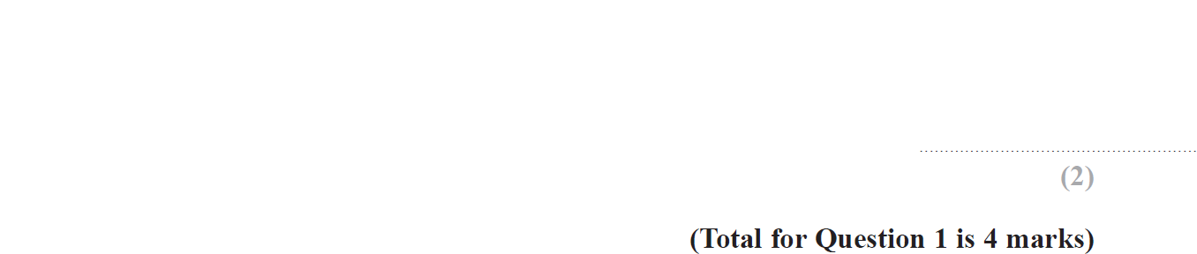

Completing the Square (84.6%)
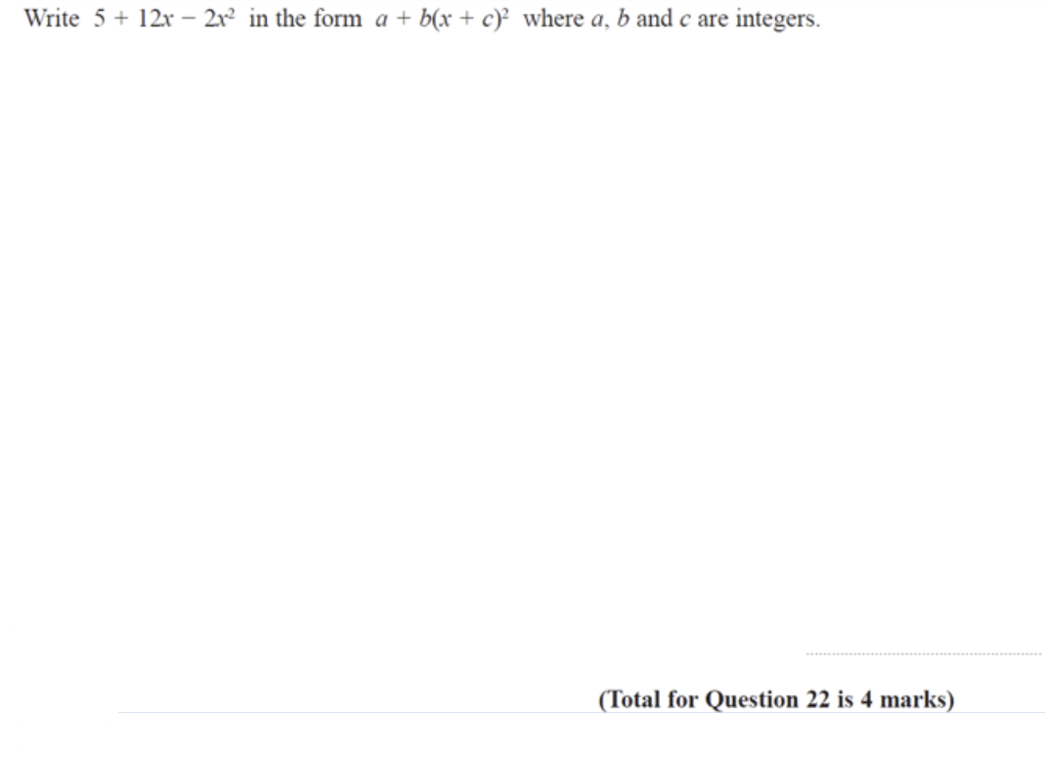
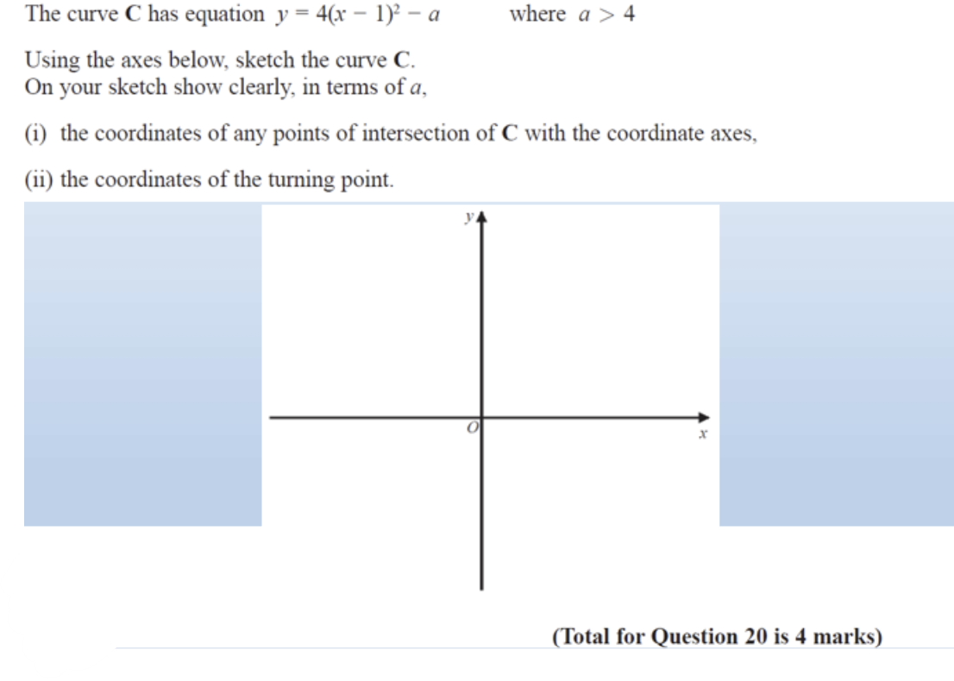
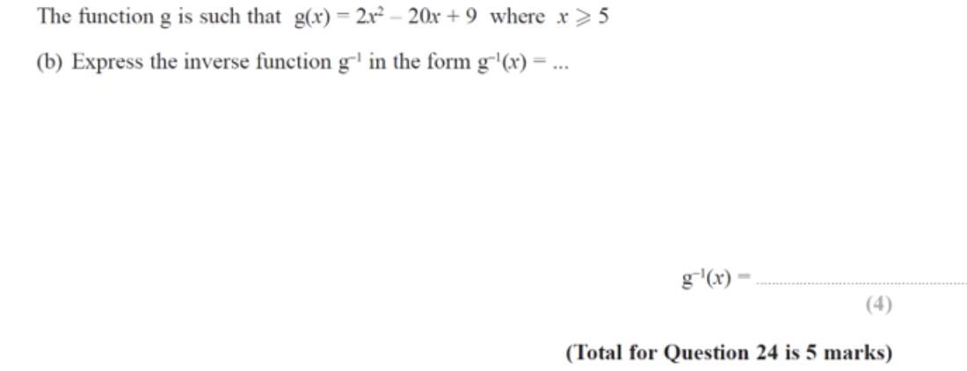
Problem Solving with Averages (84.6%)
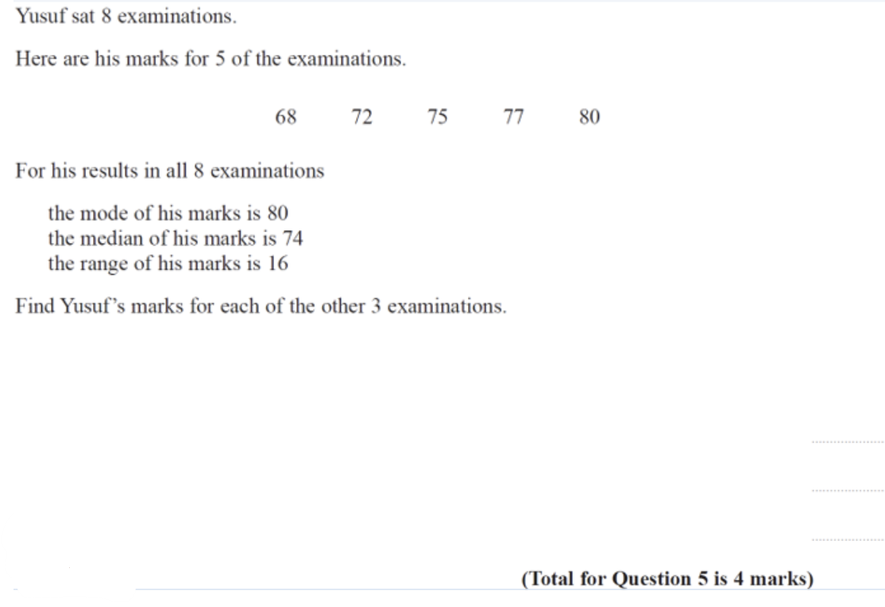
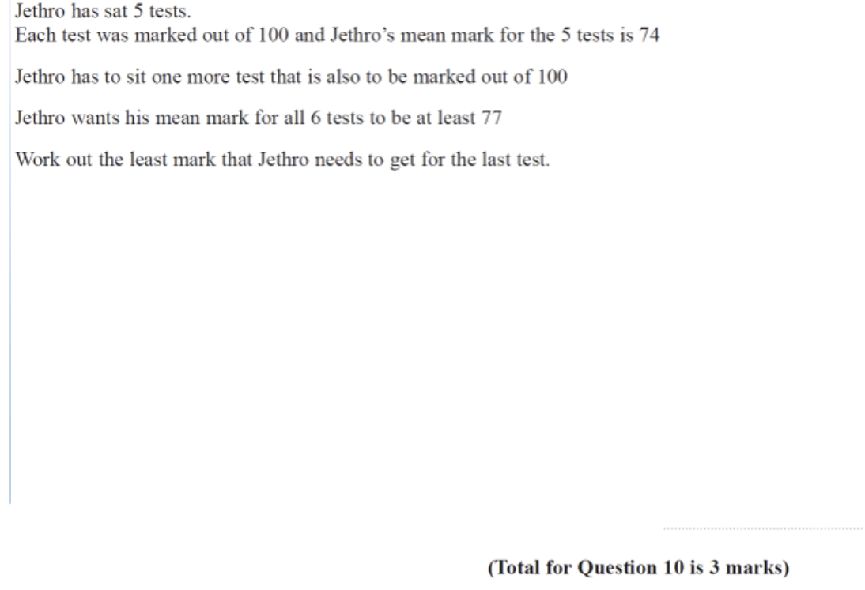
Indices – Negative and Fractional (80.8%)
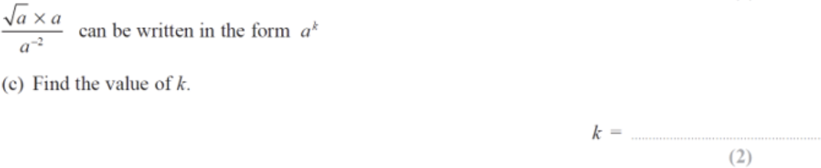
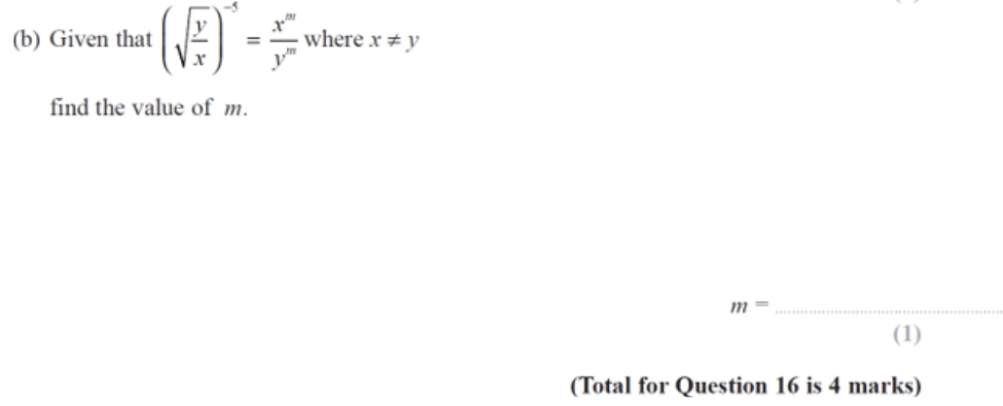

Ratio (80.8%)
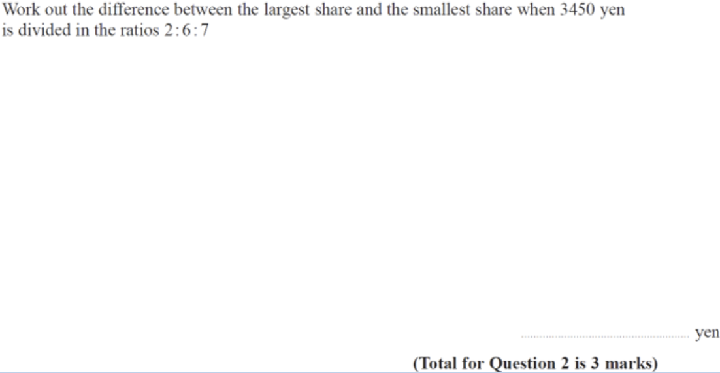

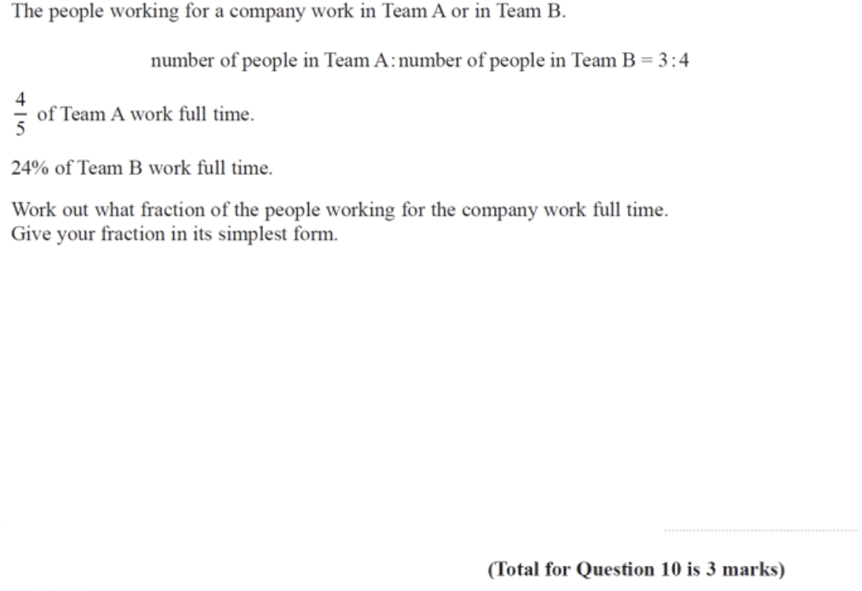

Very Likely to Likely (80%-60%)
Inequalities (76.9%)
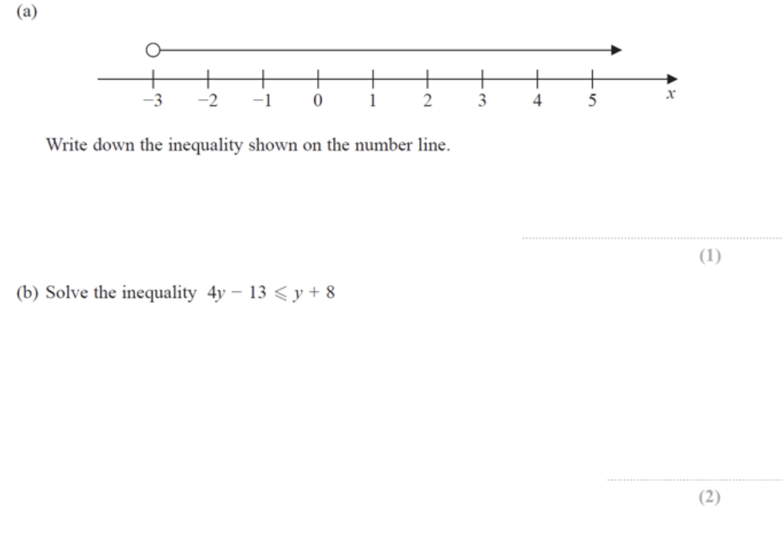

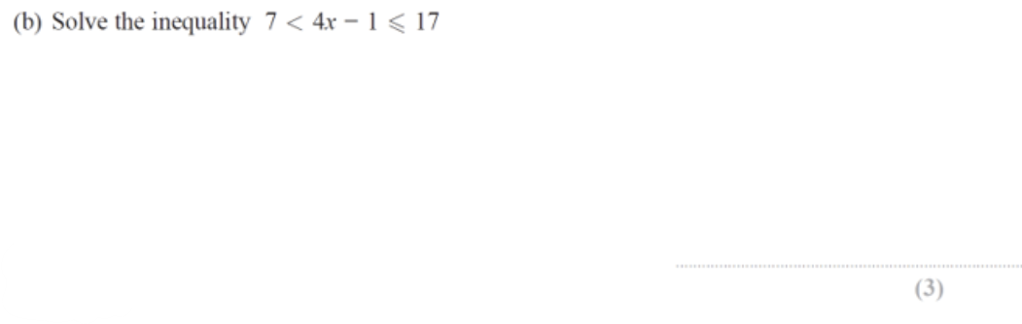

3D Trigonometry/ Pythagoras (76.9%)
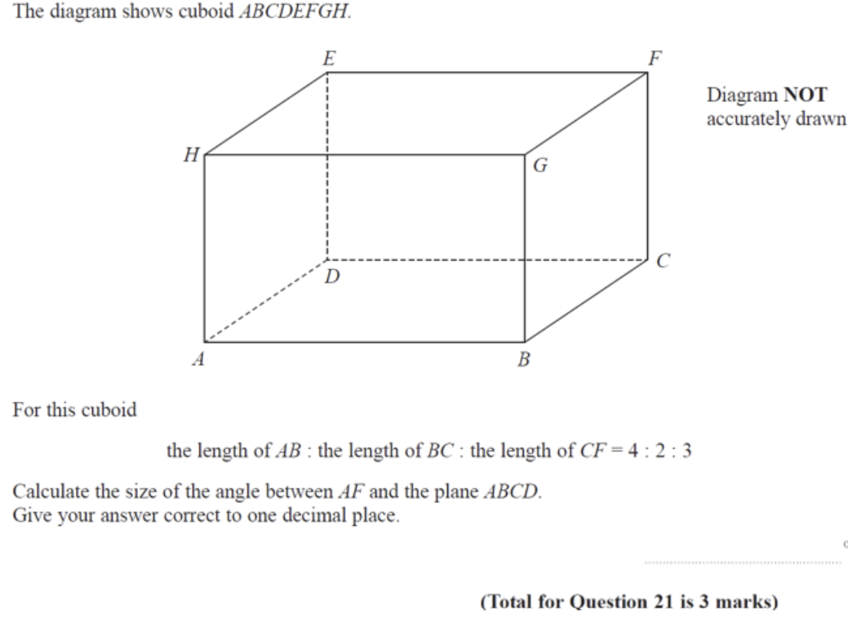

Basic Probability (76.9%)
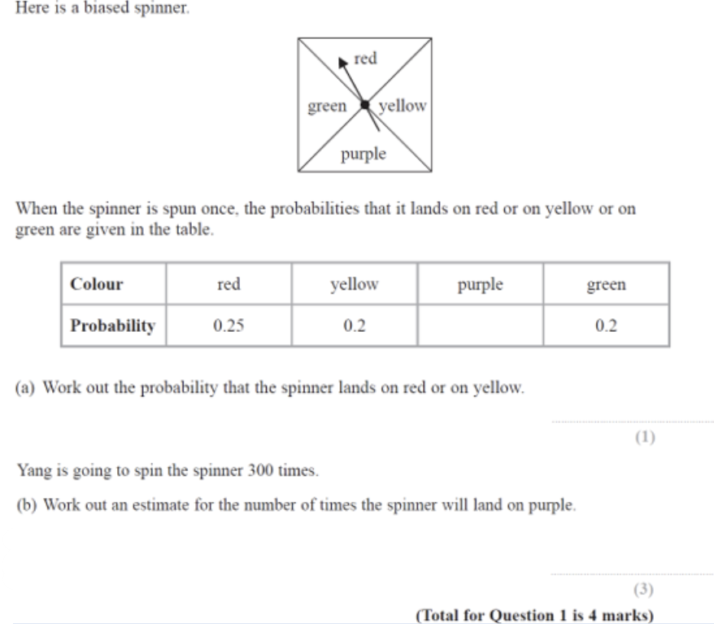
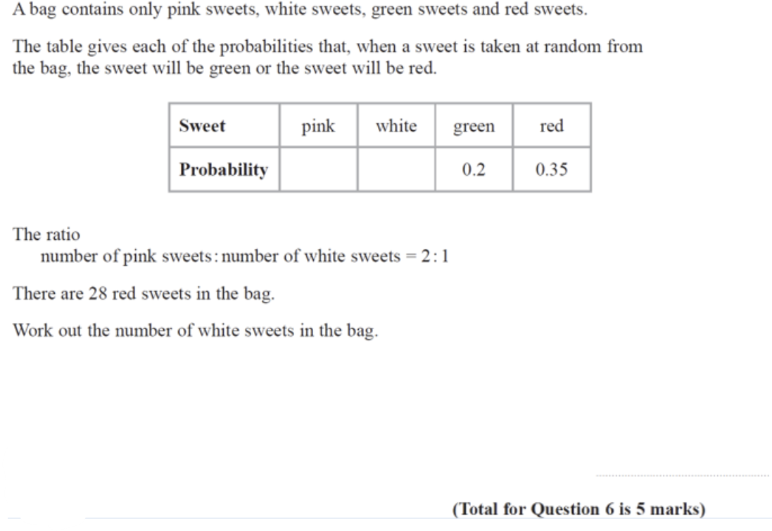
Linear Graphs – no Perpendicular Element (73.1%)
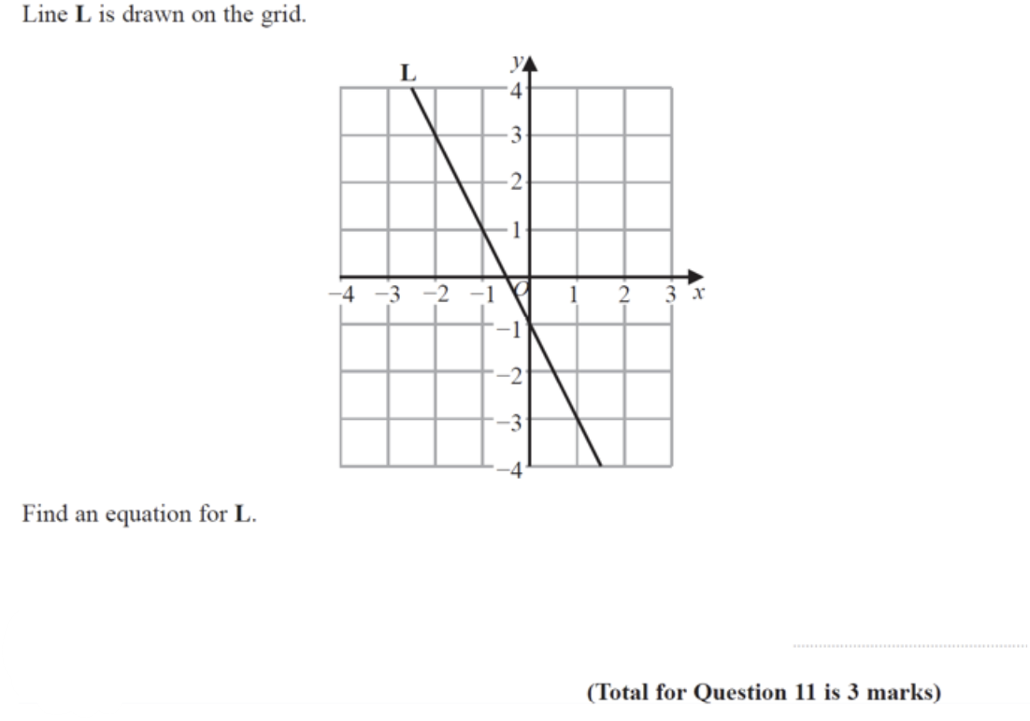
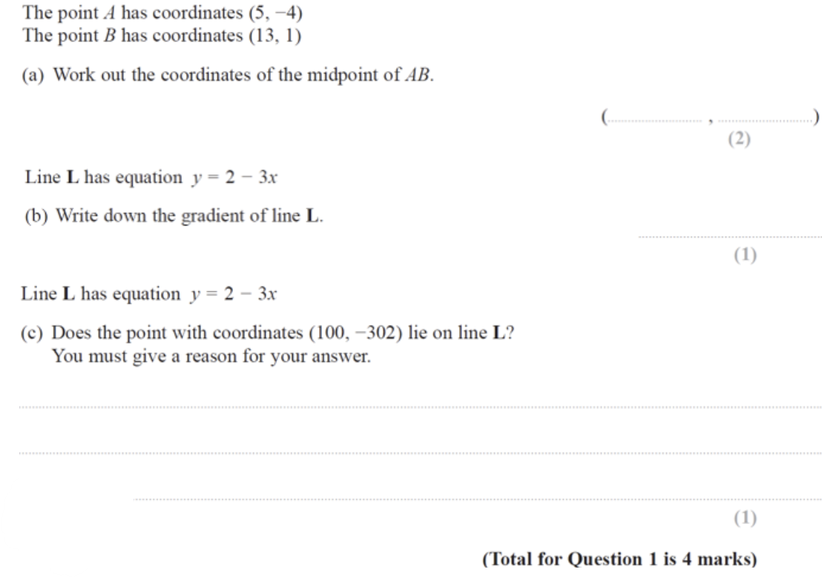
*also consider Q’s asking for lengths of line segments (using Pythagoras)
Expanding Brackets (73.1%) and Expanding Triple Brackets (73.1%)
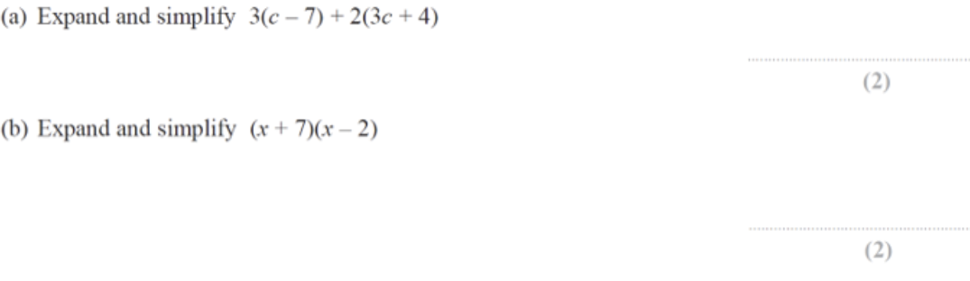

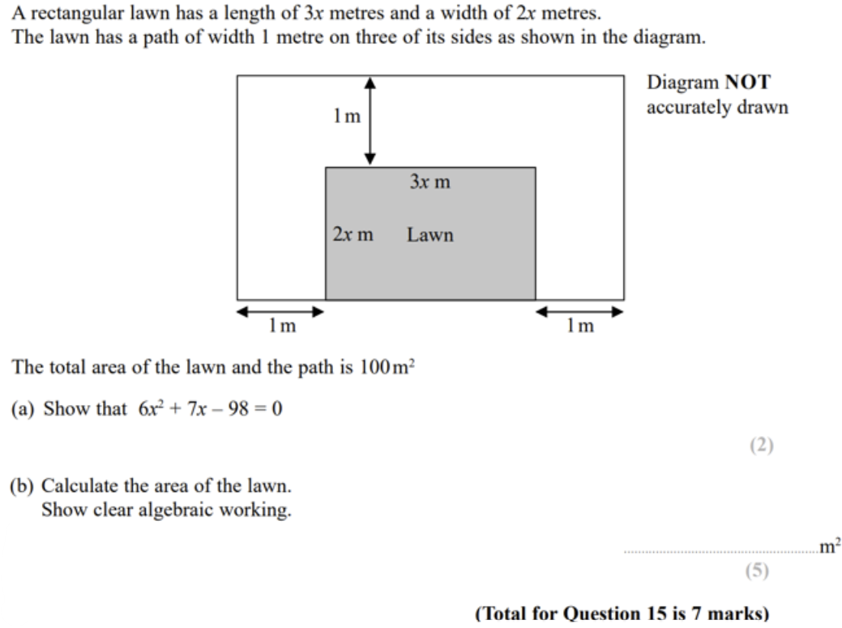

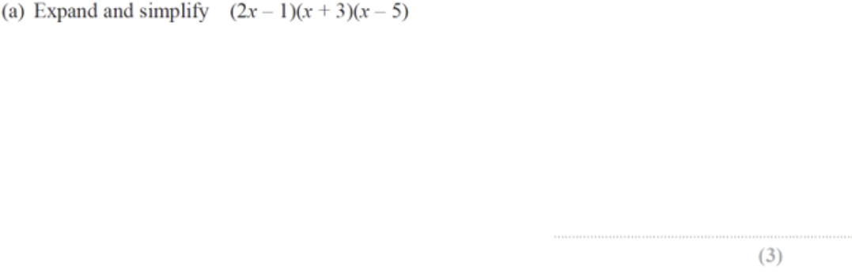
Fractions (73.1%)
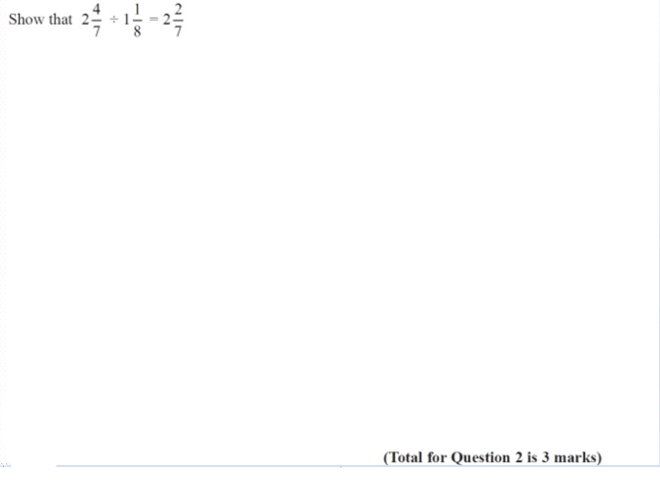
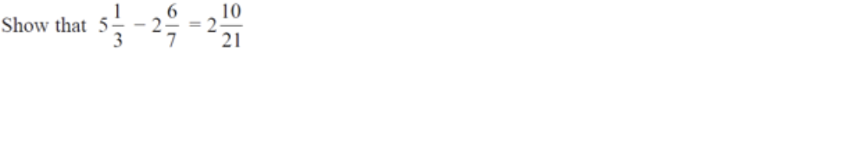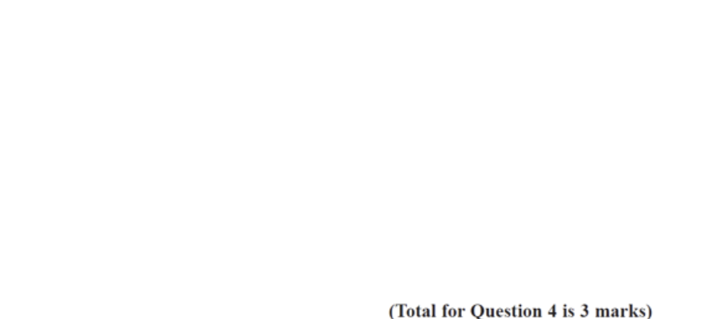
Basic Factorising (69.2%)
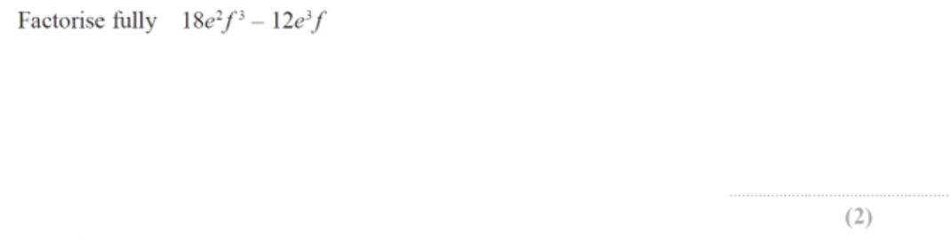
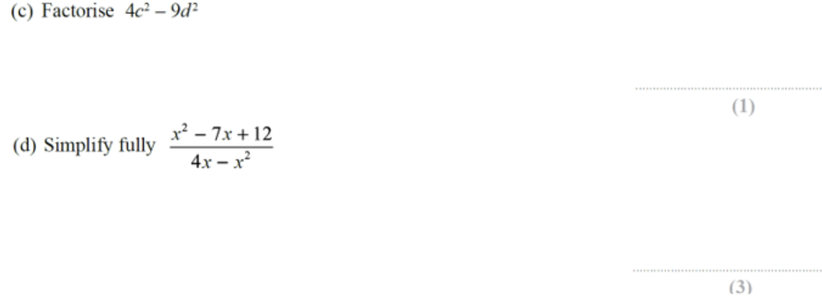
Similar shapes – Area and Volume (69.2%)
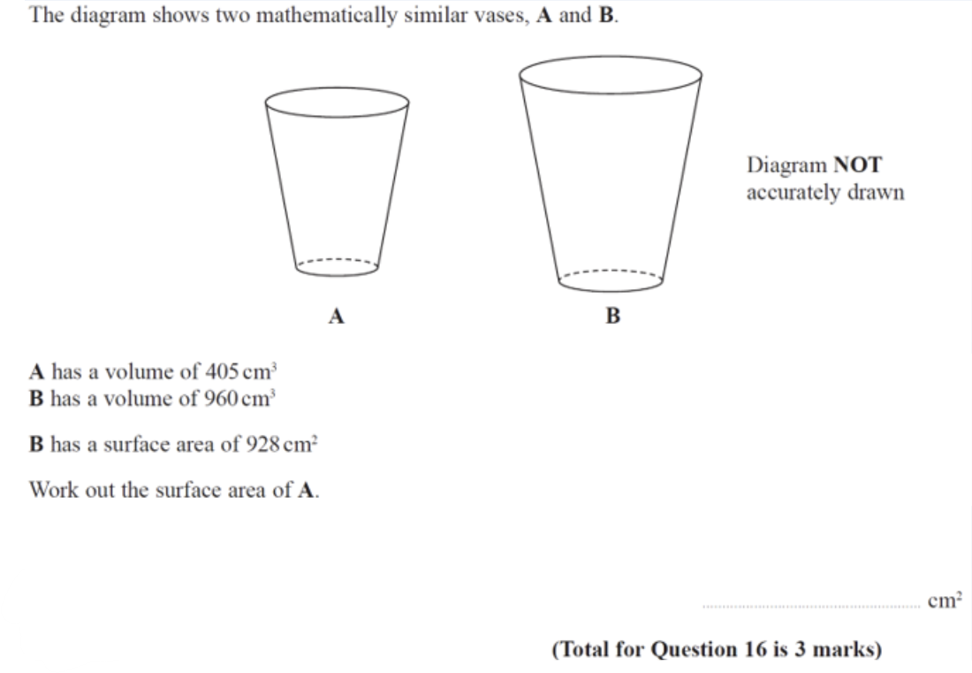

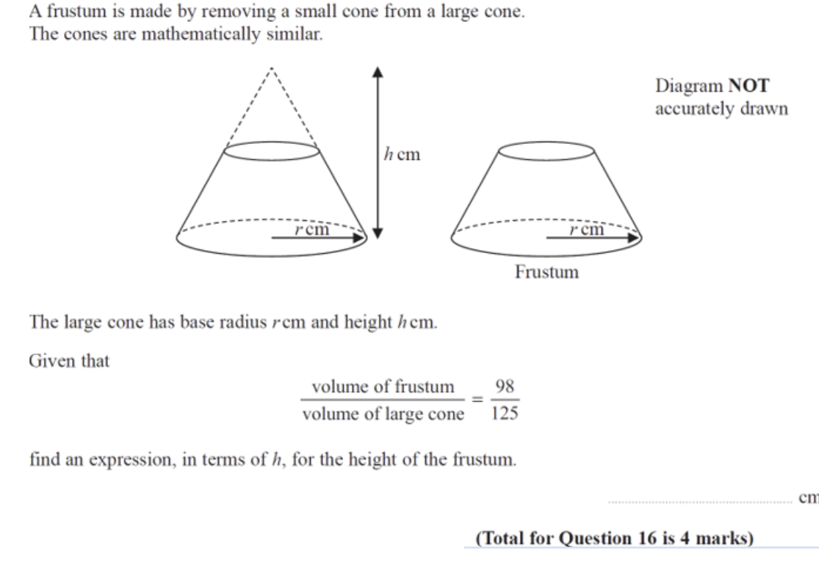

Volume & Surface Area (69.2%)
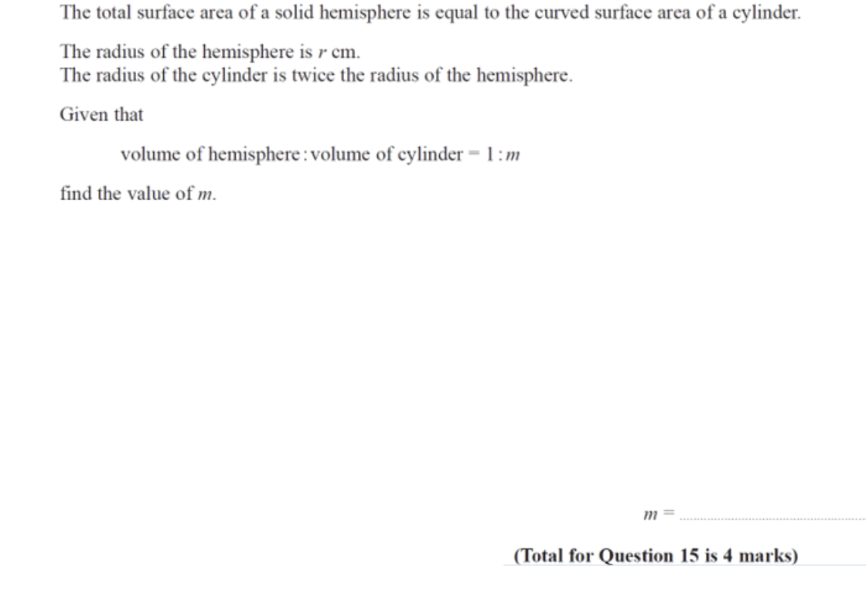

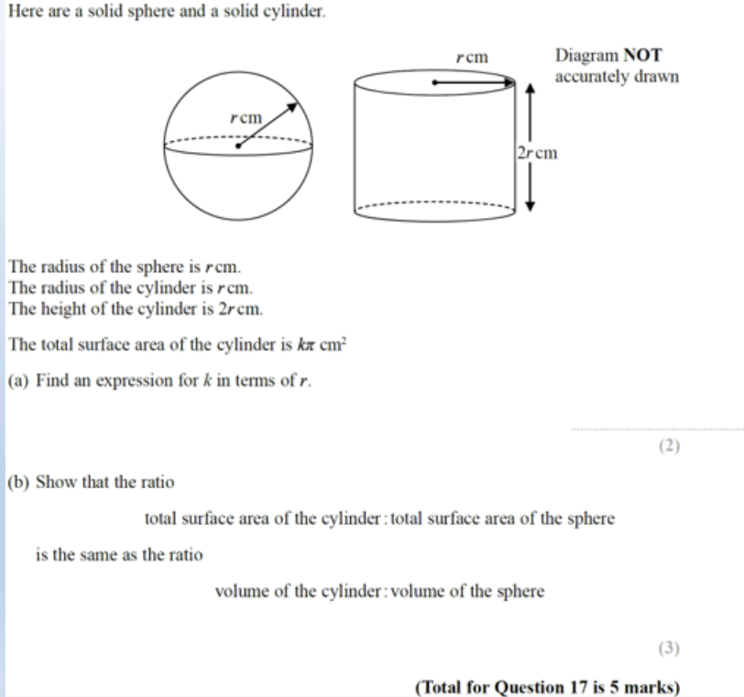

*don’t forget about cones too
Circles and Sectors (68.2%) *I doubt there will be another sectors Q but maybe something like this
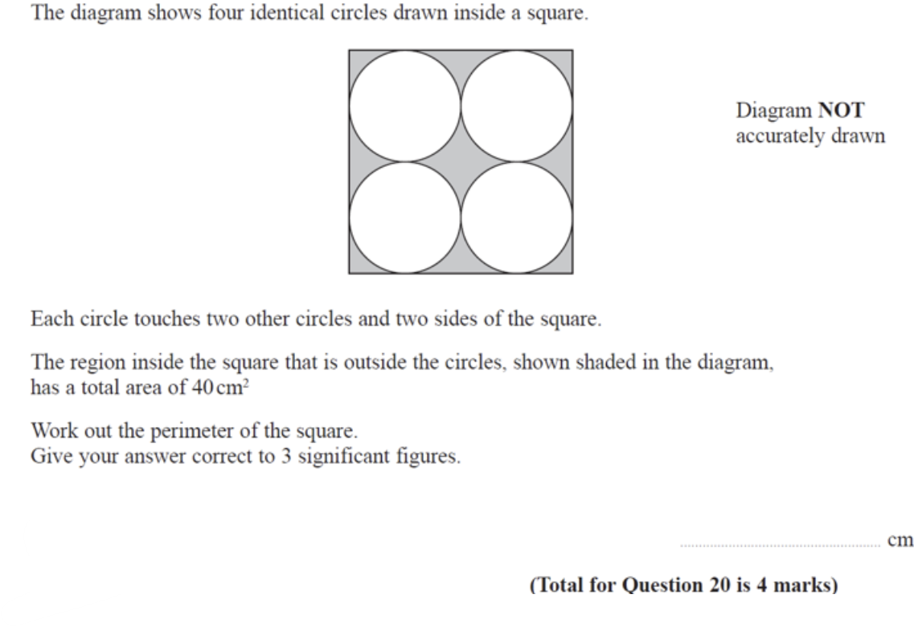

Solving Quadratics by Factorising (68%)
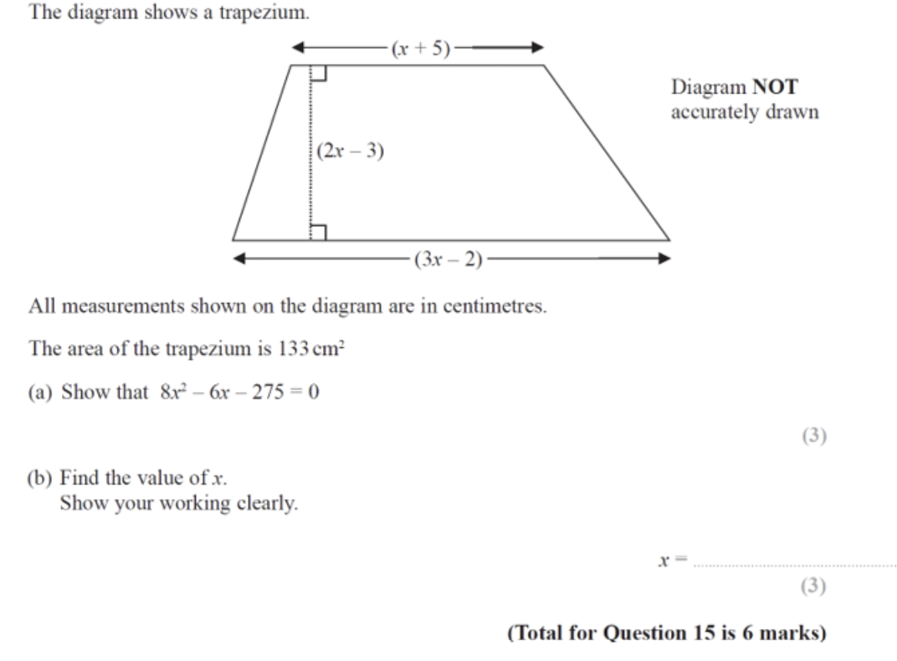

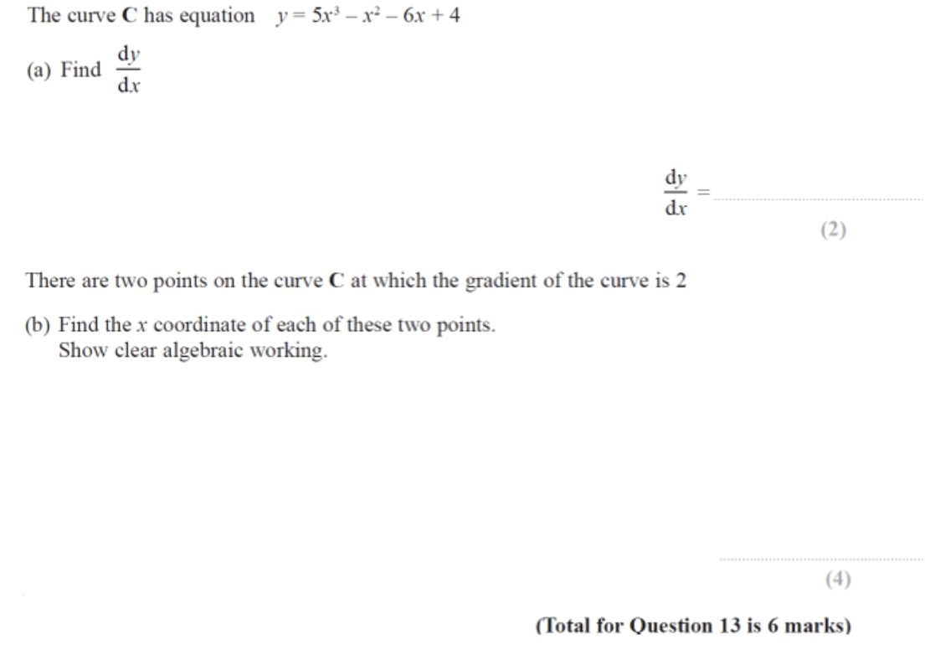

Graphical Inequalities (65.4%) *with linear graphs only coming up as a harder perpendicular question, I feel this has a good chance
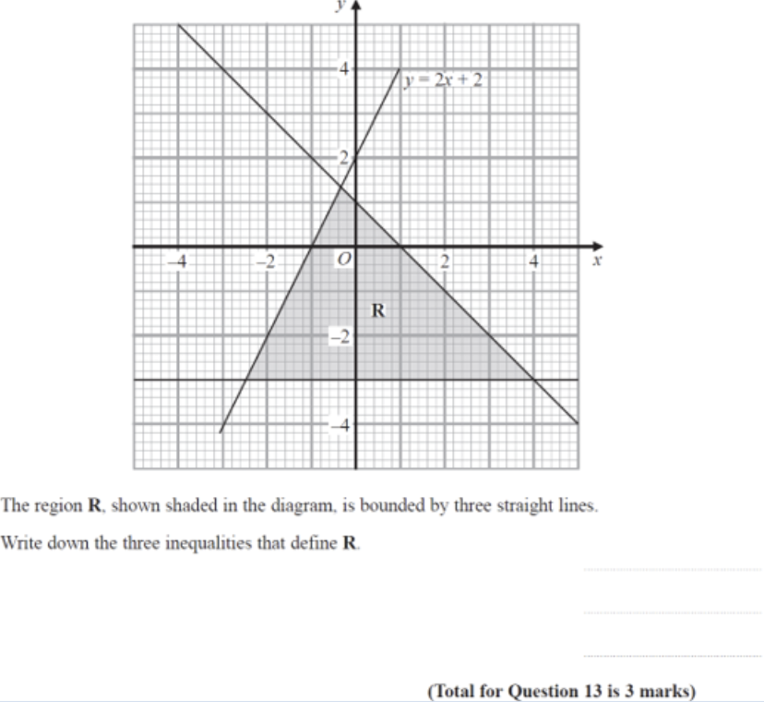
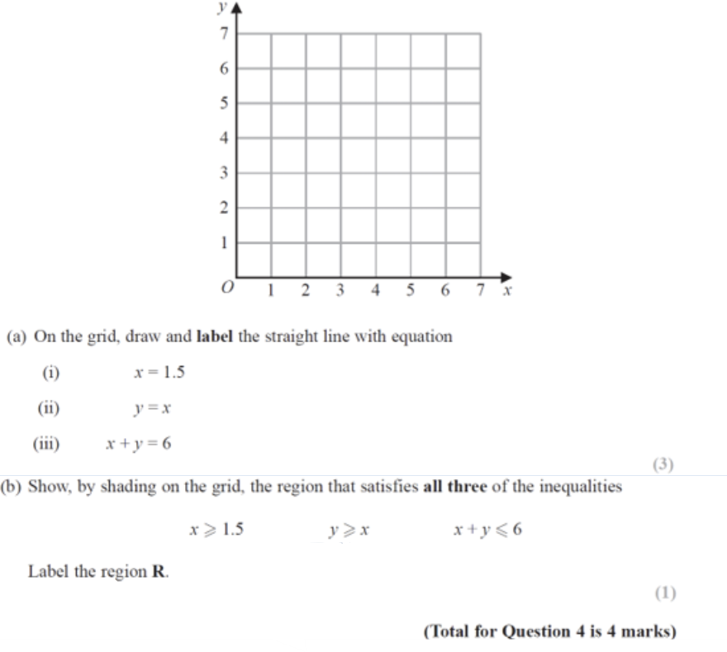
Indices – Basic (61.5%) and rewriting bases (61.5%)
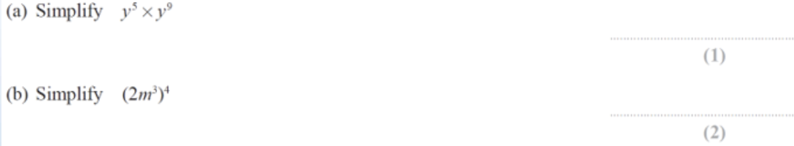
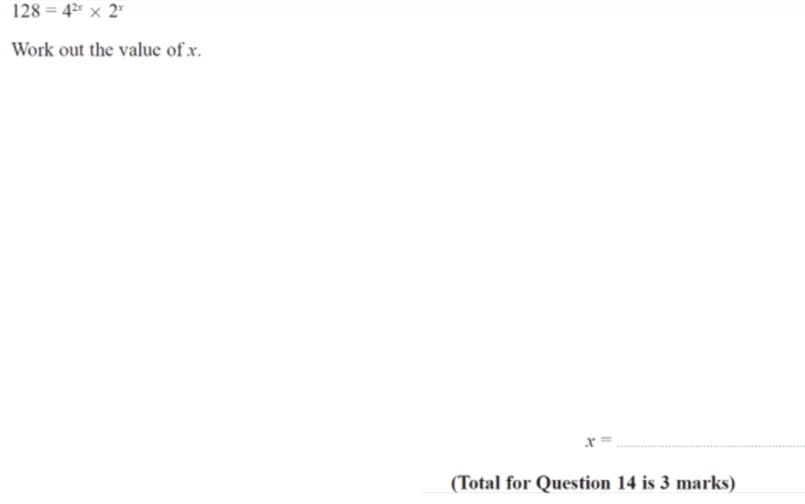
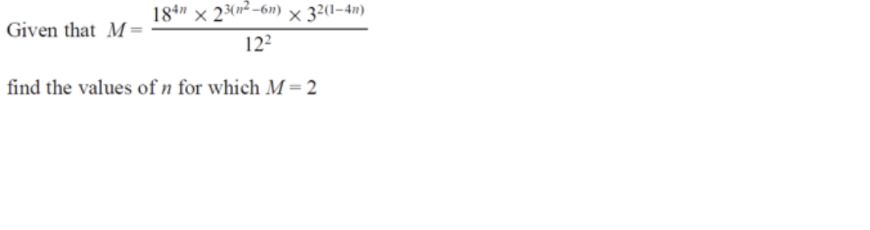

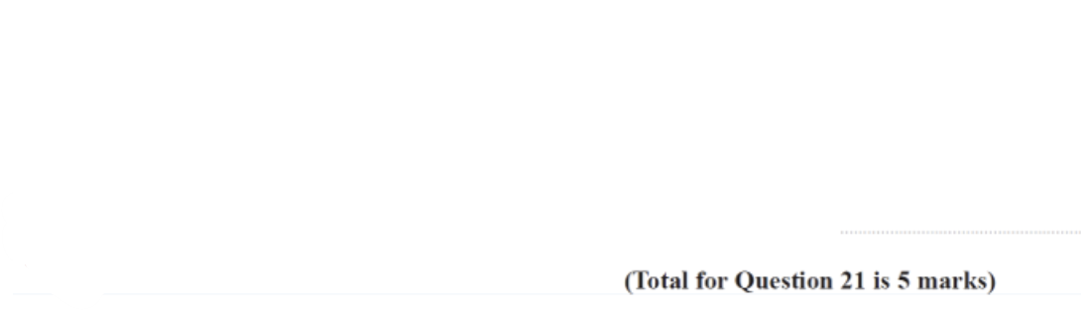
Likely to Unlikely: 60%-40%
Basic Trigonometry (57.7%)
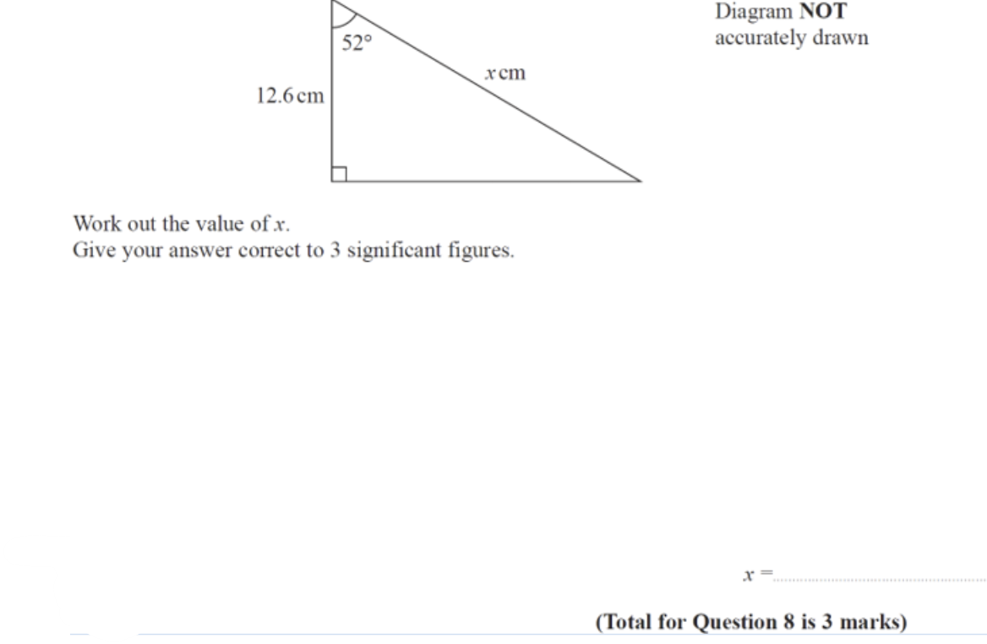
Advanced Trigonometry (56%) *Probably Area formula if it does come up again
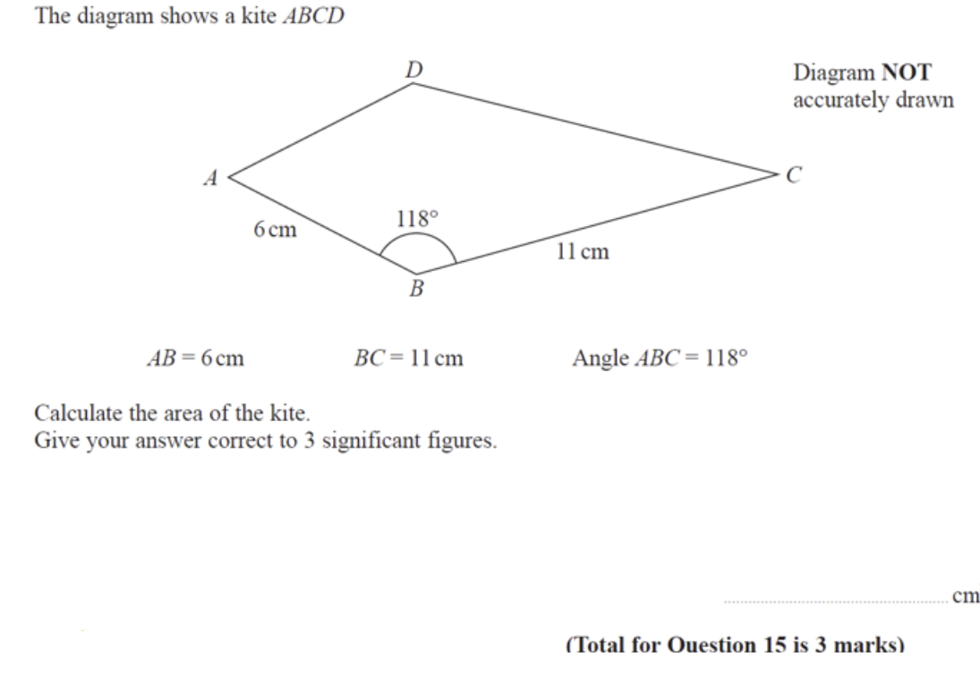
Recurring Decimals to Fractions (53.8%)
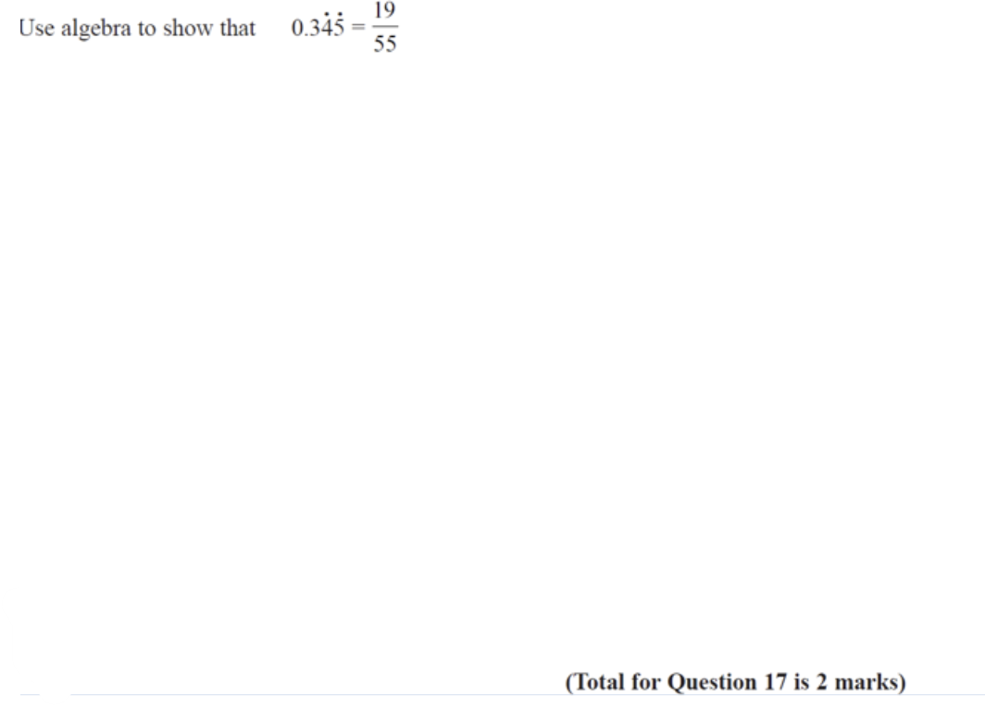
IQR from Discrete Data (53.8%)
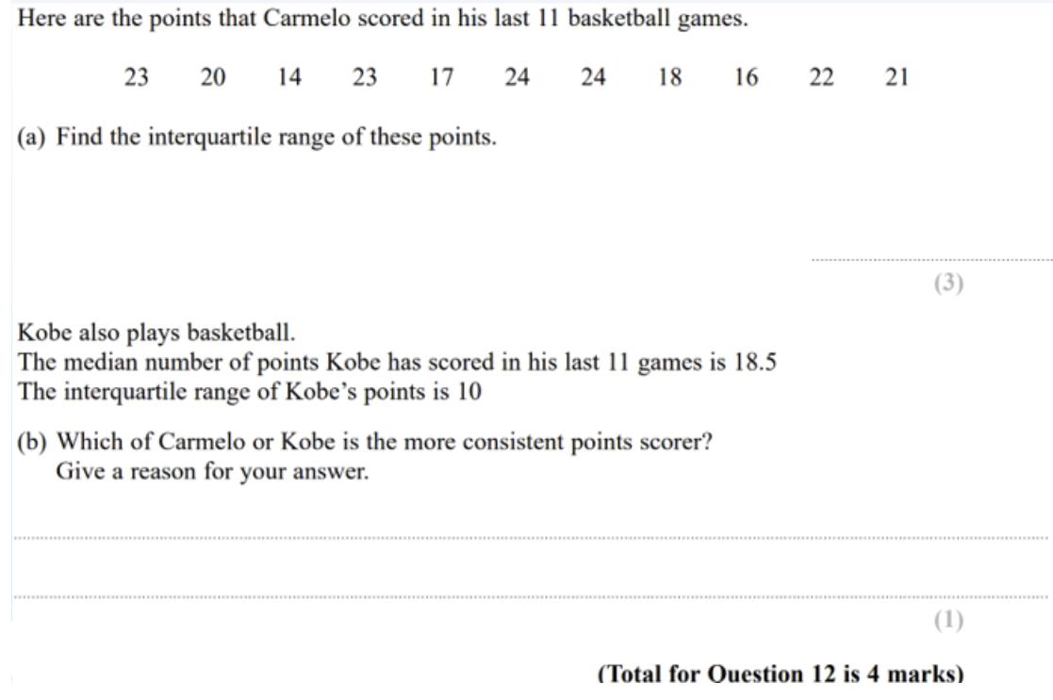
Sets – Notation (53.8%)
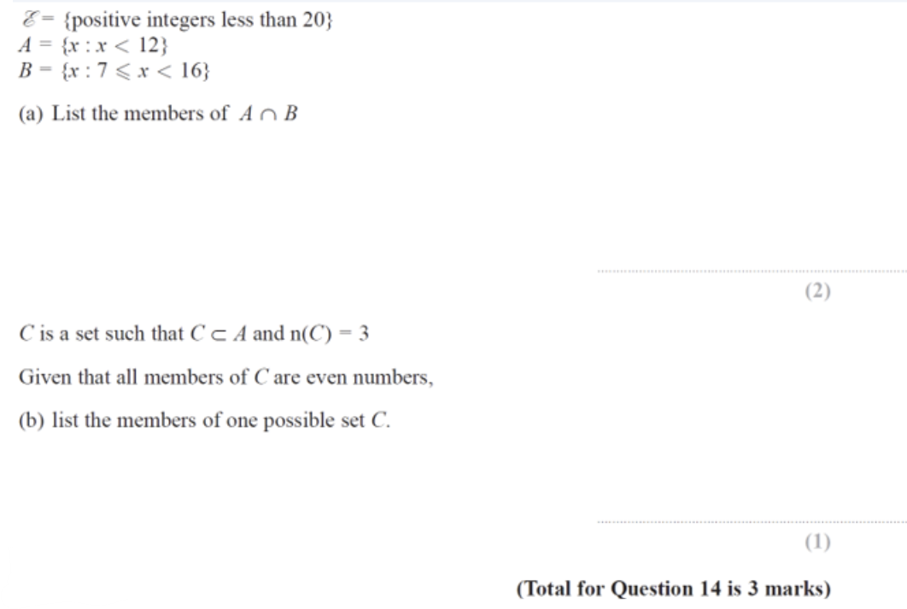
Quadratic Inequalities (50%)
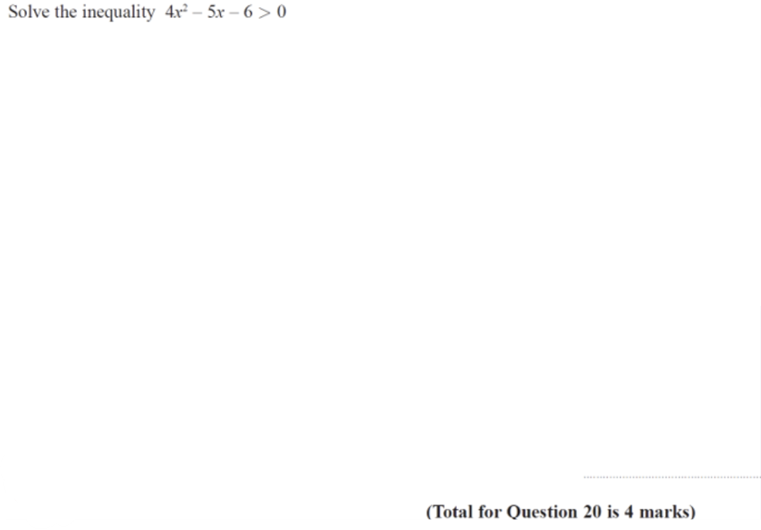
Algebraic Fractions (50%)
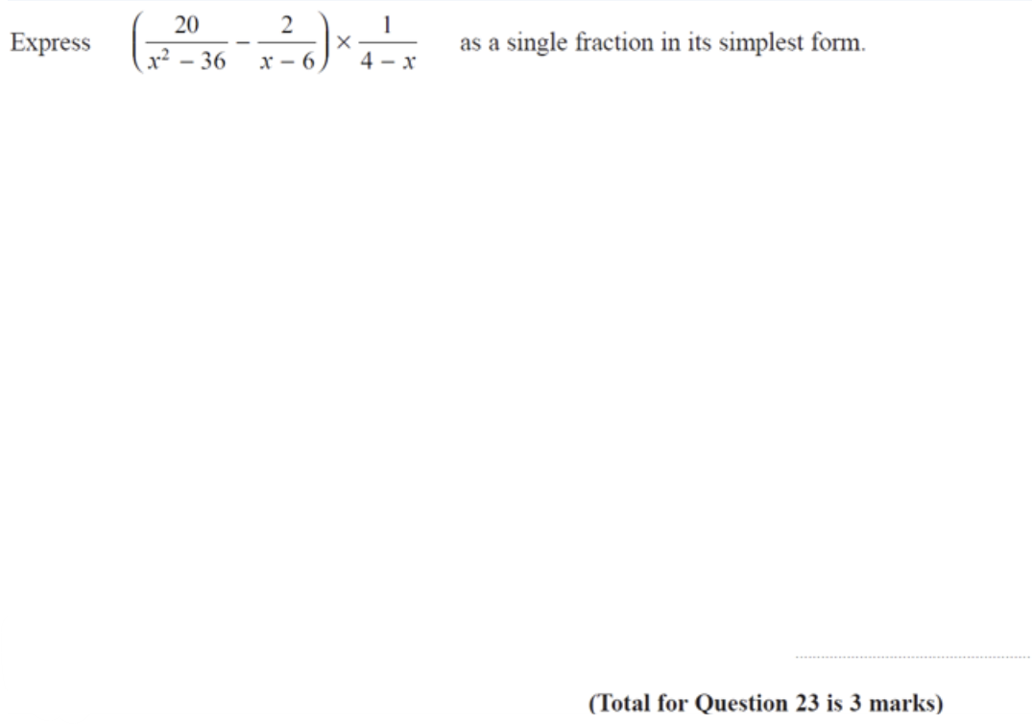
Proof (42.3%)
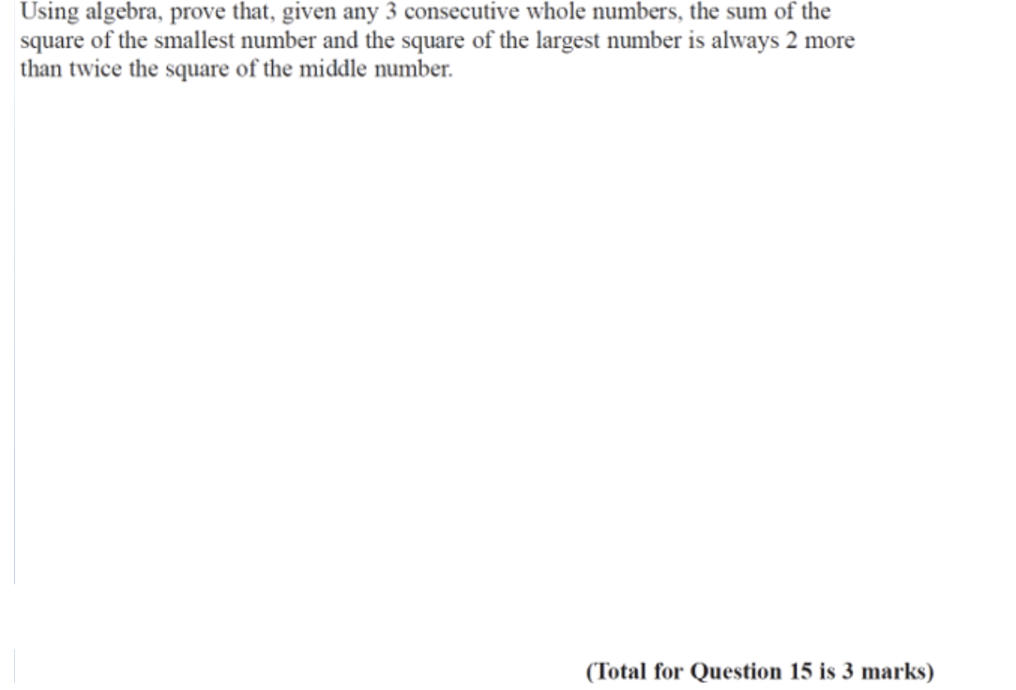
Percentage Change (41.7%)
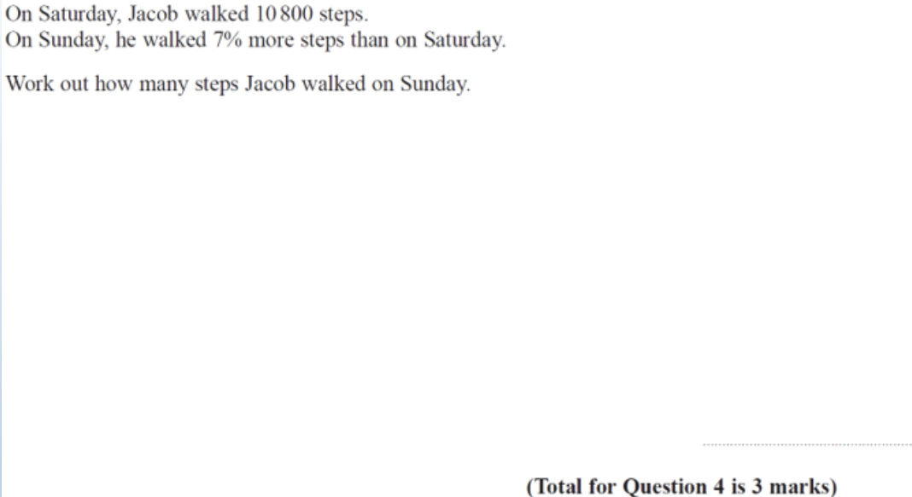

Unlikely to Very Unlikely: 40%-20%
Constructions (38.5%)
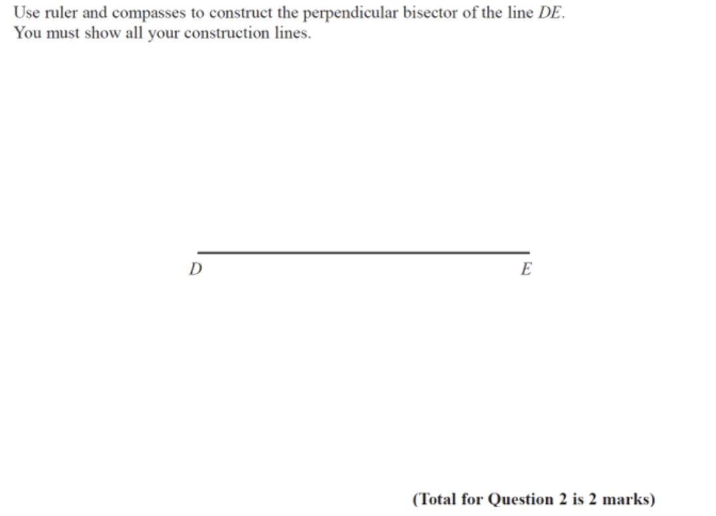
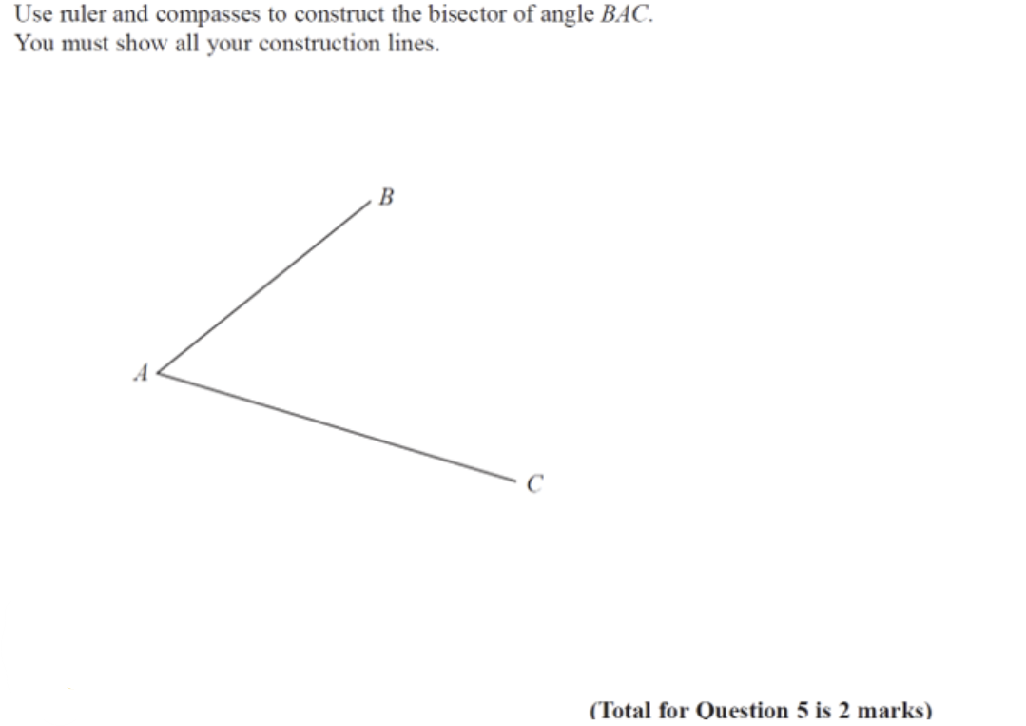
Transformations of Shapes (38.5%)
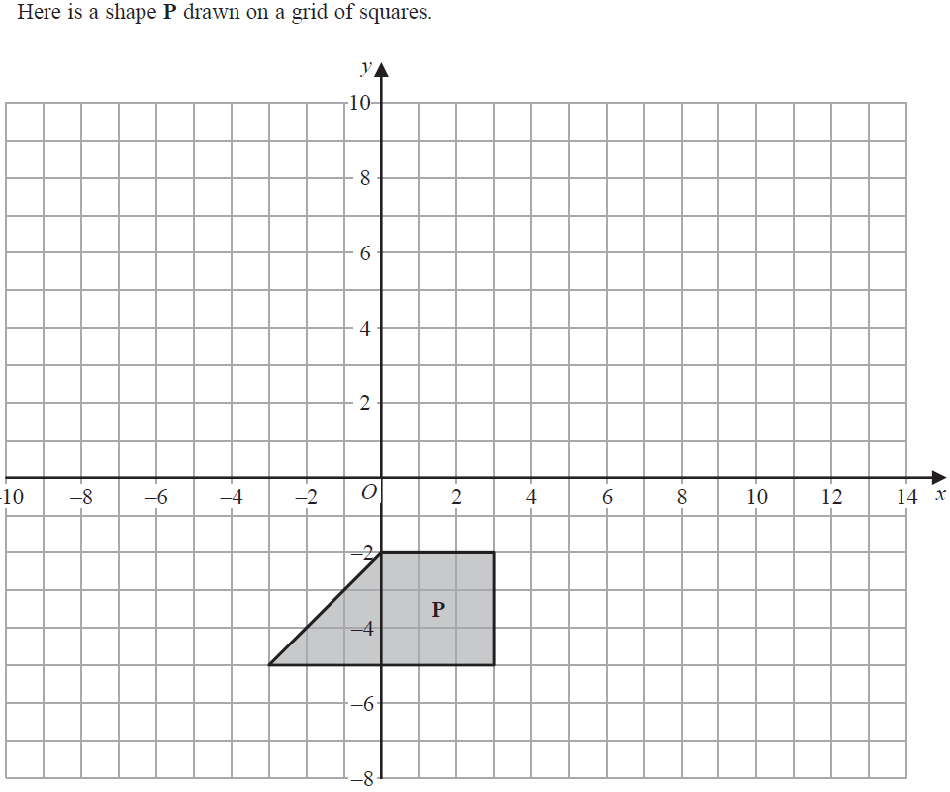
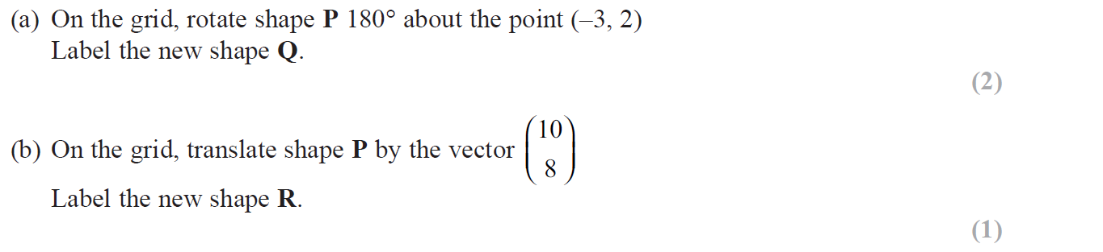
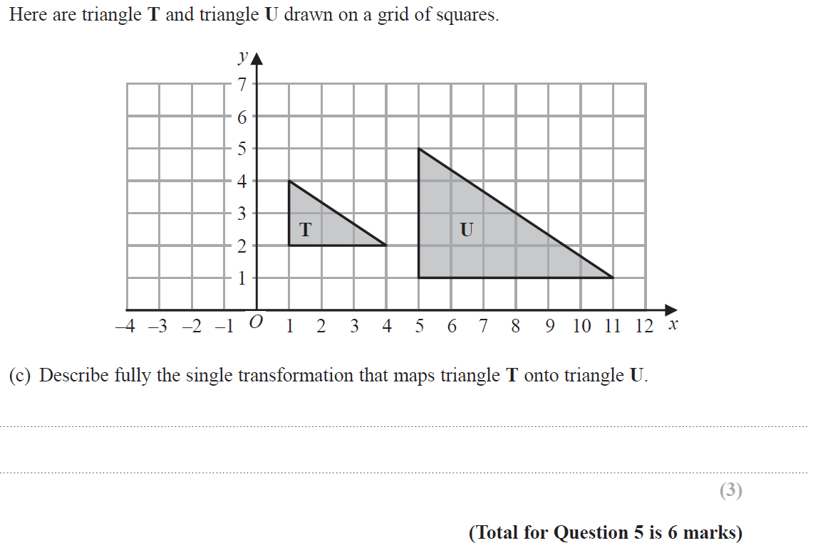
Similar Shapes – Linear (38.5%)
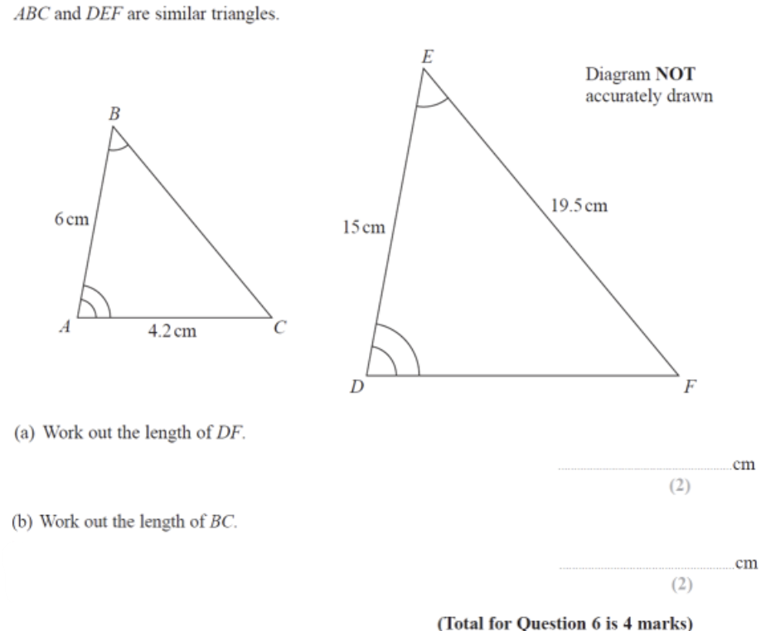
Prisms and Cylinders (37.5%)
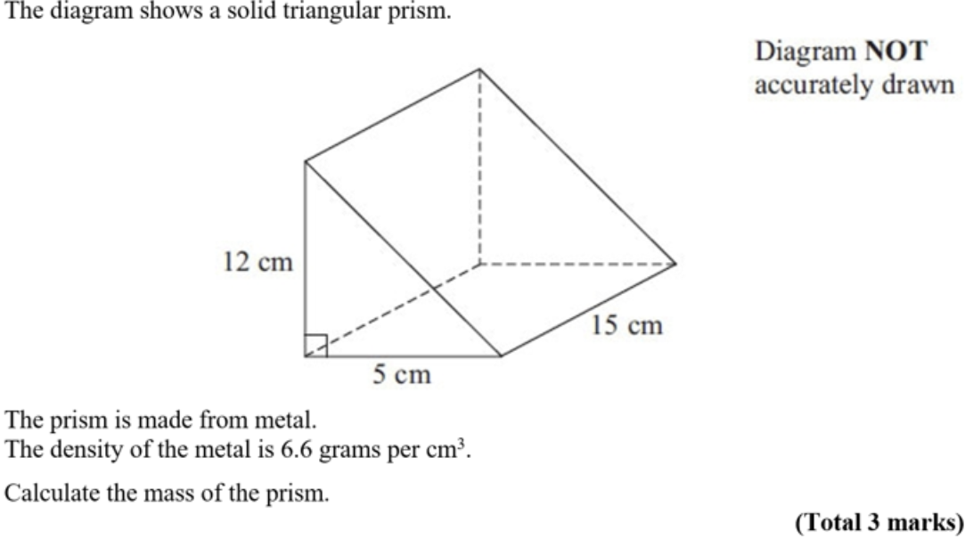
Solving Simple Equations (35%)
Angles in Parallel Lines (34.6%)
Arithmetic Sequences and Series (30.8%) *if this does come up again, it will probably be a fairly straightforward one at the start
Factorising Quadratics (27.3%)
Standard Form (26.9%)
Circle Theorems – Intersecting Chords (26.9%)
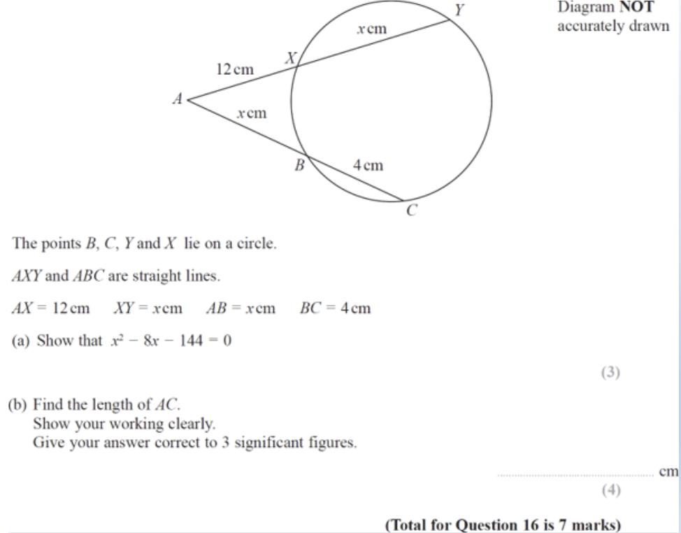

Area and Perimeter (25%) *Maybe with a circle?
Multiple event scenarios (23.8%) *Possibly algebraic fractions involved
Drawing and Using Graphs (23.5%) *Possibly a graphs to equation match up
Graphical Transformations (20.8%) *Not in function format, but possibly a graph that has already been drawn and in equation form – maybe completing the square form or a trig graph.
Angles in Polygons (20%)

Unlikely to Impossible – 20%-0% *I am only going to mention things I feel worthwhile here
Compound Percentages (19.2%) *As the Q in the first paper combined different changes and reverse percentages there may be a more standard question here that you can use powers on
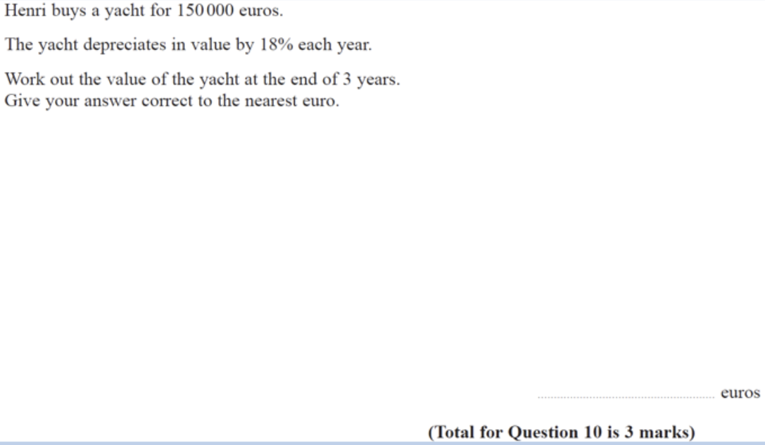

Upper and Lower Bounds (15.4%)
Functions (12%)
Quadratic Formula (11.5%)
Vectors (7.7%) *maybe a small one asking for magnitude using Pythag
Grouped Data (5.6%)
Non-Linear Simultaneous Equations (4.5%)
Surds (4.2%)
Time Series (3.8%)

Differentiation
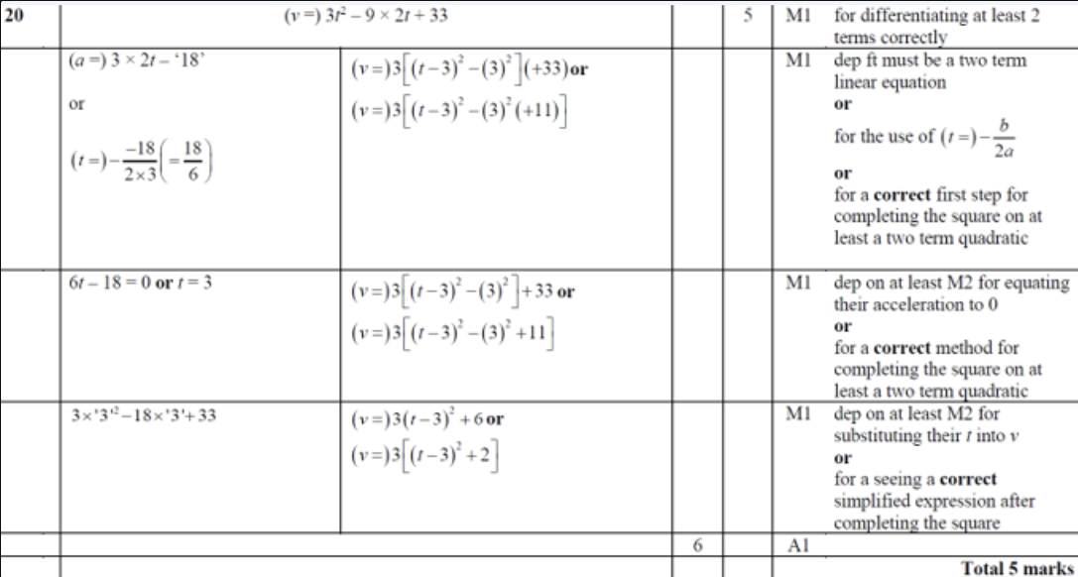
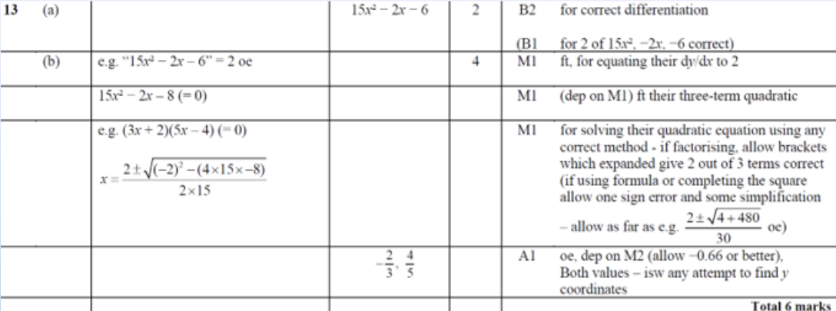
Pythagoras
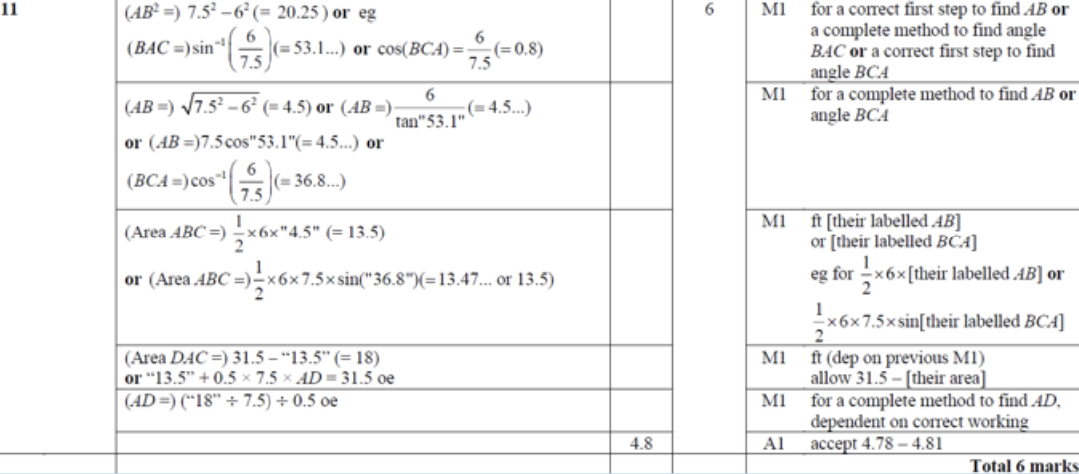
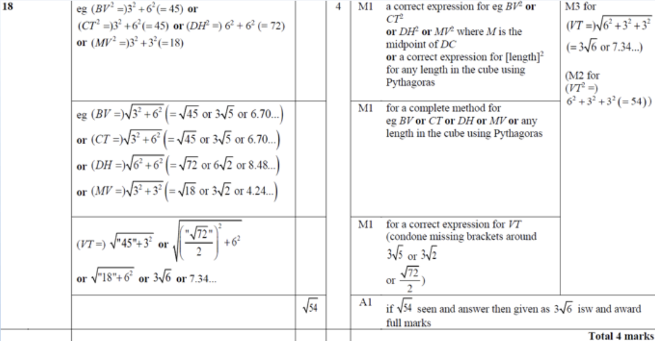

C.Frequency
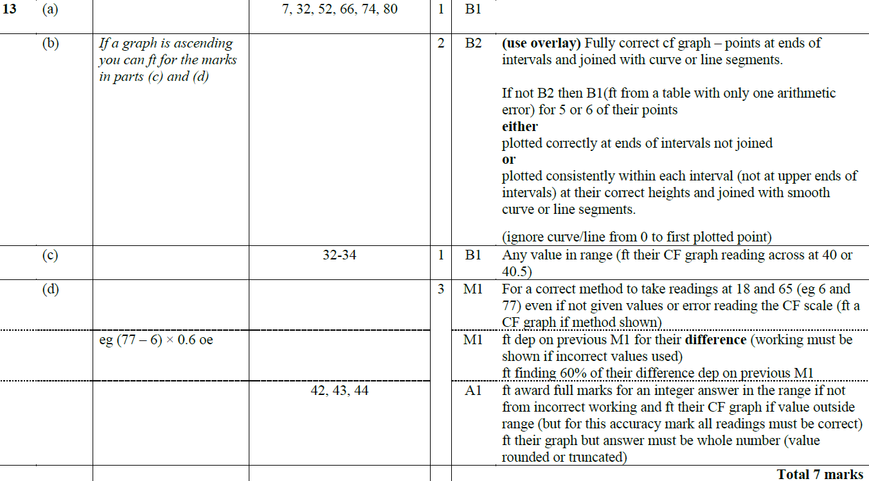

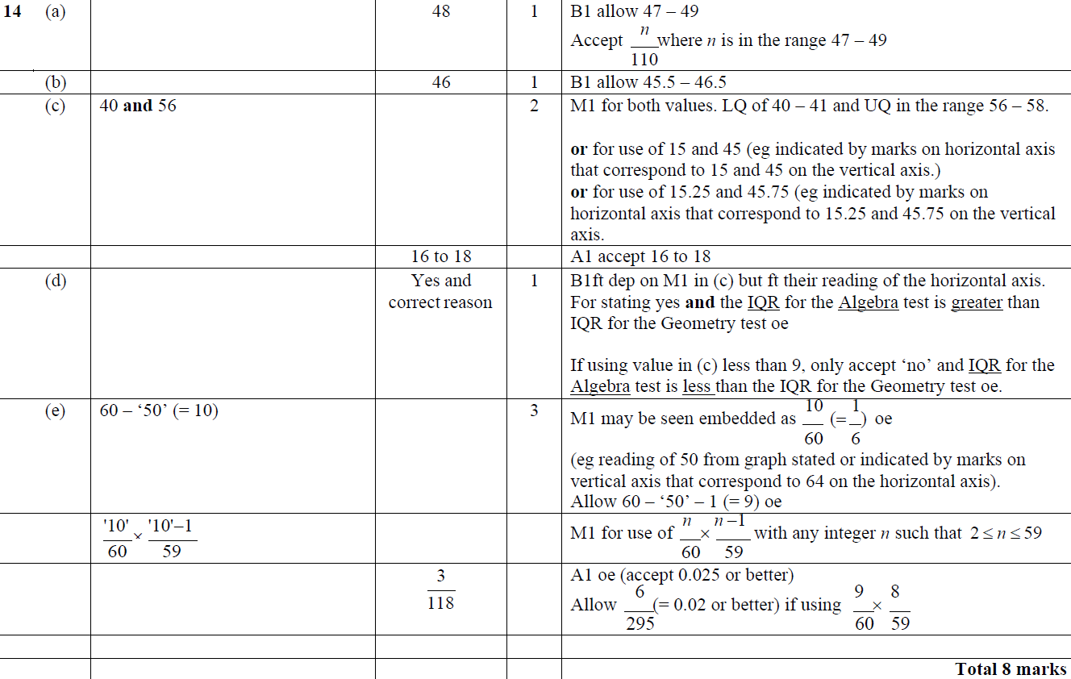

Changing the Subject
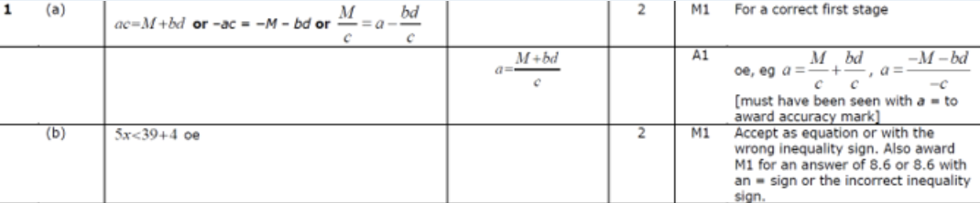
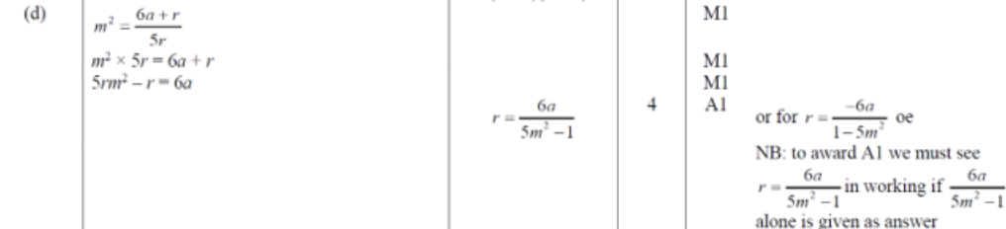
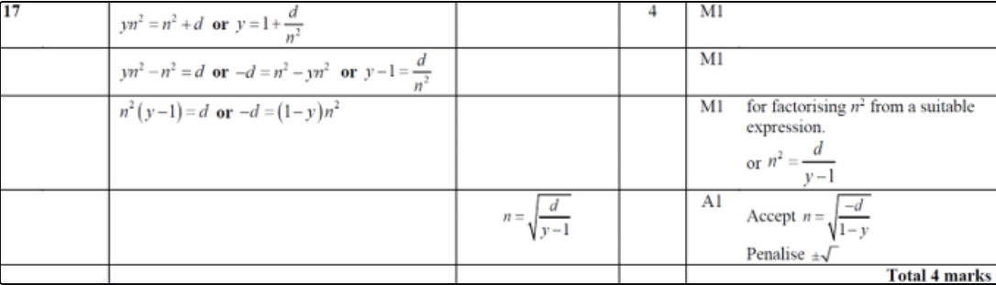
Properties of Numbers
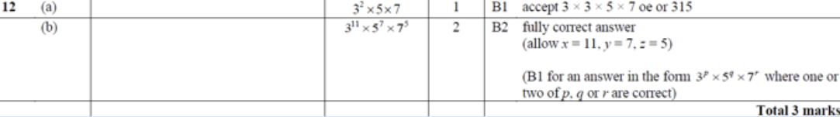
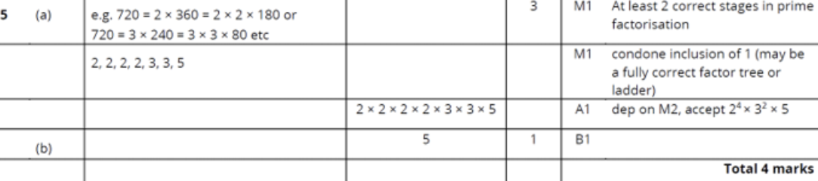
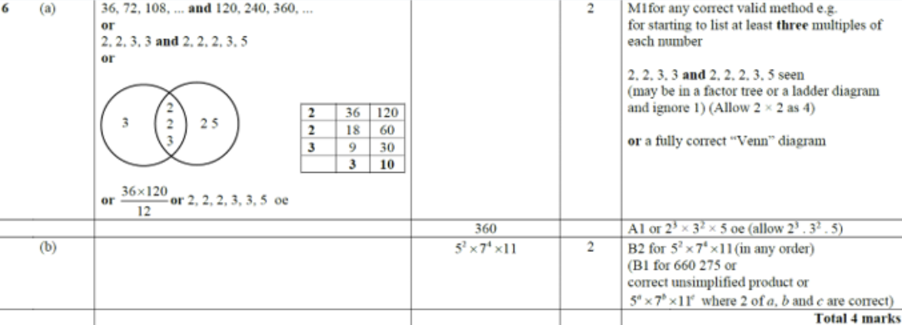
Circle Theorems - Angles
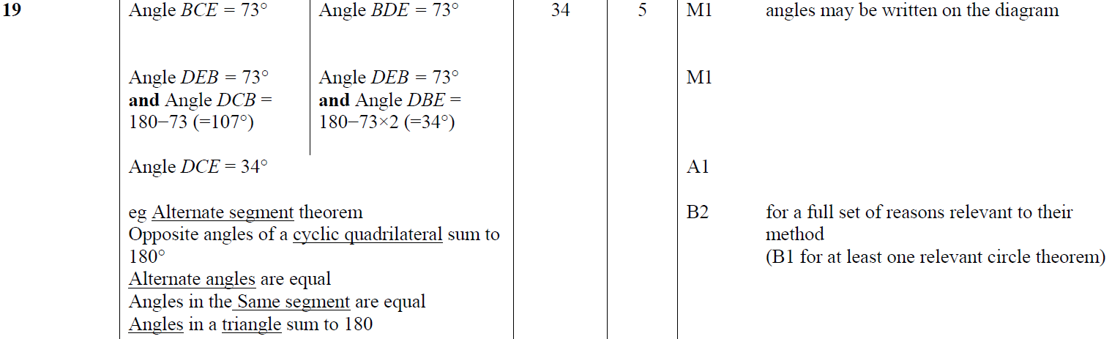
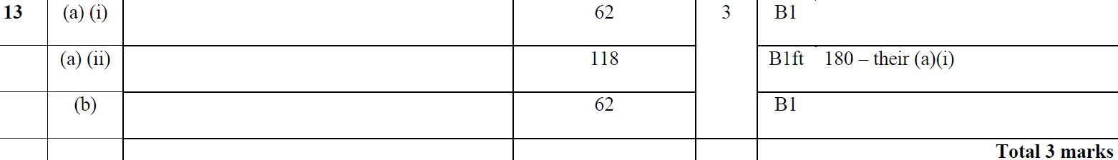

Linear Simultaneous Equations
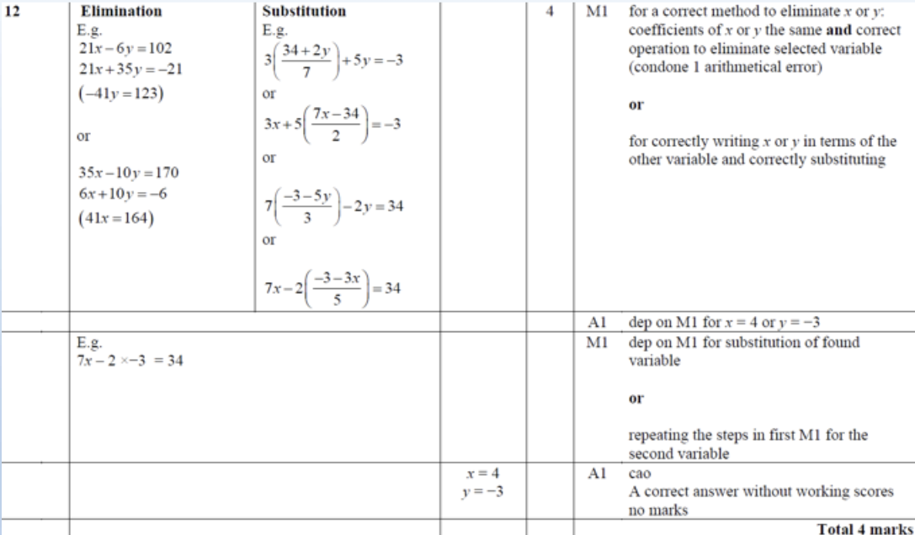
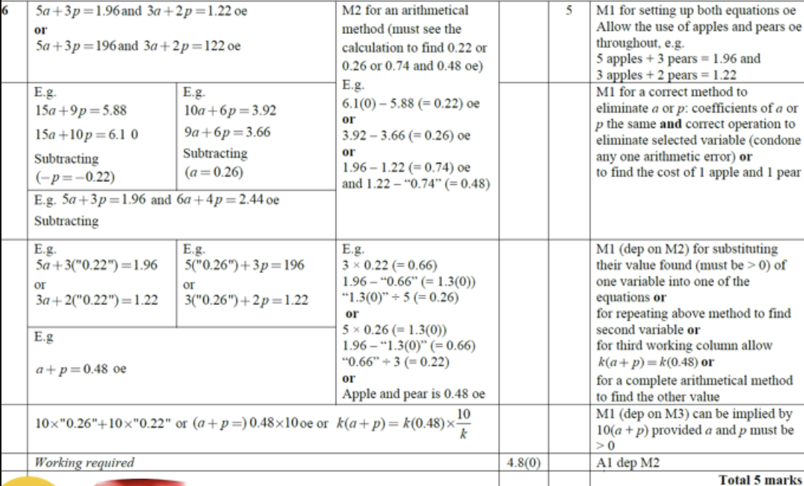
Compound Measures 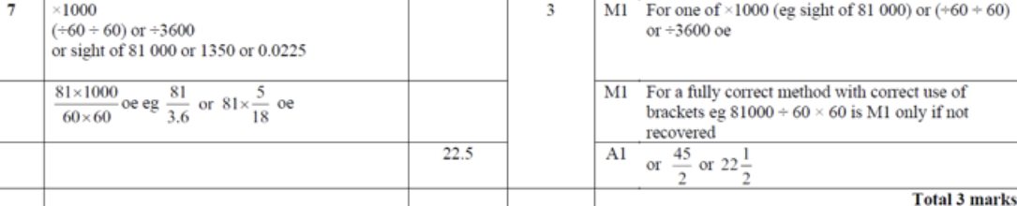
Sets – Venn
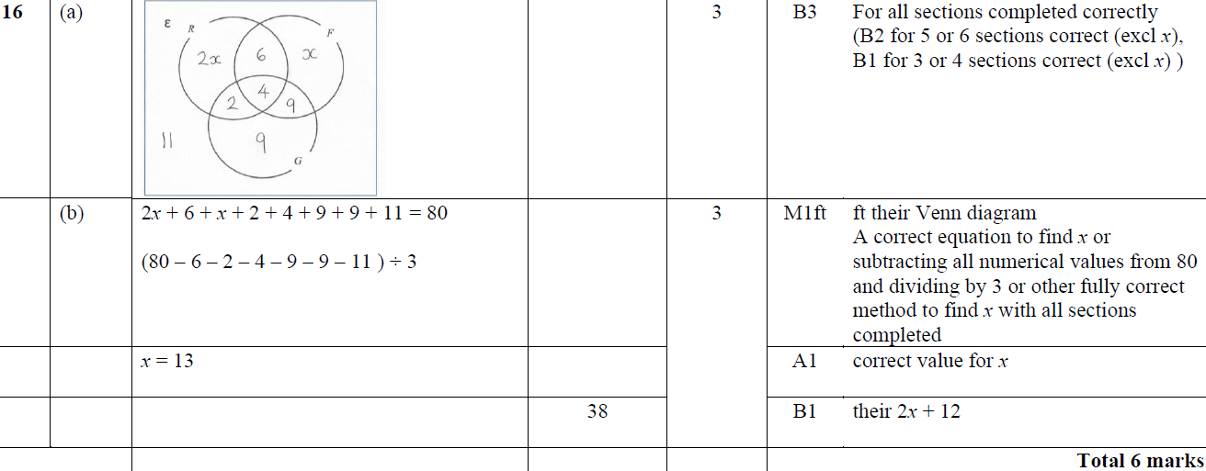
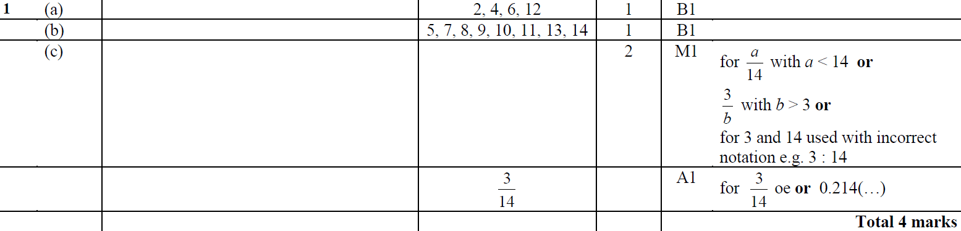
Completing the Square
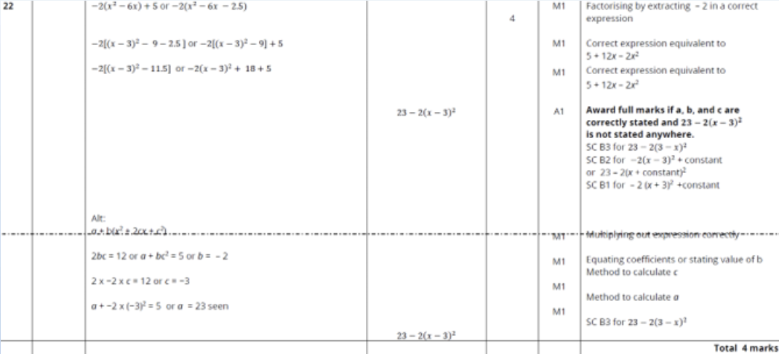
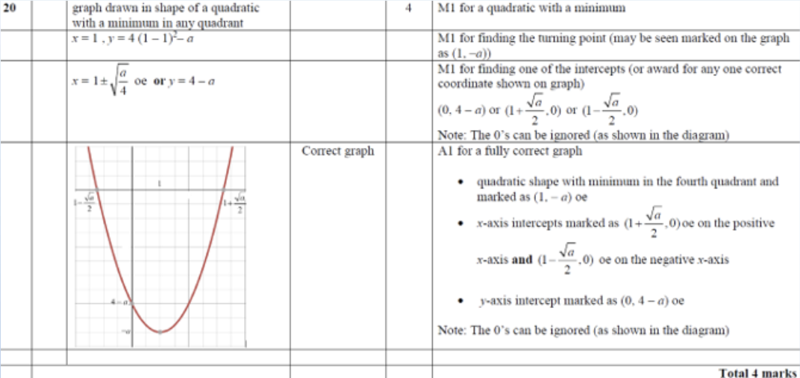
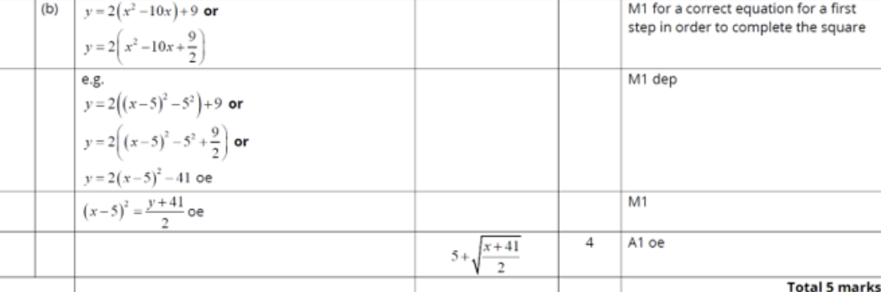
Problem Solving with Algebra
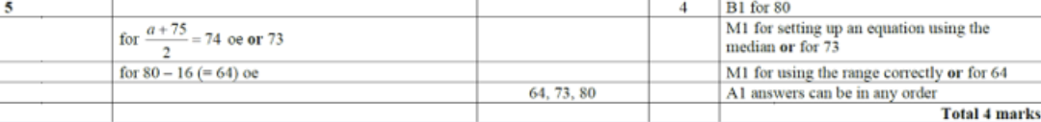
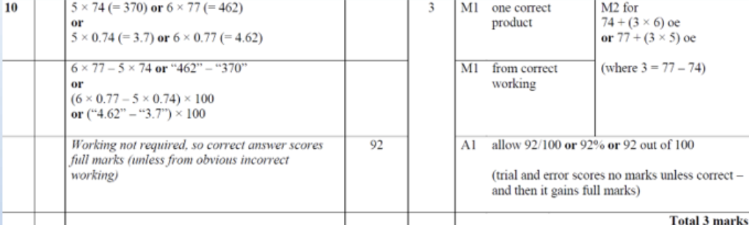
Indices - Negative and Fractional
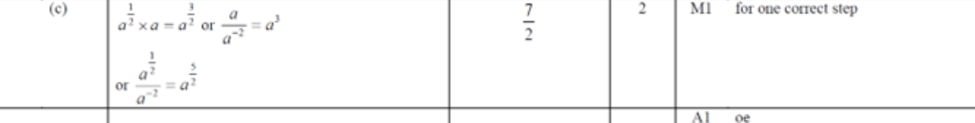
Ratio
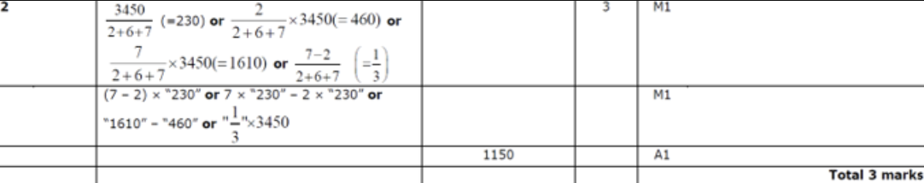
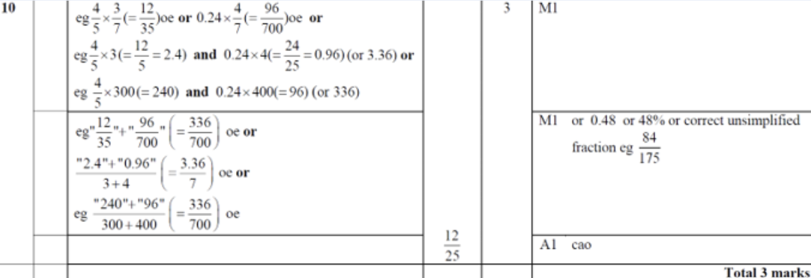
Indices
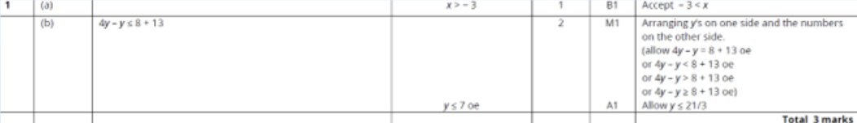
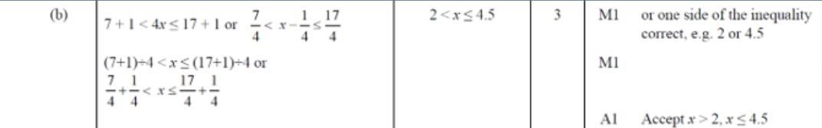
3D Trig/ Pythag
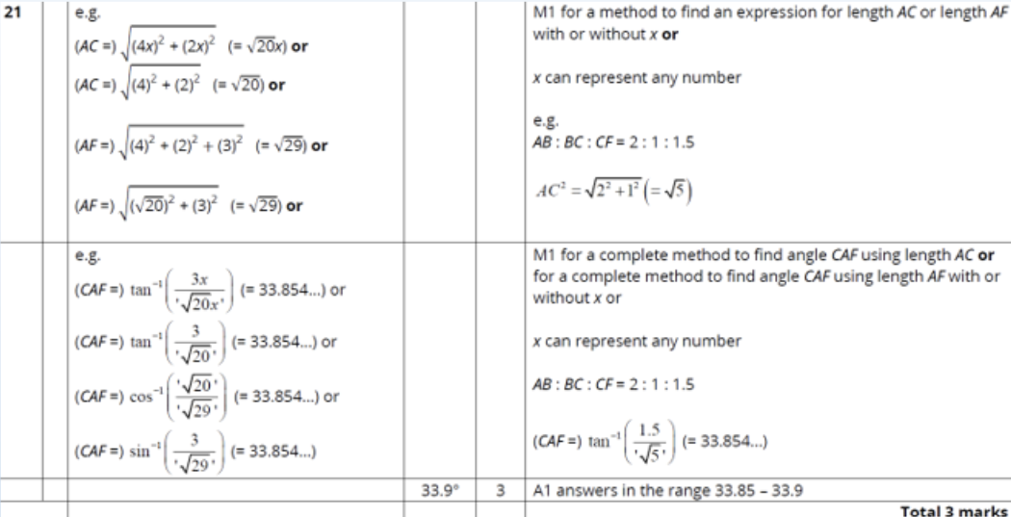
Basic Probability
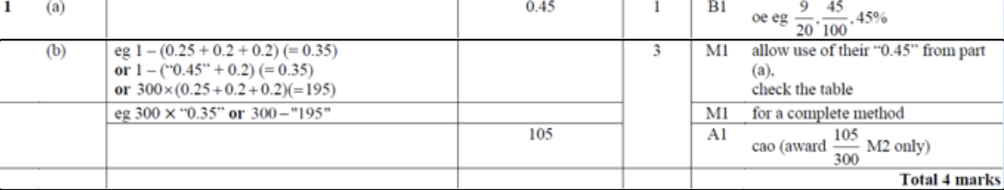
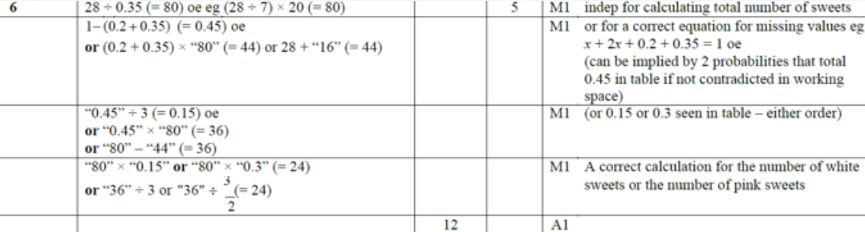
Linear Graphs
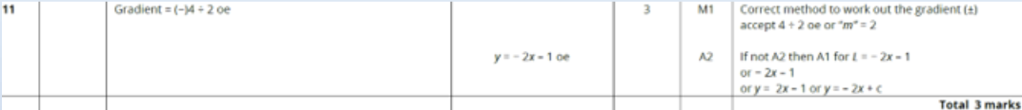
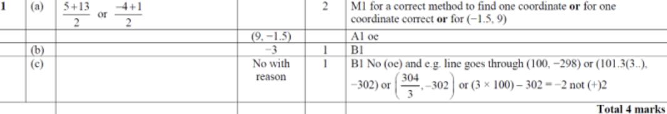
Expanding Brackets
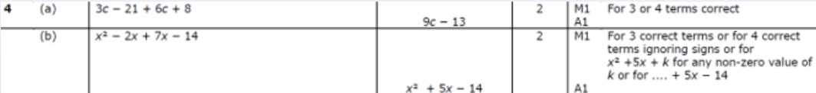
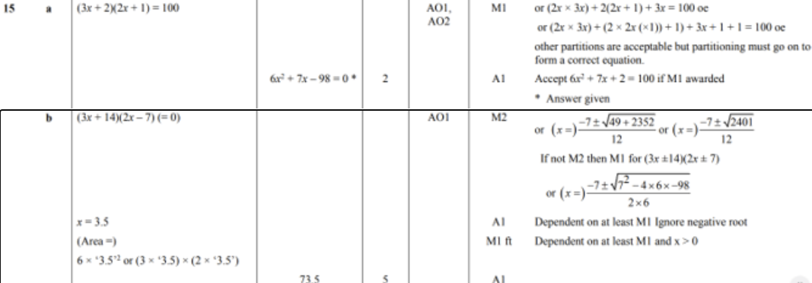
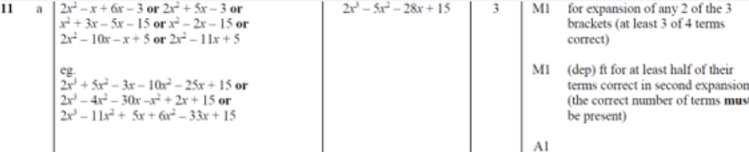
Fractions
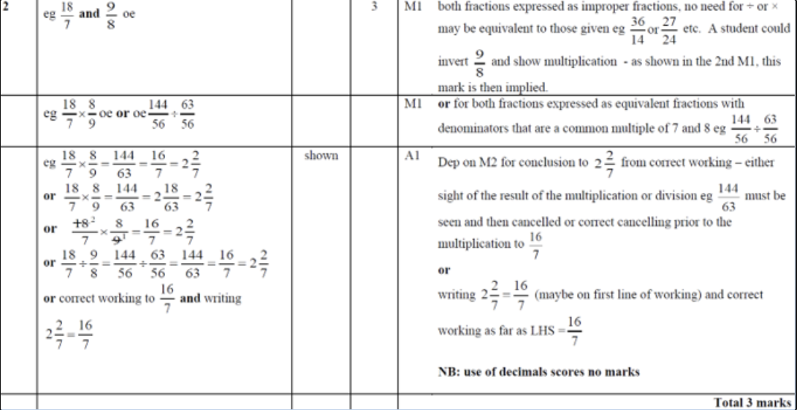
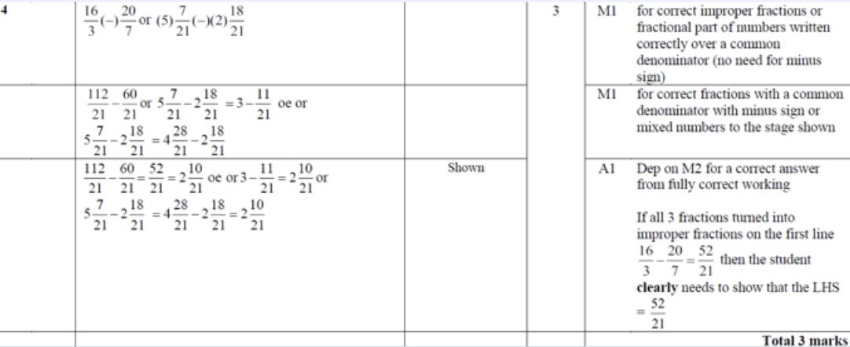
Basic Factorising

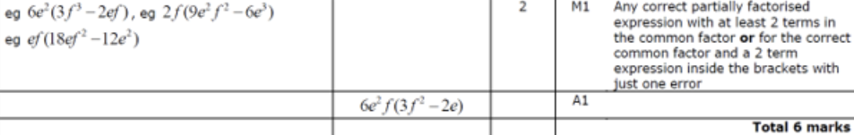
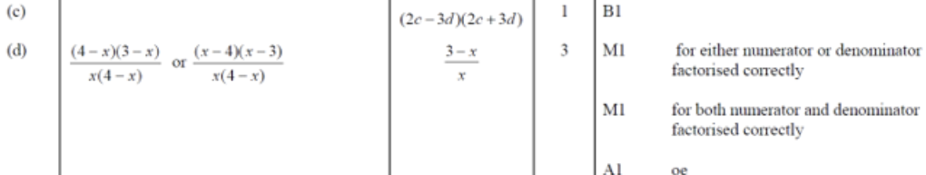

Similar Shapes A&V
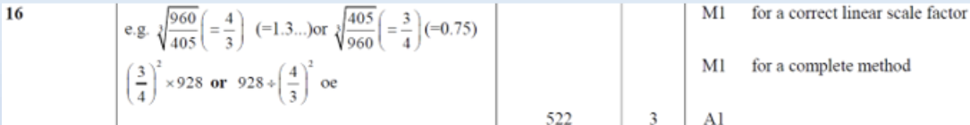
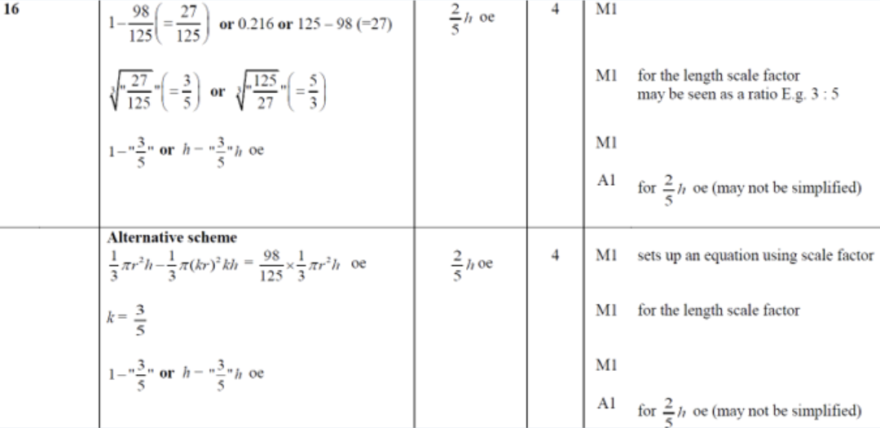
Volume and Surface Area

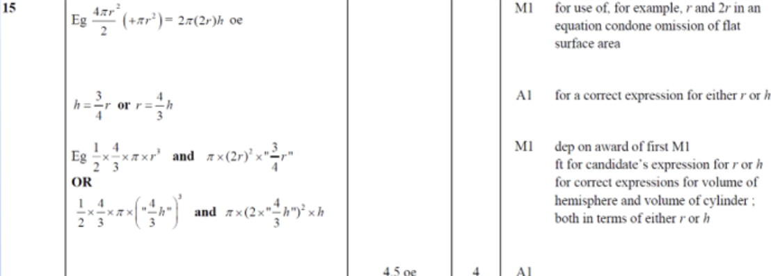
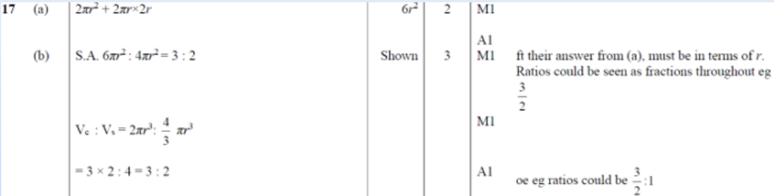

Circles and Sectors
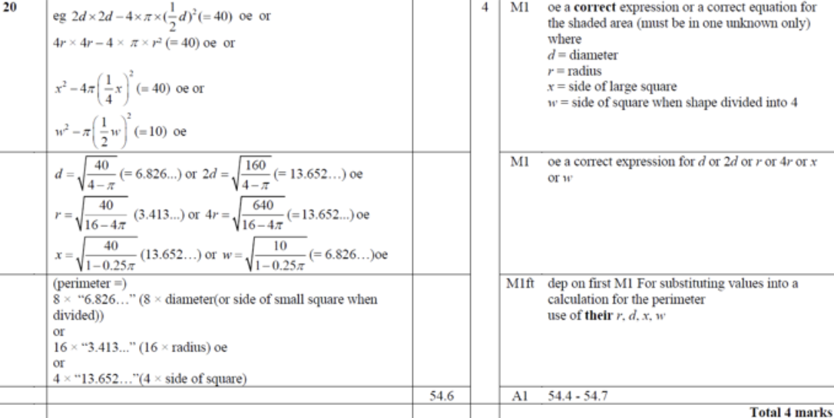
Solving Quadratics by Factorising
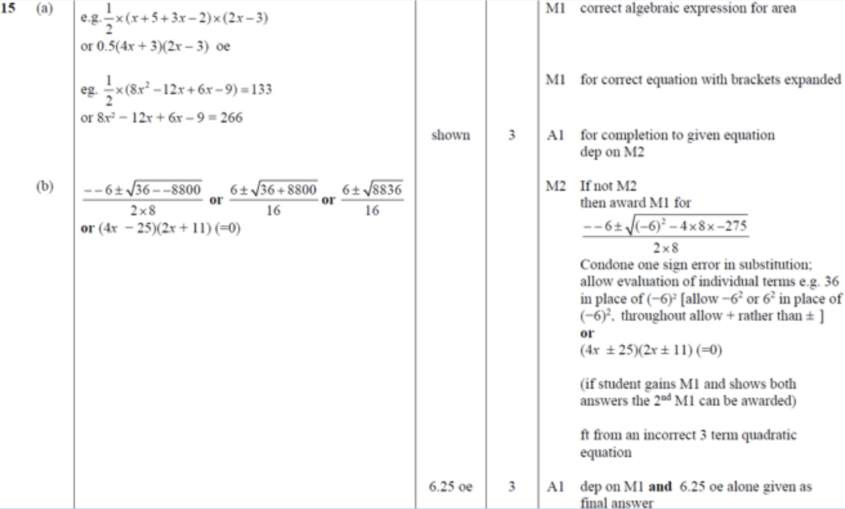
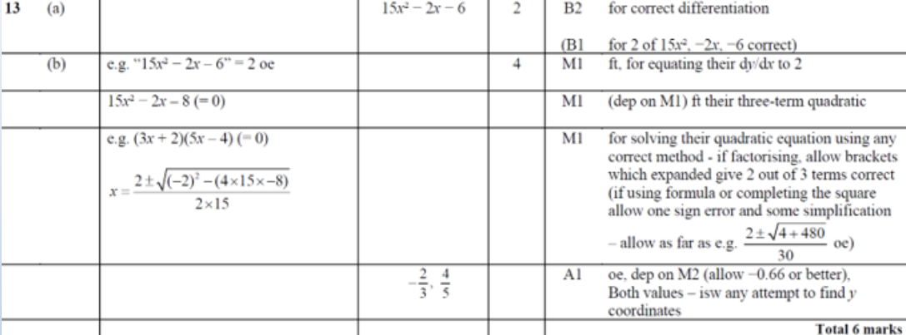
Graphical Inequalities
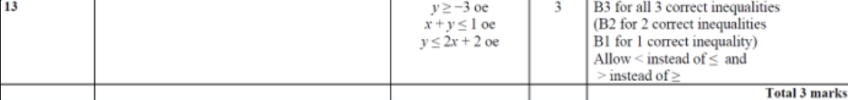
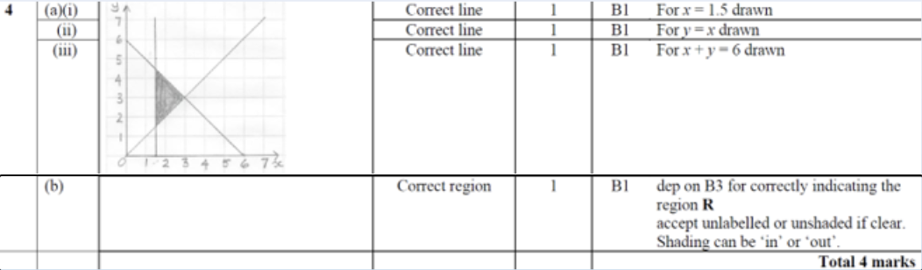
Indices

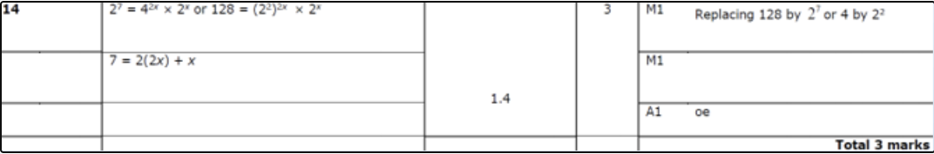
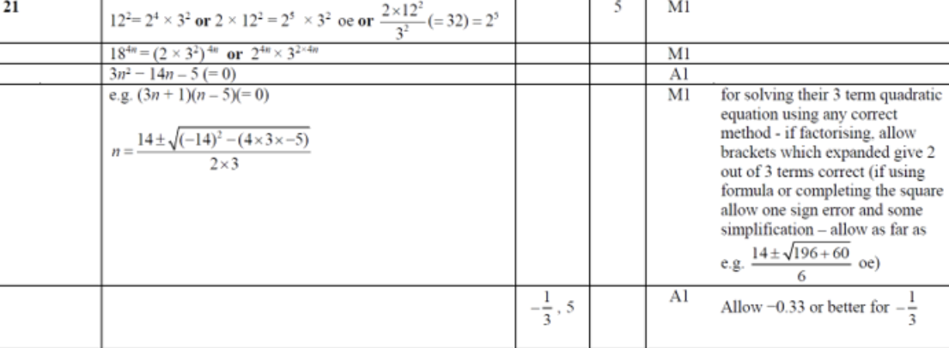

Basic Trig
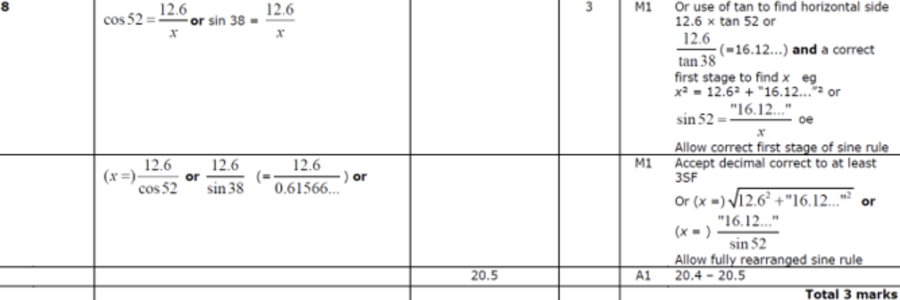
Advanced Trig
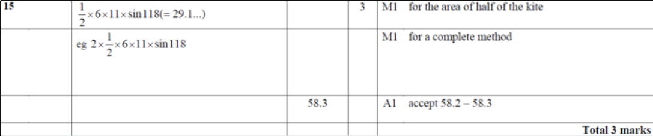
Recurring Decimals to Fractions
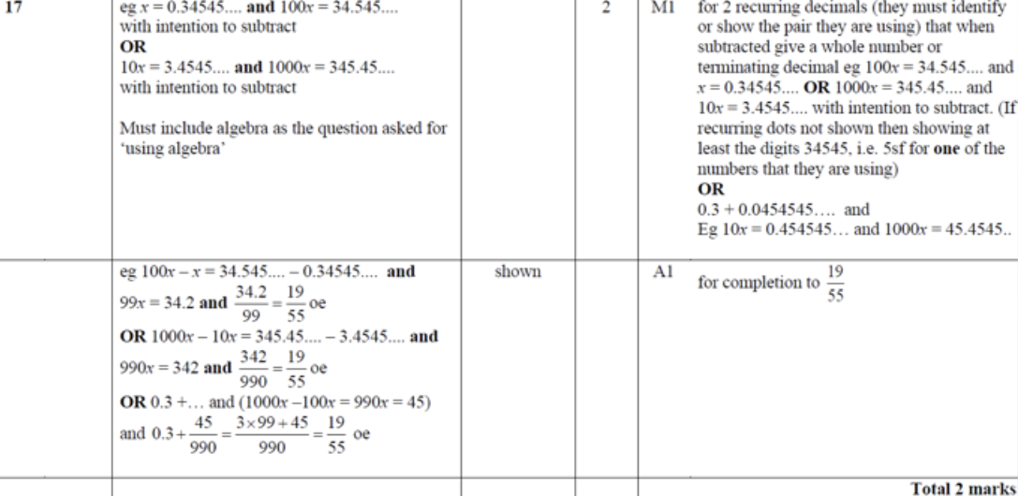
IQR from Discrete Data
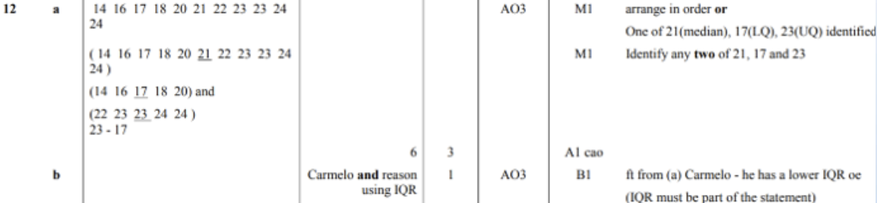
Sets Notation
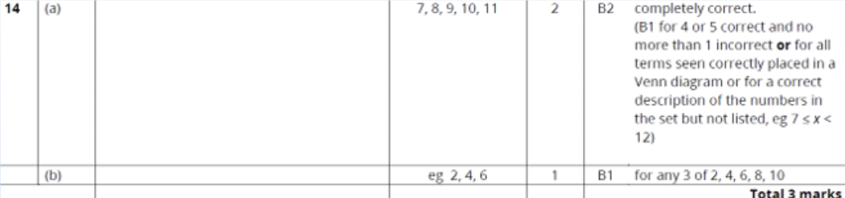
Quadratic Inequalities
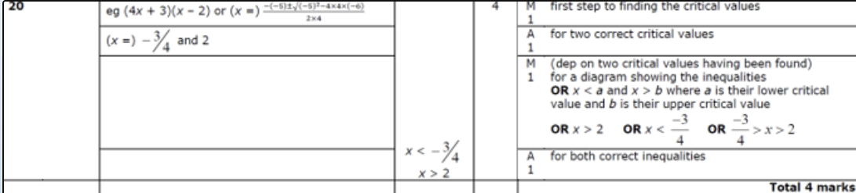
Algebraic Fractions
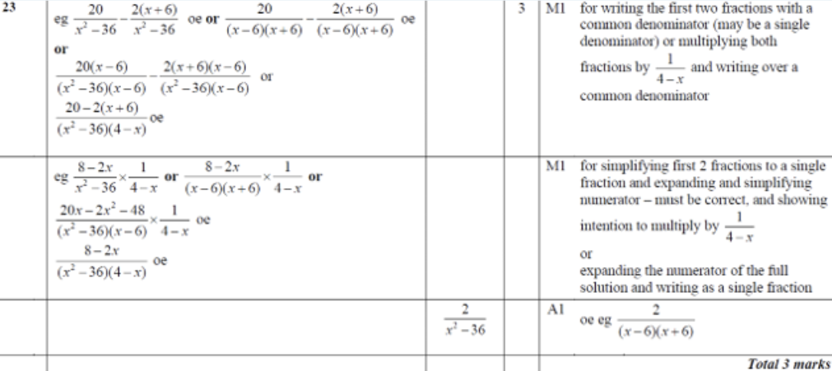

Proof
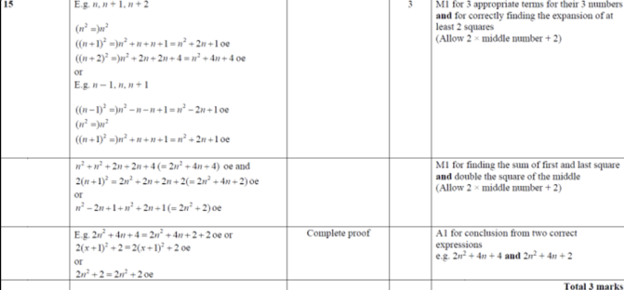
Percentage Change
Constructions
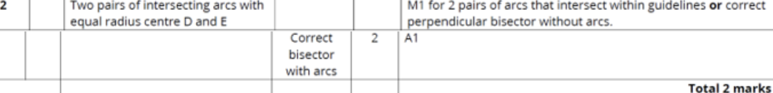
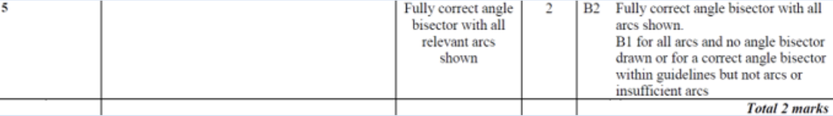
Transformations of Shapes
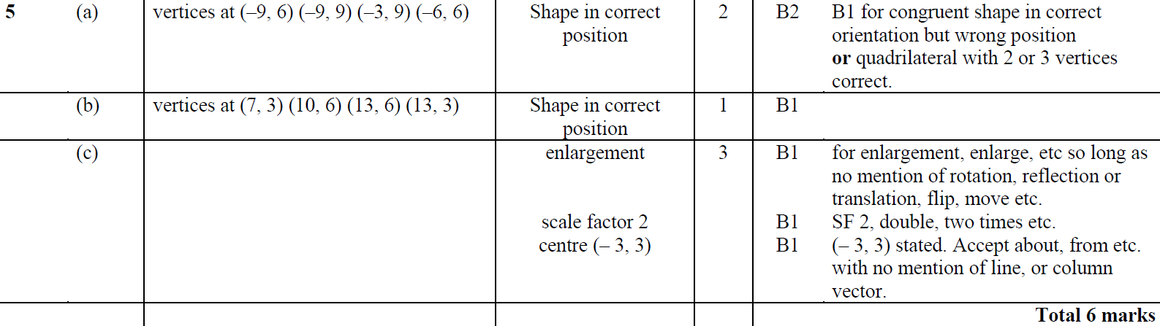

Similar Shapes Linear
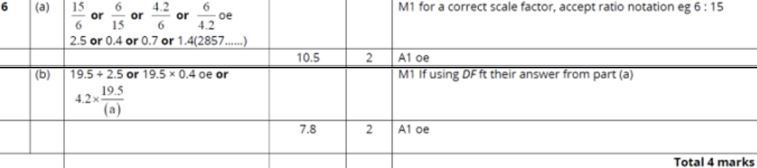
Prisms and Cylinders
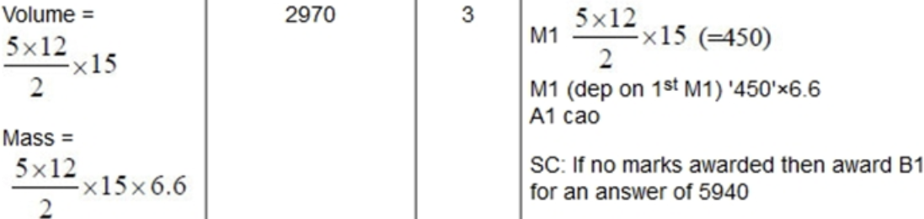
Circle Theorems – chords
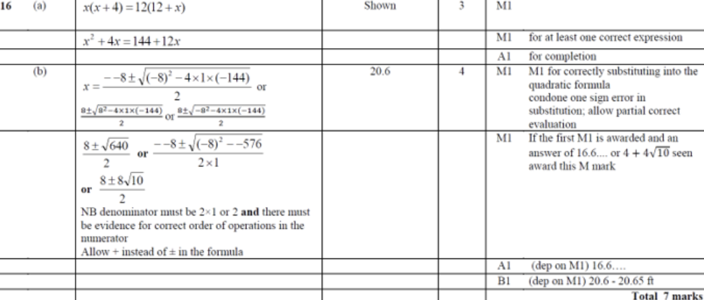
Compound Percentages
