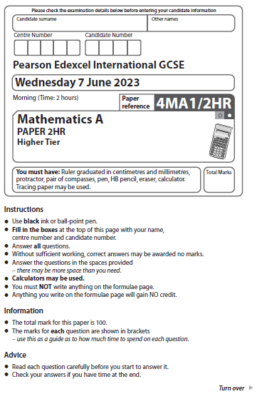
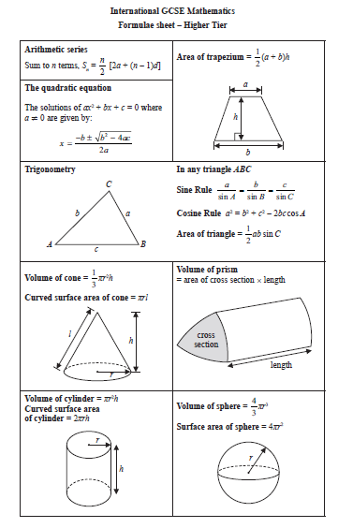

Answer ALL TWENTY SIX questions.
Write your answers in the spaces provided.
You must write down all the stages in your working.

1 P = m² – 4c
(a) Work out the value of P when m = –5 and c = 3

P = ......................................................
(2)
(b) Expand and simplify (x + 5)(x – 7)

......................................................
(2)
(Total for Question 1 is 4 marks)
__________________________________________________________________________

2 Sandeep wants to buy some packets of pens and some boxes of pencils for his
stationery shop.
Each packet of pens contains 9 pens.
Each box of pencils contains 12 pencils.
Each packet of pens costs £7.60
Each box of pencils costs £4.80
Sandeep can only buy full packets of pens and full boxes of pencils.
He wants to buy exactly the same number of pens as pencils.
Work out the minimum amount Sandeep needs to pay.

£......................................................
(Total for Question 2 is 4 marks)
__________________________________________________________________________

3 Anjali travels on the Eurostar train from Paris to Amsterdam.
The distance the train travels between Paris and Amsterdam is 515 km.
The time taken by the train to travel between Paris and Amsterdam is
3 hours 18 minutes.
Work out the average speed of the train.
Give your answer in km/h correct to the nearest whole number.

...................................................... km/h
(Total for Question 3 is 3 marks)
__________________________________________________________________________

4 Here are the first four terms of an arithmetic sequence.

38 31 24 17

Find an expression, in terms of n, for the nth term of the sequence.

.......................................................
(Total for Question 4 is 2 marks)
__________________________________________________________________________

5 A field is in the shape of a trapezium.
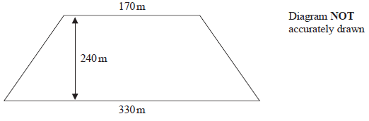
The field is sold for a price of $49 650
Given that 1 hectare = 10 000 m²
work out the average price of the field per hectare.

$......................................................
(Total for Question 5 is 4 marks)
__________________________________________________________________________

6 In his previous job, Pierre was paid 400 euros in total for working a 5-day week.
In his new job, Pierre is paid 14 euros per hour.
In his new job, Pierre works for 7 hours each day for a 5-day week.
(a) Work out the percentage increase in the amount that Pierre is paid for a 5-day week.

......................................................%
(4)
Marie changes her job.
Her salary decreases by 6%
Her new salary is 23 030 euros.
(b) Work out Marie’s salary before she changes her job.

...................................................... euros
(3)
(Total for Question 6 is 7 marks)
__________________________________________________________________________

7 (a) Simplify (4^{–2})⁰

......................................................
(1)
3^{–14} × 3⁸ = 3^{m}
(b) Find the value of m

m = ......................................................
(1)
(Total for Question 7 is 2 marks)
__________________________________________________________________________

8 (a) Solve 9 – 4x > 17

......................................................
(2)
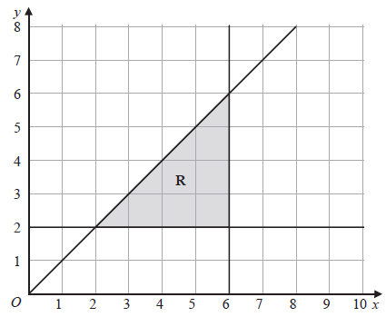

(b) Write down the three inequalities that represent the shaded region R

......................................................

......................................................

......................................................
(3)
(Total for Question 8 is 5 marks)
__________________________________________________________________________

9 The diagram shows a rectangular sheet of metal ABCD

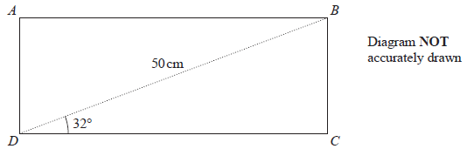

BD = 50 cm and angle BDC = 32°
Nasser joins side AD to side BC to form a cylinder.
BC is the height of the cylinder.
DC is the circumference of the cross section of the cylinder.
Work out the volume, in cm³, of the cylinder.
Give your answer correct to 3 significant figures.

...................................................... cm³
(Total for Question 9 is 6 marks)
__________________________________________________________________________

10 Gemara works as a taxi driver.
Last week, he recorded the following information about the distances he drove.
For the 5 days from Monday to Friday, the mean number of kilometres he drove
was 104
For the 7 days from Monday to Sunday, the mean number of kilometres he drove
was 127
On Saturday, Gemara drove 132 kilometres.
Work out the number of kilometres he drove on Sunday.

...................................................... kilometres
(Total for Question 10 is 3 marks)
__________________________________________________________________________

11 Express in the form where a, b and c are integers to be found.

......................................................
(Total for Question 11 is 2 marks)
__________________________________________________________________________

12 Here are six graphs.

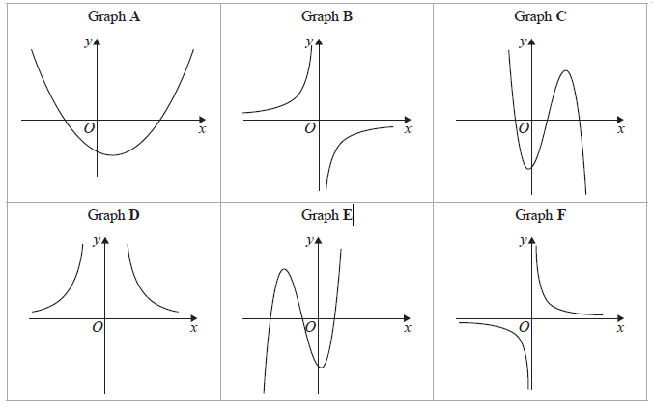

Write down the letter of the graph of
(a) y =

......................................................
(1)
(b) y = x – 3 + 3x² – x³

......................................................
(1)
(c) y = –

......................................................
(1)
(Total for Question 12 is 3 marks)
__________________________________________________________________________

13 Feruzi invests 80 000 Kenyan shillings (KES)
He invests the money for 3 years at x% compound interest each year.
At the end of 3 years, the total interest he receives is 6151.25 KES
Work out the value of x

x = ......................................................
(Total for Question 13 is 3 marks)
__________________________________________________________________________

14 Akari played a computer game eleven times.
Here are her scores.

25 | 20 | 28 | 27 | 26 | 22 | 23 | 29 | 20 | 29 | 26

(a) Find the interquartile range of her scores.

......................................................
(3)
Machi played the same computer game eleven times.
The interquartile range for Machi’s scores was 9
(b) Who had the more consistent scores, Akari or Machi?
Give a reason for your answer.

......................................................................................................................................................

......................................................................................................................................................(1)
(Total for Question 14 is 4 marks)
__________________________________________________________________________

15 Osvaldo has a biased coin.
He spins the coin three times.
The probability that the coin lands on a head three times is

Work out the probability that the coin will land on a tail three times.

......................................................
(Total for Question 15 is 3 marks)
__________________________________________________________________________

16 Show that can be written in the form a + where a is an integer.
Show your working clearly.

(Total for Question 16 is 3 marks)
__________________________________________________________________________

17 Make x the subject of y =

......................................................
(Total for Question 17 is 4 marks)
__________________________________________________________________________

18
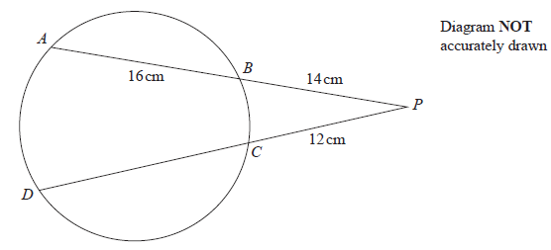
A, B, C and D are points on a circle.
ABP and DCP are straight lines.
AB = 16 cm BP = 14 cm CP = 12 cm
Work out the length of DC

...................................................... cm
(Total for Question 18 is 3 marks)
__________________________________________________________________________

19 30 adults booked to stay in a hotel.
19 adults booked breakfast
15 adults booked dinner
4 adults did not book breakfast or dinner
Some adults booked breakfast and dinner.
Meihui chooses at random two of the 30 adults.
Work out the probability that these two adults each booked breakfast and dinner.

......................................................
(Total for Question 19 is 4 marks)
__________________________________________________________________________

20 A, B and C are points on a circle.

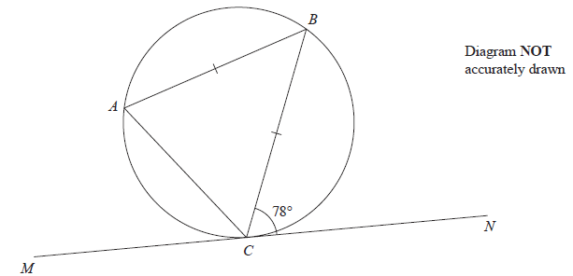

MN is the tangent to the circle at C
AB = CB
Angle BCN = 78°
Find the size of angle ABC

......................................................°
(Total for Question 20 is 2 marks)
__________________________________________________________________________

21 Work out the coordinates of the points of intersection of

y – 2x = 1 and y² + xy = 7

Show clear algebraic working.

(............................ , ............................)

(............................ , ............................)
(Total for Question 21 is 5 marks)
__________________________________________________________________________

22 Here is a cuboid ABCDEFGH
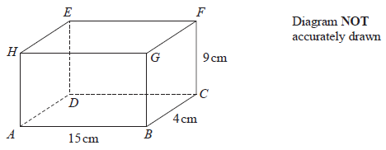
AB = 15 cm BC = 4 cm CF = 9 cm

(a) Work out the length of BE
Give your answer correct to 3 significant figures.

...................................................... cm
(2)

Here is a cuboid PQRSTUVW
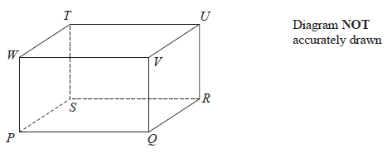
PR = 42 cm
The size of the angle between PU and the plane PQRS is 30°
M is the midpoint of PR
(b) Work out the size of angle UMR
Give your answer correct to 3 significant figures.

......................................................°
(3)
(Total for Question 22 is 5 marks)
__________________________________________________________________________

23 Here are the first three terms of an arithmetic sequence.

8p 7p – 3 4p + 2

The sum of the first n terms of the sequence is –1914
Work out the value of n
Show your working clearly.

n = ......................................................
(Total for Question 23 is 5 marks)
__________________________________________________________________________

24 The surface area of sphere A is nine times the surface area of sphere B
The difference between the volume of sphere A and the volume of sphere B is 117π cm³
Find the radius of the smaller sphere.
Show your working clearly.

...................................................... cm
(Total for Question 24 is 5 marks)
__________________________________________________________________________

25 The straight line with equation y – 2x = 7 is the perpendicular bisector of the line AB
where A is the point with coordinates ( j, 7) and B is the point with coordinates (6, k)

Find the coordinates of the midpoint of the line AB
Show clear algebraic working.

(............................ , ............................)
(Total for Question 25 is 6 marks)
__________________________________________________________________________

26 Here is a sketch of the curve with equation y = a cos bx° + c where –90 ≤ x ≤ 450
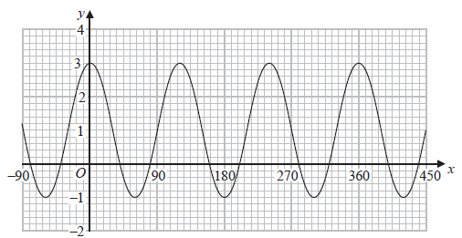
Find the value of a, the value of b and the value of c

a = ......................................................

b = ......................................................

c = ......................................................
(Total for Question 26 is 3 marks)
__________________________________________________________________________
TOTAL FOR PAPER IS 100 MARKS

