Examples
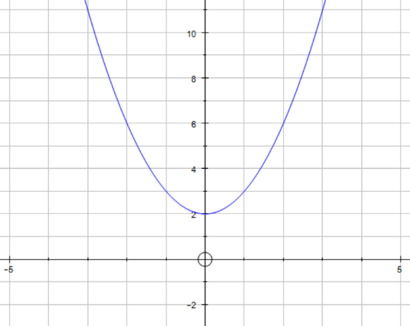
This is the graph of y = f(x)
Find f(2) _______________

Find f(0) _______________

Find f(-1) _______________

Find f(x) = 3 _______________

Find f(x) = 11 _______________

Find f(x) = 2 _______________

State the range of f(x) _______________
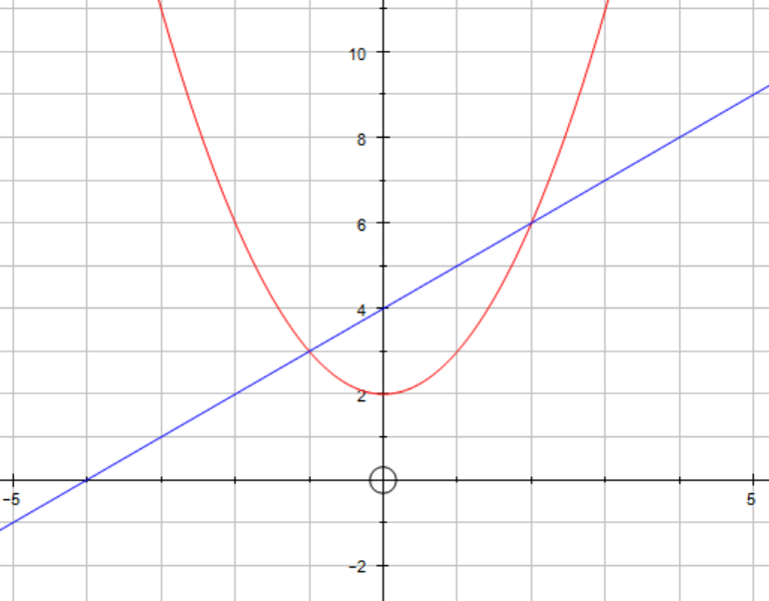
f(x)
g(x)
Solve f(x) = h(x)
_______________

f(x) = h(x) has two solutions at x = -3 and x = 2
h(x) can be written in the form h(x) = m x + c
Find the values of m and c

1
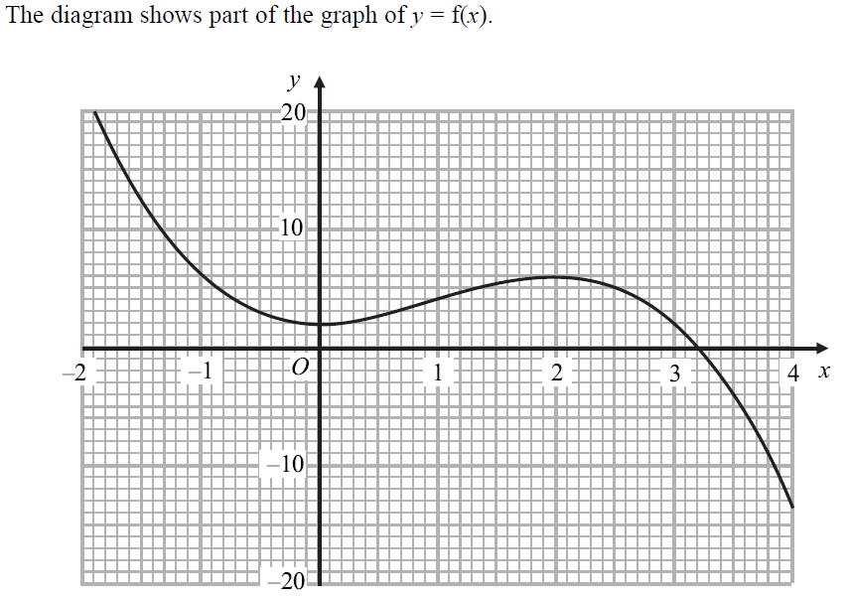
- Find f(-1)
_____________________________
- Find f(1)
_____________________________
- Find f(2)
_____________________________
- Find f(3)
_____________________________
- Find ff(0)
_____________________________
- Solve f(x) = 0
_____________________________
- Solve f(x) = 10
_____________________________
- The equation f(x) = a has exactly 2 solutions
Find the possible values for a
_____________________________
- The equation f(x) = b has 3 solutions
Find the range of values for b
_____________________________
2 The diagram shows part of y = f(x)
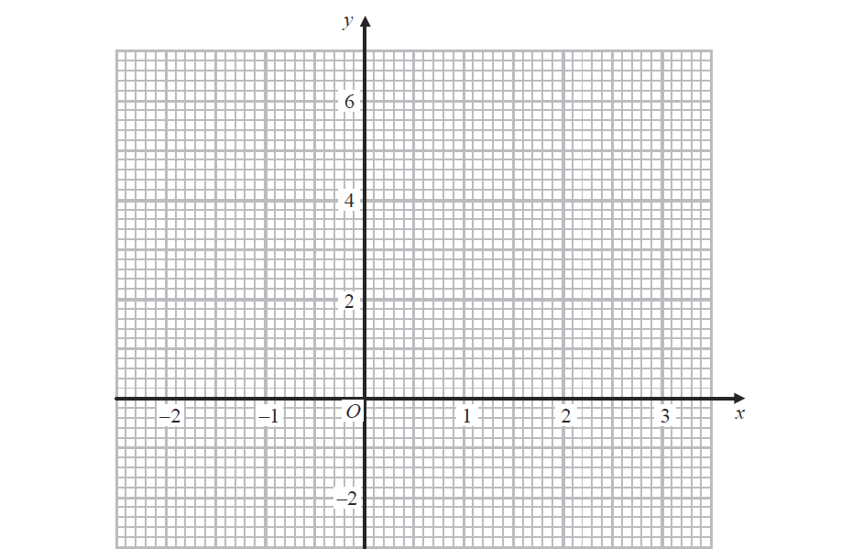
- Find f(1)
_____________________________
- Find f(0)
_____________________________
- Find ff(2)
_____________________________
- Solve f(x) = 0
_____________________________
- Solve f(x) = 2 - x
_____________________________
- State the range of f(x)
_____________________________
- The equation f(x) = b has exactly 1 solution
Find the value of b
_____________________________

3

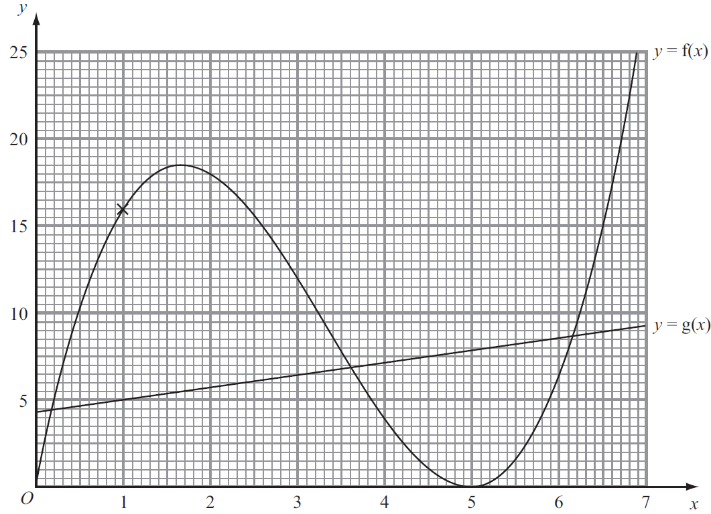

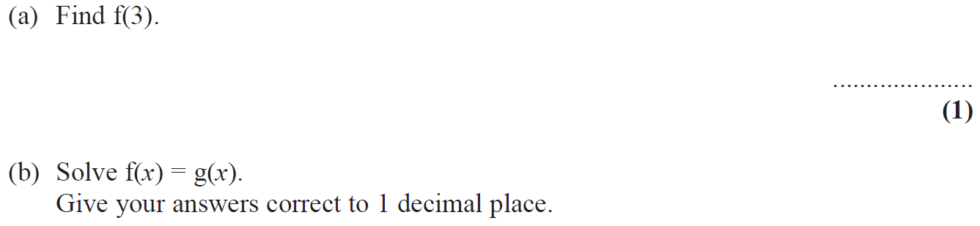

4
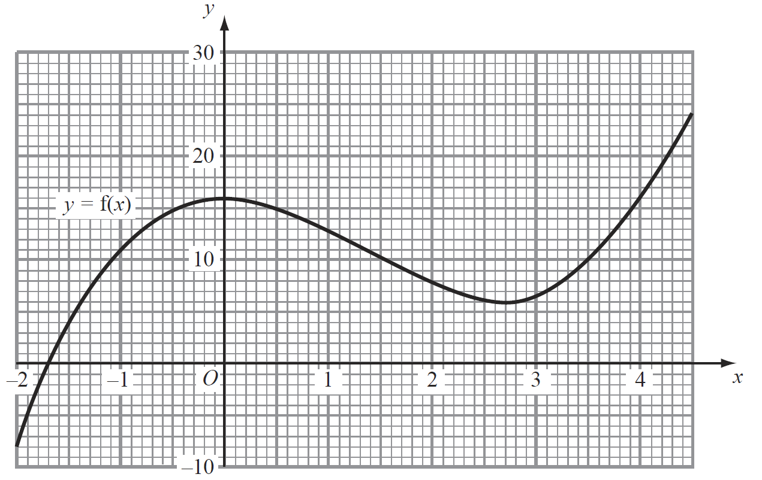
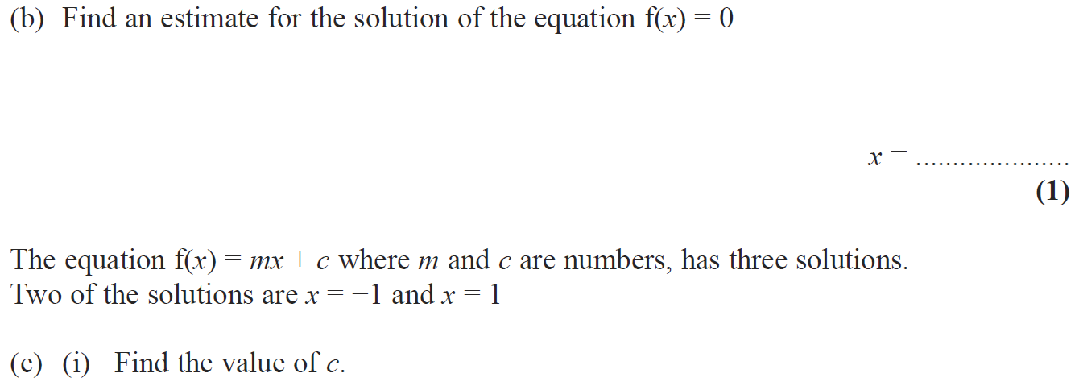
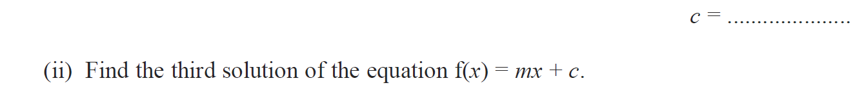

5
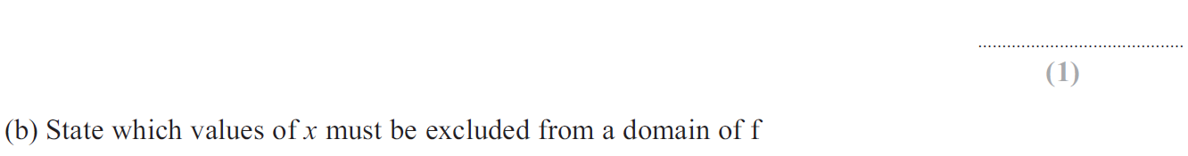

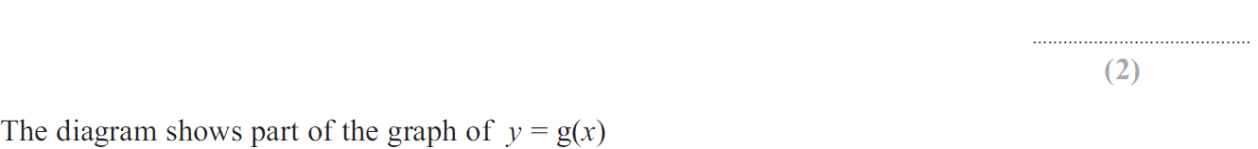

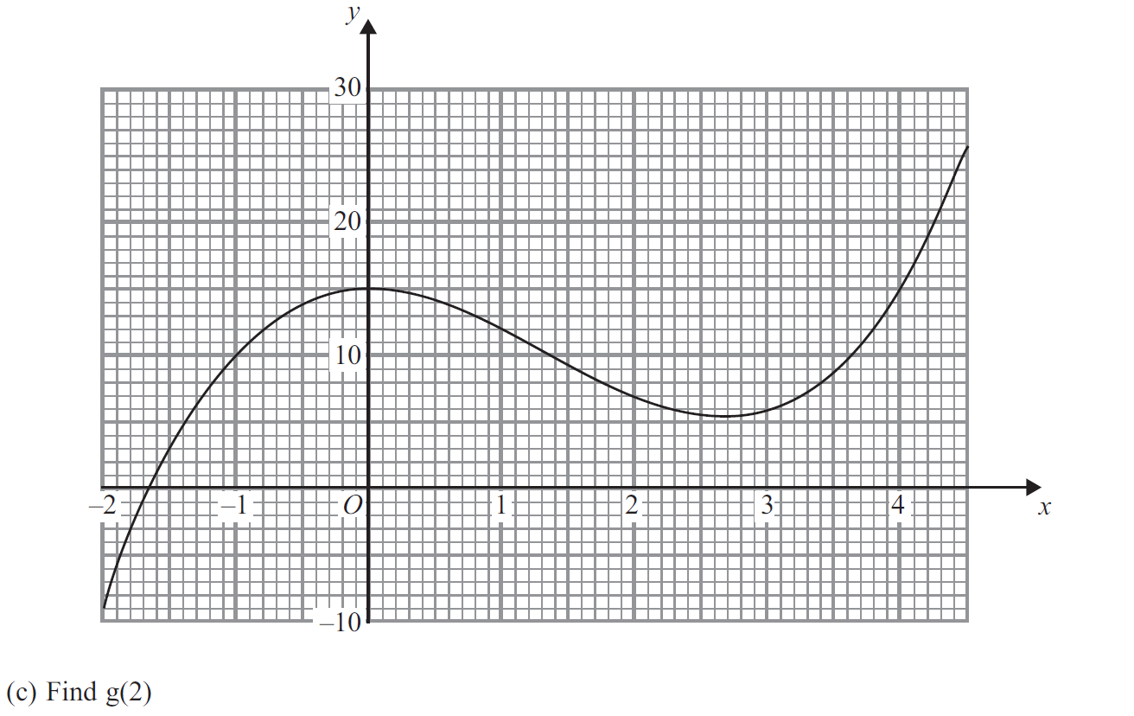

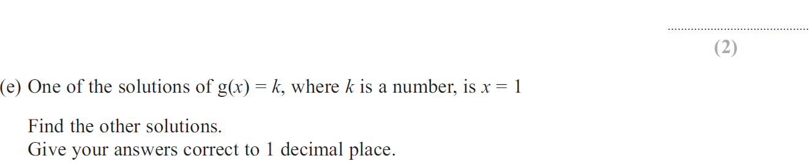

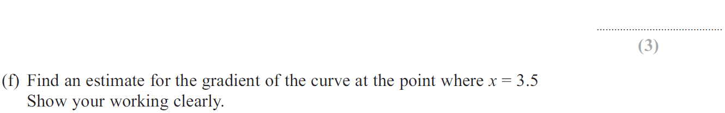

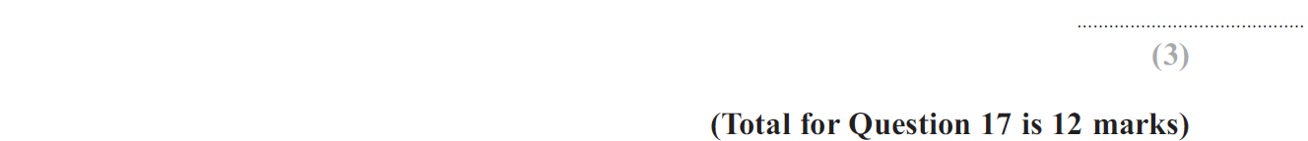

6

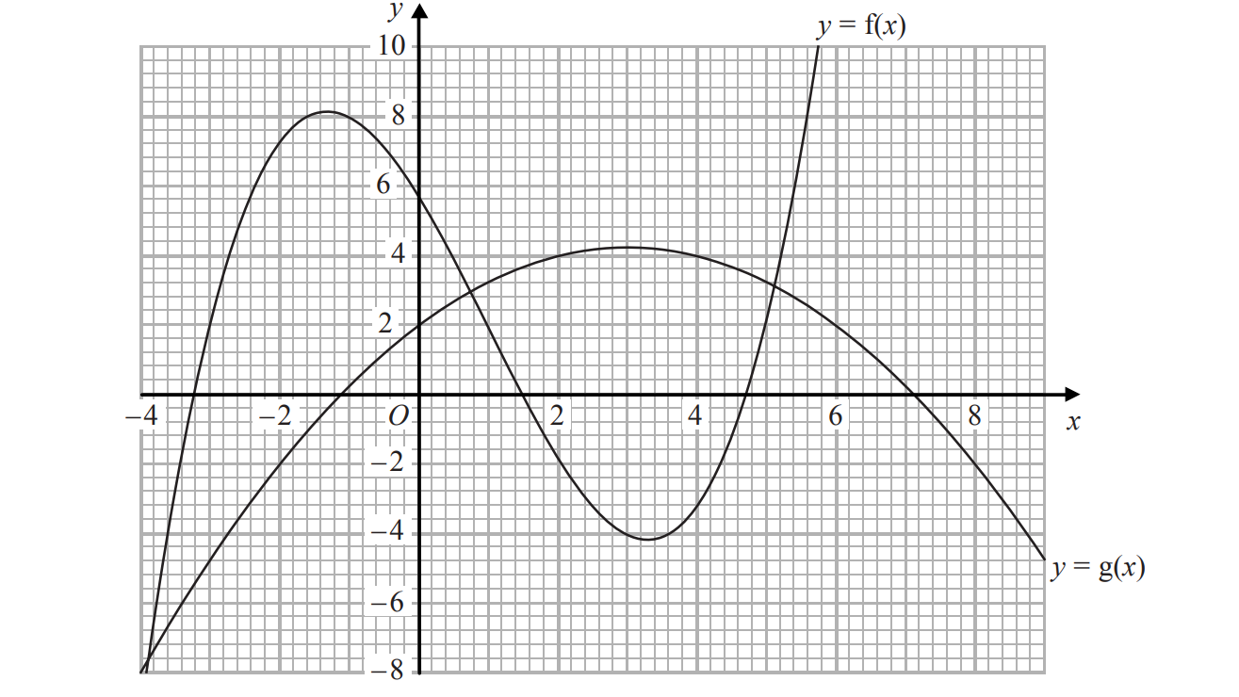

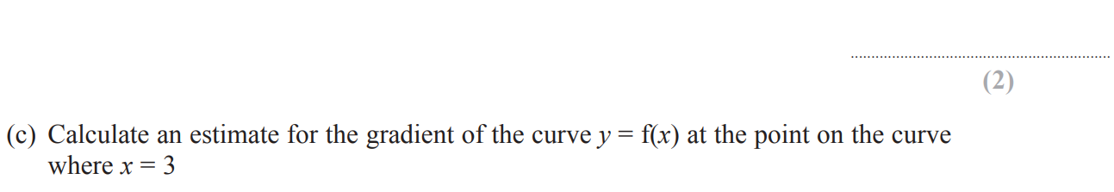

7
