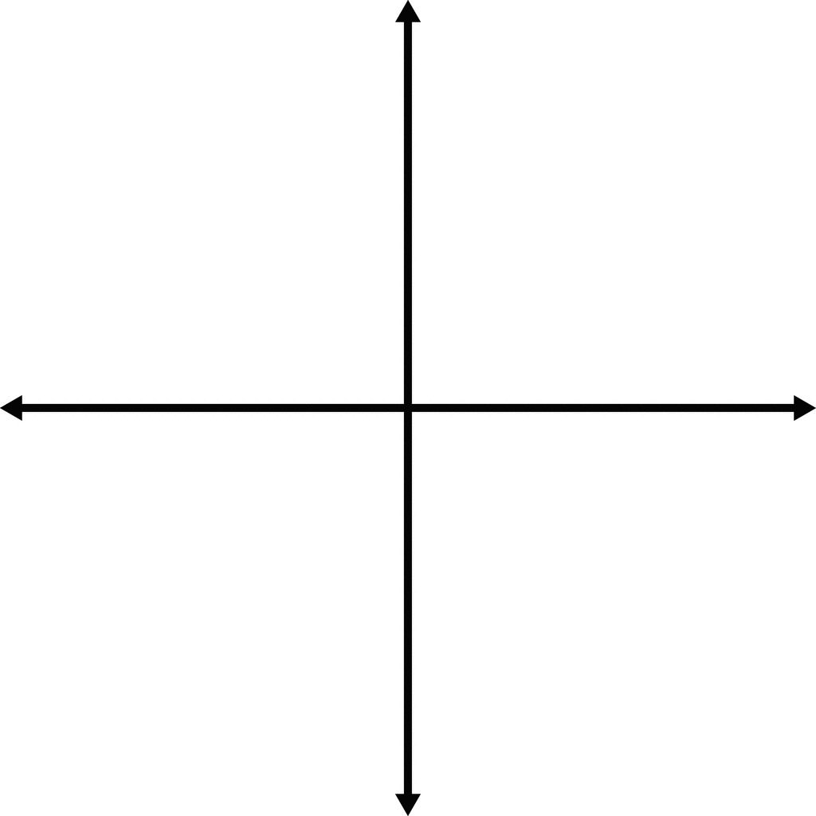
Sketch the following graphs, indicating clearly where the roots are.

y = x² – 2x – 8

y = x² + 6x + 5

y = x² + 18x + 65

y = – x² + 2x + 8

y = x² – 9

Quadratic Inequalities
Example 1: Solve the inequality
$$x^{2} – 2x – 8 > 0$$

Step 1: Find the roots of the equation

Step 2: Sketch the Graph

Step 3: Shade the part of the graph that satisfies the inequality

Step 4: Think about the graph ‘squashed down’

Step 5: Describe the inequality.

Step 6: Check some points to ensure they work in the original inequality

Example 2: Solve the inequality
$$x^{2} – 2x – 8 ≤ 0$$

Step 1: Find the roots of the equation

Step 2: Sketch the Graph

Step 3: Shade the part of the graph that satisfies the inequality

Step 4: Think about the graph ‘squashed down’

Step 5: Describe the inequality.

Step 6: Check some points to ensure they work in the original inequality

Quadratic Inequalities: Worksheet
Q1 $x^{2}-9>$ 0
$\left(x+3\right)\left(x-3\right)> 0$
$$x=-3 or x=3$$

-3
3

Q2 $x^{2}+ 6x + 5 ≤ 0$
$\left(x+1\right)\left(x+5\right)≤0$
$x=-1 or x=-5$

-5
-1

Q3 $x^{2}+ 18x + 65 ≥ 0$
$\left(x+13\right)\left(x+5\right)≤0$

Q4 $x^{2}+ 6x- 7< 0$
$\left(x+7\right)\left(x-1\right)≤0$

Q5 $x^{2}+4x-21> 0$

Q6 $x^{2}- 10x + 16 ≤ 0$

Q7 $x^{2}- 2x- 63 ≥ 0$

Q8 $x^{2}+x- 20< 0$

Q9 $-x^{2}+ 14x- 40 ≥ 0$
Hint: try to make x² positive first

Q10 $2x^{2}- 6x- 56< 0$
Hint: divide by 2 first to make
the inequality simpler

Q11 $5x^{2}≥- 55x- 120$
Hint: group all terms on the
same side first

Q12 $3x^{2}+ 14x- 5> 0$
Hint: 3 and 5 are prime so have limited factors

