The Quadratic Formula
A general quadratic equation: $ax^{2}+bx+c=0$
The quadratic formula: $x=\frac{-b±\sqrt{b^{2}-4ac}}{2a}$
Fill in the blanks below:
Equation | Quadratic formula | Simplified | Solutions ($2$dp)
$$x^{2}+4x+2=0$$ | $$\frac{-\left( \right)±\sqrt{{\left( \right)}^{2}-4\left( \right)\left( \right)}}{2\left( \right)}$$ | $$x=\frac{-4±\sqrt{8}}{2}$$ | $x=$  and  $x=$
$$x^{2}-5x+3=0$$ | $$\frac{-\left( \right)±\sqrt{{\left( \right)}^{2}-4\left( \right)\left( \right)}}{2\left( \right)}$$ | $$x=\frac{5±\sqrt{ }}{2}$$ | $x=$  and  $x=$
$$x^{2}+x =0$$ | $$\frac{-\left( \right)±\sqrt{{\left( \right)}^{2}-4\left( \right)\left(-3\right)}}{2\left( \right)}$$ | $$x=\frac{ ±\sqrt{ }}{ }$$ | $x=$  and  $x=$
$$2x^{2} x =0$$ | $$\frac{-\left(7\right)±\sqrt{{\left(7\right)}^{2}-4\left( \right)\left(1\right)}}{2\left( \right)}$$ | $$x=\frac{ ±\sqrt{ }}{ }$$ | $$x=$$  and  $x=$
$$x^{2} x =0$$ | $$\frac{-\left(-5\right)±\sqrt{{\left(-5\right)}^{2}-4\left(3\right)\left(-4\right)}}{2\left(3\right)}$$ | $$x=\frac{ ±\sqrt{ }}{ }$$ | $x=$  and  $x=$
$$x^{2} x =0$$ | $$\frac{-\left( \right)±\sqrt{{\left( \right)}^{2}-4\left( \right)\left( \right)}}{2\left( \right)}$$ | $$x=\frac{-3±\sqrt{5}}{2}$$ | $x=$  and  $x=$
$$x^{2} x =0$$ | $$\frac{-\left( \right)±\sqrt{{\left( \right)}^{2}-4\left( \right)\left( \right)}}{2\left( \right)}$$ | $$x=\frac{2±\sqrt{24}}{2}$$ | $$x=$$  and  $x=$
$$x^{2} x =0$$ | $$\frac{-\left( \right)±\sqrt{{\left( \right)}^{2}-4\left( \right)\left( \right)}}{2\left( \right)}$$ | $$x=\frac{6±\sqrt{28}}{4}$$ | $x=$  and  $x=$

Can you link each quadratic formula below to each function?
Function |  | Equation |  | Quadratic formula
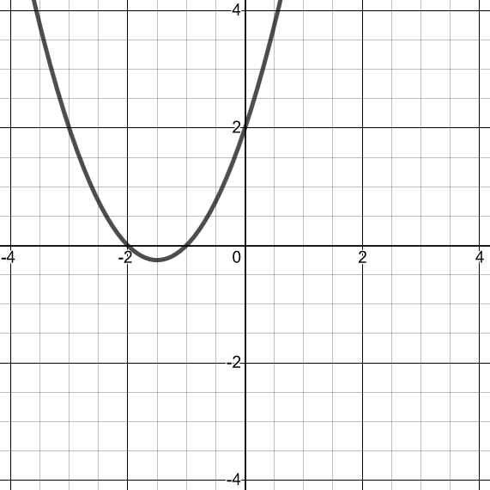 |  | $$y=x^{2}-4x+3$$ |  | $$x=\frac{-3±\sqrt{1}}{2}$$
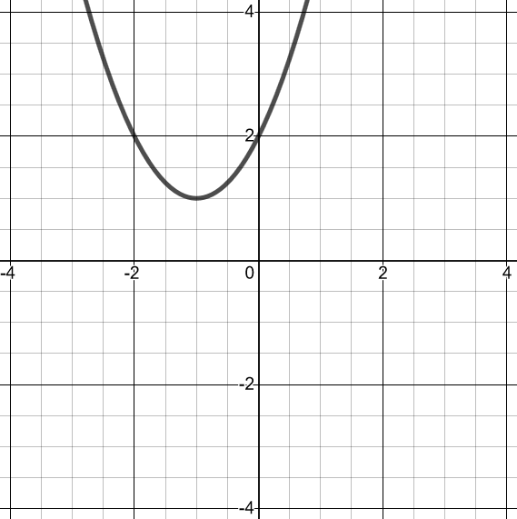 |  | $$y=x^{2}+3x+2$$ |  | $$x=\frac{4±\sqrt{0}}{2}$$
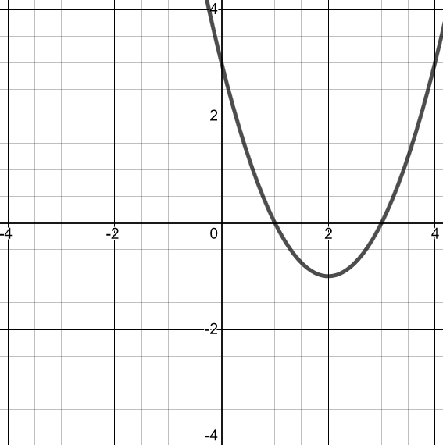 |  | $$y=x^{2}-x-2$$ |  | No solutions
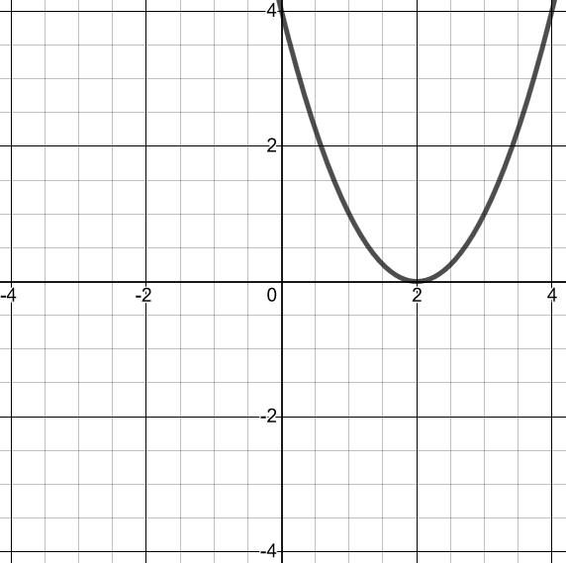 |  | $$y=x^{2}-4x+4$$ |  | $$x=\frac{4±\sqrt{4}}{2}$$
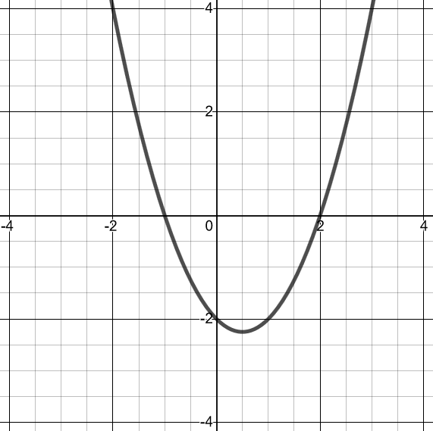 |  | $$y=x^{2}+2x+2$$ |  | $$x=\frac{1±\sqrt{9}}{2}$$

