The Quadratic Formula - Answers
A general quadratic equation: $ax^{2}+bx+c=0$
The quadratic formula: $x=\frac{-b±\sqrt{b^{2}-4ac}}{2a}$
Fill in the blanks below:
Equation | Quadratic formula | Simplified | Solutions ($2$dp)
$$x^{2}+4x+2=0$$ | $$\frac{-\left(4\right)±\sqrt{{\left(4\right)}^{2}-4\left(1\right)\left(2\right)}}{2\left(1\right)}$$ | $$x=\frac{-4±\sqrt{8}}{2}$$ | $x=-0.59$  and  $x=-3.41$
$$x^{2}-5x+3=0$$ | $$\frac{-\left(-5\right)±\sqrt{{\left(-5\right)}^{2}-4\left(1\right)\left(3\right)}}{2\left(1\right)}$$ | $$x=\frac{5±\sqrt{13}}{2}$$ | $x=4.30$  and  $x=0.70$
$$x^{2}+x-3=0$$ | $$\frac{-\left(1\right)±\sqrt{{\left(1\right)}^{2}-4\left(1\right)\left(-3\right)}}{2\left(1\right)}$$ | $$x=\frac{-1±\sqrt{13}}{2}$$ | $x=1.30$  and  $x=-2.30$
$$2x^{2}+7x+1=0$$ | $$\frac{-\left(7\right)±\sqrt{{\left(7\right)}^{2}-4\left(2\right)\left(1\right)}}{2\left(2\right)}$$ | $$x=\frac{-7±\sqrt{41}}{4}$$ | $x=-0.15$  and  $x=-3.35$
$$3x^{2}-5x-4=0$$ | $$\frac{-\left(-5\right)±\sqrt{{\left(-5\right)}^{2}-4\left(3\right)\left(-4\right)}}{2\left(3\right)}$$ | $$x=\frac{5±\sqrt{73}}{6}$$ | $x=2.26$  and  $x=-0.59$
$$x^{2}+3x+1=0$$ | $$\frac{-\left(3\right)±\sqrt{{\left(3\right)}^{2}-4\left(1\right)\left(1\right)}}{2\left(1\right)}$$ | $$x=\frac{-3±\sqrt{5}}{2}$$ | $x=-0.38$  and  $x=-2.61$
$$x^{2}-2x-5=0$$ | $$\frac{-\left(-2\right)±\sqrt{{\left(-2\right)}^{2}-4\left(1\right)\left(-5\right)}}{2\left(1\right)}$$ | $$x=\frac{2±\sqrt{24}}{2}$$ | $x=3.45$  and  $x=-1.45$
$$2x^{2}-6x+1=0$$ | $$\frac{-\left(-6\right)±\sqrt{{\left(-6\right)}^{2}-4\left(2\right)\left(1\right)}}{2\left(2\right)}$$ | $$x=\frac{6±\sqrt{28}}{4}$$ | $x=2.82$  and  $x=0.18$

Can you link each quadratic formula below to each function?
Function |  | Equation |  | Quadratic formula
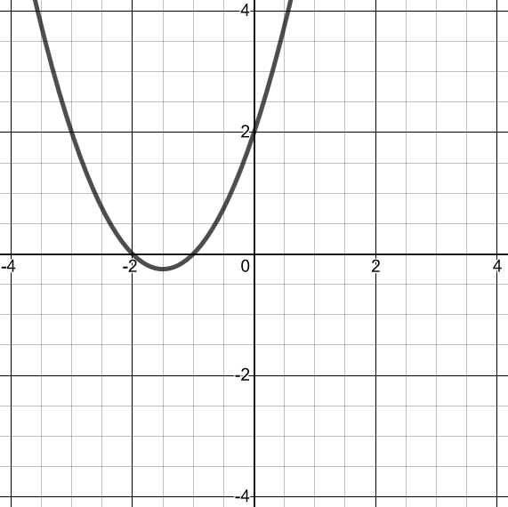 |  | $$y=x^{2}-4x+3$$ |  | $$x=\frac{-3±\sqrt{1}}{2}$$
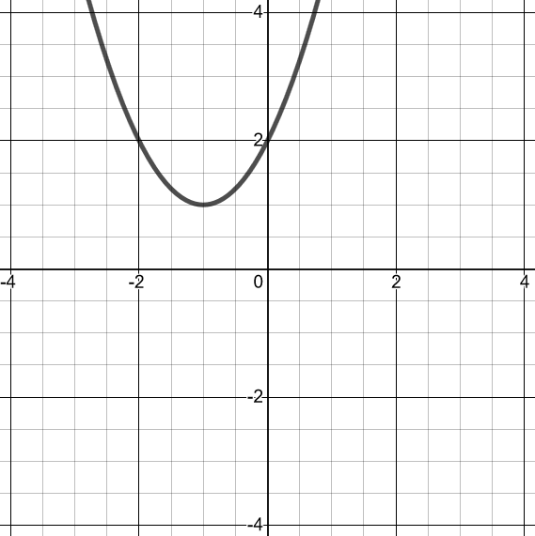 |  | $$y=x^{2}+3x+2$$ |  | $$x=\frac{4±\sqrt{0}}{2}$$
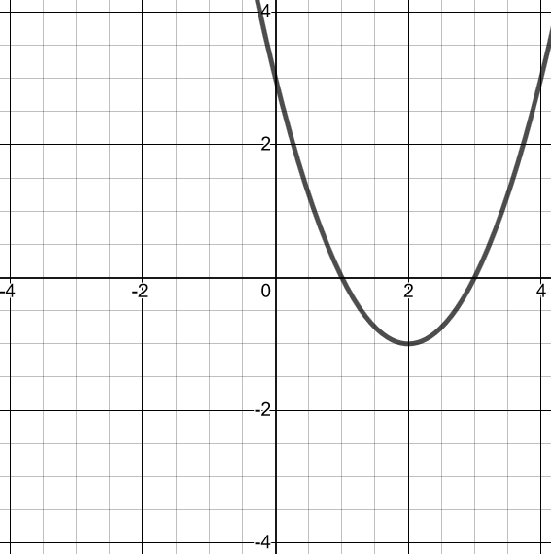 |  | $$y=x^{2}-x-2$$ |  | No solutions
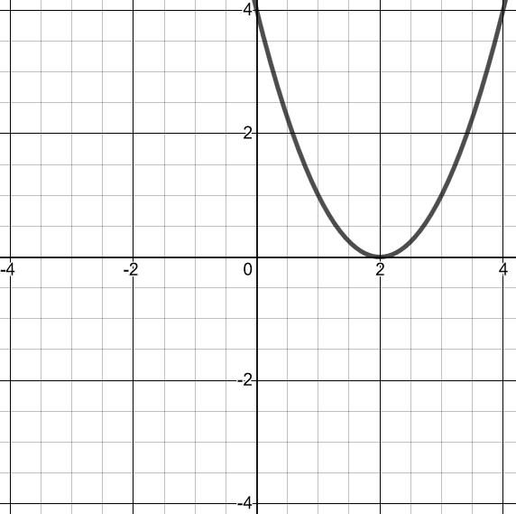 |  | $$y=x^{2}-4x+4$$ |  | $$x=\frac{4±\sqrt{4}}{2}$$
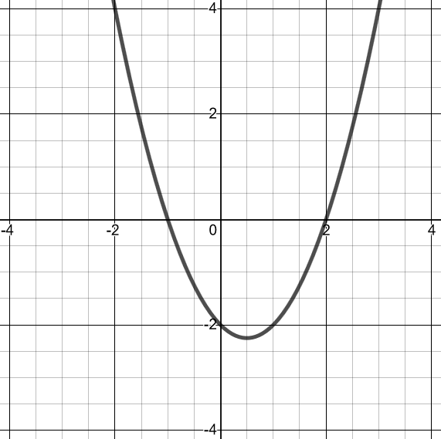 |  | $$y=x^{2}+2x+2$$ |  | $$x=\frac{1±\sqrt{9}}{2}$$

