QQQ – Further Mechanics 1 - Chapter 1 –
Impulse and Momentum (v2)
Total Marks: 26
(26 = Platinum, 23 = Gold, 20 = Silver, 17 = Bronze)
1.
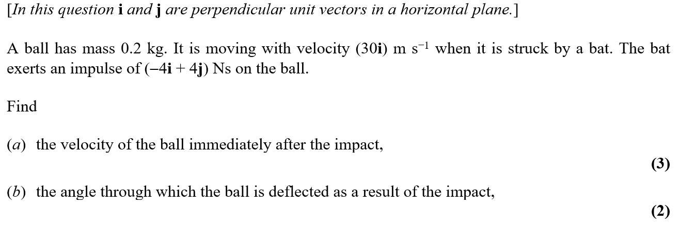

2.
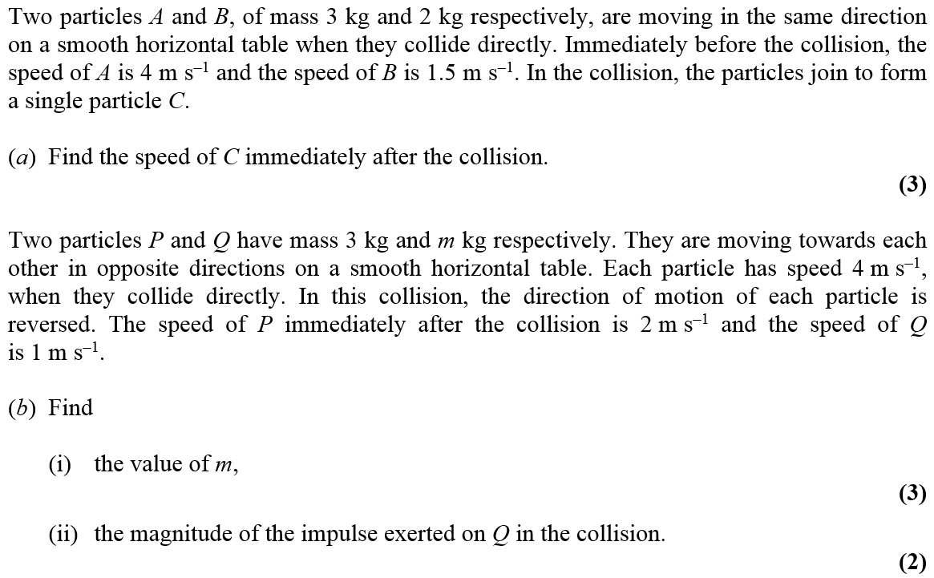

3.
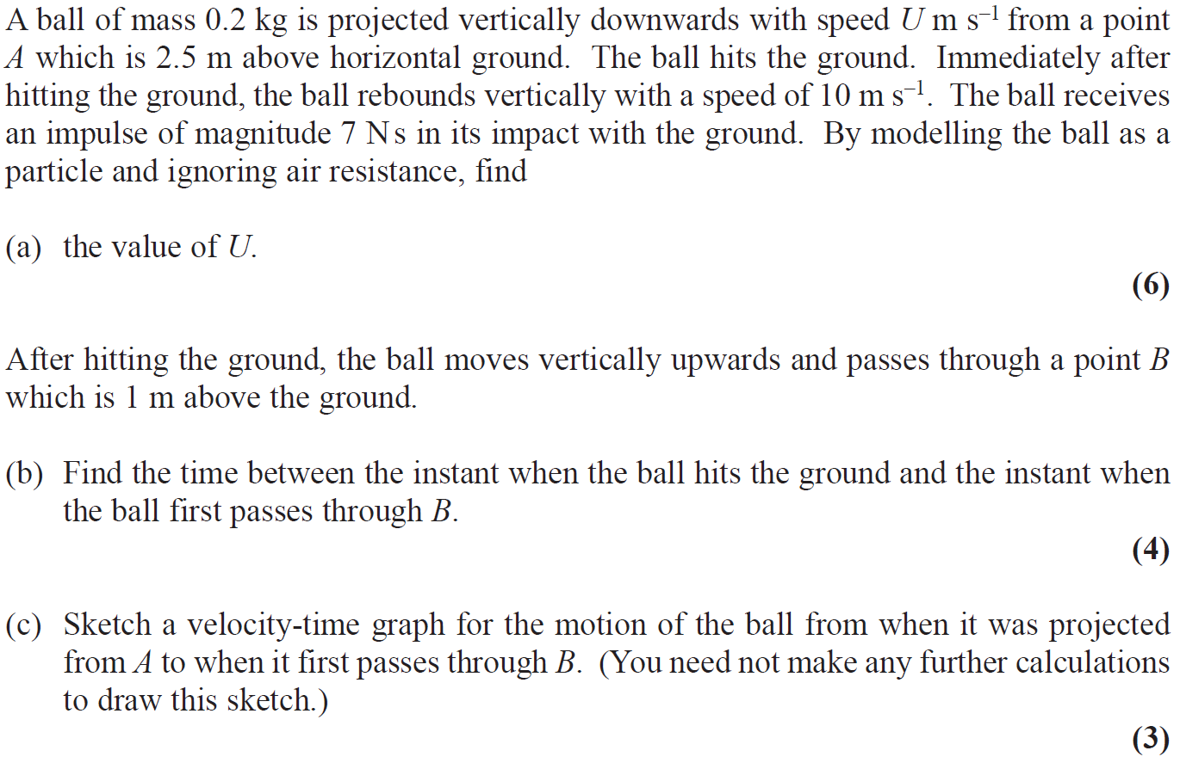

1.

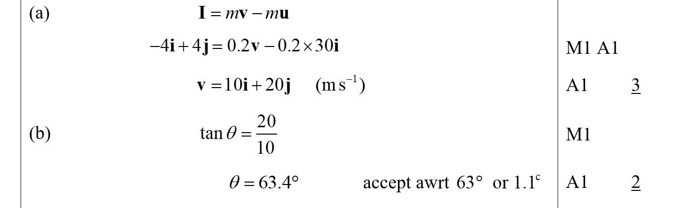
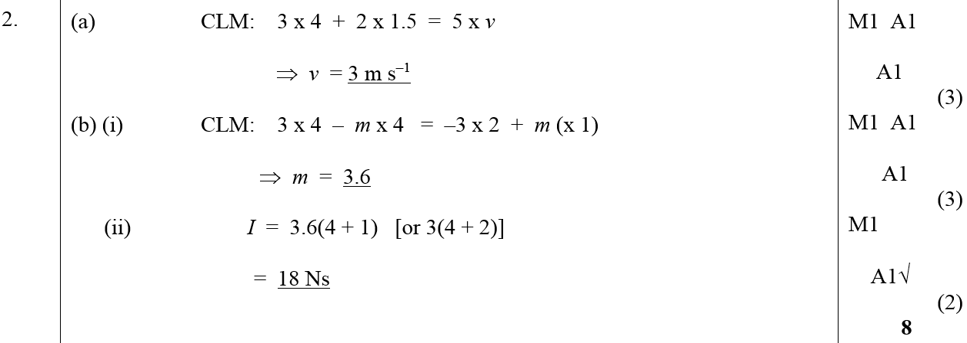
3
