**Woody’s Fraction Roundup - Answers**



Answers:

$$\frac{12}{20}, \frac{9}{15}, \frac{60}{100}$$

Answers:

$$\frac{9}{12}, \frac{75}{100}, \frac{18}{24}$$

Answers:

$$\frac{3}{6}, \frac{10}{20}, \frac{18}{36}$$

Answers:

$$\frac{7}{21}, \frac{4}{12}, \frac{12}{36}$$

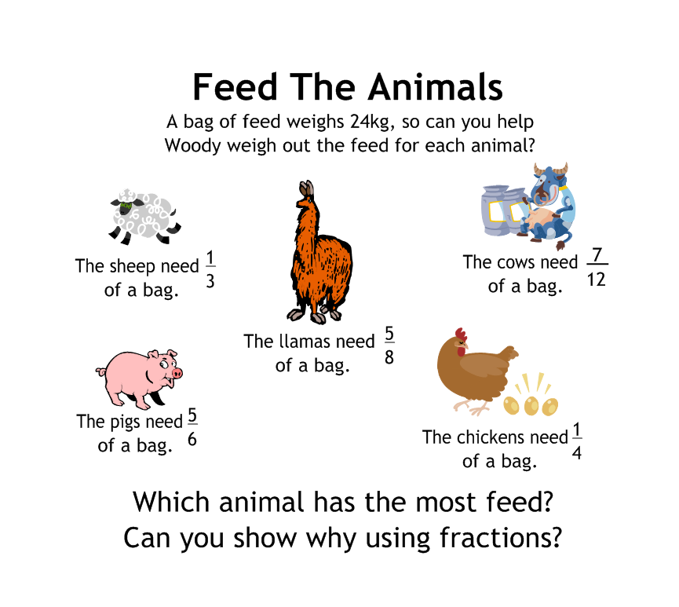

Answers:

Sheep: 8kg

Pigs: 20kg

Llamas: 15kg

Cows: 14kg

Chickens: 6kg

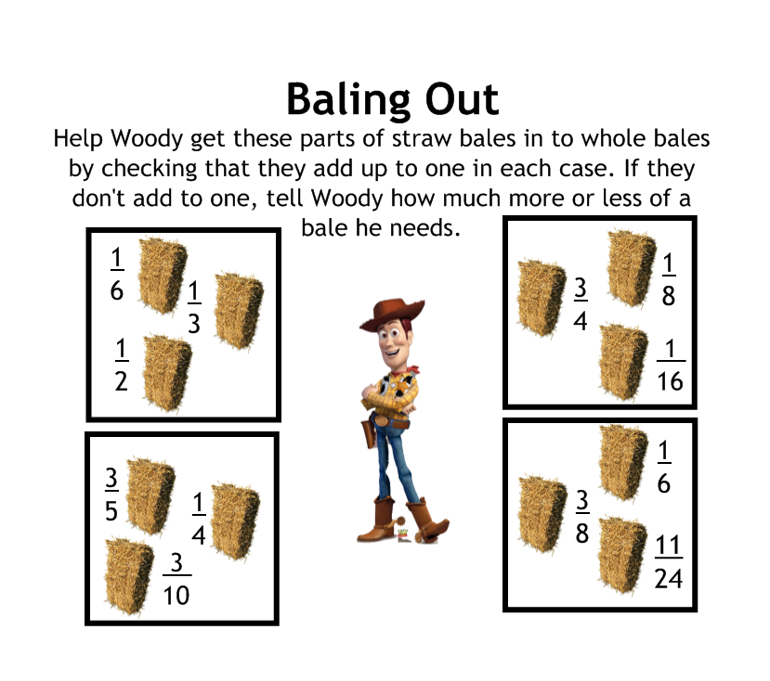

Answer:

Adds to $1\frac{3}{20}$

Answer:

Adds to $\frac{15}{16}$

Answer:

Adds to 1

Answer:

Adds to 1

**Show your working underneath:**