Find the Hidden Treasure!
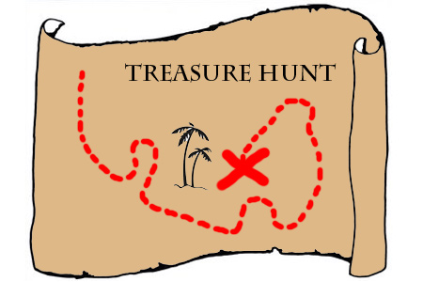
You are on a desert island and have found a treasure map! Each clue will give you a co-ordinate point where treasure is buried. When you have found all the treasure, use the co-ordinate points to generate the final lock code which will unlock all the treasure chests. Remember, you must not guess – but show all your lines of construction!

7 Digit Answer:

Information to share with students:
Each completed clue will give a coordinate point - and so a number. Students need to write their completed 7 digit number in the box to win the treasure! Measure from the base of all trees. Measure from the top of mountains. "East Hill coconuts" should be "Eight Hill coconuts". 1cm=1m. If the line intersect crosses 2 boxes choose the largest.
Clue 1 part i  The first treasure chest is buried equidistance from the tree on 3 Bone Island (D1) and the tree on Four Palms Beach (H5) | Clue 1 part ii  The first treasure chest is buried equidistant from Bone Island Tree A3 and 3 Bone Island Tree D1
Clue 2 part i  The second treasure chest is less than 2 metres from the tree at Double Palm Rise | Clue 2 part ii  The second treasure chest is closer to the Yellow Creek River mouth H18 than the Double Palm Tree Rise tree
Clue 2 part iii  The second treasure chest is due east from Double Palm Rise tree | Clue 3 part i  The third treasure chest is due west from the tree on Eight Hill Coconuts and due north from Pythagoras Peak
Clue 4 part i  The fourth treasure chest requires you to travel northwest from Glutton Rock (hint do the angle bisector of North and West. | Clue 4 part ii  The fourth treasure chest requires you to travel southwest from Six Palm Point. (hint do the angle bisector of South and West.
Clue 5 part i  The fifth treasure chest is equal distance from Pythagoras Peak and the Lone Leaning Tree. | Clue 5 part ii  The fifth treasure is on the Blue Bay Beach

Additional Teacher information:
ANSWER 1) D5 2) G18 3) K16 4) J8 5) P8. So 7 digit number = 5181688.
This is more fun if the students have already cut up the clue sections first. If you want a really energetic lesson the clues could be put around the room for the students to "discover".

Students need to know how to find line bisectors, angle bisectors, understand compass co-ordinates.

