Defuse the Bomb – Fractions, Decimals, Percentages 2
The Mathematician, a notorious terrorist has planted a bomb. You must defuse that bomb using the mathematical clues he’s left.
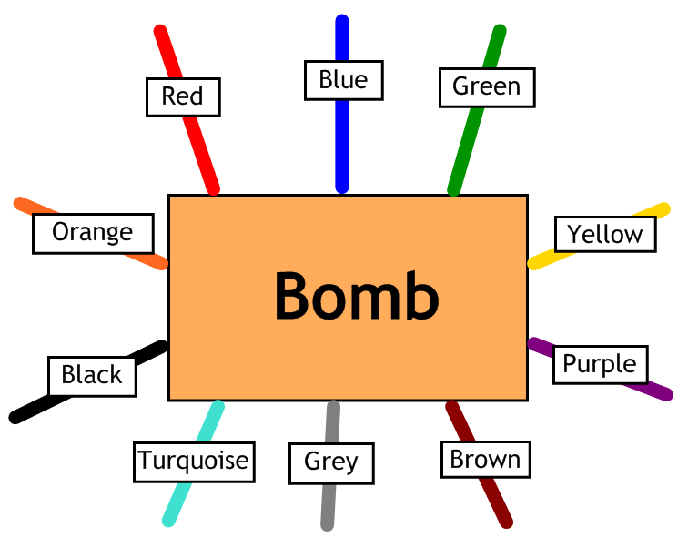
Answer the questions, then cut the coloured wires in the order that the answers appear, using the table below:
Red | Blue | Green | Yellow | Purple | Brown | Grey | Turquoise | Black | Orange
22.5 | $$\frac{13}{20}$$ | 0.83 | 18 | $$\frac{8}{25}$$ | 40 | 75 | $$\frac{17}{50}$$ | 28 | 44

Here are the clues that show which order to cut the wires:
1 | What is $\frac{3}{4}$ as a percentage?
2 | What is 83% as a decimal?
3 | Write 32% as a fraction in its lowest terms.
4 | What is $\frac{11}{25}$ as a percentage?
5 | Which is the smallest: 0.2, $\frac{9}{50}$, 26%, $\frac{1}{4}$, 0.32, $\frac{2}{5}$?  Give your answer as a percentage.
6 | Write 65% as a fraction in its lowest terms.
7 | What is $\frac{9}{40}$ as a percentage?
8 | Which is the largest: 0.23, $\frac{1}{5}$, 26%, $\frac{1}{4}$, 0.19 or $\frac{7}{25}$?  Give your answer as a percentage.

