Defuse the Bomb – Fractions, Decimals, Percentages 1
The Mathematician, a notorious terrorist has planted a bomb. You must defuse that bomb using the mathematical clues he’s left.
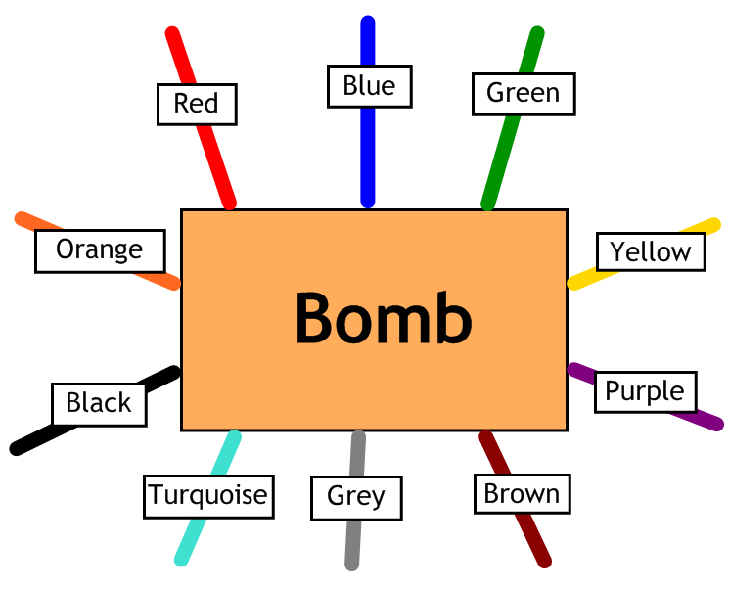
Answer the questions, then cut the coloured wires in the order that the answers appear, using the table below:
Red | Blue | Green | Yellow | Purple | Brown | Grey | Turquoise | Black | Orange
$$\frac{4}{10}$$ | 50 | $$\frac{2}{5}$$ | 70 | 43 | 34 | 25 | $$\frac{3}{4}$$ | 60 | $$\frac{3}{10}$$

Here are the clues that show which order to cut the wires:
1 | Write $\frac{1}{2}$ as a percentage.
2 | What is 0.34 as a percentage?
3 | Write 30% as a fraction in its lowest terms.
4 | Write $\frac{1}{4}$ as a percentage.
5 | Write 40% as a fraction in its lowest terms.
6 | Write $\frac{7}{10}$ as a percentage.
7 | Write 75% as a fraction in its lowest terms.
8 | Write $\frac{3}{5}$ as a percentage.

