Defuse the Bomb – Fractions, Decimals, Percentages 1 - Answers
The Mathematician, a notorious terrorist has planted a bomb. You must defuse that bomb using the mathematical clues he’s left.
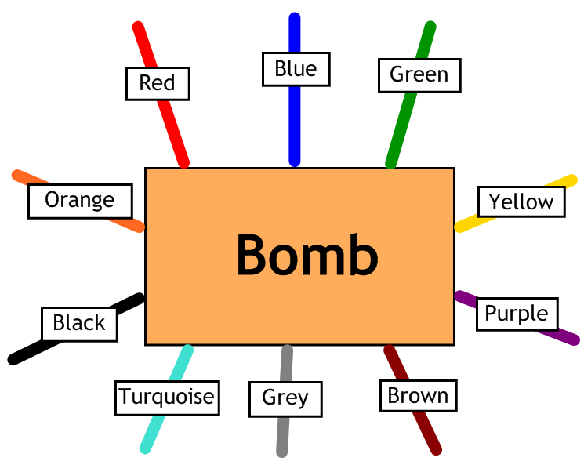
Answer the questions, then cut the coloured wires in the order that the answers appear, using the table below:
Red | Blue | Green | Yellow | Purple | Brown | Grey | Turquoise | Black | Orange
$$\frac{4}{10}$$ | 50 | $$\frac{2}{5}$$ | 70 | 43 | 34 | 25 | $$\frac{3}{4}$$ | 60 | $$\frac{3}{10}$$

Here are the clues that show which order to cut the wires:
1 | Write $\frac{1}{2}$ as a percentage. 50% - Blue
2 | What is 0.34 as a percentage? 34% - Brown
3 | Write 30% as a fraction in its lowest terms. $\frac{3}{10}$ - Orange
4 | Write $\frac{1}{4}$ as a percentage. 25% - Grey
5 | Write 40% as a fraction in its lowest terms. $\frac{2}{5}$ - Green
6 | Write $\frac{7}{10}$ as a percentage. 70% - Yellow
7 | Write 75% as a fraction in its lowest terms. $\frac{3}{4}$ - Turquoise
8 | Write $\frac{3}{5}$ as a percentage. 60% - Black

