Defuse the Bomb – Fraction of a Number 2
The Mathematician, a notorious terrorist has planted a bomb. You must defuse that bomb using the mathematical clues he’s left.
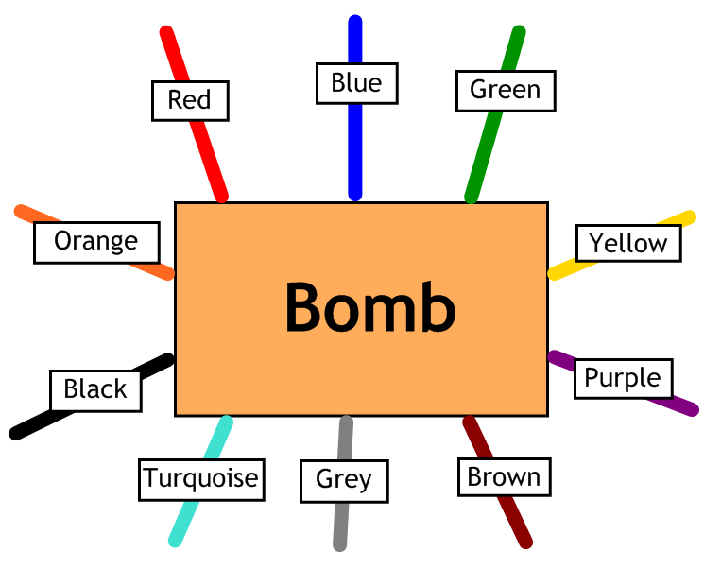
Answer the questions, then cut the coloured wires in the order that the answers appear, using the table below:
Red | Blue | Green | Yellow | Purple | Brown | Grey | Turquoise | Black | Orange
18 | 9 | 14 | 50 | 40 | 20 | 32 | 15 | 24 | 12

Here are the clues that show which order to cut the wires:
1 | What is $\frac{2}{3}$ of 18?
2 | What is $\frac{3}{4}$ of 24?
3 | What is $\frac{2}{5}$ of 35?
4 | What is $\frac{3}{8}$ of 40?
5 | Harry has a jar containing 36 sweets. He eats $\frac{1}{4}$ of the sweets. How many sweets did Harry eat?
6 | Suzie took a maths test. Her teacher tells her that she got $\frac{4}{5}$ of the marks. If the test was out of 40, how many marks did Suzie get?
7 | Jodie has £50 in her bank account. She decides to spend $\frac{3}{5}$ of it on a shopping trip. How much does she have left in her account?
8 | Dave won £150 in a competition. He decides to keep $\frac{2}{3}$ of it and donate the rest to charity. How much did Dave donate to charity?

